Title: Utilization of Amla Pomace Generated in Fruit Processing Industry for Functional Food Product Development (A Field Investigation)
Ajay Patel*, S.N. Naik, Santosh Satya
Centre for Rural Development and Technology, Indian Institute of Technology, Hauz Khas, New Delhi 110016, India

Abstract
Indian Gooseberry or amla (Emblica officinalis), is also known as anola, amalakki, or nelliis. The fruit, being richest source of vitamin C demonstrate a very high antioxidant activity (Tarwadi and Agte, 2007). Now a days for human health as per Ayurvedic health care system lot of emphasis is given on consumption of amla juice leading to its commercial availability of different brands. Production of amla juice generates large quantity of amla pomace which remains unutilized and considered a waste material in juice production industries.
Inview of above a field study was conducted in Patanajali Herbal and Food Park, Haridwar and necessary data was collected. It was noted that 250 MT amla fruit is processed per day, thus generated nearly 62 MT amla pomace/day. In present study amla pomace collected from above industry at Haridwar is dried by three methods viz sun drying (SD), oven drying (OD) and Freeze drying (FD). Antioxidant potential (DPPH assay), dietary fibre and functional properties (Water holding capacity (WHC), swelling capacity (SWC), oil holding capacity (OHC), bulk, hydrated and packed density) of three types of dried amla pomace powder have been determined by standard methods. Data revealed that WHC, SWC, and OHC of FD sample is highest as compared to OD and SD. Bulk density, packed density and hydrated density of FD is lowest followed by OD and SD. It may be due to water removal at low temperature creates porous structures within the cell wall matrix, which enables easy and complete rehydration (Z.W. Cui, et. al, 2008). Dietary fiber (both soluble and insoluble) is also found maximum in FD sample as compared to SD/OD. All the dried samples were found to possess quite good % radical scavenging activity. These properties indicate that amla pomace is a valuable food resource and can be effectively used for preparation of functional food products such as cookies, noodles and muffins.
Keywords: Amla pomace, functional properties, functional food, Fruit Processing Industry

Related Images
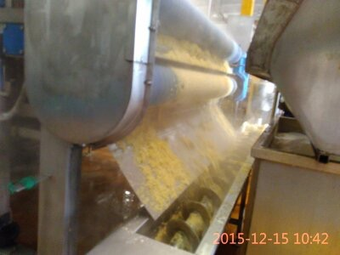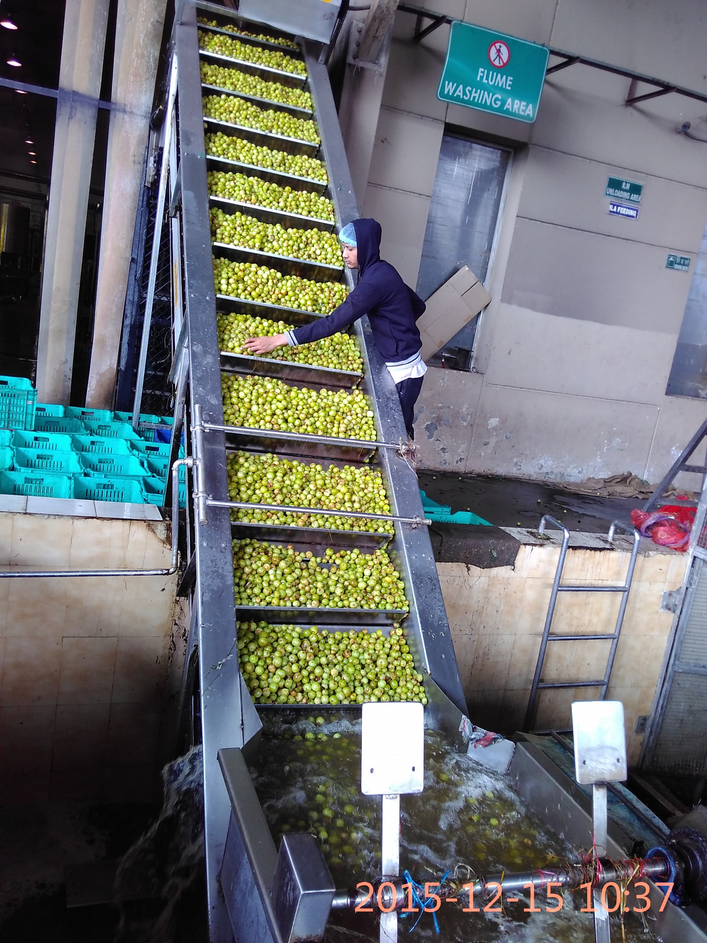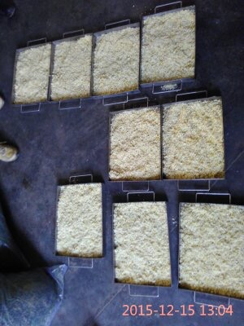

List of Recent Publications journal and conference (Maximum 5)
1. Measurement Of Respiration Rate of Light Red Stage Tomatoes (Lycopersicon esculentum Mill.) and its modeling (Billoria S., Patel A. and Mishra H.N. (2016). International Journal of Agriculture Sciences, ISSN: 0975-3710 & E-ISSN: 0975-9107, Volume 8, Issue 57, pp.-3125-3131.

2. Functional Properties of Gular (Ficus Racemosa) for Functional Food Preparation” (Poster presentation, International conference on Emerging technologies on agricultural and food engineering held on 27-30th Dec, 2016 at IIT Kharagpur, Proceeding abstract Page - 260

Biography
I am Ajay Patel a research scholar in IIT Delhi working under Prof. S. N Naik and Prof. Santosh Satya. I have done my masters from IIT kharagpur in food process engineering. My research area is utilization of industrial food waste to improve the rural economy of industries.
Presenting author details
Full name: Ajay Patel
Email: ajayp928@gmail.com
Contact number: +91-9971763055
Twitter account: @ajayp928
Linked In account: Ajay Patel
Session name/ number:
Category: Poster presentation

Notes/Comments: Further study is going on product development that can be incorporated during conference.

