Title: Study of Antioxidant Potential and Functional Properties of Amla (Emblica officianalis) Pomace for Functional Food Product Development
Ajay Patel*, S.N. Naik, Santosh Satya
Centre for Rural Development and Technology, Indian Institute of Technology, Hauz Khas, New Delhi 110016, India

Abstract
Indian Gooseberry or amla (Emblica officinalis), is also known as anola, amalakki, or nelliis. It is considered to be a wonder fruit for health because of its unique properties. The fruit, being richest source of vitamin C 445 mg/100 g (Tarwadi and Agte, 2007), demonstrates a very high antioxidant activity. The main objective of the study is to scientifically utilize the amla pomace (AP) for functional food product development. Literature review revealed that amla pomace have great medicinal value, which can be used to prepare nutraceuticals/functional food, in this context antioxidant and functional properties has been studied. Amla pomace were collected from amla juice extraction industry. The amla pomace were dried by using three different techniques freeze, sun and oven drying. Dried AP powder were taken to study functional properties and to extract phytochemicals. Freeze dried AP extract shows higher antioxidant property as compare to oven and sun dried. Also Water holding capacity (WHC), swelling capacity (SC), oil holding capacity (OHC), bulk, hydrated and packed density of freeze dried (AP) is found significantly more as compare to oven and sun dried (AP) powder. Water removal at low temperature creates porous structures within the cell wall matrix, which enables easy and complete rehydration (Z.W. Cui, et. al, 2008), thus showing higher SC in freeze dried powder. BD of oven dried AP is more this is because high shrinkage of cells at high temperature (L.G. Bakre, 2009).
Keywords: Amla pomace, antioxidant, functional properties, functional food.

Related Images
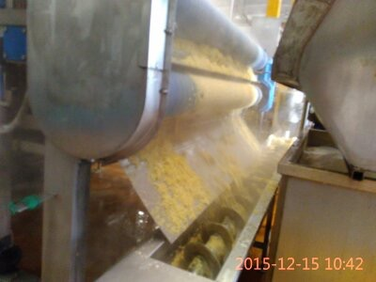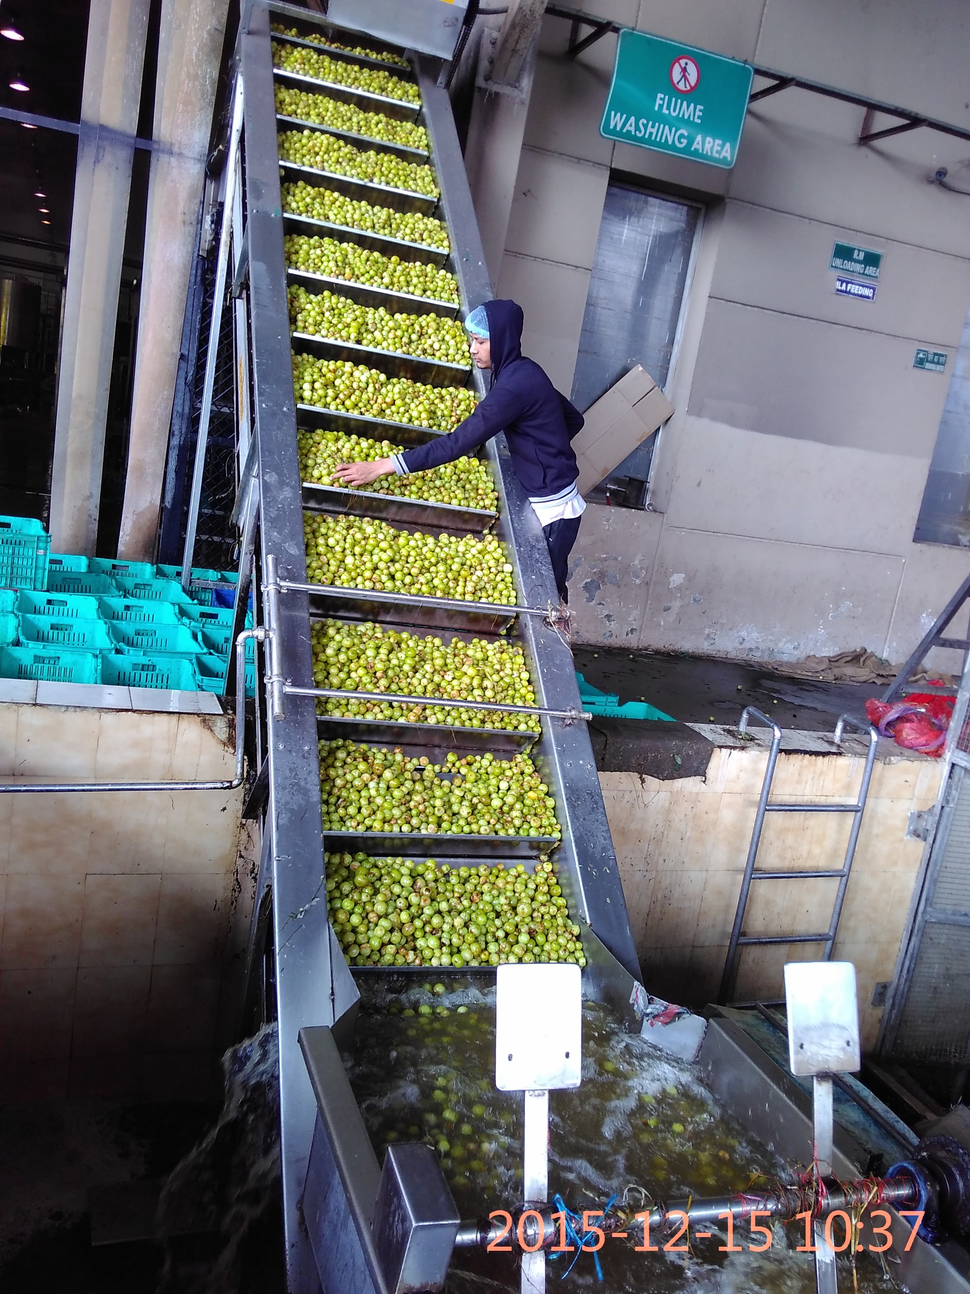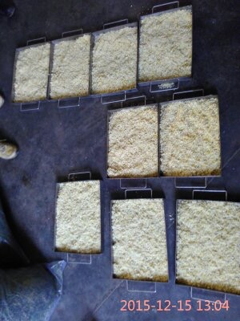

List of Recent Publications journal and conference (Maximum 5)
1. Measurement Of Respiration Rate of Light Red Stage Tomatoes (Lycopersicon esculentum Mill.) and its modelling

2. Functional Properties of Gular (Ficus Racemosa) for Functional Food Preparation”

3. Scientific Utilization of By-products in Fruit Processing Industry- A field investigation”

4. Use of agro-industrial wastes for production of bio pigments by fungus using solid state fermentation

5. Extension of Shelf life of fruits with edible coating

Biography
I am Ajay Patel a research scholar in IIT Delhi working under Prof. S. N Naik. I have done my masters from IIT kharagpur in food process engineering. My research area is utilization of industrial food waste to improve the economy of industries.
Presenting author details
Full name: Ajay Patel
Email: ajayp928@gmail.com
Contact number: +91-9971763055
Twitter account: @ajayp928
Linked In account: Ajay Patel
Session name/ number:
Category: Poster presentation

Notes/Comments: Further study is going on product development that can be incorporated during conference.

