Probiotics against viruses; COVID-19 is a paper tiger: A Systematic Review
Zamzam Paknahad, PhD, Isfahan University of Medical Sciences, Isfahan, Iran. Amir Reza Moravejolahkami, Isfahan University of Medical Sciences, Isfahan, Iran.

Abstract (300 word limit)

Background

Probiotics can improve immune function for prevention and management of viral infections like SARS-CoV-2 infection (COVID-19 disease).

Methods

We searched on PubMed, EMBASE, Google Scholar, Science Direct, Scopus, and Web of Science up to May 2020 to identify interventional & observational studies documenting the effects of probiotics on incidence, severity, duration, and other clinical manifestations of viral infections especially SARS-CoV-2-induced.

Results

From a total of 91 records, 24 studies were obtained and classified into three domains based on the efficacy of probiotics on 1) shortening the period and severity of infections (n=9), 2) incidence (n=6), and 3) Other clinical complications that may be followed by viral disorders (n=9). The selected probiotics have positive effects on the mentioned domains.

Conclusion

Based on the evidence, some probiotic strains may be useful in SARS-CoV-2 infection; the randomized trials are needed to show the facts.

PROSPERO Registration code: CRD42020181453

MeSH Keywords: Virus Diseases, Probiotics, COVID-19, SARS-CoV-2, microbiome, immunity
Image
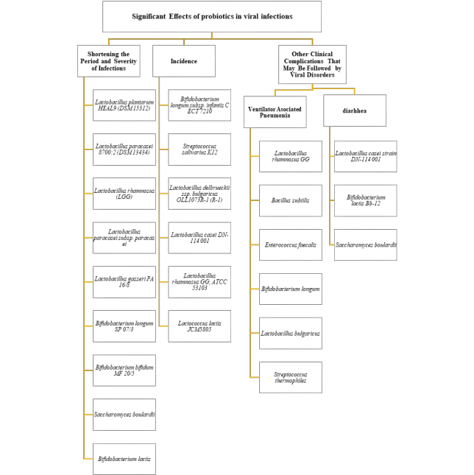

Recent Publications (minimum 5)
- Heidari‐Beni M, Moravejolahkami AR, Gorgian P, Askari G, Tarrahi MJ, Bahreini‐Esfahani N. Herbal formulation “turmeric extract, black pepper, and ginger” versus Naproxen for chronic knee osteoarthritis: A randomized, double‐blind, controlled clinical trial. Phytotherapy Research. 2020 Aug;34(8):2067-73.
- Bohlouli J, Moravejolahkami AR, Ganjali Dashti M, Balouch Zehi Z, Hojjati Kermani MA, Borzoo-Isfahani M, Bahreini-Esfahani N. COVID-19 and Fast Foods Consumption: a Review. International Journal of Food Properties. 2021 Jan 1;24(1):203-9.
- Askari G, Ghavami A, Shahdadian F, Moravejolahkami AR. Effect of synbiotics and probiotics supplementation on autoimmune diseases: A systematic review and meta-analysis of clinical trials. Clinical Nutrition. 2021 Feb 17.
- Bahreini-Esfahani N, Moravejolahkami AR. Can Synbiotic Dietary Pattern Predict Lactobacillales Strains in Breast Milk?. Breastfeeding Medicine. 2020 Jun 1;15(6):387-93.5.
- Hemati N, Venkatakrishnan K, Yarmohammadi S, Moradi M, Moravejolahkami AR, Hadi A, Moradi S, Aneva IY, Farzaei MH. The effects of supplementation with Cynara scolymus L. on anthropometric indices: А systematic review and dose-response meta-analysis of clinical trials. Complementary therapies in medicine. 2020 Nov 7:102612.



Biography (150 word limit)
Amir Reza Moravejolahkami is an Academic Researcher at the School of Nutrition & Food Science, Isfahan University of Medical Sciences and he is a big fan of nutrition interventions in inflammatory diseases. Email: amimohs@gmail.com; a.moravej@mail.mui.ac.ir

Notes/Comments:

