“Food and nutrition security in Nepal”

Keywords : food security ,polices and food nutrition

Introduction:
The number of undernourished people in the world is estimated to be increased to 815 million in 2016, up from 777 million in 2015 but still down from about 900 million in the year 2000. Similarly, while the prevalence of undernourishment is projected to have increased to an estimated 11 percent in 2016, this is still well below the level of a decade ago. Nonetheless, the recent increase is a cause for great concern and poses a significant challenge for international commitments to end hunger by 2030.
The 2030 SDG Agenda call on all countries and stakeholders to work together to end hunger, achieve food security and improved nutrition and promote sustainable agriculture by 2030. A multi-sectoral approach which connects nutritional outcome, agricultural productivity and household income is needed to address the issue. Such an approach must highlight the interconnectedness between agriculture and nutrition and the need to consider food diversity as an important aspect of food security. Multi-sectorial approach also needs to consider the agri-food systems as a whole instead of focusing on individual food components.
Among countries in the SAARC region, prevalence of undernourishment (PoU) is highest for Afghanistan at 23%, followed by Sri Lanka at 22% for 2014-16. The estimate is lowest for Nepal at 8.1%. The proportion in Bangladesh and India are similar and in the range 14-15% with these two populous countries accounting for most of the absolute number of under-nourished in the region (FAO, IFAD, UNICEF, WFP and WHO, 2017).
Likewise, among countries in the SAARC region, prevalence of stunting is the highest for Pakistan at 45%, followed by Afghanistan at 40.9%, India at 38.4%, Nepal at 37.1%, Bangladesh at 36.1%, Bhutan at 33.6% and Sri Lanka at 14.7% for 2014-16. Prevalance of wasting is the highest for Srilanka at 21.4%, followed by India at 21%, Bangladesh at 14.3%, Nepal at 11.3%, Pakistan at 10.5%, Maldives at 10.2%, Afghanistan at 9.5% and Bhutan at 5.9%. Similarly, prevalence of underweight is the highest for both Afghanistan and Bangladesh at 32.9% , followed by Pakistan at 31.6%, Nepal at 30.1%, India at 29.4%, Srilanka at 26.3%, Maldives at 17.8% and Bhutan at 12.8% (FAO, IFAD, UNICEF, WFP and WHO, 2017).
Despite Nepal has no worse food and nutrition security situation among SAARC countries, it is realized that the nutritional status of women and children, especially the vulnerable groups (infant, children, pregnant and lactating mothers) is still very poor. Nepal has a very high rate of child malnutrition, 36% and 27% of children under five are stunted and underweight, respectively. About 17% women of reproductive age have chronic energy deficiency (Body Mass Index less than 18.5) and 41% of those populations are anemic (NDHS, 2016). Similarly, women and children also suffer from some of the world’s highest levels of vitamin and mineral deficiencies which can be emphasized by the fact that Vitamin A deficiency is the cause of deaths of approximately 6,900 children in Nepal each year. One in five (21%) children is born with low birth weight in Nepal reflecting malnutrition in the womb. Consequently 2 to 10 times the risk of death and also at higher risk of diabetes and cardiovascular disease in adulthood. Iodine deficiency in pregnancy causes more than 200,000 babies a year in Nepal to be born mentally impaired and IQs that are 10 to 15 points lower than those not deficient. About 2-3 % of GDP (US$ 250 to 375

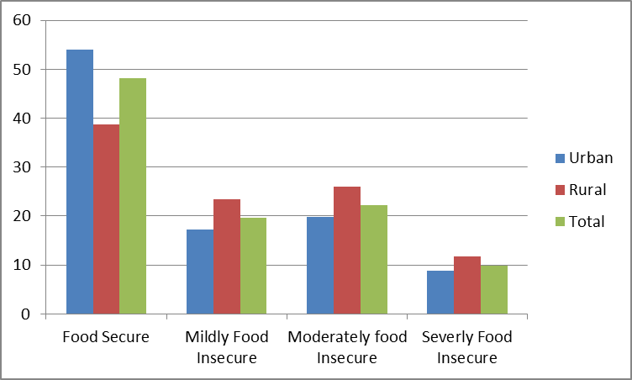
Nepal Demographic and Health Survey (NDHS), 2016 has shown that the national household food security is only 48.2% whereas in rural areas the percentage is only about 38.8%. The severely food insecure households are about 10% (Figure 1). Geographically, the mountain region is suffering more from food insecurity where the percentage of food secure households is 38.4% compared to terai where the statistics is about 51% (Figure 2). Furthermore, the severely food insecure households in mountain region are about 13.8% compared to 9.2% of terai region. Development Region wise the food secure households are lowest in Mid-Western region (only 27.7%) and percentage of severely food insecure households in that region is highest (about 16.9%) (Figure 3). State wise (Figure 4) the Karnali Province has lowest level of food security (food secure households are only 22.5%) and the severely food insecure households are about 17.5% (NDHS, 2016).
Figure 1. Percent distribution of household food insecurity of Nepal(Source: NDHS, 2016)
60
50
40
30
20
10
0
Food Secure
MildlyFood Insecure
Moderately food Insecure
Terai
Severly Food Insecure
Mountain
Hill

Figure 2. Percent distribution of households food insecurity by geographical regions

70

60

50

40

30

20

10

0
Eastern
Central
Western Mid-western Far-western
Food Secure Mildly Food Insecure Moderately foodInsecure Severly Food Insecure
Figure 3. Percent distribution of households food insecurity by development regions (Source: NDHS, 2016)
60
50
40
30
20
10
0
Province 1 Province 2 Province 3 Province 4 Province 5 Province 6 Province 7
Food Secure
Mildly Food Insecure
Severly Food Insecure
Figure 4. Percent distribution of households food insecurity by provinces (Source: NDHS, 2016)

Food and nutrition security in Nepal

Significance of agriculture in improving malnutrition
With respect to food and nutrition security, Pearl S. Buck (2018) stated that "A hungry man can't see right or wrong. He just sees food”. In the same line, previously our focus was only on food rather than its quality and diversified foods to address overall food and nutrition security.
The Table 1 shows the current cereal balance situation of Nepal. Except high hill region other regions (hill and terain) are surplus in major cereals. Out of 16 high hill districts such as Taplegunj, Sankhuwasabha, Solukhumbu, Dolkha, Sindhupalchowk, Rasuwa, Manang, Mustang, Dolpa, Mugu, Humla, Jumla, Kalikot, Bajura, Bajhang, and Darchula; 12 districts, except Sankhuwasabha, Solukhumbu, Dolkha, Sindhupalchowk have food deficit situation . Nepal is in food surplus situation at the national level.
It is positively indicated that food security can so far be achieved with balancing cereal distribution system within the country. However, this is not the indication of nutrition security in the nation. There is need of diversified food including pulses, vegetables, fruits, eggs, milk, fish and meat in cereal based foods for nutrition security. So, certainly there is need of diversified agriculture production system in the country for nutrition security.
Table 1. Cereal balance sheet 2073/2074(2016/2017) 000Mt

Region | Paddy | Maize | Finger millet | Buck wheat | Wheat | Barley | Available | Requiremen t | Surplu s or Deficit
High hill | 77.37 | 136.8 | 40.71 | 4.27 | 55.79 | 4.32 | 319.27 | 356.59 | -37.32
hill | 692.27 | 1319.38 | 184.14 | 3.71 | 459.27 | 3.16 | 2661.93 | 2479.12 | 182.82
Terai | 2087.93 | 325.59 | 7.74 | 1.31 | 996.42 | 0.352 | 3417.14 | 2664.52 | 752.62
Nepal | 2857.57 | 1781.78 | 230.38 | 9.30 | 1511.49 | 7.83 | 6398.35 | 5500.23 | 898.11
Moreover, with the context of malnutrition; besides under nutrition, overweight and obesity is also becoming challenge in Nepal. In both contexts, creation of nutrition balance in the country is prerequisite. So without agriculture, we cannot think to meet the goal of sustainable nutrition security.

Food and nutrition security: policies, plans and strategies

Constitutional provision
Right relating to food is one of the fundamental rights provisioned in our constitution, it is stated as below:
Fundamental Rights
- 36. Right relating to food:
  - Every citizen shall have the right relating to food.

  - Every citizen shall have the right to be safe from the state of being in danger of life from the scarcity of food.
  - Every citizen shall have the right to food sovereignty in accordance with law.

Major policy, plan, strategy and program
Major policy, plan, strategy and program related to food and nutrition security are listed below:
- Agriculture Development Strategy (ADS), 2015-2035;
- Agro-biodiversity Policy, 2007;
- Dairy Development Policy, 2007;
- Trade Policy, 2009; National Agricultural Policy, 2004;
- Multi-sectoral Nutrition Plan (MSNP) I & II;
- National Seed Policy, 2000;
- Agri-business Promotion Policy, 2006;
- NeKSAP: Nepal Food Security Monitoring System (NeKSAP); and
- Agriculture and Food Security Project (AFSP) 2013-2018.
Some of them are directly related to food and nutrition security and some are indirectly related.

Agriculture Development Strategy 2015-2035
Agriculture Development Strategy (ADS) 2015-2035 was launched in 2072/2073 to guide agricultural sector for next 20 years. The ADS action plan and roadmap are formulated in order to move towards the ADS vision "A self-reliant, sustainable, competitive, and inclusive agricultural sector that drives economic growth and contributes to improved livelihoods and food and nutrition security leading to food sovereignty." The major indicators of ADS, directly related to food and nutrition security, are given below (Table 2):
Table 2. Targets and indicators of ADS: food and nutrition security

Vision Component | Indicators | Existing situation (2010) | Target short term (5 years) | Target Medium  term (10 years) | Target long term ( 10 years)
Food and  nutrition | Food poverty | 24% | 16% | 11% | 5%
security | Nutrition | 41.5% | 29% | 20% | 8% stunting;
 |  | Stunting; | stunting; | stunting; | 5%
 |  | 31.1% | 20% | 13% | underweight;
 |  | underweight | underweight; | underweight; | 1% wasting;
 |  | 13.7% | 5% wasting; | 2% wasting; | 5% women
 |  | wasting | 15% women | 13% women | with low
 |  | 18% | with low | with low | BMI
 |  | women with | BMI | BMI
 |  | low BMI

For achieving its vision, ADS has planned to accelerate agricultural growth through four strategic components related to governance, productivity, profitable commercialization and competitiveness while promoting inclusiveness (social and geographic), sustainability(economic and natural resources), development of private and corporate sector and connectivity to market infrastructures (rural roads, collection centres, packing house, market centers), information infrastructure and ICT, Power infrastructure(rural electrification, renewable and alternative energy sources). The acceleration of inclusive, sustainable, multi-sector and connectivity based growth is expected to result in increased food and nutrition security, poverty reduction, agriculture trade competitiveness, higher and more equitable income of rural households and strengthened farmers' right.
The ADS is implemented through three different types of programs: the core programs, the flagship programs, and other programs. The core programs are implemented mostly through existing agencies already in place at the ministry levels or department levels of agencies. The flagship programs on the other hand require different management structure in view of the innovative and multi-sector nature of their activities. Other programs are those that are currently implemented but are not part of the currently formulated flagship or core programs. Moreover, the ministry of agricultural development will lead the implementation of flagship programs too. Over time, the ADS will include only two types of programs, namely the flagship and the Core Programs. Based on evaluation, the existing other programs will be either discontinued after their completion or will be absorbed in a new formulation of flagship and core programs.
The ADS envisages some prioritized national programs around which could be mobilized sufficient consensus, resources, and effective management. These prioritized national programs will be referred to as “ADS Flagship Programs”. The flagship programs of the ADS are:
Food and Nutrition Security Program (FANUSEP)
Decentralized Science, Technology, and Education Program (DSTEP) Value Chain Development Program (VADEP)
Innovation and Agro-entrepreneurship Program (INAGEP)
The ADS vision is aligned with the Multi-sectoral Nutritional Plan (MSNP) and the food and Nutrition Security Plan of Action (FNSP) 2013-2022. In Agriculture Development Strategy, one of the priority component is food and nutrition security, in which for 20 years, 5 potential indicators are drawn. Right to food bill, Food safety policy and food and nutrition security policy are drafted and going to be finalized soon.

Nutrition Sensitive Agriculture
Nutrition-sensitive agriculture is a way to define agriculture investments made with the intention of improving nutrition which requires deliberate and appropriate forethought and planning to yield impact on nutritional status and consequently sustainable good health and wellbeing. There is need to protect, promote and improve established food and agriculture based systems (increased production and productivity, agricultural and dietary diversification, bio-fortification and food fortification) as the sustainable solution to ensure food and nutrition security, combat micronutrient deficiencies, improve diets and raise levels of nutrition principally to rural poor, to achieve the nutrition-related SDGs. Current focus needs to be given to not only increasing the

production and access to foods but also its consumption, ensuring that the poor have access to adequate quantities of safe, good quality food for a nutritionally adequate diet including energy, protein and fats but also micronutrients (the vitamins and minerals) and other trace elements so necessary for normal growth and development. Started early, this approach can contribute to physiological, mental and social development, enhance learning potential, reduce nutritional disorders and contribute to the prevention of diet-related diseases later in life. Therefore, national policy has focused on:
- Increasing agricultural and livestock productivity through use of improved inputs and techniques.
- Reducing post-harvest losses through storage and processing technologies.
- Growing and husbanding a nutritious variety of plant and animal food sources.
- Increasing incomes from off-farm livelihoods and from sales of surplus food production though improved market access.

Sustainable Development goal (SDG) 2016-2030
In 2015, Nepal joined other members of the United Nations in adopting the global sustainable development goals (SDGs) that follow the Millennium Development Goals (MDGs) as the international development targets. Among 17 goals, SDG 2 aims at ending hunger, achieving food security to improve nutrition through sustainable agriculture by 2030. SDG 2 has following major targets,
- Ending hunger by 2030 and ensuring access by all people to safe, nutritious and sufficient food all year round,
- Ending all forms of malnutrition,
- Doubling agricultural productivity and incomes of small-scale food producers,
- Ensuring sustainable food production systems and implement resilient agricultural practices,
- Maintaining by 2020 the genetic diversity of seeds, cultivated plants and farmed and domesticated animals and their related wild species, including through soundly managed and diversified seed and plant banks at the national, regional and international levels (NPC, 2017).
Some of indicators proposed for SDG 2 include reduction in prevalence of undernourishment (measure of sufficiency of access to food at country level) to three percent and prevalence of underweight children under five years of age to nine percent by 2030. The other indicators are to reduce the prevalence of anemia among women of reproductive age and children both targeted to reach 10 percent by 2030. The indicator set for per capita food grain production increases by at least 66 percent by 2030 (NPC, 2017).
As per reviewed that Nepal has made good progress on reducinghunger, achieving food security and improving nutrition. The proportion of underweight children 6 to 59-month-olds dropped from 43 percent in 2000 to 27 percent in 2016. The prevalence of stunted children dropped from 57 percent in 2000 to 36 percent in 2016 and prevalence of wasting among under 5-year-olds dropped from 15 percent in 1996 to 10 percent during the same period (NPC, 2017).

Implementation mechanisms
Many stakeholders have taken the initiative to implement the SDGs in Nepal. The Government has formed three levels of committees. The Prime Minister and Chairman of the National Planning Commission (NPC) chairs the high-level SDGs Steering Committee, while the NPC Vice Chairman chairs the SDGs Coordination and Implementation Committee, and NPC members chair the nine SDGs Implementation and Monitoring Thematic Committees. Other government and non-government agencies have also initiated activities including institutional setups for implementing the SDGs.
The private sector has joined hands with the government for implementing the SDGs through job creation and infrastructure building. The cooperative sector has taken initiatives under the slogan of ‘Cooperatives for Sustainable Development.’ Civil society organizations have formed an SDG forum, which has identified target groups and formed thematic groups. The development partners have shown interest in supporting government's efforts (NPC, 2017).

Zero Hunger Challenge (ZHC) 2016-2025
Nepal is one of the signatories of Zero Hunger Challenge declared by Rio+20 Conference in 2012 and has committed to make nation free from hunger by 2025. The country have developed national action plan to achieve the goal of zero hunger challenge. The ZHC aims at eliminating starvation in our lifetimes by scaling-up development efforts with the vision of ending the hunger into reality. It anticipates increased investment in agriculture, and the rural development activities that contribute to create greater employment opportunities and social protection. It is based on a vision where all people would enjoy their fundamental rights to food to make their livelihoods and food systems resilient with necessary ability to withstand the effects of climate change as they may emerge.
The broad objective of the formulation of Nepal Action Plan (NAP) on ZHC is to ensure “rights to food” by improving food and nutrition security of people to achieve a society free of hunger and malnutrition by 2025. Its specific objectives are given below:
- Provide access to adequate food for meeting the consumption requirements of all people at all times;
- Increase food productivity to double the volume of production and also doubling the income of the smallholder farmers and landless rural poor (SFLRP);
- Control food loss by maintaining the food chain in all levels i.e., producers to the consumers;
- Promote off farm income generating opportunities for the poor to improve food affordability;
- Eliminate stunting of children under the age of two years with their improved nutritional status;
- Make adequate availability, accessibility and utilization of food by establishing a sustained food system;
- Protect vulnerable groups with safety net provision; and
- Improve food governance service for easy access and utilization of food to all.

Implementation modality
The priority of the ZHC initiative is over the activities related to five strategic pillars. These pillars emphasize on the improvement of agricultural systems to overcome poverty, hunger and malnutrition. They intend to create new scopes for access to increased incomes for adequate micro-nutrient intake affordability. They also emphasize on changing nutritional behavior for best utilization of selected food items. Five strategic pillars that emphasized Zero Hunger Challenge (ZHC) are as follows.

Pillar I

100% access to adequate food all year around
Enabling all people access the food they need at all times through nutrition- sensitive agriculture and food systems, marketing, decent and productive employment, a social protection floor, targeted safety nets and food assistance; boosting food supply from local producer; through open, fair and well functioning markets and trade policies at local regional and international level, preventing excessive food volatility.
Pillar II
Zero Stunted Children less than 2 years

Ensuring universal access to nutritious food in the 1000-day window of opportunity
between the start of pregnancy and a child's second birthday, supported by nutrition- sensitive health care, water, sanitation, education and specific nutrition interventions coupled with initiatives that enable empowerment of women as encouraged within the Movement for Scaling Up Nutrition.
Pillar III
All food systems are sustainable

Ensuring that all farmers, agribusiness, cooperatives, government, union and civil society establish standards for sustainability; verifying their observance and being accountable for them; encouraging and rewarding universal adoption of sustainable and climate-resilient agriculture practices; pursuing cross- sectoral policy coherence(encom passing energy, land use, water and climate); implementing responsible governance of land, fisheries and forests.
Pillar IV

100% increase in smallholder productivity and income
Reducing rural poverty and improving wellbeing through encouraging decent work and increasing small- holders 'income', empowering women, small farmers, fishers, pastoralists, young people, farmer organizations, indigenous people and their communities; supporting agricultural research and innovation; improving land tenure, access to assets and to natural resources, making sure that all investments in agriculture and value chains bare responsible and accountable; developing multi- dimensional indicators for people's resilience and well being.
Pillar V
Zero loss or waste of food

Minimizing food losses during harvesting, storage and transport, and waste of food by retailer and consumers; empowering consumer choice through appropriate labeling; commitments by producers, retailers and consumers within all nations; achieving progress through financial incentives, collective pledges, locally- relevant technologies and changed behavior.

The strategic priorities of NAP of ZHC are:
- Sustainable food production with diversity,
- Increased Investment of resources and their optimum utilization,
- Development of physical infrastructure,
- Promotion of the role of cooperatives for production and marketing support
- Making agricultural occupation attractive for youths,
- Smallholders supported with access to productive resources,
- Protection of vulnerabilities against the natural disaster shocks,
- Agri-business development with market access to vulnerable groups,
- Food affordability improved with increased employment opportunities,
- Making safe and nutritious food available at local level,
- Women empowerment,
- Improvement of processing, storage and preservation facilities for food
- Nutrition promotion and education,
- Improved food governance,
- Safety net support for the vulnerable groups

Major indicators and targets of NAP
Through the implementation of five pillar specific activities, NAP intends to accomplish its envisaged outputs and outcomes (Table 3).
Table 3. Major indicators and targets of Zero Hunger challenges -National plan of action

S.N | Indicator | Baseline | Targets
S.N | Indicator | Baseline | 2020 | 2025
1 | Population with food inadequacy (%) | 31 | 15.5 | 0
2 | Proportion of undernourished population | 6.8 | 3.4 | 0
3 | Calorie intake among undernourished population (Kcal) | 1700 | 1960 | 2220
4 | Sticking capacity of household to meet seasonal shortage of food (Kg) | 362 | 644 | 925
5 | % of farmland solely or jointly owned by women | 10 | 15 | 30
6 | % Farmers reached by agricultural program (%) | 12 | 17 | 22
7 | Average annual growth of GDP (%) | 3 | 4 | 5
8 | Agricultural land productivity ($/Ha) | 1804 | 2302 | 2938
9 | Agricultural labor productivity ($/labor/year) | 749 | 979 | 1206
(FAO, IFAD and WFP, 2014, MOAD 2016, ADS 2015)

Collaborative efforts made
Some collaborative efforts have been made among different stakeholders such as Department of Agriculture for production and productivity enhancement of cereals, vegetables, fruits; Department of Livestock Services for production and productivity enhancement of meat, milk and eggs; Department of Food Technology and Quality Control for recipe and quality control along with the preparation of draft food safety policy; Vegetable Development Directorate for the promotion of home garden; Crop Development Directorate for the promotion of cereal based production; Food Research Division for recipe and quality control aspects; National Planning Commission for national level collaboration; The Ministry of Federal Affairs and Local Development for the implementation of MSNP I and II; Child Health Division, Department of Health Services as a key implementer of MSNP towards nutrition security; The World Bank as a donor organization for GAFSP I and GAFSP II (AFSP and FANUSEP); WFP for the formulation and implementation of NeKSAP; FAO for policy support and drafting the Food security policy and Right to Food bill; Libird for the promotion of home garden and community seed bank; SUAAHARA Project II and HELVETAS towards food and nutrition security in Nepal
Although various collaborative efforts have been made to promote nutrition sensitive agriculture in Nepal; as it is a multi-dimensional and multi-functional nature, need more attentions for collaborative efforts on planning, implementation, monitoring/feedback and sharing results and lessons learned.

Challenges on food and nutrition security in Nepal
Some challenges on food and nutrition security are,
- Low production and low productivity
- Fragmented land and scattered production
- Subsistence farming and population pressure
- Food habit change
- Low in climate resilience, climatic shocks and events and low irrigated land
- High costs of production and soaring food prices
- Transportation and distribution problem
- Inadequate food buffer stock
- Inadequate access to food diversity
- Lack of realization: diversified agriculture is the sustainable key to address food and nutrition security
- Collaboration and cooperation in planning, implementation, monitoring and evaluation and reporting system among the stakeholders

Learning experiences of different stakeholders

Food and Nutrition Security Program (FANUSEP)

Department of Food Technology and Quality Control (DFTQC)
Food and Nutrition security program is one of the flagship programs of Agriculture Development Strategy 2015-2035 (ADS). The ADS has three types of programs, such as flagship programs, core programs and other programs which differ in their implementation modalities. The Core Programs are implemented mostly through existing agencies already in place at the ministry levels or department levels of agencies whereas the Flagship Programs require different management structure in view of the innovative and multi-sector nature of their activities.

Objective of FANUSEP
FANUSEP aims at improving food and nutrition security of the most disadvantaged groups of the population. It will consist of three subprograms: the Nepal Food Security Project (NAFSP, the Food and Nutrition Security Action Plan (FNSP) and Food and Nutrition security enhancement project (FANSEP) implemented to complement NAFSP and FNSP. The commonality of the subprograms of FANUSEP is to target the poor, the disadvantaged groups and the geographically disadvantaged areas. The program will promote interventions that improve productivity, livelihood, and nutritional practices of targeted beneficiaries including pregnant and lactating women farmers (ADS, 2015).

Implementation modality
The ADS adopted new mechanisms to improve implementation of programs. The traditional way of implementing strategies and plans for the agricultural sector envisaged an institutional framework whereby the National Planning Commission (NPC) provided overall policy coordination; the Ministry of Agricultural Development (MoAD) provided leadership in implementing agricultural programs, and related agencies supported the implementation. In the traditional way of implementing agricultural programs in Nepal, the key stakeholders of the agricultural sector, namely farmers, cooperatives, and private agro-enterprises have often been left in the backstage of development, with the front stage taken by government agencies. In the new mechanism adopted by ADS, in addition to the NPC, MoAD and other related agencies, the ADS implementation will rely on the combination of institutions, farmers and value chain actors, prioritized national programs, and key stakeholders (ADS, 2015). The new mechanisms build upon the existing mechanisms and complement, support, and strengthen them. Linkages among the existing and new mechanisms are illustrated in Figure 5.

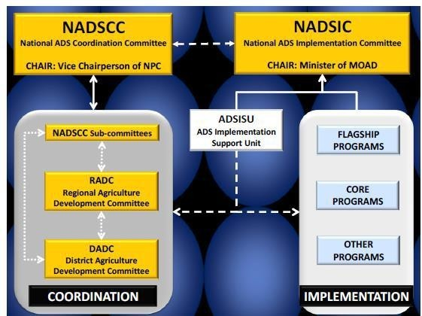
Figure 5. Implementation modality of FANUSEP

Implementation and progress status
There are 8 activities of FANUSEP as provisioned in ADS, their lists and implementation statuses are given in the Table 4.
Table 4. FANUSEP implementation status

S.N | Activities | Implementation status | Implementing  agency
1 | Implement Nepal Agricultural and Food Security Project (AFSP)  Project focused on 19 hill and mountain districts of the Mid and Far Western development region of Nepal | Completed | MoALMC
2. | Implement Food and Nutrition Security Plan of Action (FNSP):  - The project focuses on 1 million hard core poor households  - The project involves a number of technology and nutrition interventions on field crops, fisheries, forestry, horticultural products, and livestock  - GESI and nutrition are mainstreamed in all components of the FNSP  - The project intends to support legislation such as Rights to Food and Food and Nutrition Security Act. | Incorporated in National level guidelines and department level programs for implementation | DoLS, DoA, DFTQC, NARC, NSB

3. | Design a targeted National Food and Nutrition Security Program  • To complement the existing projects on food and nutrition security (AFSP, MSNP and FNSP)  • The project will be designed towards the mid of the first 5-year term of the ADS  • The project will benefit from monitoring, mid- term review, and evaluation of existing food and nutrition security programs, in coordination with ADS Implementation Support Unit (ADSISU). | Food and Nutrition Security Enhancement project (FANSEP)  design is completed | Different stakeholders led by MoALMC
4 | Implement National Food and Nutrition Security program  • Targeted to poor and disadvantaged groups and to geographically disadvantaged areas  • Include interventions to improve productivity, livelihood, and nutritional practices of targeted beneficiaries  • based on the review and lessons learned from other similar programs including the already planned AFSP and FNSP, MSNP  • The new program will use best practices and expand them to broader national coverage. | Will be implemented from FY2075/76
5. | Coordinate with ongoing Food and Nutrition Security Projects:  • Coordinate with Zero Hunger challenge, Feed the Future funded by USAID, programs supported by WFP, and programs funded by GoN and other development partners within the umbrella of the MSNP to ensure that the rural households and farmers most food insecurity are reached by various programs  • FANUSEP Manager will report to the subcommittee on food and nutrition security of NADSCC. | As part of program one coordination meeting was conducted with different stakeholders and update was shared | DFTQC
6 | Review of National Programs on Food and Nutrition Security  - To be undertaken towards the completion of the first 5-year period of the ADS. | It will be done after completion of 5 year ADS implementation | Different stakeholders
7 | Strengthen the capacity of the central and district food security coordination echanisms | Ongoing | Different stakeholders
8 | Promote formulation of Rights to Food and Food Sovereignty Legislation and monitor their implementation | Under formulation process | MoALMC, MoAJCAPA

FANUSEP activities carried out by DFTQC in 2074/75
• Develop the prescribed range and quantity (serving size and portion size) of various foods for each household and recommend food exchange system for improving status of food and nutrition.
• Prepare and disseminate extension materials for food nutrition and safety measures based on food based dietary guidelines.
• Coordinate with different programs on food and nutrition security.
• Monitor different food and nutrition security projects.
• Conduct study tour on success projects of the Food and Nutrition security interventions.

Challenges
Following challenges are identified during implementation of the FANUSEP:
• Food and nutrition security covers various sectors and stakeholders beyond Agriculture; hence there is a need of strong coordination and collaboration.
• Implementation of food and nutrition security programs in new federal system.
• Formulation and implementation of Rights to Food and Food Sovereignty legislation.
• Development of Recommended Dietary Allowance (RDA) for Nepalese standard.
• Dual responsibility of Flagship Manager

Way forward
• Develop institutional mechanism for ensuring horizontal and vertical coordination with ongoing food and nutrition Security Projects.
• Food and nutrition security programs/projects at federal, provincial and local level need to be developed, managed and documented nationally to avoid duplication.
• National Food and Nutrition Research Center should be established for research/surveillance at national and provincial level to address national issues.
• Establish a separate PMO for FANUSEP

Enhancing Food and Nutrition Security in Nepal

Experience of AFSP (Agriculture and Food Security Project)
Low food availability and poor nutrition status (particularly women and children below two years of age) in the mid and far western development regions of the country, were the key problems identified. Country Investment Plan (CIP) has also pointed out comprehensively that the need of investment in agriculture and food security issues. The Government of Nepal (GoN) designed Agriculture and Food Security Project (AFSP) to enhance food and nutrition security of the residents of selected location of 19 project districts in mid and far western regions of Nepal with competitive grant support of US $ 46.5 Million from GAFSP and US$11.5 million GoN contribution for 5 years' period (1st April 2013 to 31st March 2018). It was envisaged that food security will be realized through increased food availability, made possible by increased productivity of both crop and livestock whereas nutrition security will be realized through improved dietary intake, promotion of diversified diets, and improved feeding and caring practices for pregnant and nursing women and children below 2 years of age.

In order to achieve its objective, four components were provisioned in the project to address the inter-locking problems in the project areas through coordinated interventions, including: (i) adaptation and release of relevant technologies for specific agro-ecologies to boost productivity and climate resilience of agriculture; (ii) enhancing local availability of improved crop variety and livestock breed; (iii) supporting farmers to adopt improved management and husbandry practices, use of modern inputs and market access; and (iv) improving household availability of nutritious foods through homestead food production, promotion of diversified diets, increased nutrient intakes and improved feeding and caring practices for pregnant and nursing women and children up to 2 years of age.
There were four components in the project (Figure 6), the first component (technology development and adaptation in crop and livestock) was implemented by Nepal Agriculture Research Council (NARC) and its various research stations situated in different locations of the country. The second component (technology dissemination and adoption in crop and livestock) was implemented by District Agriculture Development Offices (DADO) located in 19 project districts under Ministry of Agriculture Development (MoAD) and District Livestock Service Offices (DLSO) located in 19 project districts under Ministry of Livestock Development (MoLD). Similarly, Component 3: Food and Nutritional Status enhancement was implemented by Child Health Division of Department of health; District Public/Health Offices in located 19 project districts under Ministry of Health (MoH) and Department of Food Technology and Quality Control (under MoAD). The fourth component was implemented by project management unit to support all components. FAO Technical assistance was provisioned to support in the implementation of all three components in specific areas. The World Bank was the designated supervising entity for the project.
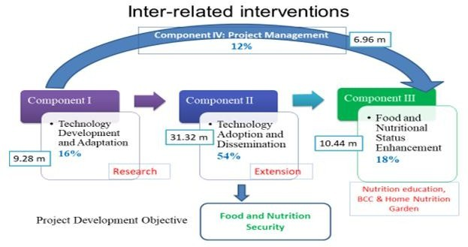
Figure 6. Project components

The project was well aligned with country need and government priorities. Country Investment Plan (CIP) and country programming framework has well pointed out agriculture and food security issues comprehensively and kept in high priority. In addition, Nepal multi-sectoral Nutrition Plan (MSNP 2013-2017) has also identified the food and nutrition security as a key issue and the project has been able to contribute in the achievements of MSNP, particularly in output 6 (availability and consumption of appropriate foods in terms of quality, quantity, frequency and safety) and women’s workload reduced) and output 7 (Capacity of national and sub-national levels enhanced to provide appropriate support to improve maternal and child nutrition).
To enhance food and nutrition security of the selected households of the selected locations of the 19 project districts, the project envisaged in increasing food availability through the enhancement of production and productivity of crop (paddy, wheat, maize, potato and neglected nutritious crop finger millet, buck wheat) and livestock (goat, poultry and dairy) through access to improved crop varieties and livestock breeds along with improved management technologies suitable for the project area.
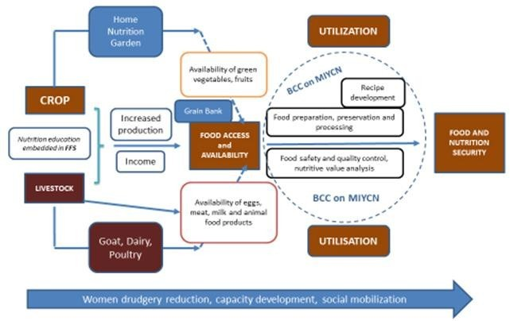
The Figure 7 has tried to show how both crop and livestock sectors are contributing in making availability of micronutrient rich foods at household level through kitchen garden and rural poultry. Farmers are receiving improved agricultural practices through Farmer Field School and Village Model Farm where they are also getting nutrition education and nutrition related BCC messages. In addition, the agriculture and health frontline workers received pro-nutrition training for nutrition sensitive agriculture and health interventions. The farmers are trained on food preparation and preservation techniques, cooking (recipe) demonstrations, consumption of animal source proteins. These activities are reinforced with maternal, infant and young child nutrition (MIYCN) BCC messages for improved dietary practice.

Figure 7. AFSP framework for food and nutrition security

Project development objective (PDO)
• To enhance food and nutritional security of targeted communities in selected locations of Nepal.
• Food security will be realized through increased food availability through increasing productivity of both crop and livestock sectors.
• Nutrition security will be realized through improved dietary intake, through the promotion of diversified diets, and improved feeding and caring practices for pregnant and nursing women and children up to two years of age.
Intervention model
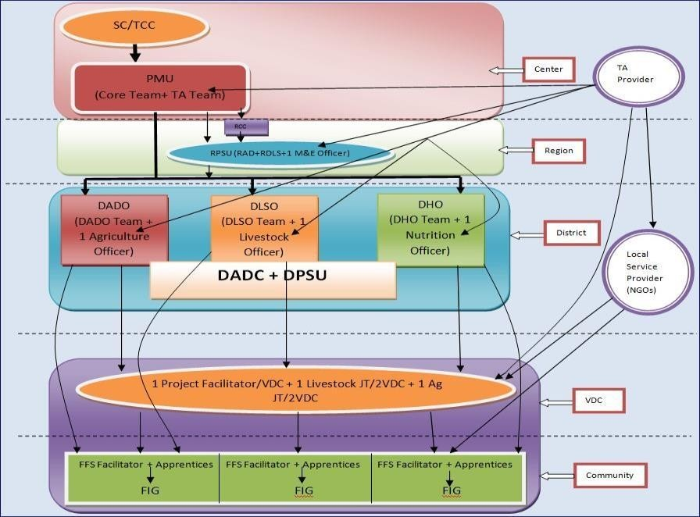

Figure 8. Implementation flow chart

Activities carried out
Key activities carried out in the four components are given below:
Table 5. Key activities carried out in the four components

S.N | Crop sector | Livestock sector | Nutrition sector
I. | Development of improved crop varieties | Development of improved technologies | Development and distribution of training  manuals and BCC materials
II. | Source Seed production | Support service provided under meat and dairy goat breeding program | Orientation on home food preparation, processing and  presentation to mothers groups meeting
III. | Seed multiplication of pipeline varieties | Support service provided under goat productivity  enhancement through goat program | Recipe demonstration in mothers group
IV. | Packaging of proven technologies | Support service provided under livelihood  improvement through goat program | Establishment of food preparation, processing unit
V. | Farmers Field School on crop production | Support service provided under dairy production  program | District level advocacy meeting
VI. | Adoption Support activities | Support service provided under rural poultry  program | Dissemination of BCC through TV and Radio
VII. | Crop Production demonstration and  Nutrition Crop demonstrations | Dairy goat promotion program | Formation of Nutrition Coordination Committee
VIII. | Seed Production program | Livestock Farmer Field School (FFS) | Golden 1000 days mother identification  and counseling
IX. | Mini kit distribution of  recently/pre-released varieties | Village Model Farm  (VMF) and Homestead Nutrition Garden(HNG) | Celebration of events  important form nutrition point of view

X. | Small scale irrigation support program |  | Advocacy program on BCC nutrition  stakeholders
XI. | Preparation of booklet on vegetable  production for nutrition enhancement |  | Interaction with mother group provided nutrition training
XII. | Technical backstopping and field monitoring |  | Support on established  food preparations processing unit
Small Grant Program

Major outcomes and findings
The effectiveness of the project was evaluated based on the outputs and outcomes of the project’s result framework. NARC has been able to develop and release 17 crop varieties (against the target of 17) and these varieties were used in the farmer Field School (FFS) and seed production program under component 2. Similarly, NARC also developed 30 improved technologies (crop-22, livestock-8) against the target of 29; which were trialed on the similar climatic condition of the project locations. These technologies were found effective to overcome the targeted specific problems/issues.
Besides, a total of 582.8 Mt of source seed was produced (against the target of 540 Mt) in various NARC stations and at farmers' field, of which 550.3 Mt was foundation seed, and 32.5 Mt of breeder seed and distributed to the project districts for seed multiplication program, FFS and demonstrations, during the project period.
FFS has provided intensive knowledge and skill to the farmers (47757 farmers against target of 40000) and also provided them adoption support; which helped them to adopt improved technologies. As a result Seed Replacement Rate of the paddy (7.2 to 39%), maize (14.7 to 35.7%), wheat (4.6 to 38 %) and potato (16 to 31.4%) has been increased drastically and also increased in the productivity of these crops.
Similarly, 1558 livestock groups involving 38430 farmers (against target of 32500 farmers) provided technical knowledge on goat husbandry, poultry rearing and dairy production along with support, which helped in increasing the livestock (milk, goat and egg) production and productivity.
Village model Farm and Homestead Nutrition garden was particularly targeted to women, nursing mothers and children under 2 years of age in order to increase the dietary diversity and particularly to increase consumption of green vegetables and animal protein. Women are provided training on vegetable cultivation, poultry and nutrition. This has helped women to increase knowledge and get access to such foods through their homestead garden.

The end line Beneficiary Result Assessment (BRA) survey 2018 shows that the consumption of animal protein and fruits and vegetable increased by 33% and 31% respectively. Similarly, three Infant Young Child Feeding (IYCF) practices of children from 6 months to 24 months have been increased by 38%. Food Preparation and Preservation training and Recipe demonstration (BCC message) along with HNG, support in the livestock program could be the reasons for this.
Similarly, the productivity of livestock weight of goat at 12 month of age has been increased from
19.18 kg to 36 kg (Boer cross); egg production/hen per year increased from 22 to 93 and the milk production per cattle per year increased from 478 litre to 934 litre. (End line BRA survey, 2018)
The project has targeted to provide project developed BCC message to 45000 pregnant and nursing women (PNW) and the project has been able to provide BCC message to 49873 PNW.

Results framework and key outputs
Table 6. Result frame work and key outputs

Project Indicator | Unit | Baseline | Cumulative Achievement as  of March 2018¹ | Data source | End-of- Project Target
Project Development Objective (PDO) Indicators
1. Improved technologies (crop and  livestock) released for project area farmers | Number | 0 | 30 (17)2 | AFSP First trimester  Progress Report, Dec 2017 | 29
2 (a) Increased productivity of crops:
Paddy | Tons/ha | 2.9 | 4.46 | End line BRA survey, Feb 2017, ERMC  and BF Consultancy | 3.77
Wheat | Tons/ha | 1.4 | 2.27 | End line BRA survey, Feb 2017, ERMC  and BF Consultancy | 1.82
Maize | Tons/ha | 1.9 | 3.03 | End line BRA survey, Feb 2017, ERMC  and BF Consultancy | 2.47
Potato | Tons/ha | 4.8 | 7.00 | End line BRA survey, Feb 2017, ERMC  and BF Consultancy | 6.24
2 (b) Increased productivity of livestock products:
Goat meat | Kg per 12 month old goat | 19.18 | All breeds 31.6  Boer Cross 36.6 | End line BRA survey, Feb 2017, ERMC  and BF Consultancy | 35
Eggs | Number per year | 20.5 | 93 | End line BRA survey, Feb 2017, ERMC  and BF Consultancy | 35.8
Milk (cow and buffalo) | Liters per lactation | 478.8 | 9343 | End line BRA survey, Feb 2017, ERMC  and BF Consultancy | 837.9

1 The end line BRA survey was carried out in 1577 beneficiary households among the total crop and livestock beneficiaries;
2 It includes 22 improved crop management technologies and 8 livestock management technologies; the figures in parenthesis gives the total no. of crop varieties developed by NARC under support of AFSP
3 Weighted average of 60% of Buffalo milk (1076 litre ) and 40% of cow milk (698 litre); the proportion estimated based on the quantity of milk contributed by buffalo milk and cow milk

3. Farmers (women farmers) with increased productivity in:
Crops | Numbers | 0(0) | 47757 (40769) | AFSP database | 40,000  (20,000)
Livestock | Numbers | 0(0) | 38430(34785) | AFSP database | 27,000  (24,000)
4 (a) Improved dietary intake for: Pregnant and nursing women
Animal protein | % over BL | 56 | 89.9 | ` | 71
Fruits and vegetables | % over BL | 57 | 78.94 | ` | 72
4 (b) Improved dietary intake for Children between 6-24 months | % over BL | 42.3 | 80.4 | End line BRA survey, Feb 2017, ERMC  and BF Consultancy | 72.3
Intermediate Indicators
Component One: Technology Development and Adaptation
5. Field Trials of Improved Technologies | Number | 0 | 6580 | AFSP database | 4000
6. Source Seed Production | MT | 0 | 582.7 | AFSP database | 540
Component Two: Technology Dissemination and Adoption
7. Producer Groups supported in:
Crops | Number | 0 | 1932 | AFSP database | 2000
Livestock | Number | 0 | 1558 | AFSP database | 1300
Homestead production | Number | 0 | 1114 | AFSP database | 1450
8. Seed Replacement Rate (BL: 6%)
Paddy | % over baseline | 7.2 | 39 | End line BRA survey, Feb 2017, ERMC  and BF Consultancy | 17.2
Wheat | % over baseline | 4.6 | 38 | End line BRA survey, Feb 2017, ERMC  and BF Consultancy | 14.6
Maize | % over baseline | 14.7 | 35.7 | End line BRA survey, Feb 2017, ERMC  and BF Consultancy | 24.7
Potato | % over baseline | 16 | 31.4 | End line BRA survey, Feb 2017, ERMC  and BF Consultancy | 26
Component Three: Food and Nutrition Security Enhancement
9. Women’s groups trained in preparation of nutritious foods | Number | 0 | 2159 | AFSP First trimester  Progress Report, Dec 2017 | 1700
10. Households with Pregnant and Nursing  Mothers receiving project-supported BCC | Number | 0 | 49873 | AFSP First trimester  Progress Report, Dec 2017 | 45000

4 These figures may vary some extent from season to season due to production season of vegetables and fruits

Lesson learned, challenges, issues and way forward

Lesson learned
- The phase wise VDC coverage in the implementation implied less time available for lately covered VDCs
- Uniform program activities (including number and cost) in all project districts were not able to cater local needs and program effectiveness
- Empowerment of local bodies for internalization and sustainability of project interventions

Good practices
- Integrated efforts by related Government organizations towards food and nutrition security
- Food processing and preservation – a new initiative at community level
- Ownership of government institutions in the AFSP intervention (Internalization)
- Small Grant Programs
- Integration of nutrition session in Farmer Field School (FFS)
- Recipe demonstration and Behavior Change Communication (BCC) in mother groups were found very effective for increasing dietary diversity and food intake
- Village Model Farm and Home Nutrition Garden emphasized the vegetable and poultry which improved the access to animal protein and fresh vegetable
- AFSP interventions enhanced dietary diversity, minimum meal frequency and consumption of animal protein
- Promotion of small-scale women drudgery reduction technologies

Issues and challenges
- Implementation of the project in new federal system of Nepal
- Ownership and sustainability of the project
- Delay in on-boarding the technical assistant team in the project
- Low agriculture produce, food taboos/culture is responsible for limited food choice for household consumption
- Language barriers; during training and BCC message dissemination
- Traditional and subsistence agriculture practices resulting in less food diversity and availability

Way forward
- Further support to farmers, 1000 days mothers and other entrepreneurs to engage in nutrition sensitive agricultural activities
- Program handover and advocacy to local bodies for the ownership and sustainability of the project interventions
- Implementation should start at the same time in all project areas
- Good practices of AFSP initiatives such as small grant, FFS, HNG, small irrigation, Boer goat should be internalized
- Information Education and Communication (IEC) and Behavior Change Communication (BCC) materials, training manuals, food based manuals can be used in similar types of project

- Need based assessment/mapping- human resources and budget allocation for next phase
- Need based activities planning in relation to specific conditions (geography, customs, language, agro-ecological conditions)
- Integrated efforts by all related service providers (Govt., Non-Govt. and Private Sectors) to avoid duplication and mismatch of activities and resources

Multi-sector Nutrition Plan (MSNP) II 2018-2022

National Planning Commission
The MSNP II was endorsed and approved by the cabinet of the Government of Nepal on November 19, 2017 for continuity of MSNP-I (2013-2017). MSNP II aims to increase the number of service delivery institutions at federal, provincial and local level governments and to scale up nutrition specific as well as nutrition sensitive services. The implementing cost of MSNP II is estimated at NPR 48.9 billion (approx. US$ 470 million). The budget is segregated by the National Planning Commission in seven sectors namely education, health, agriculture, livestock, drinking water and sanitation, women children and social welfare and local governance. It is estimated that 59 percent of the budget will be supported by the government and 41 percent by development partners.

Objectives of MSNP II
• To increase use of services after having increased access to the nutrition specific services to all by expanding service delivery institutions.
• To improve healthy behavior by increasing access to and use of nutrition sensitiveservices.
• To improve the condition of health and nutrition of woman, children and adolescent girls by implementing integrated programs on nutrition and food security.

Implementation modality
MSNP-II is implemented by local level through policy guidelines, monitoring & evaluation by federal and provincial government, through conditional/complimentary/special grants from federal and provincial government with the mobilization of local financial resources.

Major outcomes/findings
Outcome 1: Improved access to and equitable use of nutrition-specific services
Outcome 2: Increased access to and the use of nutrition sensitive services and improved healthy habits and behaviors.
Outcome 3: Improved policies, plans and multi-sectoral coordination at federal, provincial and local levels to enhance the nutrition status

Outputs with respect to Agriculture
Output 2.1: Increased availability and consumption of safe and nutritious food Output 2.2: Increased physical and economic access for food diversification

Agriculture sensitive intervention
• Make available tools like breeding improvement and necessary seeds, fertilizers for agriculture and livestock production at households and community level.
• Provide technical support (training, demonstrations) to promote the production of fruits, vegetables, nutritious roots, cereals and pulses to improve the consumption of diversified foods at household level.
• Increase production and promote consumption of fresh fruits and green leafy vegetables.
• Build capacity of livestock farmers and entrepreneurs to increase milk, fish, meat and eggs production.
• Provide technical support for managing small irrigation project and alternative irrigation to produce diversified and micronutrient rich foods.
• Technical support to food processing industries on GMP and quality promotion measures through training, workshops and observation. Monitor for ensuring the quality.
• Provide training to farmers on safe food storage, food processing, preparing food, minimizing pesticides use, minimizing loss after production and during consumption.
• Study and improve local food recipes.
• Preserve and promote nutrition rich indigenous crops.
• Publish and disseminate the updated food composition table.
• Prepare/ update food-based dietary guidelines in local authorities and publish and disseminate to local level.
• Develop, publish and disseminate audiovisual materials on food safety, food processing and good behavior about nutrition.

Issues, challenges, lesson learned and way forward

Issues
• Baseline data in local level
• Incorporate Nutrition and Food Security Indicators in Periodic Planning
    - Multi-stakeholder’s capacity
• Advocacy to invest on nutrition
• Linkage of existing social security programs with nutrition
• Integrated efforts
• Adolescent nutrition is necessary
• Over nutrition issues
• Enabling environment

Challenges
• Full of understanding by all
• Resource requirements
• Community ownership for sustainability
• Better coordination among three tiers of government and other stakeholder

Lesson learned from MSNP-I
• More convergence and complementarities are needed while implementing MSNP interventions.
• Improved information management and the sharing of information are needed for the effective implementation of the MSNP approach.
• Need to manage human, physical and financial resources,
• Multi-stakeholders need to enhance capacity in the field of nutrition and food security and development partners need to provide necessary technical support in this regard.

Way forward
• Coordination in the creation of baseline data in province and local level
    - Incorporate of nutrition and food security indicators in province and local levels’ periodic plan
• Coordination in capacity development and resource mobilization
• Advocacy and communication
• Monitoring and evaluation
• Governance
  - Food System Approach: a key to address all forms of malnutrition

Child Health Division, MoHP
Under-nutrition has been a long-standing public health problem in Nepal. Malnutrition during pregnancy increases the risk of complications and maternal death as well as the likelihood of low birth weight. Similarly, under-nutrition among children affects health, education and work productivity, and is a major impediment to the economic growth and development of the country. Malnutrition is detrimental for overall physical and mental growth and cognitive development in children. Despite many progress, particularly in controlling micronutrients deficiency disorders, malnutrition remains a serious challenge for public health program. The prevalence of malnutrition varies widely across regions and socio-economic groups. The relationships between causes of malnutrition at different level are presented in Figure 9.
In view of the situation of nutrition, a multiplicity of problems and challenges remain major issues in Nepal. Out of them, some problems and challenges are following:
• Inadequacy of tangible support for nutrition interventions and insufficient prioritization of nutritional issues at national as well as local levels.
• Poor coverage of many essential nutrition interventions, including the prevention and control of anemia among children, and management of severe acute malnutrition, addressing the issues of wasting and addressing the issues of adolescents and maternal malnutrition. Poor coverage is the result of weaknesses in the demand and provision of services.
• The available opportunities to integrate nutrition interventions into all possible contacts with service providers are missed, which limits coverage and impact. There are also inadequate linkages between programs and projects in different sectors, divisions that could provide synergistic services to address the issues of malnutrition.

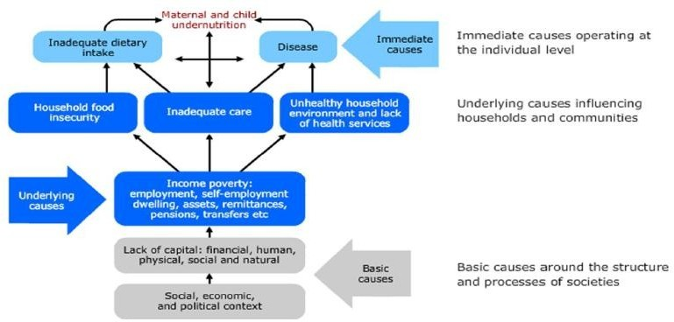

Figure 9. UNICEF conceptual framework for the causes of under nutrition

• Key decisions about priorities and resource allocations for nutrition are made at the local government level, where the understanding on nutrition and how to deal with nutrition problems is limited. Very few nutrition professionals are available to provide high quality technical advice to local government authority efforts to address malnutrition.
• Limited financial resources are made available for nutrition interventions in Nepal. However, all like-minded actors are trying to provide specific attention on addressing nutrition issues. Still there is low understanding of the severity of the problem, and the concrete actions that can be taken to address it.
• In Nepal, effective nutrition architecture under health system and at different levels need to be established with well-defined terms of reference and enhanced capacity. Further, monitoring of nutrition status through the systems and the coverage of nutrition interventions at national and sub-national levels should be strengthened.
Different studies and researches have shown that unless nutrition interventions are implemented at a large scale with the necessary resources and institutional structures for sustainability, they will not be able to affect national rates of malnutrition. Without a major national effort to address the issues outlined above, it is highly unlikely that Nepal will meet the target for maternal and child nutrition, health or poverty reduction.
In recognition of the need for concentrated efforts to address under-nutrition within health sector, the Nutrition Program of Child Health Division ensures implementation of various activities on nutrition aspects in Nepal. The national nutrition program is also a priority program of the

government. It aims to achieve the nutritional well-being of all people so as they can maintain a healthy life and contribute to the country’s socioeconomic development. There is high-level commitment to improving the nutritional status especially of women and young children. There is some national, scale up and small scale program for nutrition sector, which has been implementing to address the malnutrition.

Nationwide
- Maternal Infant and Young Child Nutrition (MIYCN)
- Growth Monitoring and Counseling
- Prevention and Control of Iron Deficiency Anemia (IDA)
- Prevention, Control and Treatment of Vitamin A deficiency
- Prevention of Iodine Deficiency Disorders (IDD)
- Control of Parasitic Infestation by deworming
- Flour Fortification via Large Roller Mills
- Community Based Integrated Management of Newborn and Childhood Illnesses
- Maternal Health (ANC, skilled delivery and PNC)
- Promotion of National Dietary Guidelines

At scale up
- Integrated Management of Acute Malnutrition (IMAM) – 32 districts
- Micronutrient Powder (MNP) Distribution linked with IYCF – 15 districts
- School Health and Nutrition Program (56 districts)
- Adolescent Girls Iron Folic Acid Supplementation Program – 15 districts
- Multi-sectoral Nutrition Plan (MSNP)–(28 districts)
- Golden 1000 Day Communication Campaign

At small scale
- Maternal and Child Health Nutrition (MCHN) Program– 6 districts (Karnali and Solu)
- IYCF Linked with Child Cash Grant (5 districts of Karnali, Achham, Bajhang and Rautahat)
- Fully nourished village/wards initiative (campaign)
- Nutrition emergency program
Nutrition section of child health division is implementing both nutrition sensitive and specific interventions targeting for improving the nutrition status of pregnant women, nursing women and 1000 days of children.

Why investment on nutrition?
  - Malnutrition increases the risk of maternal and child mortality by up to 45%
  - Malnutrition and poor diets constitute the number one driver of the global burden of disease
  - Nepal is on Track to meeting WHA targets for stunting but NOT in underweight, wasting and anemia
  - Under nutrition diminishes learning capacity, lowers economic productivity and ultimately reduces GDP up to 11% for Asian and African Countries (GNR, 2016).
  - Every $1 investment in prevention delivers a $16 return, so should be the top priority investment/interventions for policymakers as well as managers (GNR, 2016).
  - Stunting at the age of 2 is an indicator for the overall human capital (Victoria et al., 2008)
  - Improvement on nutrition is a prerequisite (component of Human Asset Index) to graduate from Least Development Countries

Current nutrition situation in Nepal
  - Malnutrition is a serious problem in Nepal, as in other countries of South Asia, and is a major threat to the health of infants, adolescent girls and pregnant and lactating mothers.
  - About 82% of all deaths among children under age 5 years in Nepal take place before a child’s first birthday, with 54% occurring during the first month of life.
  - Although child mortality has reduced in recent years, malnutrition amongst the increased number of surviving children remains unacceptably high.

Trend of child mortality
Childhood mortality rates have declined since 1996. Infant mortality has decreased by more than half from 78 deaths per 1,000 live births in 1996 to 32 in 2016. During the same period, under-5 mortality has declined threefold from 118 to 39 deaths per 1,000 live births (Figure 10).
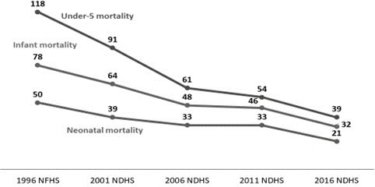

Figure 10. Trends in childhood mortality (deaths per 1000 live births for the 5-year period before the survey)

Nutrition status
About 36% of children below 5 years of age are affected by stunting (short for their age), which can be a sign of early chronic under-nutrition. About 10% of the children are underweight (low weight for age) and 27% of the children are wasted (thin for their age), which can be an indicator of acute under-nutrition. There have been substantial improvements in stunting over the last fifteen years, but it still remains high wasting practically unchanged, at critical levels (Figure 11).

60

57 57
50

Nutrition status(child)

49

40 42 43 39 41

36
30 29 27
20

10 15 11 13 11 10

0
1996 2001 2006 2011 2016

Stunting Wasting Under weight

Figure 11. Nutrition status of children below 5 years of age.

Exclusive breast feeding
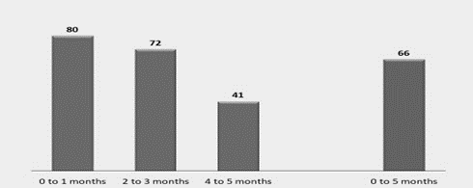
Percentage of exclusive breastfed children under 6 months is 66%, however this coverage is still low. Only about half of the children continue to be exclusively breastfed by the time they are 4-5 months old (Figure 12).
Figure 12. Percentage of exclusive breastfed children (percent of children exclusively breastfed)

Trends in anemia among children and women

Anemia prevalence among children has increased since 2011 when 46% of children were anemic. Since 2006, anemia among women has increased from 36% to 41% in 2016 (Figure 13).

Trends in anemia Women
age 15-
49
Children

48 46 53
36 35 41
age 6-59 months

2006 NDHS 2011 NDHS 2016 NDHS

Figure 13. Percentage of women and children having anemia
Trends in nutritional status of women
Overweight or obesity among women has increased alarmingly, i.e., more than doubled 9% to 22% from 2006 to 2016 (Figure 14).
Nutritional status of women
Thin
28
27
24
22
2
7
18
14
17
1996 NFHS
9
2001 NDHS 2006 NDHS 2011 NDHS 2016 NDHS
Figure 14. Nutritional status of women
Adult nutritional status
The 2016 NDHS also took weight and height measurements of women and men age 15–49 years. Overall, 17% of women are thin (body mass index or BMI < 18.5). Comparatively, 22% of women are overweight or obese (BMI ≥ 25.0). Among men, 17% are thin (BMI < 18.5) and 17% are overweight or obese (BMI ≥ 25.0) (Figure 15).

Percentdistribution of women age 15-49

 22 17
17 17

61 66

Overweight/Obese Thin
Normal

Women Men

Figure 15. Nutritional status of adult

Micronutrients for children
Micronutrients are essential vitamins and minerals required for good health. Vitamin A, which prevents blindness and infection, is particularly important for children. In 24 hours time period before the survey, 63% of children age 6-23 months ate foods rich in vitamin A. Eighty-six percent of children age 6-59 months received a vitamin A supplement in the six months prior to the survey. Iron is essential for cognitive development in children and low iron intake can contribute to anemia. Thirty-five percent of children age 6-23 months ate iron-rich foods the day before the survey, while 8% of children age 6-59 months received an iron supplement in the week before the survey (Figure 16).

Micronutrients for children
86
63
35
8

Consumed foods rich in vitamin A Consumed foods rich in iron in last Given vitamin A supplement in last Given iron supplement in past 7

in last 24 hours (% children age 6- 23 months)
24 hours (% children age 6-23 months)
6 months (% children age 6- 59 months)
days ( % children age 6-59 monhts)

Figure 16. Micronutrients consumption in children under 5 years of age

Minimum acceptable diet
For breastfed children, 46% of breastfed children had an adequately diverse diet and had been given foods from the appropriate number of food groups, while 71% had been fed the minimum number of times appropriate for their age. The feeding practices of more than 1/3 of breastfed children age 6-23 months meet the minimum standards for all three IYCF feeding practices. For non-breastfed children, 63% had a diverse diet, 77% were fed the minimum number of times, and 23% met the minimum standards for all 3 IYCF feeding practices. For all children, 47% had a diverse diet, 71% ate the appropriate number of times, and 36% met the minimum standards for all 3 IYCF feeding practices (Figure 17).
Percentage of children age 6-23 months Breastfed children

63
46 47
71 77 71

Non-breastfed children
All children
36 36
23

Minimum dietary diversity Minimum meal frequency Minimum acceptable diet

Figure 17. Percentage of children age 6-23 months having minimum acceptable diet

National nutrition policy
The overall objective of the policy is to reduce child and maternal mortality through nutritional interventions. Specific objectives are given below:

Objectives
• To reduce chronic as well as acute malnutrition among women and children i.e. stunting, underweight, wasting, low BMI
• To reduce iron deficiency anemia among children, adolescent girls, women and children
• To prevent and control iodine deficiency disorder (IDD) and vitamin A deficiency disorder (VAD) especially among women and children
• To improve maternal nutrition
• To align the health sector programs on nutrition with multi-sectoral Nutrition Initiative
• To improve nutrition related behavior change and communication through nutrition education and counseling
• To improve the dietary and care practices for improved nutrition in women and children through the promotion of locally available foods
• To improve monitoring and evaluation system and encourage evidence based planning for nutrition related programs/activities

• To improve health and overall nutritional status of school children through the implementation of School Health and Nutrition Program
• To reduce the critical risk of malnutrition in life during exceptionally difficult circumstances

Nepal's status against WHA global nutrition targets
Table 7. Nepal's status against WHA global nutrition targets

SN | World Health Assembly (WHA) 2025 Global Targets | Status (Base year 2011) | WHA target for Nepal  (Not set yet nationally) | Nepal’s current status (NDHS 2016)
1 | Achieve a 40% reduction in the number of children under - 5 who are stunted | 40.5% | 25% | 35.8%
2 | Achieve a 30% reduction in low birth weight | 12.1% | 8% | 24%
3 | Ensure that there is no increase in childhood overweight | 1.4% | ≤1.4% | 1.2 %
4 | Increase the rate of exclusive breastfeeding in the first 6 months up to at least 50% | 69.6% | >50% | 66.1 %
5 | Reduce and maintain childhood wasting to less than 5% | 10.9% | 5% | 9.8%
Lesson learned, challenges, issues and way forward
Lesson learned
• Advocacy for agri/food based nutrition
• Rolling out Food Based Dietary Guideline
• Generating data related to FNS
• Research and knowledge management
• Community Trust Building; fully demand based activities
• Community based interventions were designed in a way to involve golden 1000 days mother
• Regularizing mother group (as part of system strengthening)
• Continuation and regularization of food based interventions through nutrition sensitive project
• Commitment from donors and external development partners

Issues and challenges
• Linking Nutrition specific Intervention with nutrition sensitive interventions and program
• Implementation of food and Nutrition program in new federal system
• Ownership and sustainability of food and nutrition program

Way forward
• Forming an alliance of organizations working for Food System Approach to Nutrition in Nepal
• Integrate field level evidence in nutrition strategies
• Work for an enabling policy environment for nutrition sensitive agriculture
• Strengthen coordination for coherent effort by all organizations involved in food based nutrition
• Support local and national efforts to strengthen food based nutrition activities
• Develop the National Nutrition Sensitive Agriculture Strategy
• Sharing of implementation plan and progress of food and nutrition security programs
• Mapping of food and nutrition security related projects/program initiatives in Nepal and discuss how they are contributing national commitment such as Zero Hunger Challenges
• Needed contribution of the new local bodies for ownership and sustainability of activities
• Integrate nutrition sensitive agriculture in various national strategies of different departments

Multi-sector Nutrition Plan: implementation experience and way forward in federal context

Ministry of Federal Affairs and General Administration
Malnutrition is still a serious problem in Nepal despite achieving some progress in last decades. Nepal Demographic Health Survey 2016 revealed prevalence of 36% stunting, 27% underweight and 10% wasting in under five year old children. In order to combat malnutrition, the government of Nepal has implemented various nutrition specific programs from health sectors such as growth monitoring; Micronutrient Powder (MNP) supplementation, management of severe/moderate acute malnutrition etc. Nutrition Assessment and Gap Analysis (NAGA, 2009) recommended that multi-sector efforts would be essential for comprehensive nutrition interventions. Keeping in mind about this recommendation, Government of Nepal has formulated multi-sector Nutrition Plan (MSNP) in June 2012 in order to provide nutrition specific and sensitive interventions. With the mandate of MSNP various sectors have prioritized nutrition in their programs and policies as nutrition a cross cutting issues of education, local level, water and sanitation, agriculture, livestock, and women and children development. Some of the movements that already have impact in reducing under nutrition are open defecation free campaign, fully immunized campaign, and so on. MSNP-I was completed in December-2017. To continue the plan, MSNP-II has been recently approved by the Ministerial Cabinet of Government of Nepal in November 19, 2017 and the plan is under implementation from January 2018 to December 2022.

MSNP intervention by former Ministry of Federal Affairs and Local Development
A multi-sector nutrition initiative has been operational in 30 districts of the country. The intervention is guided by MSNP document which was endorsed by Nepal Government and is being implemented through seven sectors namely health, education, agriculture, livestock, women and children, water and sanitation under the coordinating role of National Planning Commission (NPC) and primary executing body as MoFALD and in coordination with sectors. The trend on budgeting and coverage is presented below in the Table 8.
Table 8. Trend of budgeting and coverage of MSNP

S.N | Fiscal year | No. of districts | Budget spent (NRs. in millions)
1 | 2014/2015 | 6 | 60
2 | 2015/2016 | 17 | 100
3 | 2016/2017 | 28 | 273.32
4 | 2017/2018 | 308 R/Municipalities | 469.98  (UNICEF: 310M, GoN:169.8M)
In the current federal structure, MSNP budget has directly been allocated to the implementing Rural Municipalities and Municipalities. They have the right and responsibilities to design the intervention to complement and supplement the regular sectoral programs as guided by MSNP implementation guideline 2074. The MSNP implementation has already reached to 308 Municipalities and Rural Municipalities in 28 districts. MoFALD has planned to roll out the program covering 372 local government levels (LGL) by the end of 2022.

Achievement after MSNP rollout
Since 2016, MSNP rolled out in 308 Local Government Units covering 30 districts. The followings are the major achievements in FY 2016/17 (MoFAGA, 2018):

Creating enabling environment
• MSNP program reached to 308 Municipalities/Rural Municipalities in 30 districts
• 469.99 million (UNICEF: 310; GoN: 169.8) NRs budget allocated for MSNP interventions in 308 local levels in FY 2017/18
• For local level, NRs. 400,585,000 has been allocated for MSNP interventions. Additional budget of NRs. 123,470,087 (31% of the MSNP budget) has been matched from the source of the local level
• 24860 social campaign were conducted on nutrition activities DCC (former DDC)
• 175 District Level Nutrition and Food Security Steering Committee (DLNFSSC) meetings held in the districts
• 92 district level orientation held in district level covering all political parties and stakeholders in districts, 1238 participated in district level orientation
• 669 Key stakeholders/decision makers were briefed about nutrition advocacy package of MSNP
• 101 Village Level Nutrition and Food Security Steering Committee (VLNFSSC) meetings held
• 6052 participants and stakeholders attended in advocacy and social mobilization workshop in selected MSNP VDCs
• 43 joint monitoring visits were held in the districts

Some examples of sectoral achievements
• 43161 chickens, 571 goats were distributed by livestock sector
• 8001 household members were trained on animal husbandry by livestock sector
• 2,494 households now have kitchen gardens by agriculture sector
• 2,608 mothers were provided training on nutrition and consumption of foods by agriculture sector
• 1390 child club members were trained by education sector
• 240 adolescent girls received nutrition education on the first 1000 days of life from education sector
• 1390 child club members were trained school health nutrition by education sector
• 3870 mothers were trained on hand washing practices by WASH sector
• 2543 WASH kit distributed by WASH sector
• 5473 women group members trained on nutrition by women and children development sector
• 45 events were conducted to demonstrate nutrition foods by health sector
• 1128 health workers received MSNP training
The followings are the major achievements in FY 2074/75:
- 308 Municipalities/Rural Municipalities completed “orientation of MSNP implementation in new Federal System”
• MSNP orientation completed in all DCCs of 30 districts
• 6692 elected officials and local level sector staffs received orientation on MSNP implementation in new Federal System
- 308 Municipalities/Rural Municipalities committed that they will declare “Fully Nourished Local Level” in their Municipalities and Rural Municipalities during the orientation
• 308 local level completed on planning of MSNP
• 308 Local Levels formed Rural Municipality Level Nutrition and Food Security Steering Committee
• 30 district coordination committees were provided MSNP orientation
• 308 Local Levels assigned focal persons in RM/M

Lesson learned
• Advocacy and social mobilization created a momentum among communities, elected officials to include MSNP in Local Government level planning
• Fully operational DLNFSSC and VLNFSSC had a crucial role in designing and implementing MSNP in district level and below
• Frequent follow up of MSNP implementation helps to amend the plans
• Ownership from implementing agencies increased as MSNP advocacy, social mobilization, and intervention support reached to them
• Media mobilization has raised the awareness and sensitization among the needy beneficiaries
• Additional support from staffs has implication in improving coordination and reporting of progress activities along with facilitated coordination

• In recent changed context, orientation about MSNP implementation in New Federal System created a momentum to reduce under nutrition, more importantly to move with the aim of Nutritional Friendly Local Governance
• Newly elected officials have made commitment to declare their Municipalities and Rural Municipalities as Malnutrition Free Local Level within the period of five years.

Issues and challenges
• To reach the target HHs of G1000 days mothers and in identifying target wards and clusters and communities as beneficiaries
• Coordination between stakeholders and duplication of activities by various agencies
• Incorporate MSNP in local level plan
• Resource mobilization to cover all wards of municipalities and rural municipalities
• Meeting the expectation of newly elected officials to end all forms of malnutrition in local level with existing support mechanism
• Expanding reach to local levels through existing support mechanism (Local MSNP facilitators may required)

Strategies for MSNP-II roll out from January 2018
• Estimate and mobilize human resource for support of MSNP in Center/Province, and local levels (clustering, MSNP facilitators in clusters, DC lead district MSNP)
• Effort to mainstream MSNP in local government plan; allocate equalization fund in MSNP interventions in local levels
• Strengthen MoFAGA in MSNP monitoring of implementation through developing web- based reporting system
- Formulate National Strategy of Nutrition Friendly Local governance and its operationalization in all local levels that committed to declare “Malnutrition Free Local Governance” within the five years
• Formulate scale-up strategy to roll out more districts and local levels including financial support
• Identifying a way to support MoFAGA to effectively implement fund transfer of UNICEF

Nutrition Sensitive Agriculture Interventions
Food Research Division (FRD), Nepal Agricultural Research Council (NARC)

Roman Karki, FRD
Nepal Agricultural Research Council (NARC) was established in 1991 AD as an autonomous organization under “Nepal Agricultural Research Council Act 1991” to conduct agricultural research in the country to uplift the economic level of the people. The objectives of the NARC are:
• To conduct qualitative studies and researches on different aspects of agriculture
• To identify the existing problems in agriculture and find out the solution
• To assist government in formulation of agricultural policies and strategies

Food science and technology research program has been active since 1994 AD under the umbrella of NARC. Food Research Unit was established in 1999 AD. Realizing the growing importance of food science and technology for development and dissemination of advance technology, Government of Nepal established Food Research Division under NARC in 2012 AD. From the beginning research projects on quality analysis, processing, storage and packaging of perishables are continuing. The division should be responsible to formulate the strategies for minimizing the postharvest losses either by modifying or manipulating the existing handling, processing and utilization techniques or by innovating and introducing new technologies.

Goal of Food Research Division (FRD)
The goal of FRD is to achieve food and nutritional security through minimizing postharvest losses, value addition, product diversification, technology dissemination and service to clients.

Research activities of Food Research Divison and its outcomes
The research activities of FRD is based on three types of research projects; core, time bound and special projects. The core project of the division is the study on processing and nutritional quality analysis of rice, wheat, maize, legumes and oilseed genotypes. The objectives of the projects are:
• Quality evaluation of different promising genotype to assist in selection of nutritionally dense variety
• To study the effect of milling and polishing on quality of rice
• Processing and value addition The outcomes of the projects are:
• Various nutritionally dense promising lines of rice, wheat, maize, legumes and oilseed has been identified and recommended
• Lower the degree of polishing, higher the level of quality, more yield of head rice
• Development of instant rice
Similarly, the Division has some time bound projects, these are:
• Nutrition evaluation, product development, technology dissemination of underutilized cereals (buckwheat, millet, prosomillet, foxtailmillet, sorghum, amaranth). The outcomes of the project are:
- Identification of underutilized cereals with high micronutrient content
- Product diversification from these underutilized cereals
• Malting and brewing characteristics of barley genotype and development of cost effective malting technology. The outcome of the projects was the identification of suitable barley germplasms with good malting quality.
• Nutritional assessment of some promising cultivars of potato during different storage and processing condition
- Identification of suitable variety of nutrition dense potato especially Vitamin C, iron and zinc
- Identification of suitable variety of potato for chips making

• Study on processing of Nepalese ginger and turmeric germplasms and the outcome of the project was nutritional evaluation of different variety of turmeric and ginger germplasms and their product diversification.
Some of the ongoing projects and their expected outcomes are tabulated in table 7.
Table 9. Ongoing activities of NARC

S.N | Projects | Expected outcomes
1 | Coffee: harvesting time, processing type and roasting effect on coffee | Proper harvesting time and processing condition for coffee will be identified
2 | Value addition of kiwi, pear and plum | Proper technology for preservation and value  addition of kiwi, pear and plum will be identified and disseminated
3 | Nutritional evaluation and value addition of Bael and fruit by-products (mango peel and kernel, sweet orange and mandarin peel, Jackfruit seed) | Possible utilization technology with nutritional profile of bael and fruits by-product (sweet orange, mandarin and mango peel; mango and jackfruit seed) will be identified and disseminated
4 | Nutritional evaluation and value  addition of oat and buckwheat, ground apple and sweet potato | Value addition technology of oats, buckwheat,  sweet potato and ground apple will be identified and disseminated
5 | Postharvest quality assessment and  value addition of Nepalese spices (chili, garlic and timur) | Proper processing technology for chili, garlic  and timur will be identified with nutritional profile
6 | Postharvest quality assessment and value addition of NepaleseCardamom | Proper processing technology for cardamom will be identified
7 | Utilization of goat milk and dairy by- product for its value addition | Proper product technology for goat milk will be developed for value addition
8 | Study on processing and value addition of underutilized cereal crops  (proso millet, foxtail millet, sorghum, and amaranth) | Proper technology of underutilized cereal crops (proso millet, foxtail millet, sorghum, and amaranth) will be developed
9 | Situational analysis, postharvest quality assessment and value addition of underutilized horticultural crops (peach, apricot, butter tree and walnut)  of mid-western (Karnali region) and mid-hills of Nepal | Possible utilization technology with nutritional profile of underutilized horticultural crops (peach, apricot, butter tree and walnut) of mid- western (Karnali region) and mid-hills of Nepal will be identified and disseminated
10 | Implementation of good  manufacturing practices (GMP) in raw milk handling | GMP of raw milk handling will be developed in at least 6 districts via training and IEC material

Status of biofortification in Nepal
Few nutrient rich crops have been introduced in Nepal (e.g. lentil) since many years (as lentil variety “Sisir” was released in 1979). Similarly, De Moura et al (2016) indicated that HarvestPlus is also engaging seed companies in G×E testing and commercialization of zinc wheat, and supporting companies in developing their own zinc varieties for commercialization by analyzing seed companies’ advanced wheat lines for zinc; free of charge. Zinc wheat varieties are also being tested in Bangladesh, Brazil, China, Ethiopia, and Nepal. Shrestha and Karki (2014) mentioned that among the various malnutrition problems, vitamin A deficiency is one of the serious dietary problems in Nepal. Development of maize varieties with increased pro-vitamin A carotenoids can provide a sustainable solution to eliminating vitamin A deficiency in the country. Therefore, research should focus on biofortification of the identified crops like maize. The collaborative research led by scientists of National Maize Research Program (NMRP), Nepal Agricultural Research Council (NARC) in collaboration with CGIAR systems, other government agencies, private sectors and I/NGOs can tackle the malnutrition problems of Nepal through developing provitamin A maize varieties.

Biofortification of lentil crop
Some significant efforts are underway in lentil crop biofortification in Nepal, in collaboration with Harvestplus Challenge Program and ICARDA. Many high micronutrients (iron and zinc) content cultivars have been identified. Most of the released lentil varieties were fortified with iron (Fe) and zinc (Zn) and few of them are also fortified with selenium, as indicated by laboratory reports.
In lentil seed, Fe and Zn content were found to be ranged from 64-127 ppm and 35-88 ppm, respectively. Khajura Masuro-2, RL 6, RL 12, ILL 8006 and Sisir are rich in both Fe (82-101 ppm seed) and Zn (62-75 ppm seed). High in Fe containing lentils are Shikhar, Simal, Simrik, ILL 7716, and RL 11 (59-84ppm); ILL 7543, ILL 3111, ILL 7164 and ILL 6260 are also have high Zn content (60-75 ppm). GLRP (2013), mentioned that iron rich cultivars were PL 4, ILL 9926, LG 12, ILL7715, ILL 3490, Shital and WBL 77 (Figure 18) and Zinc rich cultivars were LG12, PL 4, ILL 9926, Shital, ILL 6467 and ILL 7715, respectively (Figure 19).
It has been reported that a number of micronutrient rich (iron, zinc and selenium) lentil lines have been identified in collaboration with ICARDA and University of Saskatchewan and scaled out under the Harvestplus Challenge Program. Based on laboratory reports, Iron rich cultivars were PL4, ILL9926, LG12, ILL7715, ILL3490, Shital and WBL77. Similarly, Zinc rich cultivars were, LG12, PL4, ILL9926, Shital, ILL6467 and ILL7715; and Selenium rich cultivars were ILL6256, Shital, Sagun, ILL6467, HUL57 and ILL3490, respectively (Figure 20).
Harvest Plus (2014) stated several released varieties that possess high iron and zinc levels and have good agronomic performance have been identified in Nepal; they are: Sisir (98 ppm Fe, 64 ppm Zn), Khajurah-2 (100.7 ppm Fe, 59 ppm Zn), Khajurah-1 (58 ppm Zn), Sital (59 ppm Zn), Shekhar (83.4 ppm Fe), and Simal (81.6 ppm Fe).

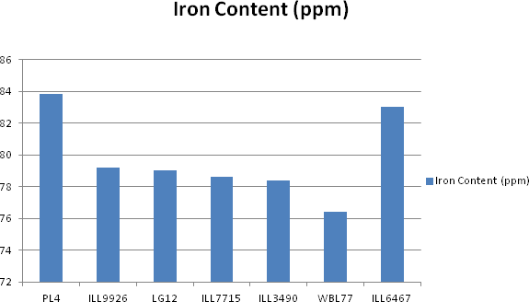
Figure 18. Iron content (ppm) of some biofortified lentil varieties
ICARDA (2017) mentioned that “In Nepal, new lentil varieties like ‘Shekhar’, ‘Khajurah-1’, ‘Khajurah-2’, ‘Sisir’ and ‘Shital’ with 81-98 ppm iron and >54 ppm zinc are rapidly replacing traditional varieties with 400,000 farmers adopting them thus far.
48.5

48

47.5
Zinc Content (ppm)
47

46.5

46
PL4
ILL9926
LG12
ILL7715
ILL6467
Figure 19: Zinc content (ppm) of some biofortified lentil varieties

0.45
0.4
0.35
0.3
0.25
0.2
0.15
0.1
0.05
0
Selenium Content (ppm)
ILL3490 WBL77 ILL6256 HUL57
Figure 20. Selenium content (ppm) of some biofortified lentil varieties

Biofortification of wheat
In 2014, a total of 50 genotypes including checks were provided by CIMMYT, Mexico to Agriculture Botany Division (ABD), NARC and were tested for phenological, morphological, grain yield parameters, agronomic and lodging scores and yellow rust resistance performance as well as zinc and iron content under irrigated condition of Khumaltar, Nepal. Genotypes were varied for heading ranging from 112 to 137 days, for maturity 173 to 184 days. In plant height, genotypes varied from 90 to 113 cm. Similarly, genotypes had produced effective tillers within ranges of 196 to 602 tillers per m². Similarly genotypes were varied from 46 to 64 in grain number per spike and 2.08 to 4.91 gm grain weight per spike. In case of 1000 grain weight genotypes were varied from 40.7 to 56.2 gm. In this trial, genotypes yielded grain varying from 5335 to 8980 kg/ha. Based on performances on studied traits 5 genotypes have been selected for Initial Evaluation Trial, 6 genotypes for 4th BWAVTR of mid hills (ABD, 2014).
Similarly in 2015, researchers of ABD, has found that the genotypes were significantly different on days to heading, maturity, plant height, peduncle length, number of tillers/m² and grains/ spike, grain weight per spike and 1000 grains grain yield, iron and zinc content in grains. The highest yield and zinc content in the biofortified varieties were obtained up to 6135 kg/ha and 64.0 ppm, respectively. Based on studied traits and diseases (rust) resistance and higher Iron and Zinc containing six superior genotypes has been selected for composition of Initial Evaluation Trial (MHH), six genotypes for Coordinated Varietal Trial (MHH) at National Wheat Research Program (NWRP) Bhairahawa, Nepal, seven genotypes for 5th BWAVTR and two genotypes were selected for nigh hills Advanced varietal Trial (5BWAVTH).
During 2015/16, selected 28 lines were tested at NWRP Bhairahawa and Zinc and Iron content was analyzed in Vanaras Hindu University, India. Zinc content in this trial was varied from 20.4 to 39.3ppm and iron content was varied from 29.0 to 53.5 ppm.
During 2015/16 at Agriculture Research Station (ARS) Sukhet, zinc content on 50 tested lines of 6HPYT was varied from 14.4 to 37.7 ppm and iron content in 25.8 to 48.7ppm. Similarly, at Hill Crop Research Program (HCRP) Kabre, Nepal, Zinc content on 50 lines of 6HPYT varied from 19.3 to 62.7 ppm and iron content was varied from 32.7 to 63.7 ppm. At Khumaltar condition, Zinc content on 50 lines of 6HPYT varied from 33.1 to 65.4 ppm and iron content was varied from 33.3 to 64.2 ppm (ABD, 2016).

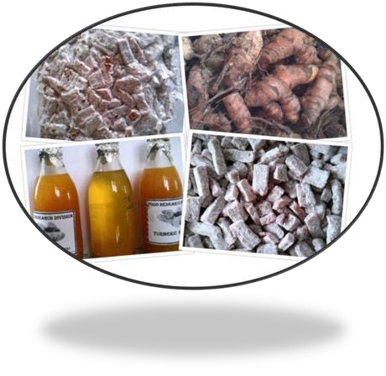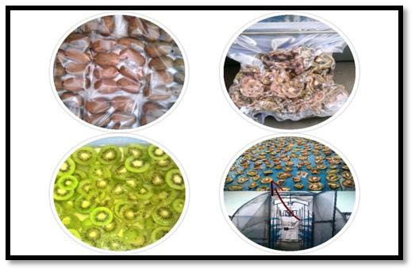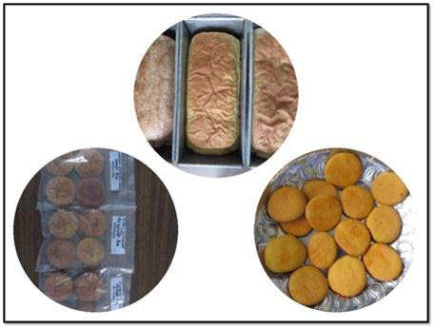Some photographs of activities of Food Research Division, NARC
Turmeric Processing
Underutilized Cereal Products
Kiwi Fruit Processing
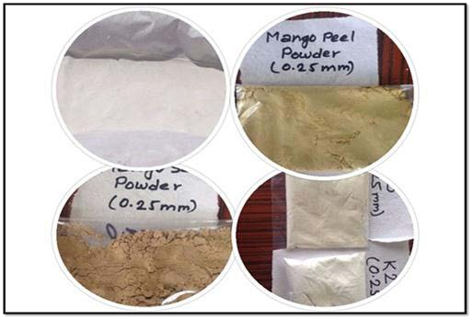
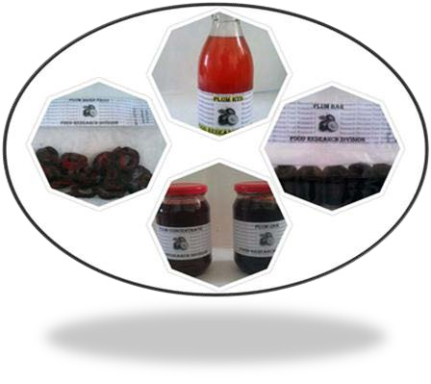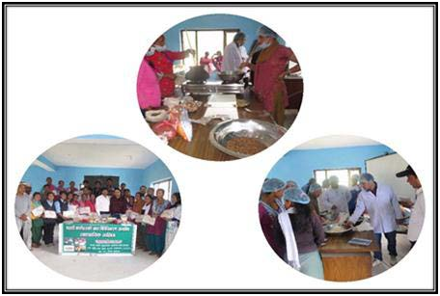Byproduct Utilization Technology Dissemination
Plum Fruit Processing

Picture 1: Activities of Food Research Division, NARC

  - Food Security and Nutrition Status
Nepal Khadya Surakshya Anugaman Pranali (NeKSAP)
Nepal Khadhya Surakshya Anugaman Pranali (NeKSAP) is the comprehensive food security monitoring and analysis system in Nepal. Initiated by the United Nations World Food Program (WFP) in 2002, NeKSAP is now jointly operated by the Ministry of Agriculture, Land Management and Cooperative (MoALMC) with the policy guidance of the National Planning Commission (NPC). WFP provides technical support. NeKSAP was developed and institutionalized in the government structure in order to formulate evidence based plan, program and policies to improve food security situation in Nepal.

Objectives
The objective of NeKSAP is to collect and analyze food security information across Nepal and effectively communicate the results to decision makers to achieve coordinated, appropriate and timely action to prevent human suffering due to food insecurity.

Intervention model, process and activities
The core of NeKSAP was the District Food Security Network (DFSN), which were operational in 74 of the 75 (except Kathmandu district) before the restructuring country in federal governance system. In the current context, there is a need to re-align NeKSAP in the federal governance structure.
Earlier, DFSNs comprised of a broad group of Government of Nepal district level agencies, UN agencies, I/NGOs, civil society organizations, and the private sector. These networks used to assess, monitor, and analyze the food security situation at the district level using a standard tool and process called the Integrated Food Security Phase Classification (IPC). Information generated by DFSNs were verified by ministry (MoALMC now) and WFP and published in periodic food security bulletins.
The NeKSAP is a decentralized food security analysis process used 17 indicators representing four dimensions of food security: availability, access, utilization and stability. NeKSAP used the Integrated Food Security Phase Classification (IPC) methodology to classify the severity of food insecurity into five phases viz., minimally food insecure, moderately food insecure (or stressed), highly food insecure (or Crisis), severely food insecure (or emergency), and humanitarian emergency (or declared famine).
- District level food security analysis: Technical Working Groups (TWGs) were comprised of technical staff or focal points from selected line agencies, local government bodies, civil society organizations, and the private sector. TWGs collected and undertook the first level of food security analysis on a trimester basis. TWGs forwarded the analysis reports to the District Food Security Networks (DFSNs) for further analysis and validation.
- Endorsement, validation, and communication: District Food Security Networks (DFSNs) used to meet every trimester to do further analysis of the food security situation and then endorse the end outputs. Some DFSNs had communicated food security information through District Food Security Bulletins and reports.

- National level analysis and communication: Team from the ministry (now MoALMC) and WFP used to further analysis the reports forwarded by DFSNs based available information from different sources related to availability, access, utilization, and stability of food security. Finally, the ministry and WFP used to release the result through Food Security Bulletins on a trimester basis and disseminate food security information through electronic and printed documents.

Major outcomes/findings
- Nepal Food Security Bulletin: Published on a trimester basis it contains updated information on the food security situation and outlook.
- Market Watch: Published monthly it provides updated information on the market price of key food commodities.
- Household survey: conducted, second round completed, report published; third round mobile survey ongoing.
- Online Food Security Information System: WFP, ICIMOD and MoAD (now MoALMC) launched the online Food Security Information System for Nepal ⁵ . The Food Security Information System for Nepal (the formal name given to the online food security atlas) was created to compile, analyse and disseminate comprehensive information on food security in Nepal, through an interactive platform.
- DFSN meeting: Meetings conducted as planned to monitor the food security situation of the district. First trimester 2074/75 meeting took place in November /December 2017; Ad hoc DFSN meetings were conducted in 15 flood affected districts in August /September 2017 and report produced and disseminated to target response.
- NeKSAP orientation to elected members and officials done in 4 districts and Food Security Monitoring Training at one municipality (Bhojpur), this was organized as part of the re- alignment of NeKSAP in the federal governance structure.
- IPC and Food Security Response Analysis (FSRA) Master TOT and one regional TOT in Pokhara completed. NeKSAP IPC and FSRA refresher conducted in one district, FSRA Training organized in 4 districts completed (cumulative achievement is 70 district).
- NeKSAP info and Market Training: Five events completed in five development regions, this training was organized for the DADO focal persons to increase knowledge and skills to market and food security monitoring.
- Crop Yield Forecasting: This is one of the innovative initiatives, NeKSAP is undertaking since 2014. The MoAD (now MoALMC), WFP and the CGIAR Research Program on Climate Change, Agriculture and Food Security (CCAFS) has collaborated on undertaking advance estimate of major cereal crops- paddy and wheat- using CCAFS’ Regional Agriculture Forecasting Toolbox (CRAFT). Other collaborative partners in the initiative

⁵http://geoapps.icimod.org/npfoodsecurity/

include the Department of Agriculture (DoA), Nepal Agriculture Research Council (NARC), and Department of Hydrology and Meteorology (DHM).
NeKSAP information products are widely used for program and policy planning, early warning, advocacy, and targeting.

Lesson learned, challenges, issues and way forward
- In the changed context in Nepal, NeKSAP process and approaches need to be adapted in the federal governance structure; there will be a transition period where availability of information on food security situation will be affected;
- There will be a dire need of resources, skills, human resource to build the capacity (753 municipality, 7 provinces) to make the system operational in the new federal structure;
- Clarity on reporting mechanism (municipality /provincial / federal level) still to be clarified and well-functioning.

Way forward
- New federal structure could be taken as an opportunity to build the food security monitoring capacity at the different level. Considering the need of evidence for designing the relevant policies and programs on food and nutrition security, there is need of special focus on awareness and capacity building at the different level;
- Feedback received from different training and interactions has reflected the importance and priority of the issues put be the officials at the different level; NeKSAP will be considering these feedbacks while designing the activities and programs;
- Increase number of interactions at the different levels to further increase awareness on the importance of evidence for the planning and facilitate institutionalizing the food security monitoring system.
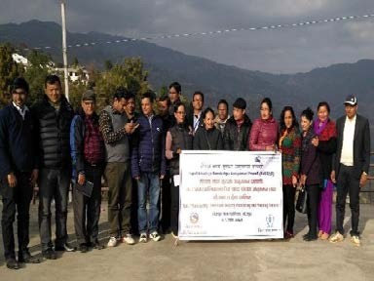
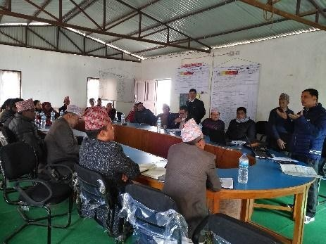
Picture 2. Field visit and interaction with stakeholders

SUAAHARA II: Food and Nutrition Security
SUAAHARA II is a five-year USAID-funded program (April 1, 2016 to March 31, 2021) that will continue and improve upon the multi-sectoral approach of Suaahara I in forty-two under- served rural districts of Nepal. The ultimate goal of the program is to reduce the prevalence of low birth weight, stunting, wasting, and underweight among children under 5 years of age; underweight among women of reproductive age; and the prevalence of anemia among these categories of women and children. Suaahara II consortia partners include Helen Keller International (HKI), CARE, Equal Access, Environment and Publich Health Organization (ENPHO), FHI360, Vijaya Development Resource Center (VDRC), and Nutrition Technical Assistance Group (NTAG). The program will incorporate a specific focus on adolescent girls and other household members as well. Suaahara II will promote greater gender equality and social inclusion (GESI), in part by targeting women and disadvantaged groups (DAGs).
Nepal is undergoing tremendous challenge and transition, including a new constitution, moving to a federal system and recovering from a devastating earthquake. Against this backdrop, safeguarding the health and nutrition of under-served groups is as critical as ever and challenges are myriad. Though under-nutrition indicators have improved over the last decade, 41% of children under five remain stunted. Anemia is also a concern, with rates among adolescent girls, children 6-59 month's old and pregnant women ranging from 39-48%. Poor maternal nutrition and infant and young child feeding practices; including insufficient dietary diversity and quantity are key determinants of under-nutrition.

Objectives
• To improve household nutrition and health behaviors-these behaviors include optimal maternal, infant and young child nutrition (MIYCN) practices, healthy timing and spacing of pregnancies (HTSP); and improved water, sanitation and hygiene (WASH) practices.
• Increase the use of quality nutrition and health services by women and children-it will be achieved through implementation of Nutrition Assessment Counseling & Support(NACS).
    - Improve women’s and children’s access to diverse and nutrient-rich foods-Suaahara II will work with communities to increase homestead food production of nutrient-dense plant and animal foods, and create resilience to nutrition shocks caused by climate change and natural disasters.
• Accelerate the rollout of the Multi-sector Nutrition Plan (MSNP) through strengthened local governance.

Intervention model, process and activities done under the project
Suaahara II recognizes that achieving results requires a holistic strategy that combines a multi- sector approach with attention to equity, gender, social inclusion, behavior change and good governance. Key project inputs and interventions will aim to catalyze shifts in capacity at household, community and systems levels across the project life to achieve the project goal.
The agriculture component of Suaahara II aims to improve women’s and children’s access to diverse and nutrient rich foods. Major activities included training in optimal techniques for vegetable gardening and poultry production, distribution of chicks to household, seasonal distribution of vegetable seeds, technical support, creation and facilitation of HFP group and

establishment of Village Model Farms as the resource center. These activities mainly focused to impact on increased availability and consumption of micro nutrient rich foods produced at home. The data from household monitoring surveys of Suaahara I showed that HFP participation may play a more important dietary role in the winter season than in the rainy season for both mountain and terai districts. The study findings pinpointed that HFP programs, and similar agriculture/nutrition interventions, should be carefully designed, implemented, and evaluated to examine variation by context including place and time.

Intervention package

CORE Package
(District wide/food secure areas)
- Social Behavior change and communication (SBCC)
- Maternal,Infant,Young child Nutrition (MIYCN)/Nutrition Assessment and Counselling support (NACS) Package
- Adolescent Health and Nutrition
- Maternal Child Health and Family Planning (MCH/FP Services)
- Water, Sanitation and Hygiene (WASH)
- Governance

CORE +Package
(Food Insecure and DAG areas)
- Social Behavior change and communication (SBCC)
- Maternal, Infant,Young child Nutrition (MIYCN)/Nutrition Assessment and Counselling support (NACS) Package
- Adolescent Health and Nutrition
- Maternal child health and family planning (MCH/FP Services)
- Water Sanitation Hygiene (WASH)
- Governance

Targeted SBC Outreach health services for Nutrition sensitive agriculture

Figure 21. Intervention package of SUAAHARA II

Ten priority behaviors for SUAAHARA II strategy
- Dietary diversity for women-eat more eggs and meat
- Attend ANC at least four times
- Take all 180 IFA tablets during pregnancy
- Use a modern method of family planning
- Dietary diversity of children-feed more meat, eggs, iron rich foods
- Feed the child the same or more during illness
- Give ORS and zinc to a child with diarrhea
- Give the child under six months only breast milk
- Treat drinking water
- Wash hands at six critical times

Outputs, reach and scale (Agriculture component of SUAAHARA II)
In this report, outputs and findings of Suaahara II’s other component-Health, Wash, GESI are not reflected. The household reached with Homestead Food Production (HFP) interventions is given in the Table 10.
Table 10. Household reached with HFP interventions

FY/Interventions | 2012/13 | 2013/14 | 2014/15 | 2015/16 | 2016/17
Mothers of 1000 day | 39148 | 62827 | 83242 | 93313 | 114567
FCHV | 3699 | 5800 | 10367 | 10367 | 10834
VMFs |  | 2640 | 5848 | 5848 | 5860
Total HH | 42847 | 71267 | 99457 | 109528 | 131261

Homestead Food Production Outputs
  - Trained 1,628 DADO and DLSO staffs in HFP
  - Trained 1,53,997 women and family members and FCHVs in HFP
  - Trained 5,977 VMFs in HFP
  - Established 7664 HFP beneficiary groups
  - Registered 641 beneficiary groups with DADO

MIYCN (Maternal Infant, Young Child Nutrition)
  - Trained 173 master trainers in MIYCN
  - Trained 10,809 health workers in MIYCN
  - Trained 3,685 non-health workers in MIYCN
  - Trained 33,688 FCHVs and social mobilizers in MIYCN
  - Reached 414,029 1,000-day women through ward-level orientation
  - Reached 343,827 family members and community members through ward-level orientation
  - Trained 8,797 religious leaders, leaders and traditional healers in MIYCN
  - Conducted home visits to 110,607 1,000-day women
  - Held 68,502 food demonstrations out of target 74,000

Challenges
  - Clearly defining the prioritized behaviors
  - Describing the priority group
  - Formative research to identify:
    - Level of knowledge about desired behavior
    - Understanding of the consequences
    - Motivating factors
    - Barriers
    - Social norms
    - Support or lack of support from family, health workers

Lessons learned
  - Household agricultural production has direct and important linkages with household dietary patterns
  - HFP programs, and similar agriculture/nutrition interventions, should be carefully designed, implemented, and evaluated to examine variation by context including place and time.
  - A homogenous/blanket approach even within one country may not the best approach

Context of Nutrition Sensitive Agriculture: Learning and Experience

Nutrition in Mountain Agro-ecosystems (NMA)/HELVETAS Swiss Inter- cooperation Nepal

Soma K. Rana and Alok Shrestha, HELVETAS
This paper covers the Nutrition in Mountain Agro-ecosystems (NMA) project phase I working modality and learning and experience, challenges and wayforward. NMA addresses poverty and malnutrition in mountain agro-ecosystems in Nepal and around the globe, and promotes Nutrition Sensitive Agriculture (NSA) at local level for diversification of diets to combat stunting of children and malnutrition of adults, particularly of women. NMA facilitates the replication and scaling up of well tested agro-ecological methods in regard to agricultural and marketing practices. It is active on local levels to facilitate diversity with demand-oriented replication and scaling up of nutrition sensitive agriculture, processing and marketing practices and with promotion of diversified diets in remote areas which are linked with different micro interventions implemented by Rural Service Providers (RSPs).
NMA has its focus on mountain agro-ecosystems that are vulnerable to malnutrition caused by limited diversification of crop production, insufficient nutrient intake, behavior change communication, poor dietary diversification, water sanitation and hygiene, poverty and awareness. The project aims at adapting agriculture, marketing and consumption towards better nutrition, particularly of children and women through increased diversity in a changing environment. It replicates and scales sustainable agriculture practices in mountain ecosystems to promote improved nutrition and resilience driven by an action network of empowered Rural Service Providers (RSPs) aiming at a broad impact on micro, national and global levels.
Households and communities depend on agriculture, which is often constrained by scarce arable land resources in difficult climatic and topographic conditions with poor infrastructure. Numerous impact studies ⁶ have shown the positive effects of ecological intensification on improved nutrition. They revealed the potentials of agro-ecological practices for poverty reduction, particularly in marginal areas and mountain ecosystems. Despite that the systemic approaches of ecological farming and improved market access of small-scale farmers have been tested and replicated in many different contexts, they haven’t reached many remote communities. Considerable development impact is expected by scaling-up of proven technologies; but this

6e.g. Report of the UN Secretary General on Agricultural Technology for Development, UNCTAD Trade and environment review 2013, Kyrgyz organic cotton impact review 2010, CDE meta study on organic impacts.

needs a special facilitation effort to promotion the uptake and adaptation of such technologies not only at the local but also at the national and global level.
A disproportionately high number of the world's hungriest and chronically malnourished people reside in mountain regions⁷. Data shown that globally 161 million children <5 have low height- for-age (i.e., stunting, chronic malnutrition), 51 million children <5 have low weight-for-height (wasting, acute malnutrition) and 45% cases of child mortality is due to malnutrition. One of the causes is lack of nutrition sensitive agriculture practices and knowledge.
Despite making significant progress in poverty reduction in recent years, Nepal still struggles with high level of hunger and poverty. Poor nutrition and food insecurity have remained as challenge and impediment to development in Nepal. National surveys over the past decades have consistently demonstrated high levels of child under nutrition plaguing the country. Approximately 36% of Nepal’s children suffer from stunting, 10% from wasting and almost 53% from anemia. Forty-one percent of women of reproductive age suffer from anemia and 17% from long term energy deficiencies. These statistics differ by geographical region and social group. The immediate causes of chronic malnutrition in Nepal include limited diversification of crop production, insufficient nutrient intake, behavior change communication, poor dietary diversification, water sanitation and hygiene, poverty and awareness. Women and children suffer more from malnutrition within the household level.
Nepal Living Standard Survey 2011 found that 38 percent Nepali people are living with less than minimum daily requirement of calories required for a healthy life. However significant disparity prevails between ecological zones, development regions and rural-urban divide. Compared to terai (24 percent), the population living with insufficient calorie intake is higher in hilly (36 percent) and mountainous (38 percent) areas. Disparity is evident in the extent of incidences of low calorie intake among development regions ranging from 24 percent in Eastern Development region to 36 percent in Mid-western Development region. By development region, the two western (Mid and Far-western) development regions are more calorie deficient compared to three eastern (Eastern, Central and Western) development regions. Thus, hilly and mountainous areas of the Mid- and Far-western development regions are worst hit by food insecurity and insufficient calorie intake.
The project started on June 2015 and will end in May 2018 with a total volume of 265,350 CHF for the Nepal component.

Objectives of the project
The NMA goal is to contribute to improved access to sufficient nutritious food for rural communities in mountain regions through a network of actors facilitating innovation and diversification of proven agro-ecological and other nutrition sensitive practices. The specific objectives are:
• Implementation of nutrition sensitive agriculture at the local level: Farmers - by applying agro-ecological practices - processors and traders diversify and intensify production, improve postharvest management and promote a nutritious product range including for self-

7 Quote from FAO, J. Diouf, http://www.fao.org/english/newsroom/news/2002/6763-en.html

subsistence and for absorbing the diversified surplus production to respond to demand of sensitized consumers.
• Development of an environment conducive to nutrition sensitive agriculture at national level: National policies and action plans support and stimulate diversified production and consumption.
• Advocacy for nutrition sensitive agriculture at the global level: Agro-ecology based diversification is promoted internationally as a feasible and implementable approach to improve nutrition in mountain agro-systems.

Intervention model, process and activities
NMA focus on promotion of Nutrition Sensitive Agriculture for diversification of diets to combat stunting of children and malnutrition of adults, particularly of women; and facilitate the Replication and Scaling Up of well tested agro-ecological methods in regard to agricultural and marketing practices. NMA focused two major approaches: Micro Interventions provide the context to implement nutrition sensitive interventions (NSI) at the local level to impact directly the situation of small-scale farmers and households in rural areas. Secondly, they generate insight and knowledge in regard to NSIs. In the latter case, the micro interventions serve as “learning sites” for the NMA project. The rural service providers (RSP), who are involved in NMA’s capacity development activities, implement the micro interventions.
- 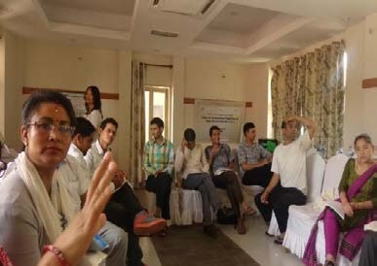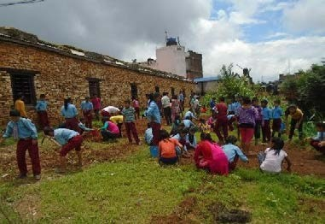Capacity development of RSP- NMA’s effort to involved RSP aims to optimize both the implementation of micro interventions and the individual and shared learning from getting them planned and implemented. In this sense, NMA’s supported in this area refers to tailor-made trainings, planning workshops, individual on the job coaching, and peer review based events to reflect the work implemented by RSPs. RSPs were main instruments to provide extension and training services to local communities in various fields: health, education, nutrition, agriculture, water, sanitation etc.
Picture 3. Capacity development of RSP Picture 4. Student preparing schoolnutrition
garden at Janata School, Dailekh Bazar
- Mountain Agro-ecosystem Network (MAAN)-MAAN is an internet based functional network that promotes stakeholder interaction regarding nutrition sensitive agricultural and marketing practices. From a conceptual point of view, MAAN is an informal and open network, linking NMA’s activities at the local, national, and international level- thus helping to ensure that

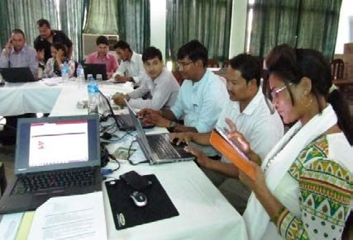
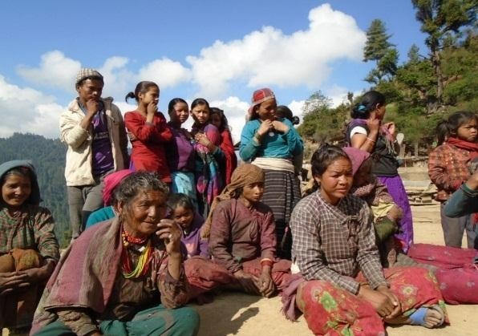
learning take place across intervention areas in the NMA implementing countries. In other words, MAAN enables a broader sharing of knowledge generated at the local level (through micro interventions) while serving as a “sounding board” to assess the relevance of the generated knowledge in regard to the potential for NSI replications in other context. Also, MAAN is NMA’s main instrument to derive and channel clear messages for policy makers, researchers, consumers, and media etc. In this regard, it also essentially supported the definition and implementation of activities relating to the national nutrition knowledge sharing campaigns and Advocacy at the national and global level. NMA supported in networking of RSPs and establishes technical platform that allows for exchange of knowledge, information and communication. NMA provides RSPs the access to functional knowledge, capacity building and coaching in context of NSIs.
Picture 5. Left: Rural service providers learning and sharing knowledge on MAAN and Right: farmers in Rara 8, Mugu-discussing about legume promotion
In order to promote most relevant NSI and innovations, NMA developed with project partners' dialogues and events at the national level. In this regard, the national intervention aims to influence both policy making and consumers’ perception about certain food/crops and practices, raising awareness for nutrition sensitive agricultural production practices and nutrition-improving consumption habits through national nutrition knowledge sharing campaigns.
The service providers who are working in different sectors and initiatives to improve food security and nutrition situation in rural areas reach and interact closely with rural communities, thereby influencing their practice and decision in different aspects of improving livelihood. Connecting them by certain mechanism expects to enhance mutual learning and sharing, and connect the dots to develop multi-sectoral approach. It ultimately broadens the impact and scaling up of nutrition sensitive agriculture (NSA). This mechanism has been initiated and is gradually being beneficial in Nepal. It brings rural service providers (RSPs) working in nutrition and agriculture into a common platform through an action-driven social and internet-based platform, i.e., Mountain Agro-ecosystems Action Network (MAAN). It capacitates them with face-to-face interactions and field-based interventions to facilitate replication and up scaling of sustainable agriculture practices to promote improved nutrition and resilience as mentioned above. An online platform also embeds knowledge bank (library) which is a publicly and freely accessible collection of relevant knowledge.

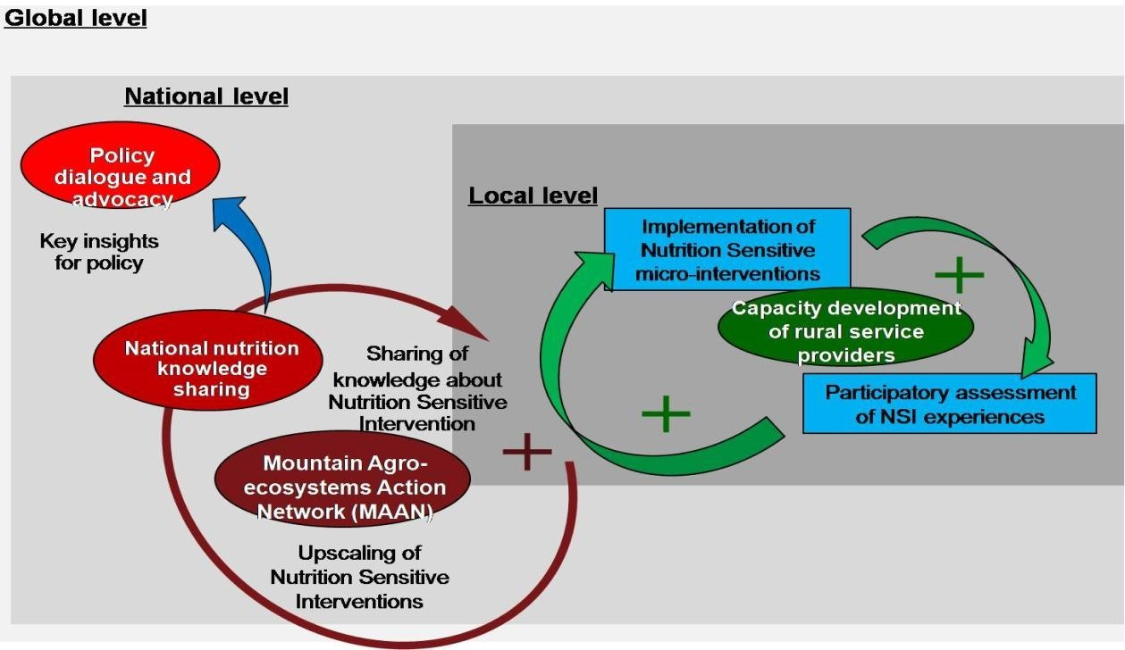
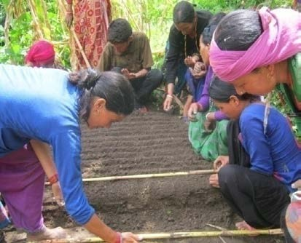
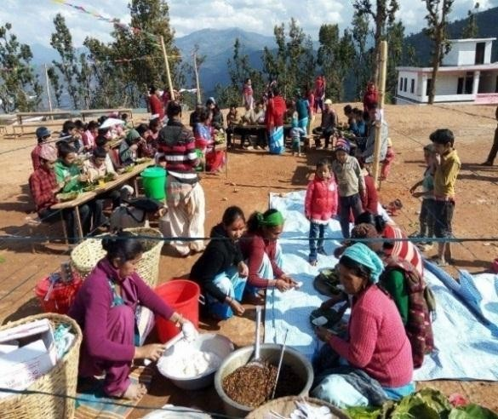
Figure 22. Overview of NMA’s intervention systems and their linkages to impact the local, national and global level
Picture 6. Nursery management practical training at Sipkhana, Kaliko and Food and agri-fair Dailekh
NMA implemented 30 different micro-interventions in 8 different themes. They are school nutrition garden, homestead garden promotion, promotion of food recipe, promotion of local agricultural crops for improving nutrition through organic manure, honey production and marketing, consumption, processing and marketing of nettle and media for nutrition improvement. The production diversification includes nutrient rich foods like vegetables. Pulses, fruits, honey and chicken are promoting. Nutrient contents local based agricultural products are marketed. Maintaining and improving natural resources based production e.g. vermi-compost is

one of the important technology to produce healthy food. NMA has collaboration and coordination with multi-sectoral stakeholders at local and national level. The micro-interventions provided benefits to 2,870 households in mountain regions - out of them around 71% arewomen and 68% are disadvantaged. These initiatives supported to promote agro-ecological practices and dietary diversity in terms of both production and consumption. In spite of limited resources, the micro-interventions were effective and efficient in improving food habits and changing behavior of people, and people are practicing the sustainable and resilient farming practices. The issue of nutrition sensitive agriculture and implementation of micro-interventions designed by the RSPs themselves (which were contextual idea) are keys behind the motivation and mobilization of RSPs to promote nutrition sensitive agriculture despite the limited time for interventions.
Media acted as effective instruments to disseminate knowledge and information about agro- ecological practices and nutrition sensitive agriculture, particularly to non-course participants including those who don’t have knowledge and access to computer and internet. In this case, other ways of face-to-face interface are also being followed, for instance, quarterly learning-sharing among RSPs, cross micro-intervention and district visit, documented 15 case stories from different micro interventions and RSP’s own experience and success. More than 80 articles published in national daily and local newspaper, news related to nutrition sensitive interventions where 20 editorial pages were included. As of part of knowledge management policy brief papers, leaflets, brochures, posters were prepared and shared to different stakeholders.

Major outcomes/findings
  - Different micro projects had interventions successfully completed in 8 districts of far-west and Midwest of Nepal through Rural Service Providers. All the micro projects were complementary to each other to promote nutrition sensitive interventions. Government policy implemented by the effort of some RSPs, for e.g., integration of NSA in school level curriculum at Mugu and Dailekh districts.
  - Via different awareness programs, nettle, a local highly nutritious vegetable has become prioritized food in the area and all social class has started to consume it in different forms. However, farmers still need more training on nettle harvesting and processing methods for producing quality product for commercial purpose. Now nettle, honey and local beans are connected to the market.
  - Local authorities allocated the budget to promote school nutrition garden in Mugu and promote local beans and nettle in Mugu and Dailekh district and honey processing and marketing at Nalagadh municipality, Jajarkot district. In this regards substantial level of support received from local bodies provides a convincing indicator of sustainability.
  - A campaign 'one school, one nutrition farm’ and 'one house, one kitchen garden’ is initiated and upscale in other districts.
  - All the package of NSI, practicing agro- ecological farming system in each working district delivered promising and context - specific nutrition message. Knowledge is disseminated and practiced in field by promoting of dietary diversification in terms of production and utilization behavior. Among the NSI package, media is an important means to disseminate information in remote community.
  - Network synergy and collaboration: Local and national level stakeholders

  - Bring Civil Society: Scaling of Nutrition (SUN) representative to advocacy on Nutrition Sensitive Agriculture (NSA). It helps to involved civil society network and its alliances from local to national level.
‘’I have learned about nutrition and its importance for good health and a productive life. I have changed the way that I eat: I used to drink Horlick’s: now I eat barley flour and honey. At my house I started a nutrition garden and now I raise honeybees and ducks. – Ms. Chetana Malla, Mugu. Project had not only changed RSPs professional activities, but had also influenced their personal lives as they learned the importance of good nutrition.

Lesson learned, challenges and way forward

Key learnings
  - Internet-based platform itself is a pioneer and real time learning-sharing platform in terms of NSA and has potential in technology era. The platform is used in local language and organized systematically through separate pages for discussions, news, blog, calendar and others. The subpages are interlinked to the main pages in order to avoid massive number of pages.
  - The issues of NSA itself is the factor behind motivation for RSPs to keep themselves engaging in spite of limited allocated time for them (which is 55 days per RSP peryear).
  - Implementation of micro-intervention designed by RSPs themselves is also key factor behind their motivation to promote the issues of NSA and effectiveness (in terms of cost) behind their mobilization (contextual concept of micro-interventions).
  - Blend of various background, disciplines and expertise of RSPs compliments one another; they can influence different people.

Challenges
  - Limited resources foe wider coverage of the project
  - Geographic challenges
  - Scattered interventions
  - Limited access and knowledge on internet

Way forward and recommendation
  - Geographical focused and increase field coverage and (human, financial) resource
  - Coordinate with local and national bodies - public, private partnership
  - Continue involvement of Scaling Up Nutrition (SUN): Focal Point of the government and civil society
  - Emphasize on utilization of the knowledge posted in MAAN platform
  - Focus on advocacy, particularly at local level; take advantage of “window” offered by recent local elected bodies
  - Face-to-face training and bilateral conversations are the most important routes to keeping RSPs engage
  - Promote gender friendly technology and nutrition sensitive value chain

  - Local level (Rural Service Providers, Municipalities): Raise awareness on the importance of dietary diversity, support farmers and entrepreneurs to engage in nutrition sensitive agriculture
  - National level (policy makers, civil society organizations): Integrate nutrition sensitive agriculture in various national strategies, work for an enabling policy environment for NSA
  - Global level (UN, donors, networks, think tanks, etc.): Integrate field-level evidence in nutrition strategies, support local and national efforts to strengthen nutrition sensitive agriculture
  - Promoting Agriculture, Health and Alternative Livelihoods PAHAL
PAHAL is a USAID funded 5 years (October 2014-September 19) food security project. The goal of the project is “Vulnerable populations in the middle and high hills of Mid and Far Western Nepal are food secure”. It has three main purposes as below:
• Improved health and nutrition status for vulnerable households, despite exposure to shocks and stresses
• Increased income for vulnerable households, despite exposure to shocks and stresses
• Increased food availability among vulnerable communities, despite exposure to shocks and stresses

Working area
In the current government structure, PAHAL works in 15 districts on Nepal, 14 Municipality, 30 Rural Municipality and 136 wards. The working districts of PAHAL are Doti, Dadeldhura, Darchula, Baitadi, Bajhang, Bajura, Surkhet, Salyan, Dailekh, Rukum East, Rukum West, Jajarkot, Rolpa and Pyuthan.

Thematic area
PAHAL works in 9 thematic areas among which 7 are core components (Agriculture, WASH, Nutrition, Financial Service, Alternative Livelihood, Natural Resource Management, Disaster Risk Reduction) and two are cross component (GESI and Governance).

Nutrition in PAHAL
Among 7 of the core components of PAHAL, Nutrition is one of the core components. Although being a core component it works as the cross cutting component in PAHAL. PAHAL adopted the nutrition messages that are being promoted by Nepal Government and also nutrition focused USAID program named Suaahara. The government led MIYCN (Maternal Infant and Young Child Nutrition) training manual is the basis for nutrition messaging. Hence, the key messages of nutrition are disseminated during training and orientation program of other sectors such as agriculture, WASH, financial service, etc. Hence, different types of community groups such as farmers groups, saving and credit groups, school child clubs, forest user groups, etc. are reached with basic nutrition messages. Following are some of the key approaches that we are applying under nutrition component:
• Work in close coordination with health related stakeholders including SUAAHARA at regional, districts and field level.

• Nutrition as one of the pillar of food security (Food Utilization)
• It works as a cross cutting component in PAHAL and integrates nutrition messages in other component interventions.
• Promote nutrition knowledge and practices through different behavior change communication (BCC) means and media.
• Organize, capacitate and mobilize school child clubs to promote WASH and Nutrition messages and practice at school, household and community level.
• Promote message on child nutrition grant maximize its utilization pattern.
• Promotion of GESI specific nutritional messages and practices.
• Organize different nutrition related campaigns, days celebration, media mobilization etc., to sensitize community people.
• Promote nutrition message during kitchen garden training, financial literacy training, child club training.

Key achievement in FY 2017
• 26,348 individuals (80% F, 21.8% Dalit and 16.6% Janajati) received nutrition messages in line with SUAAHARA’s best practices
• 82 outreach activities with 2,241 gatekeepers (traditional healers, faith healers, HH key decision makers) on food consumption norms
• 72 outreach events on government nutrition grants reached 1,602 individuals
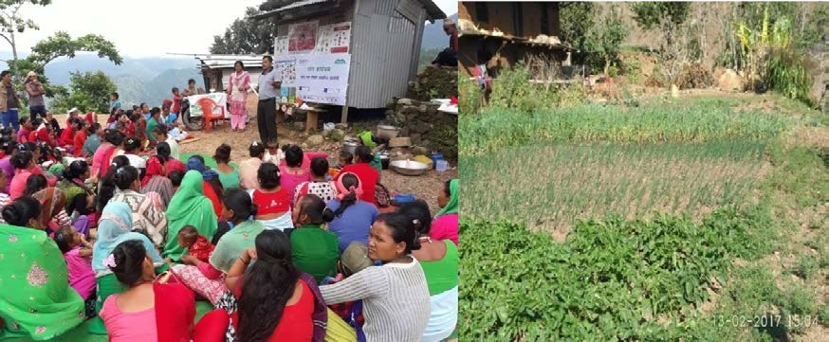
Picture 7. Community people receiving nutrition training and kitchen garden at household

  - Feed the Future

Nepal Knowledge-based Integrated Sustainable Agriculture in Nepal (KISAN-II)
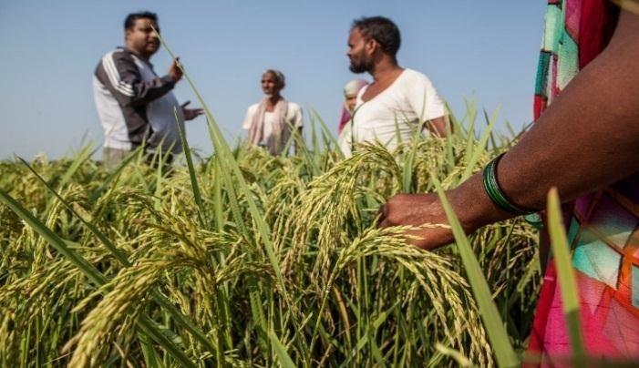
Feed the Future Nepal Knowledge-based Integrated Sustainable Agriculture in Nepal (KISAN) II Project is to contribute to Agriculture Development Strategy of Government of Nepal and is funded by USAID. Winrock International is the prime to implement the KISAN II Project, which aims to increase resilience, inclusiveness
and sustainability of income growth in the Feed the Future Zone of Influence.
Agriculture employs 78 percent of the economically active population in Nepal, and contributes 34 percent to the Gross Domestic Product. At the same time, Nepal is food insecure and the agricultural sector faces persistent challenges, including limited irrigation, increasingly

extreme and erratic weather, and insufficient access to quality inputs. Given the obstacles, there is an opportunity to support sustainable agricultural growth for Nepal’s transition into a more food secure country.
Arbind Kumar Shah of Dev Bhar Rice Mill in Nepalgunj provided agriculture trainings and introduced improved production techniques for 1000 farmers with support from USAID’s KISAN project. Shah is willing to make further investments in local farmers to reduce his rice imports from India and increase his paddy purchases locally.
Photo credit: USAID’s KISAN project/Winrock International

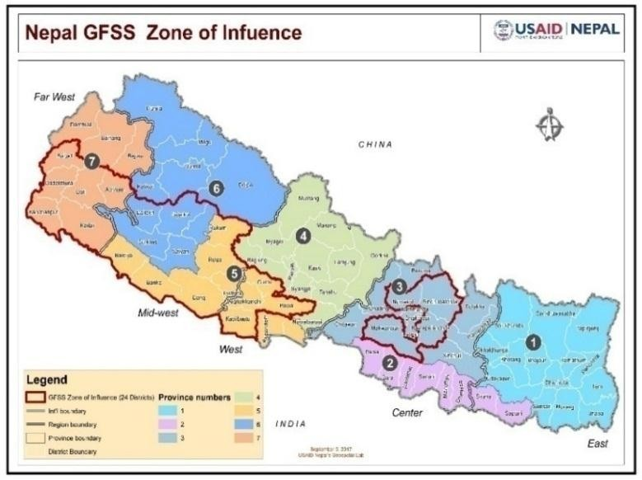
The project is working in selected areas of Metropolitan, Sub-metropolitan, Municipalities and Rural-municipalities in province 7, 6, 5 and 3; and will reach 200,000 farming households of 24 districts mentioned below:
Province 3: Kavrepalanchok, Nuwakot, Makwanpur, Sindhupalchok,
Province 5: Kapilbastu, Palpa, Arghakhanchi, Gulmi, Pyuthan, Dang, Rolpa, Banke, Bardiya, Rukum East,
Province 6: Surkhet, Dailekh, Jajarkot, Salyan, Rukum West,
Province 7: Kailali, Kanchanpur, Doti, Accham, Dadeldhura, Baitadi

Objectives of the project
The goal of KISAN II will be achieved through five components, listed below:
• Component 1: Improved productivity of selected agricultural market systems,

• Component 2: Strengthened competitiveness, resilience, and inclusiveness, of selected agricultural market systems,
• Component 3: Strengthened enabling environment of selected agricultural market systems,
• Component 4: Increased ability of vulnerable communities to act on business opportunities within selected market systems,
• Component 5: Collaboration, learning and adaptation (CLA) applied to market systems Development.

Intervention model, process and activities done under theproject
KISAN II is focusing market systems thorugh private-sector actors. The training required in these domains are generally provided by private sectors working on rice, maize, lentil, vegetable and goats. The private-sector actors are selected on competitive basis. However, KISAN II has a push approach to empower and graduate farming households into more productive, reliable, and lucrative agricultural enterprises evolving from vulnerable to developing, to commercially- minded, and finally to competitive household agricultural enterprises.

On the nutrition front, KISAN II is contributing in nutrition sensitive agriculture in following ways:
• Promote nutrition-rich commodities such as: okra, cabbage, cauliflower, spinach, bitter gourd, carrots, pumpkin (we may be able to expand the list),
• Encourage households to set aside nutrient-rich commodities for home consumption,
• Organize two-month long training classes for 49,000 families on nutritioneducation.

Major content of nutrition training will be:
• Food and Nutrition,
• Nutrition of girls, pregnant women and lactating mothers,
• Nutrition in Golden 1000 Days, Breastfeeding, Child nutrition, Supplementary food,
• Food diversity and food safety,
• Childhood illnesses,
• Nutrition sensitive agriculture, traditional nutritious food undervalued,
• Drinking safe water, WASH.

Implementation modality of nutrition training will be:
• Prepare module,
• Training of Master Trainers and Community Trainers,
• Beneficiary selection and logistics,
• Training,
• Monitoring, surveys, tests and data handling.

Major outcomes/findings
KISAN II is in the first year of its operation, that’s why this is not applicable now.

Lesson learned, challenges, issues and way forward
KISAN II is in the first year of its operation, that’s why this is not applicable now.

Improving Nutrition Situation: back yard poultry

Heifer International
Sumnima Shrestha, Heifer International
The importance of dietary improvements to meet nutrient adequacy and to address malnutrition is well established, and this has motivated increased advocacy and investments in “nutrition sensitive” agriculture interventions that does not only boost production, but ensures availability, access and consumption of diverse nutritious foods, particularly in developing countries. The Sustainable Development Goal 2 (SDG 2) is clear on this, as it seeks to end hunger and achieve food security and the globally agreed nutrition targets by promoting sustainable agriculture. Adequate amounts of Animal Source Food (ASF) are critical components of a nutritious diet because of the essential role they play in achieving nutrient adequacy and improving nutritional status, especially of young children and women of reproductive age.
A back yard poultry system is an important factor in food security and women empowerment in food-insecure resource poor areas and contributes to 8% of AGDP in livestock sector of Nepal. These systems are easily accessible to vulnerable groups of the society and provide households with alternative income and nutrition rich food sources. Run mostly by women and children, back yard poultry is widely prevalent and contributes to 55% of total poultry population. In the villages of Nepal, nearly all farmers rear a few chickens and birds under a back yard poultry system. Back yard poultry isn’t solely limited to family consumption, but is also a part of tradition and culture as many birds are sacrificed during festivals. The average BYP size is 5-10 per household with a maximum of 50.
A study done in Ecuador revealed that stunting was reduced by 46% in children aged 6 months who ate one egg per day for a period of 6 months (Iannotti et al., 2017). Eggs have the highest micronutrient, vitamin B12 which is critical for growth, neurological function and immunity and can play a huge role in the global reduction of stunting among children under 5 years of age. Despite having such big potential, the lack of knowledge in improved backyard poultry disease/mortality is major hurdles to the farmers. Proper care of livestock is pivotal in the production of quality meat; good animal raising practices result to less fatal diseases in the animals and save a lot of the farmers’ finance. Having understood the benefits of BYP, Heifer international Nepal has been pushing for back yard poultry in its beneficiaries’ home. Although not all meat is seen as healthy, poultry meat is more affordable than other meat. It enhances food availability and dietary diversity. Through this Heifer Nepal has also been able to enhance family income and support in value chain development.
Though the importance of poultry has been recognized widely, there still needs attention in the growth of this sector. Newcastle disease (ND) is one of the major causes of high poultry mortality. Although vaccines are available, they are mostly used for commercial poultry farms. Backyard poultry keepers are unaware of the preventive measures that can save their birds. Even amongst the commercial poultry farmers who are aware of the vaccines and are using it are not getting maximum benefit because of the fact that cold chain has not been properly maintained. It was found that vaccine sellers and administers were not aware of the importance of maintaining cold chain and /or were unable to do so because of the lack of appliances needed.

Heifer International Nepal has been working to prevent the spread of “Newcastle disease" in chickens by regular deworming and vaccination and has developed the guidelines for a successful back yard poultry system. The Newcastle Disease (ND) Control Project under a partnership between Heifer Project Nepal and GALVmed was designed to mitigate the spread of ND which bore a major financial loss for the smallholders. A sustainable supply chain of poultry medicine, vaccines, and technical services are most needed components to improved backyard poultry health, husbandry, cold-chain maintenance, and vaccination.

Objectives
The goal of this project is to control Newcastle Disease (ND) in BYP by regular vaccination to increase income and nutrition of BYP farmer of project area. The objectives are:
• To enhance accessibility of veterinary vaccines, medicines and services to project families.
• To prevent and control ND through regular vaccination campaigns.
• To increase productivity of BYP through adoption of improved management.
• To increase income and nutrition of project families especially women and children through the expansion of BYP keeping.
• Engaging government of Nepal to realize the importance of vaccination in BYP and to appreciate the issues of BYP farmers.

Intervention model, process and activities
This project had targeted more than 39,000 poultry rearing households in 50 VDCs in Banke, Bardiya and Surkhet. It aimed at vaccinating more than 140,000 poultry reared by the targeted households. To achieve above mentioned goal and objectives, three types of interventions were planned in the project:
• Poultry medicines and vaccination input supply: In Nepal, poultry vaccines are produced by Central Biological Production Laboratory (CBPL) in Kathmandu and sold to local distributors. Similarly, vaccines are also imported from other countries. In the project, Lasota vaccine produced by CBPL as well as imported Lasota vaccines produced by Ventri Biologicals were used. Thermostable I2 vaccine produced by CBPL was not regularly used due to its limited availability. The distributors transport the vaccines to district headquarters using cool boxes through road transport or by air and retailers stock the vaccines received in domestic refrigerators.
• Service delivery of deworming and vaccination: The country has a robust system in place for providing primary animal health services and vaccination through Community Animal Health Workers (VAHWs) who undergo 35 days institutionalized training using government approved curriculum. The training is much focused on large and small ruminants and commercial poultry while backyard poultry is not covered at all. This weak link was strengthened by giving them orientation training on backyard poultry keeping, vaccination and cold chain maintenance during transport and storage of vaccines.
• Improved poultry farming practices: Knowledge and information on improved poultry farming techniques were imparted to the farmers through various trainings, awareness campaigns and IEC materials. The improved techniques include proper housing, feeding, health care and breeding techniques that can help increase production and profit. The intervention model is shown below (Figure 23).

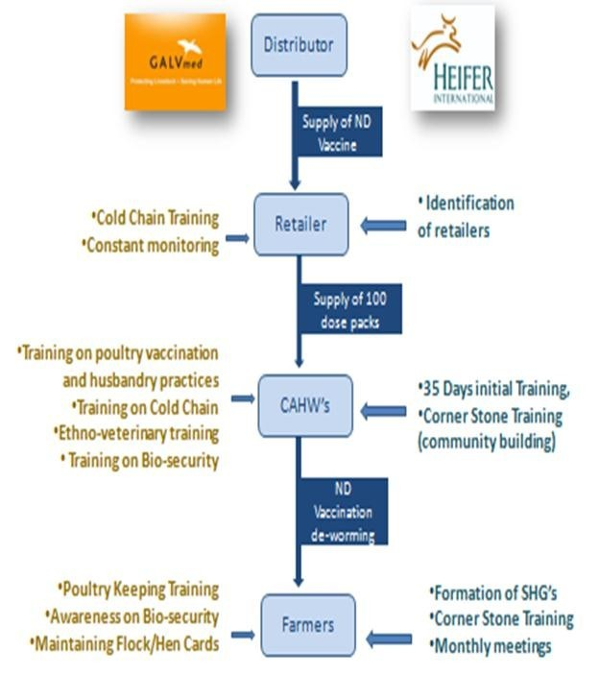

Figure 23. Intervention model

Major activities carried out through project are listed below:
• VAHWs were trained on common diseases in Backyard poultry, good husbandry practices including balanced feeding, housing, de-worming, ethno-veterinary medicine for common ailments, etc. VAHWs were trained to remain vigilant of symptoms of the disease and take preventive measures when occurrence of disease is proven through lab tests.

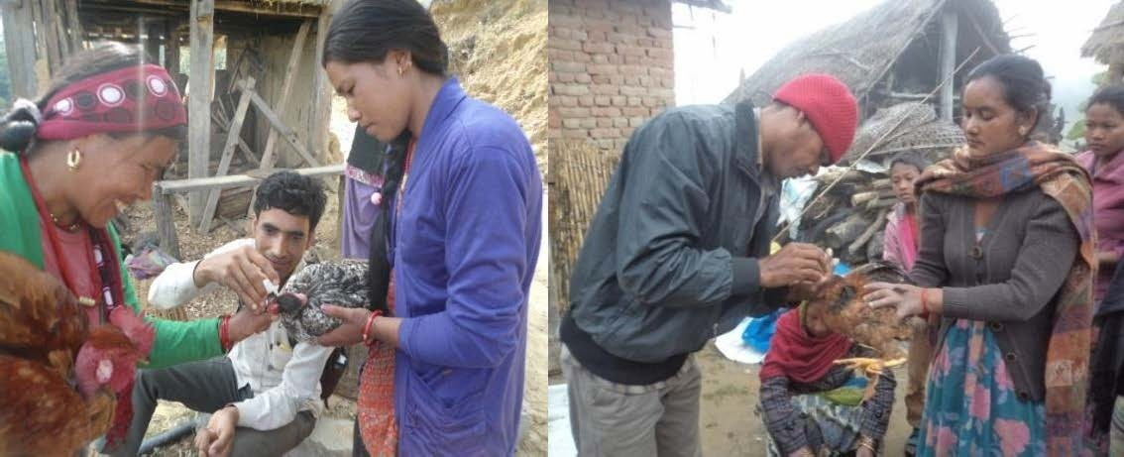
Picture 8.VAHWs doing vaccination of chickens

• VAHWs were trained to vaccinate birds against ND. The ND vaccine used was Lasota and was administered through intraocular route every three months. They were taught to transport and administer quality vaccine considering strong technical aspects. They gained practical skills on vaccine transport using cool box, reconstitution of vaccine with provided diluents; and correct administration techniques. Campaigns of vaccination and deworming program were conducted after the trainings. There is a high possibility that the ongoing vaccination campaigns will be sustainable because of the establishment of demand driven system, paid system of technical service delivery, benefits seen in all engagedstakeholder.
• Training was imparted to VAHWs, Government Livestock services staffs and local retailers on the importance of maintaining cold chain and means of doing it. They were made aware strongly on the importance of maintaining cold chain right from production up to administration level. The training mainly focused on the system of transporting and storing vaccines including equipment required to maintain this system.
• BYP keepers were trained in following good husbandry practices in rearing poultry, made aware of ND vaccination, use of local herbs, and adopt bio-security measures; economics of poultry keeping, and other common diseases by VAHWs in SHG meetings.
• Timely de-worming, vaccination, use of local herbs to control internal and external parasites has increased the immunity of birds to fight infection.
• Extensive knowledge transmission was done through posters\pamphlets; mobile vans with loud speakers, talk programs in FM radio, roadside hoardings, etc.
• Installation of a refrigerator under supervision of VAHWs where vaccines can be storedfor easy access by other VAHWs.

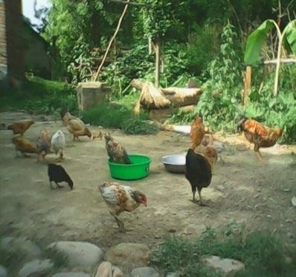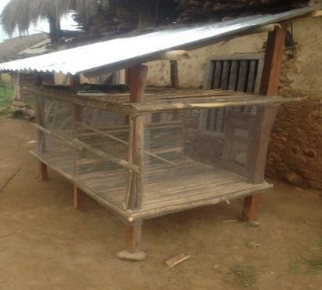

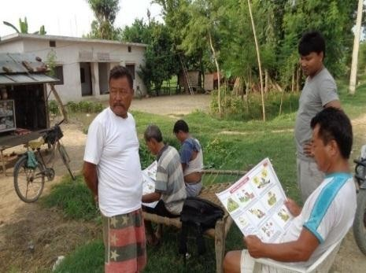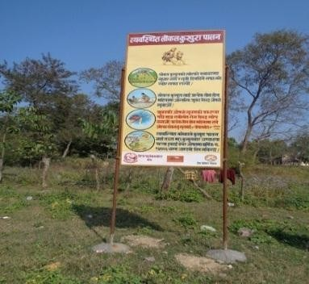Picture 9. Good husbandry practices adopted by BYP farmers
Picture 10. Knowledge transmission through posters

Major outcomes/findings
The project vaccinated 142,964 poultry reared by 39,826 households. The project has been successful in making changes in mindset of BYP farmers to voluntarily get birds vaccinated and pay for the services. The project has made a considerable impact as neighboring villages; other organizations including government offices like district livestock service offices (DLSO) are replicating the model. This model shows signs of sustainability as farmers are demanding not only ND vaccination but also fowl pox vaccinations from VAHWs and are paying for the same. Maintaining cold chain of vaccine has increased its effectiveness as no outbreak of ND has been reported in vaccinated area implying vaccine cold chain has not been compromised. It can be claimed that the project has contributed to increasing production and productive of BYP and thereby income and nutrition of BYP rearing families.
The BYP farmers have significantly increased the flock size. The flock size has increased from 10 to 18 on average. This significant increase is mainly due to increase in hatching percentage and number of clutch per year.

Figure 24. Flock size of BYP farmers
Clutch Data
15
11.0
Base Line
End Line
10
8.0
8.6
6.0
6.2
5
3.6
3.6
1.7
0
Put to hatch
Chicks Hatch
Reared to maturity
Poultry Sold
25
20
15
10
5
0
Flock Sizes
Base Line End Line
18
10
2
3
2
3
6
7
3
4
Cocks Hens Growers Chicks Total
Clutch Data*
Average Number of Birds

Figure 25. Clutch data
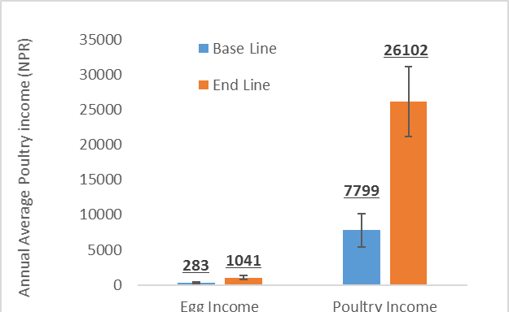There has been significant increase in annual income by selling eggs and birds. The annual income from poultry has increased on an average by NPR.18, 303 per household (Figure 26) after the project intervention.
Annual Poultry Income

Single Poultry value = 500 Npr Single Egg Value = 20 Npr
Figure 26. Annual poultry income

The poultry meat consumption has increased among the BYP keeping families (Figure 27). The frequency of meat consumption has increased significantly among these families, which has contributed to nutrition of children and women.
50.0
40.0
Base Line End Line
30.0
20.0

10.0

0.0
Times per week poultry meat consumed
0
1
2
3
4
5
6
7
Percentage Responses(%)

Figure 27. Meat consumption in BYP farmers

It can be safely claimed that the BYP systems help in solving the problems of poverty, food security, malnourishment and gender discrimination prevalent in the village areas, an increase in income through BYP automatically increases a sense of wellbeing especially amongst women who are major beneficiaries of these systems.

Lesson learned, challenges, issues and way forward

Lesson learned
    - Working with women’s groups improved chances of adoption and expansion. Farmers in this setup were more communicative of their concerns and confusion.
• Heifer cornerstones training have helped in making the participant more open to new ideas.
There was an increased sense of support amongst the farmers after the training.
• BYP keepers are recognizing that even backyard poultry farming can contribute substantially to household income and nutrition, and are ready to invest in BYP farming.
• Having local VAHWs was useful in understanding the challenges faced by farmers. Similarities in language and culture helped to create deeper bonds that prove beneficial to the project outcomes.
• Using VAHWs for social mobilization with the community facilitator also helped him/her improve his/her social ties eventually benefitting the whole farm community.
• Local level meetings and trainings were helpful to not only the target families but also the whole community.
• Local FM Jingle, Posters/pamphlets and street drama were efficient means of communication.
• Coordination with government service providers helps in replication into other areas.

Challenges
• Area coverage: It is difficult to carry vaccination and deworming campaign in large area because of distant geographical make up of residence communities.
• Vaccine availability: Regular supply and appropriate dose of thermostable vaccine.
    - Cold chain maintenance of vaccine: Proper cold chain maintenance is still an issue especially in rural areas due to intermittent supply of electricity. Also, due to involvement of various actors in supply chain of vaccines, quality maintenance of cold chain can’t be ensured at all levels.

Way forward
• BYP and other livestock and poultry related intervention programs should be incorporated with social mobilization programs for better acceptance and deeper impact. Heifer has great experience of utilizing social capital strength to help learn and adopt livestock technologies by rural families in a sustainable way.
• Heifer has promoted and will continue to promote BYP in all of its project areas introducing improved technologies and vaccination program with objective to improve family nutrition and income.

Experience of SABAL

Sustainable Action for Resilience and Food Security
SABAL is a $59 million project implemented by Save the Children together with its partners, is implementing the in six central and eastern districts of Nepal; Makwanpur, Sindhuli, Ramechhap, Khotang, Okhaldhunga, and Udayapur, and is funded by USAID 2014-19. It aims to increase resilience for targeted vulnerable communities in Nepal, and is being implemented in close coordination with the Government of Nepal Ministry of Agricultural Development, Ministry of Health and Population, Ministry of Federal Affairs and Local Development and other relevant line ministries, district level line agencies and local NGO partners. The first year was marked by devastating earthquakes in April and May 2015, followed by numerous aftershocks, landslides and avalanches, severely impacting 24 of Nepal’s 75 districts, including 4 of the 6 Sabal districts. Recognizing the necessity to respond to the disaster as well recover from the shock, USAID/Food For Peace expanded the Sabal program into five additional districts heavily impacted by the earthquakes (Rasuwa, Nuwakot, Kavrepalanchowk, Sindhupalchok and Dolakha), with the mandate to contribute in a major way to community recovery from the disaster using the Sabal development modalities approved under the Cooperative Agreement (USAID, 2014).

Project objectives

Strengthen and diversify livelihoods
• Empower individuals and local organizations, and facilitate market access to increase resilience and improve access to economic opportunities
• Strengthen farm-to-market links, encourage investment, improve access to inputs and agricultural services, and increase off-farm income

• Promote diversified livelihood opportunities, including masonry and other relevant housing reconstruction skills
• Improve financial literacy, increase savings, and promote productive investment of remittance income
    - Strengthen women’s participation in decision-making

Improve health and nutritional status
• Promote the adoption of improved health, water and sanitation, and nutrition behaviors for mothers and their children
• Influence positive health and nutrition behaviors using social marketing tools and mass media
• Support community mobilization through Female Community Health Volunteers, mothers' groups, and schools

Strengthen the ability of households and communities to mitigate, adapt to, and recover from shocks and stresses
• Ensure that individuals, households, and communities have the necessary processes, information, and services for sound risk management
• Promote integrated disaster risk management (DRM) and climate change adaptation (CCA) planning, and develop disaster early warning systems in partnership with stakeholders
• Increase local access to weather information and train community leaders and farmers to use data for agriculture and risk management

Implementation modality

Consortium partners
- Save the Children - Lead
- Helen Keller International
- CARE Nepal
- LIBIRD
•DEPROSC Nepal
- NEWAH
- Action Against Hunger
- NTAG
- TANGO
Local partners
•14 Partner NGOs
- 2 per district in original 6 districts
•1 per district in expansion districts

Key approaches
Strengthen Government system Strengthen community and community groups
Achievement: livelihood
• Foundational trainings on improved farming systems to 80,773 farmers.
• 5,536 varietal demonstrations for wheat, maize and rice.
• Trained 227 VAHWs - 41% actively providing support.
• 25 CFW projects (irrigation, drinking water, trail rehabilitation, river training and collection center rehabilitation).
• 14 irrigation projects implemented in 7 districts provide irrigation facility to ~443 hectares.

Achievement: health and nutrition
• Trained all GoN health workers and FCHVs in the 6 districts.
• 83% FCHV had knowledge and skills on Infant and Young child feeding practices.
• 91% of FCHVs enrolling new 1000 days mothers in health mothers group (631 FCHV followed up).
• 578 severely malnourished children treated.
• 53,772 new children <2 yrs age monitored for growth by Health Facility.
• 5% increase from previous year (HMIS FY16/17).
• Trained district nutrition and food security steering committees on MSNP in five districts.
• 44 VDCs allocated NRs 11,722,500 from block grant budget for health, nutrition and WASH.
• 1000 days mothers in 1529 EHFP groups trained and supported for homestead food production and backyard poultry.
• 90% mothers consuming garden vegetables.
• 34% mothers gave eggs for 6-23 month-olds (24 hour recall with 504 mothers followed up).
• 1478 Village Model Farm established (one per ward) for homestead garden and backyard poultry: 63% VMFs providing technical assistance to EHFP beneficiaries (among 342 followed up).

Achievement: DRR and CCA
• 194 Climate Vulnerability Assessments - CDMCs developed action plans + GoN and stakeholders informed their planning processes.
• DRR/CCA mainstreaming in 160 VDCs - allocated NRs 14,110,600.
• All integrated DRR/CCA plan implemented with environment checklist.

Challenges
Federal transition appeared as both challenge and opportunities

Lessons learned
• VAHW has complemented GoN in increasing outreach of extension services
• Technical Support Visit is useful for monitoring and improving practices
• Regular interaction with local bodies is important to access resources for DRR/CCA from block grant
  - Improving Livelihoods of Marginalized Community

Welthungerhilfe (WHH)
Welthungerhilfe (WHH) is a Germany based agency which aims to help reduce global hunger and resulting malnutrition. The projects of WHH are focusing on sustainable rural development and on supporting smallholders. In accordance with the guiding principle of empowering people to help themselves, WHH has helped many people around the globethrough their local NGOs. Improving Livelihood of Marginalized Community is project of WHH Nepal funded by German Federal Ministry for Economic Cooperation and Development. Total budget

of this project is Euro 1,466,667 and is implemented through local partners: Libird, RRN and ASAMAN from November 2015 to December 2018, targeting 6000 households in Salyan district.

Objectives of the project
Overall objective (impact): Food and nutrition security has been substantially improved through enhanced livelihoods.
Project purpose (outcome): Agricultural productivity and income has increased through sustainable integrated farming systems and value chain development and empowered communities are aware on right to food issues.

Intervention model, process and activities done
The Project follows integrated community-based, market-driven and right-based methodology/ approaches. The project will be implemented in partnership with the local NGO, community- based organizations, governmental line agencies, and private entities. And, project implementation process involves the engagement of civil society (NGO, CBO), private sector, and government body. Table 11 shows the Result-wise project design/implementation framework.

Result (Output) | Current status/Rational//Background
CBOs are strengthened to ensure right to adequate food | The CBOs are mainly working on informal basis and those who are institutionalized are very weak. Therefore, the groups do not have any influence and/or power to make their voices heard. People have no knowledge about existent government entitlements not to speak about their rights although Food Sovereignty is part of the current transitional Nepalese constitution.
Increased productivity by adapting Sustainable integrated farming system | The targeted area belongs to ecologically vulnerable regions, dominated by ethnic groups and economically disadvantaged groups. Food insecurity is a concern with a hunger period of about 4-6 months and diet diversity is very poor. Water scarcity and small land holding with poor investment capacity results in low or no-  surplus situation.
Value chains of three commodities are developed and financing models established | Collective marketing and processing of agriculture products is hardly done in the area. Existing cooperatives are not very active lacking capital and resources although potentiality for several  value chains is promising. Missing funds are not provided by private institutions because they hesitate to provide capital.
The nutrition status of household substantially improved | Women are the main caretakers of families but hardly decide on products to be cultivated. The education rate is low and there is less  knowledge about malnutrition causes, optimal usage of locally available food and feeding practices.
Table 11. Result wise project design/implementation framework

Project result (Output) | Design/ Implementation framework
Result 1. Governance | Right-based-approach (Duty-bearer and right-holders)

Result 2. Agriculture | Sustainable Integrated Farming System (SIFS); Participatory Learning and Action (PLA – farmer field school)
Result 3. Value Chain | Inclusive Value Chain Development (iVCD)
Result 4. Nutrition | PLA: for nutrition outcome (LANN Plus – Linking  Agriculture, Natural Resource and Nutrition – 17 steps process/ sessions); CMAM

The general implementation methods (non-exhaustive/ non-exclusive) include:
• Training, capacity building and citizen empowerment
• Assessment, PRA process, data based and information management
• Community and stakeholder mobilization (local elected representatives)
• Knowledge exchange/ exposure visits
• Provision of inputs, services and information
• Coordination, synergy and alignment
• Facilitating market linkages
• Innovation (Research) and scale up of good practices
• Policy review, advocacy and networking

Major outcomes and findings
Table 12. Major outcomes and findings

Target/ Indicator | Progress/Outcome (until December 2017)
75% of CBOs (8 cooperatives and 16 groups) have reached medium level according to Participatory Organizational Capacity Assessment  Program (POCAP) | 63% CBOs (7 Cooperative and 8 farmers group) are reached in medium level as per POCAP score
At least 75 % target HHs are aware  about government services at local level | 61% target households are aware about government service at local level
Irrigated land increased additionally by 525 ha through new construction/  renovation of 42 small irrigation systems | Additional 437.26 ha irrigated land through small irrigation schemes (canal and water collection pond)
At least 3 additional crops varieties are cultivated by 3000 farmers (in total 7) | 3,368 farmers cultivated fresh vegetables and seed production of rice, wheat and maize
Agriculture production of targeted farms has at least increased by 25% | Cereals production 1538 (18.9%) Kg/HH
Use of firewood reduced by 30% through promotion of Improved  Cooking Stoves /alternative energy interventions | 400 ICSs and 26 Bio-gas installed to reduce firewood consumption by 426 farm households

3 value chains are sustainably functioning and benefit 1500 HHs | Selected 5 VCs; Beneficiaries reached 1,085; Final stage of Collection center construction
At least 200 households access funds from fair financial institutions to invest in value chains | Banking reach 291 beneficiaries; Loan taken 157 Beneficiaries; Total Loan – NPR 9,840,000; Total outstanding- NPR 6,532,786
75% of targeted 6,000 households change their behavior on diet diversity | Community People including mothers aware about need to consume different types of food; Most of the community people started the nutrition garden
75% of targeted household have improved their knowledge in regard to Infant and young children feeding practices. | Mothers focus on locally available food items; Knowledge of food combination and importance of different food groups for health; Continued exclusive breastfeeding even to a girl child upto 6 months with supplementary feeding at 6 months onwards; Health seeking behavior is developed;  Slogan “Harek baar khana char” (Everyday four types of food) has been popular in the community

Lesson learned, challenges, issues and way forward

Lesson learned
    - People’s mobilization (right based) is equally important to hardware support and infrastructure
    - Ultimately the GoN responsible for citizen’s rights
• Capacity building (soft-skills and equipment) to local level government to strengthen delivery (supply side)
• Government is highly supportive when project is transparently managed
• Nutrition-sensitive agriculture (e.g., integrated farming system) is the MUST to address ‘underlying causes’ of malnutrition.

Issues and challenges
• Result-wise partnership (staff management)
• Geography and difficulty in local hire (technical capacity)
• State re-structuring process (suggestion to cover whole RMC)
• Targeting (most vulnerable; e.g., lead farmer, value chain)
• Role of DPAC (as RMC level monitoring body required)
• Right-based mobilization Vs Hardware support (SWC)
• Overall capacity/clarity of recently elected government on their authorities and responsibilities (e.g., recent Microfinance issue in Bajura)

Way forward
Be transparent, be ready to collaborate, and make sure what you do is within the framework of GoN’s policy, plan and program, as well as local need, potential and aspirations-RMC’s periodic plan; MUST to engage/ collaborate with local government structure and community-based institutions and stakeholders to succeed and sustain.

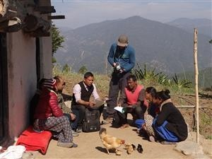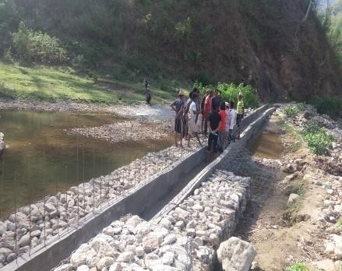
Picture 11. Sharing knowledge with community members and irrigation canal constructed
  - Mainstreaming Home Garden for nutrition sensitive agriculture
LI-BIRD’s Experiences

Purushottam P. Khatiwada, Roshan Adhikari, Ram B. Rana, Parshuram Bishwakarma and Shambu B. Basnet
Home garden is a traditional system in Nepal and reflects the predominant system of integrated farming. Despite the long history, a systematic study on home garden in Nepal was started from 2002 by Local Initiatives for Biodiversity, Research and Development (LI-BIRD) with technical support of Bioversity International and financial support from Swiss Agency for Development and Cooperation (SDC). The four-year-long research project explored the potential of home gardens in major agro-ecological domains as well as the socio-economic settings. It further elucidated the technical aspects of home garden system like size, structure, composition and use value. The main conclusion derived from the research phase was the home garden managed by households is an effective means of securing family nutrition through the consumption of own produced diverse foods and hotspot of agro-biodiversity maintenance. On the footing of the first phase, the four-year-long second phase was implemented immediately in order to scale out the outcomes of the first phase.
The second phase aimed to adopt home garden technology and harvest benefit from the better availability of diversified dietary sources produced in home garden by disadvantaged groupsand generates extra cash income through the sale of surplus products. The main learning of the second phase was that home garden initiative in isolation or standalone approach would not yield impact in greater extent. However, the realization was made that it could be one of the key components to complement the livelihood improvement program targeted to smallholder farmers. To translate the learning in the real situation, the third phase of the project (2009-2013) was executed to strengthen the complementarities of the home garden initiative by its integration into other livelihood improvement programs. While integrating the home garden initiative in other livelihood improvement programs, the focus was paid in integrating the home garden elements in SDC cluster districts and regular activities of District Agriculture Development Offices (DADOs). Additionally, the third phase proved that home garden approach supports

disadvantaged groups (DAGs) to improve their nutrition through diverse sources of food and reduce economic vulnerability through the sale of surplus products. Furthermore, it is found to be a more resilient system in the context of climate change because of the diversity of plant and animal species in the home garden.
Capturing the lessons from the earlier phases, the fourth phase (Home Garden Project Phase IV, HGP IV in short) was designed for four years (2014-2018) in a form of bi-lateral agreement project between the Government of Nepal and the Government of Switzerland. The project document spelled out 20 project districts providing space to work in two other districts mobilizing the civil society networks.
Food and nutrition security has been a challenge in Nepal despite the involvement of the majority (66 percent) of the population in agriculture. Considering the gravity of the problem, Agriculture Development Strategy (2015) has ear-marked food and nutritional security as a flagship program for agriculture development. In agriculture development, food security had always been in top priority but kitchen gardening program was the only one focused on nutrition-related interventions in the past. However, launching of Multi-sector Nutrition Plan brought together major stakeholders (nine ministries) and nutrition sensitive agriculture became an issue within the agricultural sector. Despite the involvement of agriculturists in nutrition interventions, supplementation approach dominated the food based nutrition approach because of a long legacy.
National Demographic and Health surveys carried out over the two decades clearly show the reduction in undernutrition indicators of children like underweight, stunting and wasting. During the period, stunting decreased from 57 percent to 36 percent, wasting decreased from 15 percent to 10 percent and underweight problem reduced to 27 percent from 42 percent in children under five years (Figure 28). However, anemia in reproductive women is increased to 41 percent (NDHS, 2016). Despite these aggregated data, the problem of undernutrition is more rampant in poor families having less educated mothers. This clearly indicates for more targeted and concerted efforts to meet the national targets and international standards. Despite gradual progress, the country has daunting milestones to meet the international standards and also to achieve the national targets. The Agriculture Development Strategy has a long-term target to reduce stunting to 8 percent, wasting to 1 percent and underweight to 5 percent and low body mass index in reproductive women to 5 percent by 2035. These ambitious targets can only be achieved with the joint efforts of multi-sectoral ministries particularly health, education and agriculture at federal and state level along with commitments from the local governments. Even within the agriculture sector, there is a need of mainstreaming nutrition-sensitive agricultural interventions across programs with the same level of understanding at all levels.

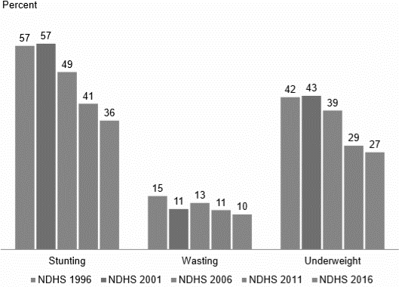

Figure 28. Nutrition Status of Nepal over two decades (source: NDHS, 2017)
Home gardens in Nepal found to be instrumental for nutritional security to all strata of farming communities, including marginalized households (Suwal et al., 2008). Home garden refers to “the traditional land use system around a homestead where several species of plants are grown and maintained by the household members and their products are primarily intended for family consumption” (Shrestha et al., 2002). Because of the agrarian system in the country, each and every rural and few urban households maintain the home garden in different size and form. Traditionally and even now in many places, our home garden is more dominated by vegetables. But vegetables alone cannot fulfill all the nutritional requirements. Hence, the project is implemented in order to promote home garden approach which includes vegetables, fruits, poultry, livestock, honey bee, fish, mushroom along with spices, religious and ornamental species. More importantly, the home garden approach has been proved to be effective means to produce nutritious food by smallholders and marginal farmers with very little external resources. Additionally, the approach is resilient to the climate change context and helpful for economic resilience to poor families through the sale of surplus produces.

Objectives of the project
Home Garden Project Phase IV aimed to contribute to improve nutrition and reduce the vulnerability of smallholders and disadvantaged groups, especially women, by scaling up home garden practices in Nepal. With this broader framework, the project has formulated two outcomes:
- Smallholders and disadvantaged groups shall have adopted home garden practices to improve family nutrition through diversified dietary sources, and ii) Department of Agriculture, District Agriculture Development Offices (DADOs) and local bodies in working districts shall have integrated home garden into regular agriculture extension program. In order to reach the unreached community, the project focused on the poor households keeping the women at the centre.

Intervention model, process and activities done
Being a bi-lateral project, HGP IV receives strategic guidance and policy-related decisions from the Project Steering Committee (PSC) chaired by the Secretary of Ministry of Agricultural Development. Project Technical Committee (PTC) functions under the PSC, which is responsible for overseeing the technical parts of the project and make necessary endorsement and recommendations to the PSC. The project is implemented through Project Support Unit (PSU) under LI-BIRD on behalf of Swiss Agency for Development and Cooperation. The PSU manages to execute the project activities in close collaboration and coordination with Vegetable Development Directorate of Department of Agriculture, which is also the focal government entity to the project (Figure 29).
Home Garden Project Phase-IV
Government of Switzerland
SDC
Project Support Unit
PNGOs/Network
Ministry of Agricultural Development
Government of Nepal
DADOs
VDD
Department of Agriculture
Technical
Project Steering Committee
Beneficiary
Beneficiary
Figure 29. Organogram of home garden project IV implementation
HGP IV is implemented in 20 districts of Nepal covering 40,000 households. The project districts were grouped under four clusters, arranging the districts in the following fashion:

Cluster I: Khotang, Okhaldhunga, Ramechhap, Sindhuli, Mahottari, Dhanusha and Siraha Cluster II: Dang, Rolpa, Salyan and Bardiya
Cluster III: Dailekh, Jajarkot, Kalikot and Jumla
Cluster IV: Kailali, Doti, Achham, Dadeldhura and Baitadi
A total of 10 then Village Development Committees (VDCs) were identified by the District Agriculture Development Committee. The main VDC’s selection criteria were i) high incidence of poverty, ii) low nutritional status of the community, and iii) farmers’ limited access to services or presence of state/non-state actors. Upon ear-marking of the VDCs, the list of ear-marked VDCs were approved by District Agriculture Development Committee (DADC). Out of 10 VDCs, District Agriculture Development Offices (DADOs) implemented the activities in three VDCs and non-government organizations implemented the project activities in seven VDCs. In order to execute the field level activities, PSU selected four partner NGOs, one in each cluster. As per the project document, two districts were identified by the Project Technical Committee and responsibilities were given to a network and community-based organization to serve 5,000 households of Banke and Gulmi districts.
Seven groups in each VDC is formed or mobilized based on the group presence in NGOs-led sites. It was suggested to maintain 25 members in a group. While identifying the wards and forming the groups, underlying causes of poverty analysis (UCPA) data were sought to prioritize discriminated and poor families. In the case of unavailability of UCPA data, target households were identified through wellbeing ranking exercise. In order to increase participation of women and poor, households of lower strata were united into the groups. While mobilizing the groups, the focus was paid to bring the women and disadvantaged group in decision-making positions and adopt the pro-poor activities while taking the decisions of the groups.
All the project activities were in line with the project document. Yearly plan of operations (YPO) was annually developed by a joint workshop involving the ministry, department, VDD, DADOs, PSU and PNGOs. The YPOs was then endorsed by the PTC and approved by PSC. Needless to mention, there was some level of flexibility to DADO’s activities since their activities need to be approved by DADC. The main activities were capacity building of beneficiaries (nutrition education, home garden management, low cost integrated vegetable management, mushroom cultivation, group management, exposure visit) by the technicians of government and non- governmental organizations, distribution of diversity kit (vegetables and fruits), promotion and use of local genotypes and food through drama, food fair and diversity fair, promotion of gender and social inclusion, policy interventions for the promotions of home garden approach, development of local resource person, and development of resource home gardens as knowledge and resource centers.

Major outcomes and findings
Despite the four-year project period, effective field implementation is done for the three-year period. The project is able to generate the following major outputs during the period:
  - The project was able to form and/or mobilize 1400 beneficiaries' groups involving smallholders and disadvantaged group. All these groups are managing saving and credit activities and functioning properly. Beneficiaries include 25 percent male and 75 percent

female in terms of gender which includes BCTN (40 percent), Janajati (29 percent), Dalit (24 percent) and others (7 percent). Likewise, 78.6 percent of the Executive positions in the groups are represented by the women members. The figures clearly indicate that the project succeeded to engage and empower women beneficiaries along with the high involvement of ethnic minorities.
  - The project trained 40,000 beneficiaries, 293 I/NGOs staff, 39 government staff, 512 Community Female Health Volunteers (CFHVs) and four instructors working for Council for Technical Education and Vocational Training (CTEVT) during the course of its implementation primarily on the technicalities of home garden and nutrition education.
  - The beneficiaries were trained on HG concept, low-cost home garden management, integrated pest management techniques, farmyard manure improvement, seed perpetuation and nutrition education. Vegetable, fruit, cattle, goat, pig, rabbit, chicken, mushroom, fish, seed production and nursery management are the main targeted home garden components. But the project directly supported on vegetables, fruits, mushroom, and training on nursery management. Output monitoring survey (OMS), carried out internally in 2017, reveals that
69.5 percent of the respondents managed five and above HG components.
• Sixteen food types listed by FAO is regrouped into seven types namely; starchy, oil and fat, leafy greens, Vitamin A rich fruits and vegetables, rest of the fruits and vegetables (not included in earlier groupings), pulses or protein-rich plants (including mushroom), and animal source food (meat, milk and milk products). Output monitoring survey, carried out internally, found 36.4 (which was only 6.6 at baseline survey) percent of beneficiaries consuming six and above types of food.
• Vegetable diversity kits were distributed for two seasons (winter and summer) to all beneficiaries of the project districts and training was provided for complete production package. The number of beneficiaries buying vegetables from outside has been reduced greatly (35.9 percent in OMS against 63.8 percent in the baseline) and this gives a clear indication of a decrease in expenditure on the vegetable purchase. Beneficiaries selling surplus vegetables increased to 33.6 percent after two years of interventions from a baseline figure of 22.5 percent. Since the majority of the home garden sites are interior villages, there is limited opportunity for fresh vegetable marketing. Opening up of new market centres at Palikas headquarters will develop vegetable markets in future, which consequently will contribute to increasing the sale volume of home garden products and numbers of beneficiaries. The OMS data reveals that the average income earned from the sale of surplus HG produce was NPR 4,763.00.
• The home garden approach is getting popular among the development practitioners for providing nutritional security to resource-poor farmers and building resilience to the effect of climate change. With their initiatives (organized or arranged by development agencies and technically supported by the HGP), development professionals/workers from Gulmi, Banke, Sindhupalchowk, Humla, Kaski, Rukum, Chitwan, Mugu, Bajura, Gorkha, Makawanpur, Palpa and Nawalparasi districts were trained on home garden approach. All the participants were involved in nutrition initiatives and their main aim of participation in the training was to integrate home garden in their nutrition and livelihood enhancement endeavors/projects.

• All beneficiary groups mobilized by NGOs (890 groups) are operating saving and credit scheme. In addition to the technical benefit, this financial activity contributed to groups becoming more active, regularly organizing meetings and properly maintaining the records.
    - The home garden approach is incorporated in course of junior technician (JT) level under CTEVT. In order to enhance the technical delivery, an orientation activity was carried out to agricultural instructors of CTEVT’s trade schools. It will have wider coverage all across the country and communities. More importantly, the home garden is recommended for food- based nutrition interventions in policy and project documents like Food and Nutrition Security Plan of Action Nepal (2016) and Project Document of Prime Minister Agriculture Modernization Project (2017).
• The project developed 890 local resource persons who can provide technical knowledge and skills for home garden management. Likewise, two resource home gardeners are developed in order to provision resource centres for planting materials and knowledge upon the termination of the project.

Lesson learned, challenges, issues and way forward
The project is unique in many senses in terms of fund flow mechanism, implementation modality, and beneficiary targeting. Following learnings and challenges were experienced in different stages of the project cycle:

Lesson learned
There is a lack of meaningful participation of women and poor in the development process. However, the project achieved a high participation of women and marginal farmers. Such participation can be achieved with constant and clear affirmative actions.
• Since the kitchen is the main responsibility of women in general, women respond quickly on nutrition-sensitive agriculture. Furthermore, issue of under nutrition in women and children are better internalized by women than anyone else. Hence, nutrition-sensitive agriculture should be designed to involve as many women as possible.
• Marginal and resource-poor farmers do not have sufficient resources for investment and also have the low risk-bearing capacity. Thus, they easily adopt the low cost and internal resources based technologies.
• Introduction of saving and credit scheme in the group and providing group grant for income generation to the ultra-poor attracted the marginal farmers to be in the groups and take the leadership position. This saving and credit function of the group will be instrumental in the sustainability of the group ever after the support of the project.
• Social discrimination is still prevalent, though in recessive form-in the interior part of the country. Forming groups of similar economic status have contributed greatly to social inclusion and better harmony.
• Beneficiaries who were exposed with the markets showed strong positive feeling towards hybrid of vegetable crops. Since they demanded the same kind of seed in diversity kit, we tried to convince them verbally that hybrid cannot perform well in low inputs management conditions. In order to demonstrate the performances (hybrids with local/improved open pollinated (OP) varieties) under low input management conditions, diamond trial (2 genotypes x 2 management practices) were found effective. In addition to convince the

exposed beneficiaries by their own demonstration, it also provides opportunity to semi- literate farmers to show how local landraces or improved OP could perform well in local management conditions.
    - Home garden products are safe and fresh and ordinary marketing processes don’t pay the growers better return of surplus products. Hence, advocacy of safe and fresh products should be planned from the very beginning in order to get a premium price for the products.
• Limited access to technologies hinders the adoption in many cases. Developing resource home gardens and local resource persons, right from initial days of project implementation, in interior parts will contribute to the adoption of technologies with a smallinvestment.
• Agricultural technicians are good on production technologies but their level of understanding on nutrition education is very low. Since nutrition education is part and parcel of agriculture (as indicated by ADS), nutrition-sensitive agriculture should be included in the course curricula in order to make the future technicians confident on it. Considering the fact, HGP IV incorporated home garden approach in curricula of CTEVT and secondary level.

Issues and challenges
• Since the project is working primarily with smallholders and disadvantaged groups, maintaining large animals in the home garden is a big challenge and this has restricted in the use of dairy products. Improvement in dairy products consumption is a challenge for marginal farmers and promotion of Saanen goat seems to be an option.
• In the context of very low hatchability of local hens, egg production and consumption being a challenge, assured supply system of dual-purpose chicks in the remote areas would be the option to mitigate the challenges.
• Agriculture technicians are less versed in nutrition education and health and hygiene. Since the majority of the HGP IV sites are in interior parts, the need for health and hygiene education along with nutritious food is more pertinent in these areas.
• Different fund flow mechanisms and approval system (YPO is approved by PSC for NGOs but need re-approval from DADC to DADOs activities) demanded more time and energy to accomplish tasks on time.
    - The deep-rooted belief in ‘filling stomach is food and nutrition secure’ demanded more time and efforts to convince the marginal farmers on nutrition aspect. Since the benefit of nutrition-sensitive agriculture can only be realized in the longer term, constant follow up and coaching is demanded during the initial stage.
• Involvement of health professionals in nutrition sensitive agriculture is highly preferred but this cannot happen in some cases. In such case, the involvement of mobilization of Female Community Health Volunteers would be an effective alternative.
• By definition, the home garden should be around the home. But management of proper home garden is a challenge in cluster settlements like in Jumla district and Tharu community.

Way forward
• Since agricultural technicians are less versed in nutrition education and health and hygiene, initial orientation to frontline staff is necessary for multi-sectoral activities (nutrition sensitive agriculture) implementation.
• Nepal is adopting supplementation strategy to combat with micro-nutrient and vitamin deficiencies. Though it is necessary when the problem is in clinic stage, agriculture could greatly contribute to prevention. Hence, agricultural extension agents should have special knowledge and skills for the extension of food-based nutrition interventions and health- related issues.
• In order to make agricultural technicians well familiar with health, hygiene and nutrition education, there should be a collective effort to make these subject parts and parcel of agricultural curricula.
• Maintaining a home garden having diverse vegetable species is a challenge since seed perpetuation of preferred species is impossible in many cases because of climatic unsuitability. In such case, the demand for extra resources from development agencies becomes necessary. Hence, informing right holders about current policies and resources around is necessary for the sustainable home garden management.
• It would be nice to examine the fund utilization scenarios based on location and gender. Adoption of Fund Flow Analysis mechanisms would be helpful to track down the budget invested to the beneficiaries.
• Majority of project impacts and learnings are limited to the project sites and only known to the related persons/professionals. Partnering with member-based networks with proper up- scaling strategy would be more efficient for up-scaling of new interventions and reaching out to a wider scale.
• In the context of more attraction with new high costing technologies, diamond trial demonstration activities can be included to promote elite landraces and new low-cost technologies.
• Since the country is going through the transformation process of governance, there is a pertinent need for a developed clear mechanism to translate national policies (related to nutritional security) into the field activities in the changing context.

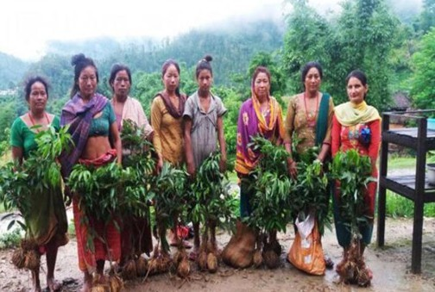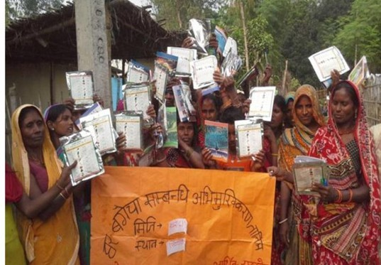

Fruit sapling distribution in Okhaldhunga
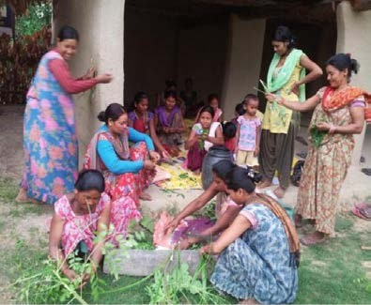
Farmers preparing JholMol with local materials

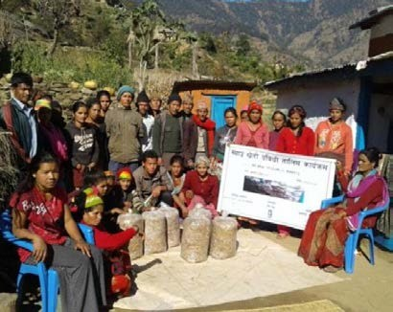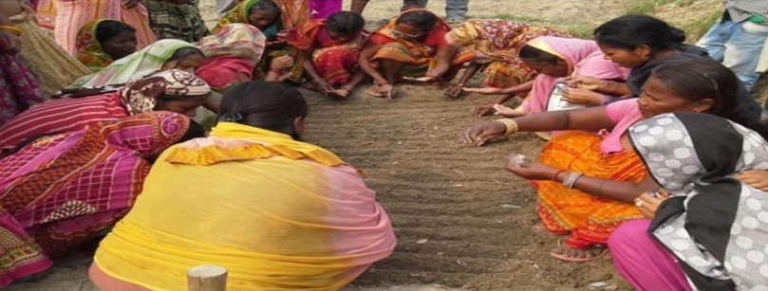Nursery preparation and seed sowing
Seed kit distribution
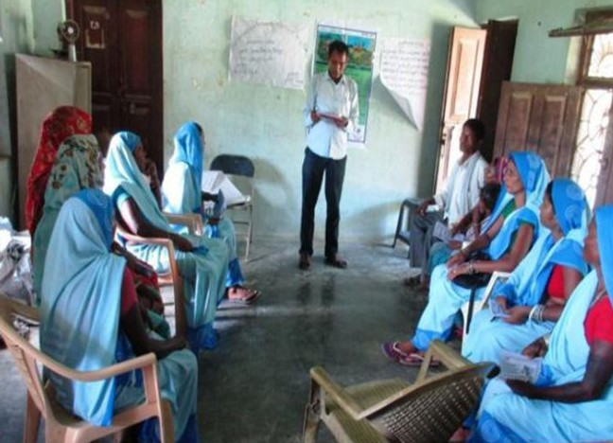
Training on HG for FCHV

Nursery preparation and seed sowing

84
84

85
84

References
ABD. 2015. Annual Report 2014/15. Agriculture Botany Division, NARC. ABD. 2016. Annual Report 2015/16. Agriculture Botany Division, NARC
ADS. 2015. Agriculture Development Strategy (ADS) 2015 to 2035. Ministry of Agricultural Development, Kathmandu, Nepal.
De Moura FF, Miloff A, Boy E. 2015. Retention of provitamin A carotenoids in staple crops targeted for biofortification in Africa: cassava, maize, and sweet potato. Crit. Rev. Food Sci. Nutr., 55 (9) (2015) (1246-69).
FAO, IFAD, UNICEF, WFP and WHO. 2017. The State of Food Security and Nutrition in the World 2017. Building resilience for peace and food security. FAO, Rome.
FAO, IFAD and WFP. 2014. The State of food Insecurity in the world 2014. strengthening the enabling environment for food security and nutrition, FAO, Rome.
FAO. 2002. Mountain people suffer more malnutrition and disease, retrieved from http://www.fao.org/english/newsroom/news/2002/6763-en.html
GNR (Global Nutrition Report). 2016. International Food Policy Research Institute: from Promise to Impact, Ending Malnutrition by 2030. Washington, DC.
Harvest plus. 2014. Bio fortification Progress Briefs, Retrieved from www.HarvestPlus.org
Iannotti LL, Lutter CK, Stewart CP, Gallegos Riofrío CA, Malo C, Reinhart G, Palacios A, Karp C, Chapnick M, Cox K, Waters WF. 2017. Eggs in Early Complementary Feeding and Child Growth: A Randomized Controlled Trial, Retrieved from https://www.ncbi.nlm.nih.gov/pubmed/28588101
ICARDA. 2017. Alleviating Malnutrition with Bio fortified Lentil, retrieved from https://www.icarda.org/project/alleviating-malnutrition-biofortified-lentil
ICIMOD. 2016. Food Security Information System for Nepal, retrieved from http://geoapps.icimod.org/npfoodsecurity/
MoAD. 2016. Food and Nutrition Security Plan of Action of Nepal. Ministry of Agricultural Development, Nepal.
MoAD. 2016. Nepal: Zero Hunger Challenge National Action Plan (2016 - 2025). Ministry of Agricultural Deveolopment, Nepal.
MoAD. 2017. Project document of Prime Minister Agriculture Modernization Project. Ministry of Agricultural Development, Nepal.
MoFAGA. 2018. Concept note on Nutrition Friendly Local Governance (NFLG). Ministry of Federal Affairs and General Administration, Nepal.
MSNP. 2012. Multi-sector Nutrition Plan for Accelerating the Reduction of Maternal Child Under- nutrition in Nepal 2013-2017 (2023). National Planning Commission, Nepal.
MSNP-II. 2017. Multi-sector Nutrition Plan- Second (FY 2074/75- FY2079/80). National Planning Commission, Nepal.

86

Biography of Author:
Mr. Karunakar Ghimire ,living in Bharatpur Chitwan ,Nepal has more than 15 year’s Experience in culturally diverse environments ,education and sustainable development . His strengths include creating innovative educational programs with a focus on culture, identifying appropriate outreach efforts to solve community problems, and empowering students for successful careers. He has been recognized for her ability to create and teach online courses, work as an advisor for a student organization, and creating positive educational strategies for optimal learning. He has been employed at Paribartan Nepal ,NGO as president since 2011.

Contact :+97756527377,9849595577 and email:paribartab.org@gmail.com

