From Coconut to Cassava: the coconut lethal yellowing phytoplasma is worsening the threat to food security in Côte d’Ivoire
Kouamé D. Kra, Marie N. Toualy, Hortense A. Diallo, Université Nangui Abrogoua, Abidjan, Côte d’Ivoire Yaima Arocha Rosete, Sporometrics Inc., Toronto, Canada

Abstract (300 word limit)
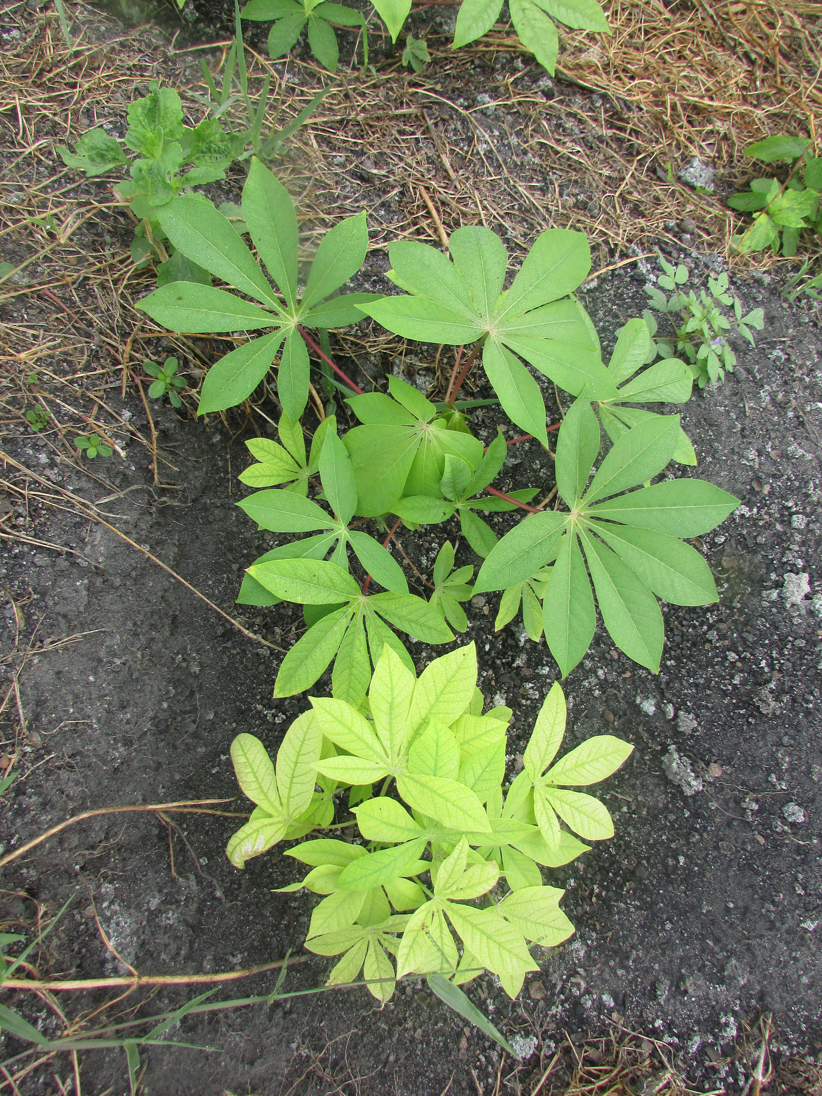Cassava (Manihot sculenta Crantz) is a staple food in Côte d'Ivoire, which produces 4,239,303 tones yearly. Cassava-based flour has been boosted by private companies but its production is now is now threatened by the Côte d'Ivoire lethal yellowing disease (CILY). Since its first report in 2013 in Grand-Lahou, CILY has destroyed over 400 ha of coconut groves in smallholder coconut farms, so cassava has been grown in yards as an alternative income source for women coconut farmers. Symptoms of leaf mosaic, curling and yellowing (Fig 1) were observed in cassava yards in two coconut-growing villages of Grand-Lahou devastated by CILY. Leaf samples were collected from symptom-bearing and symptomless cassava plants. Total DNA was extracted and subjected to PCR and sequencing with phytoplasma universal 16S rRNA primers, and group-specific primers for subgroup 16SrXXII-B ‘Candidatus Phytoplasma palmicola-related strains’ and for the African/Eastern cassava mosaic viruses (ACMV, EACMV). Phytoplasma DNA was amplified from six out of 12 symptom-bearing samples, five of which co-amplified for virus DNA (Table 1). Phytoplasma sequences were over 99% identical to those of the 16SrXXII-B phytoplasma. One phytoplasma-infected cassava plant was co-infected with ACMV, while the other four showed co-infection with both ACMV/EACMV. Results evidence that CMVs and CILY phytoplasma are able to co-infect the same cassava plant host difficulting disease management and control. Cassava as an alternative host for the CILY phytoplasma may play a role spreading and worsening CILY severity across the coconut palms in Grand-Lahou. Gender-responsive prompt actions are urged to adopt by farmers, stakeholders, extension agents and policymakers while waiting for a suitable local resistant coconut cultivar. Cassava yards should be replanted with resistant varieties to help women to secure family income and nutrition and to improve the livelihoods of the smallholder coconut farmers in Grand-Lahou, Côte d'Ivoire.

Image

Figure 1.
Symptoms of yellowing observed in leaves of a cassava plant in the village of Badadon, Grand-Lahou.

Sample | PCR CILY phytoplasma | PCR CMVs | Village
ME7 | Positive | ACMV | Badadon
ME8 | Negative | ACMV+ECMV | Badadon
ME9 | Negative | None | Badadon
ME10A | Positive | ACMV+ECMV | Badadon
ME10B | Negative | ACMV | Badadon
ME11 | Positive | None | Badadon
ME12A | Negative | None | Badadon
ME12B | Negative | ACMV+ECMV | Badadon
ME13 | Positive | ACMV+ECMV | Badadon
ME14 | Positive | ACMV+ECMV | Braffedon
ME15 | Positive | ACMV+ECMV | Braffedon
ME16 | Negative | ACMV+ECMV | Braffedon

Table 1. Summary of PCR and sequence results for the cassava
samples collected in Grand-Lahou.

Recent Publications (minimum 5)
- Arocha Rosete Y et al. 2017. Detection and differentiation of the coconut lethal yellowing phytoplasma in coconut-growing villages of Grand-Lahou, Côte d’Ivoire. Annals of Applied Biology, 170(3): 333-347.
- Toualy MNY et al. 2014. Incidence and distribution of cassava mosaic begomoviruses in Côte d’Ivoire. International Journal of Agronomy and Agricultural Research, 4(6): 131-139.


Biography (150 word limit)
Dr. Yaima Arocha Rosete is a molecular plant pathologist with over 15 years of expertise on diagnosis, identification, characterization, epidemiology and management of diseases associated with phytoplasmas and viruses in crops of economic importance in developing countries of Africa, South Asia and Latin America. Her research includes a recent research project funded by Global Affairs Canada focused on the study of the coconut lethal yellowing phytoplasma in Cote d’Ivoire in partnership with Ghana with significant project outcomes for farmers, stakeholders and policy makers.
Email: yarosete@sporometrics.com

Notes/Comments:

