Phenotypic Responses of Maize (Zea mays L.) for Grain Development under Drought Stress

Javed Hussain Umrani*, Qammarudin Chachar, Mohammad Ibrahim Keerio, Irfana Parveen, Mohammad Ashraf Mirjat, Gul Afshan Soomro, Mehrunisa Narejo, Shahnila Ysmeen Chang
Department of Crop physiology, Faculty of Crop Production, Sindh Agriculture University, Tanojam, Pakistan

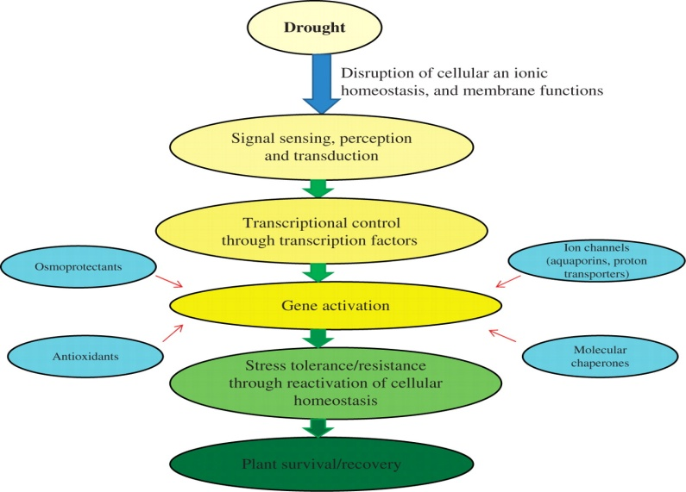

Abstract

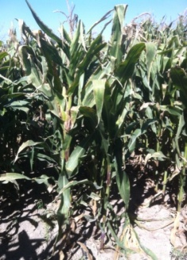
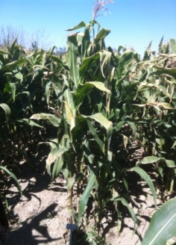
Climate change and drought stress are a major challenge for sustainable food production as they may decrease the potential yields in crop plants. Drought is a major environmental factor that harshly lowers plant production worldwide. Globally, maize (Zea mays L.) is a major crop seriously affected by drought. Success in genetic engineering and plant physiology for better adapted varieties to abiotic stresses depends upon intensive efforts using physiological approaches. Many abiotic stress-induced genes have been identified and some have been approached. The use of current tools physiologically to reveal the control mechanisms of drought-stress tolerance in maize. Previously composition and expressions of stress and light harvesting-responsive genes were investigated in ABP9 [ABA-responsive-element (ABRE) binding protein 9] transgenic Arabidopsis. Hence, phenotypic such as chlorophyll florescence, NDVI and ASI approaches allow the development of drought stress-tolerant to transgenic maize. Transgenic plants carrying ABP9 gene relating to drought stress tolerance have been developed in crop plants like maize. This phenotypic result focuses on recent progress in transgenic technology of [Pubi-ABP9-3 flag (809 & 815)] for the improvement of drought stress tolerance in plants. Metabolically it includes biosynthesis and accumulation of phenomes (i.e. chlorophyll florescence, NDVI and ASI) to scavenging in plant cells under drought stress situation.

References
- Harper C (2009) The neuropathology of alcohol-related braindamage. Alcohol Alcohol 44:136-140.
- Heilig M, Egli M (2006) Pharmacological treatment of alcohol dependence: Target symptoms and target mechanisms. Pharmacology and therapeutics 111:855-876.
- LiX, SchwachaMG, ChaudryIH, ChoudhryMA (2008)Acutealcohol intoxication potentiates neutrophil-mediated intestinal tissue damage after burn injury. Shock 29:377.
- Room R, BaborT, Rehm J (2005) Alcohol and public health. Lancet
365: 519-530.
5. Sullivan EV, Zahr NM (2008) Neuroinflammation as a neurotoxic mechanism in alcoholism: Commentary on “Increased MCP- 1 and microglia in various regions of human alcoholic brain”. Experimental neurology 213:10-17.

 Biography
Dr. Javed Hussain Umrani Assistant Professor at Department of Crop Physiology, Sindh Agriculture University, Tandojam, Pakistan. PhD on performance of transgenic maize for kernel development under drought stress from Beijing, China. Teaching and Research on abiotic stress provides the techniques on molecular and physiological studies. I have published plenty of research papers in reputed journals and participated in various conferences internationally.
Email: javed.umrani@gmail.com

