Obtaining Food Security Through Economically and Ecologically Sustainable Methods Can Lead to Positive Psychological Attitudes and a More Productive Society
Alexandra Kvapil, Undergraduate, Psychology, St. John’s University

Abstract
Soup kitchens, better defined as meal centers, or, other facilities with the means of providing free food to people who otherwise cannot afford to feed themselves are often underfunded or neglected in a systematic and societal manner. Society tends to hold the belief that people should always possess their own means to feed themselves and their families and if they do not it is a reflection of their own invalidity, rather than a systematic poverty trap. The aim of this research is to present practical reasoning in support of creating a societal push for members of society to volunteer at meal centers and for more government funded multi-serviced meal centers to develop. Feeding those who cannot feed themselves presents its moral values but also can present a possibility for an increase in overall productivity in our global society. This research and consequential conclusions are applicable to the United States government funding allocation following the 2016 presidential election are provides suggestions for meal centers with sustainable, locally grown, nutritious, and chemical-free foods.

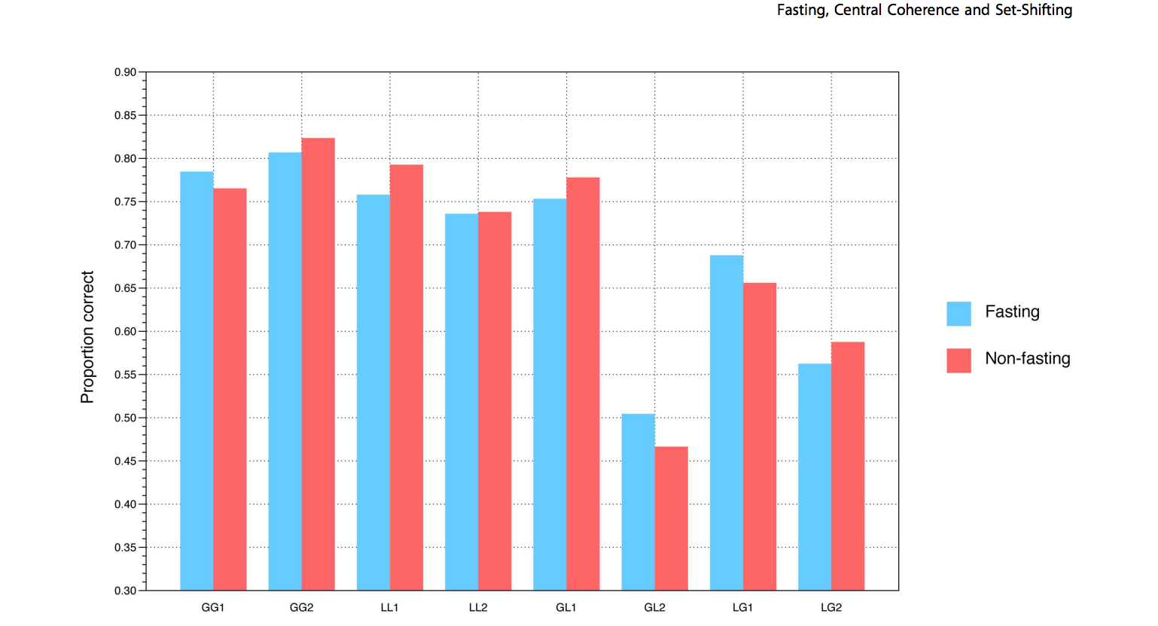
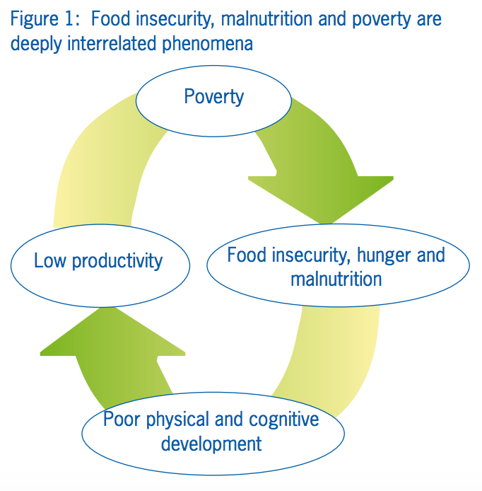
The below graph depicts the results of Pender, Gilbert, and Serpell’s 2014 study. Those who fasted reported lower levels of central coherence than those who did not fast. These results support the hypothesis that those who starve exhibit slower mental processes then those who are properly nourished.

The graph below, created by the Food and Agricultural Organization (1994), illustrates the cycle of poverty as a direct result of those who face persistent hunger.

Recent Presentations/Recognition
- Student Research Day, April 07, 2017, Taffner Field House St. John’s University Queens Campus, 8000 Utopia Parkway, Queens, NY 11439
- Recognition from the Ozanam Scholars Program, Queens Campus, Lourdes Hall, 8000 Utopia Parkway, Queens, NY 11439, 718-990-8320

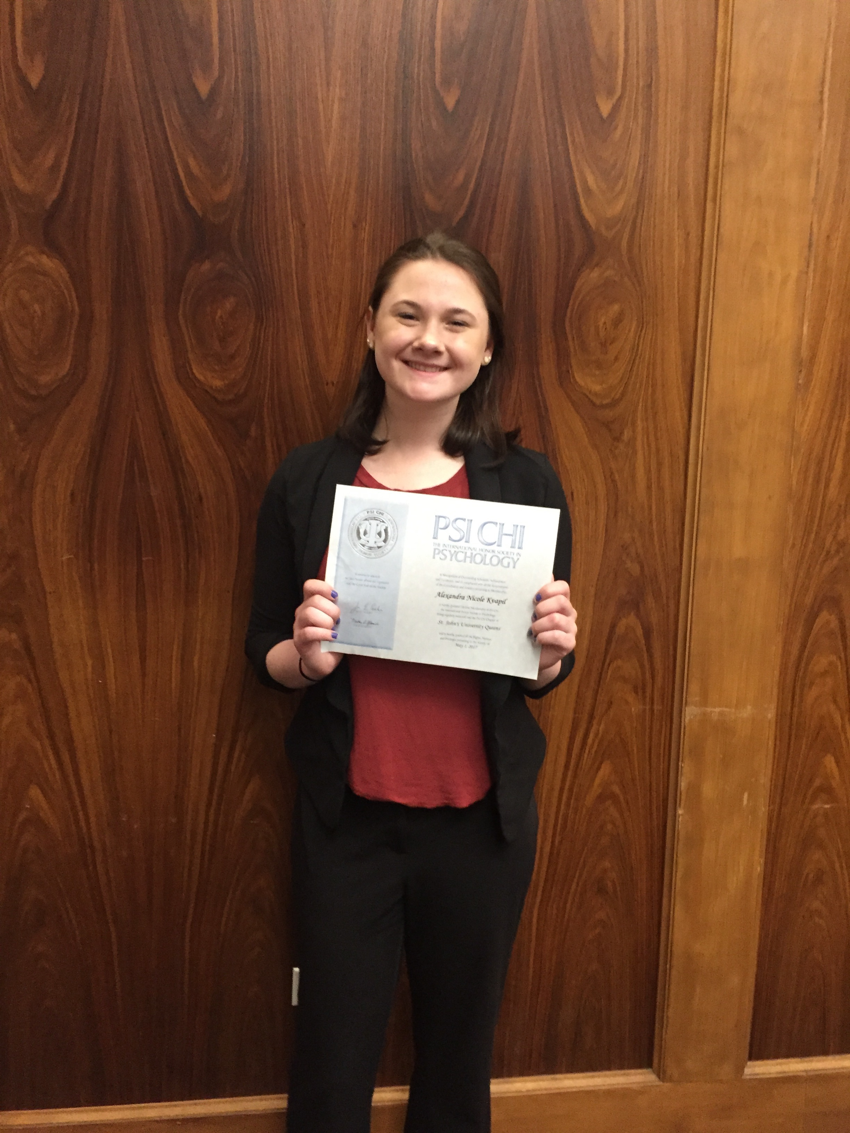
Biography
Alexandra Kvapil is an undergraduate student at St. John’s University. She is currently on track to graduate in May of 2018 with a major in Psychology and a minor in Social Justice Theory. She is involved in a philanthropic sorority on campus as well as a member of the Ozanam Scholars Program. Her future aspirations are to obtain her MA in Psychology and begin her career as a mental health counselor. Her focus in her educational studies is adults with disabilities and mental disorders as well as researching sustainable and practical ways to achieve justice and equity for marginalized groups. She completes three to six hours of volunteer work through her University weekly. She is currently in the process of completing a study involving the measurement in levels of hope and productivity within meal center participants.
Email: Alexandra.kvapil14@stjohns.edu

