
Center for Rural Development
College of Development Studies
Addis Ababa University

The Role of Crop marketing In Improving Food Security among Smallholder Crop Producer Farmers: The Case of Ada’a Wereda, Central Ethiopia.

By: Chalachew Shibabaw

Advisor : - Abrham Seyoum (PhD)

A Thesis Submitted to the School of Graduate Studies of Addis Ababa University in Partial Fulfillment of the Requirements for the Degree of Master of Arts in Development Studies (Specialization in Rural Livelihood and Development)

May, 2017
Addis Ababa, Ethiopia

Addis Ababa University
School of Graduate Studies

This is to endorse that this thesis is prepared by Chalachew Shibabaw Belay entitled: The Role of Crop Marketing In Improving Food Security Among Smallholder Farmers: the Case of Ada’a Wereda, central Ethiopia, submitted in partial fulfillment of the requirements for the Degree of Master of Arts in Development Studies (Rural Livelihood and Development) complies with the regulations of the University and meets the accepted standards with respect to originality and quality.

Signed by the examining committee:

External Examiner: _____________________Signature ______ Date __________

Internal Examiner: _____________________Signature _______ Date __________

Advisor: _____________________________Signature _______ Date __________

____________________________________________________________
Chair of the Center or Graduate Program Coordinator

Acknowledgment

My special and uppermost thanks extended to the Son of St. Mary the Lord of Lord Jesus Christ.
I would like to express my sincere thanks with special homage to my advisor, Dr. Aberham Seyoum for his consecutive support & unselfish sharing of his knowledge and for giving fruitful and constructive suggestions and assistance in the entire development of this thesis. I would further like to take this opportunity to express abundant thanks to Dr. Degefa Tolossa, who contributed by giving his prominent & constructive comments as a promoter of this thesis proposal.
In fact my thesis would not have been possible without the positive cooperation and modern bureaucratic leadership style of the rural livelihood and development center head Dr. Worku Tuffa and MSc graduate programme coordinator Dr. Bamlak Alamirew, I received their special support and positive cooperation for the presentation of this thesis, I thank them with special homage.

I am deeply grateful to Ada’a Wereda agricultural Offices deputy head Ato Akelilu Metekiya who allowed conducting the research without any bureaucratic obstacles and Ato Aserse Diro who made facilitation, especially for Yatu, Gice and Gubsaye kebele development agents (DA) who highly support during data collection. I am especially grateful to Zemenaye Asefa who was this research key informant interviewees. I am also thankful to all those who gave their time to this research as data enumerators, respondents to surveys and FGDs.
At last, but not least, my special gratitude goes to my whole family, workplace friends & school mates to Minyamer Yetayehe & others for their valuable support, specially for my wonderful wife Eyeruse Destaw(Jerecho) for her special care, pray & valuable support during my school life and in the entire preparation of this thesis.

Contents
List of Figures and Graphs v
List of Tables vi
List of Appendices vii
ACRONYMS AND ABBREVIATIONS viii
Abstract ix
CHAPTER ONE: INTRODUCTION 1

1. Background 1

1.2. Problem statement & justification 4

1.3. Objectives 6

1.3. General objective 6

1.5. Significance of the study 6

1.6. Scope of the study 6

1.7. Ethical Consideration 7

1.8. Organization of the Study 7
CHAPTER TWO: LITERATURE REVIEW 8

2.1. Definition of Terms and Concepts 8

2.3. Theoretical Literature 9

2.3. Factors affecting crop market participation intensity in the rural area 12

2.4. Empirical literature review 14

2.4. Analytical framework 16
CHAPTER THREE: RESEARCH METHODOLOGY 18

3.1. Description of the Study Area 18

3.2. Research Design and Approach 19

3.3. Population, Sample Size Determination and Sampling Technique 20

3.4. Data Sources 21

3.5. Data Collection Tools/Instruments 22

3.6. Methods of Data Analysis 22

3.7. Specification of the Models 24

3.8. Diagnostic Test 28
CHAPTER FOUR: RESULTS AND DISCUSSIONS 29

4.1. Household Socioeconomic Characteristics 29

4.2. Descriptive Statistics and Discussion 32

4.2.2. Factors affecting crop market participation intensity 42

4.2.3. Effect of crop marketing on household food security 49

4.3. Econometric Analysis and Discussion 54

4.3.1. Diagnostic test result 54
CHAPTER FIVE: SUMMARY, CONCLUSIONS AND RECOMMENDATIONS 56

5.1. Summary and Conclusions 56

5.2. Recommendations 59
Reference 61

List of Figures and Graphs

Figure 1: Analytical framework -------------------------------------------------------------------------------------17

Figure2: Map of the study area---------------------------------------------------------------------------------------19

Graph 1: Crop market participation situation in Ada’a Wereda--------------------------------------------------

Graph 2: gladder,histogram by transformation ----------------------------------------------------------34

Garph 3: One -sample T Test Statistics, househod market participation intensity------------------35

Graph 4: One Way ANOVA test Statistics, househod market participation intensity -------------36

Garph 5: Food security situation in Ada’a Wereda at the household level--------------------------35

Graph 6:gladder,histogram by transformation-----------------------------------------------------------38

Graph7: One sample T Test Statistics household food security--------------------------------------------------39

Graph 8: One Way ANOVA test Statistics household food security--------------------------------------------40

Graph 9: Situation of crop marketing at different challenges in Ada’a Wereda---------------------41

Graph 10: Food Security in weighted sum vs. market participation in Ada’a Wereda--------------42

List of Tables

Table 1: Proportional sample size determination--------------------------------------------------------21

Table 2: Hypothesized transaction cost variables-------------------------------------------------------27

Table 3: Household socioeconomic characteristics-------------------------------------------------30-32

Table 4: Ordered logit regression estimation result-------------------------------------------------44-46

Table 5: Tobit regression estimation result-----------------------------------------------------------51-53

Table 6: Summary of model diagnosis test----------------------------------------------------------55-58

List of Appendices

Appendix A: Questionnaire----------------------------------------------------------------------------66-81

Appendix B: Focus group discussion questions-----------------------------------------------------------81-84

Appendix C: Key informant interview questions----------------------------------------------------85-88

Appendix D: Diagnosis test for appendix F----------------------------------------------------------90-92

Appendix E: Tobit regression estimation result -----------------------------------------------------98-99

Appendix F: Ordered logit regression estimation result--------------------------------------------93-94

Appendix G: Variable information ----------------------------------------------------------------100-101

Appendix H: Diagnosis test for appendix E----------------------------------------------------------95-97

Appendix I_{i}: Ordered logit regression estimation result with cuts-----------------------------101-102

Appendix I_{ii}: Ordered logit regression estimation outreg2 result with cuts-------------------103-108

ACRONYMS AND ABBREVIATIONS

GTP -------------Growth and Transformation Plan
MT----------------Metric Tone
WFP-------------World Food Programme
IFDC-------------International Fertilizer Development Center
MNL-----------Multinomial Logistic
SSA----------- Sub-Saharan Africa
TCE -----------Transaction Cost Economics
CSA------------- Central Statistical Agency
LSMS------------Living Standards Measurement Study
SPSS -----------Statistics package for Social Science
FGDs------------ Focus Group Discussions
DA----------------Development Agent
VIF--------------Variance inflation factor
pwcorr------------pair wise correlation
hettest------------hetroskesdacity
gof --------------model goodness of fit
FS----------------Food security
hh-------------household

Abstract

This study has assessed crop market situation of crop producer farmers with the association of food security in Ada’a Wereda, central Ethiopia, through descriptive statistics incorporating with histogram graphs, local polynomial smooth graphs, one sample T Test, and One Way ANOVA tests and identified the factors affecting crop market participation intensity using ordered logit regression model. Moreover, the study has analyzed the effect of crop market on household food security by incorporating the Tobit regression model within 160 sample sizes for the study area of Ada’a Woreda in four Kebles of Yatu, Gice, Gubsaye and Denkaka Keble. Main findings of this study indicated that there are factors hindering crop market participation intensity of small holders at different levels among crop market challenges both descriptive statistics and ordered logit regression results empirically signified that unavailability of crop market place near the smallholders, unavailability or low volume of infrastructure that exposed them for transport, to be inaccessible to group market, to market information, exposed to household distance and other transactional costs and unavailability of financial institutions near their area all challenges were expressed as high degree of crop market challenges ,low degree of crop market challenges, medium and none degree of crop market challenges and arable land size were found statistically significant and influential determinate factor for household market participation intensity. The empirical result from Tobit regression model signified that household market participation intensity, extension services, none crop market challenges and beans/groundnuts of producing groups of crops were found statistically significant and had positive effect on household food security in Ada’a wereda, which verified the descriptive statistics results. Whereas household activity was found statistically significant but had negative effect on household food security in the wereda. The total crop production of household in Ada’a wereda, empirically indicted that total crop production was found statistically insignificant with household market participation which implies that the production decision of Ada’a wereda's smallholder crop producers were not based on market signals, rather they produce merely for household consumption which indicates negatively affecting the wereda's household food security.
Keywords: Crop marketing, food security, smallholder crop producer farmers, descriptive statistics, ordered logit & Tobit regression model analysis

CHAPTER ONE: INTRODUCTION

Background

Smallholder farmers in the globe have been producing around 80% of the global population food, even though they are being food insecure at household level. They are estimated around 500 million in the world and have been cultivating a large share of global agricultural land (Upali , et al., 2014).The authors also stated that, those smallholder farmers are paradoxically the poorest and most food-insecure.
Many literatures such as "Agriculture for impact" had revealed the necessity of market linking systems for the entire life change of smallholder farmers by taking Farm Africa's endeavor as an example claimed that, Over the last 25 years, Farm Africa has provided essential field-level support for improved yields on smallholder farms in Africa. However, it is very clear that without parallel support for market linkages and value addition, smallholders will not reap the full benefit of this increased productivity (Agriculture for impact, 2013). Thus defining & researching the capable, possible and acceptable ways to foster reliable & accessible marketing system for the smallholder farmer's food security improvement needs high attention.
Marketing should be more than just selling. Marketing includes setting financial goals, assessing risk, exploring pricing and deliver alternatives, seeking market opportunities and keeping one’s pride in check. Good marketing takes planning, selling discipline, access to good market information and a good understanding of pricing and delivery alternatives. Expecting to price everything at the market peak is unrealistic (Alberta, 2015).
The Kenyan country program of WFP is supporting 21,000 smallholder farmers in 300 farmer organizations to competitively engage in formal and structured markets via WFP(World food programme) of Market Access program, due to this program farmer organizations have increased their marketing capacity, selling over 11,700mt(metric ton) to other buyers. Some organizations have started adding value to their produce by milling the grains. About 13,000 farmers, small traders and partners (among them 7,845 women) have been trained on various modules such as marketing and commercialization, resource mobilization and financial literacy, grain quality, post-harvest handling, storage, good agricultural practices and entrepreneurship(WFP,2015a).
Creating reliable accessible market opportunities for smallholders will inject much needed income into some of the poorest food-insecure rural communities (WFP, 2015b).
Lack of reliable markets has also been found to be one of the main constraints faced by smallholder farmers. The majorities of smallholder farmers are not capacitated with financial and marketing skills and are unable to meet the quality standards set by fresh produce markets and food processors (Department of Agriculture, Forestry & Fisheries, 2012).
As Leykun and Jemma (2014) stated about Ethiopia’s agriculture that; the agricultural sector is predominantly subsistence where the major part of farm production is used for household consumption rather than for market. According to those authors, smallholder peasant farms cultivate close to 95% of the total cropped land and produce more than 90% of the total agricultural output. On the contrary, in Ethiopia, the aforementioned reliable accessible market opportunities are limited for such 95% of majority smallholder farmers of the country. These limitation of reliable & accessible market opportunities, forced those majority smallholder farmers to be less market participant in the agriculture sector specifically in crop marketing that has led its production to be limited merely for household consumption rather than for market. The remaining crop from the household consumption is sold for traders with low prices. Such situation leaves them with little income for long last till the upcoming harvesting season. This is also empirically supported by the following literature.
The empirical results of determinants of market orientation(production decision based on market signals)and market participation(sale of output) in Ethiopia, by Berhanu Gebremedhin as corresponding author, showed that ,the determinants of market orientation and market participation in crop output markets are not the same, but market orientation translates strongly into market participation. Results imply that while interventions to enhance market orientation could also help in promoting market participation (Berhanu & Moti, 2010).
Therefore in order to shape the current market orientation of Ethiopian smallholder crop producers & to enhance their sale of output which also improve their food security, working for the establishment of the aforementioned reliable & accessible market opportunities to the Ethiopian smallholder crop producers are necessary.
The study by the work of (Williamson, 2007; North, 1991; Matungul et al., 2002).Claimed as the establishment of institutions with the intent of lowered transactional cost centered new institutional economics are required to be adapted in order to reduce the implicit cost of (i.e. cost
of banking & marketing, cost of new partner searching, cost of gathering market information, cost of traveling and waiting time) & to reduce the explicit cost (transport costs, for example bus fares). In addition IFDC claimed that, a certain level of organization among smallholder farmers can be quite beneficial to helping them access markets; improved knowledge of how to access markets and how to engage in transactions in competitive markets is also required. Improved access to timely information on prices is needed so that farmers can respond to market incentives and thereby help improve food security at the family and national levels. Enabling, favorable policies that allow for the development of farmer-to-market linkages are required (IFDC, 2015).
Maxwell & Smith claimed that, in the 1970s, "food security" was mostly concerned with national & global food supplies and in the 1980s, the focus of "food security" shifted to questions of access to food at household and individual levels (Maxwell & Smith, 1991). John Hoddinott stated that, food security is a concept that has evolved considerably over time and there is much literature on potential household food security indicators. There are approximately 200 definitions and 450 indicators of food security (Hoddinott, 1999). In addition, in the same work of Hoddinott; dietary diversity, individual intakes, household caloric acquisition & indices of household are identified as the four ways of measuring household food security outcomes. Thus this study has been measured the smallholder crop producers household food security outcomes, due to their market participation in terms of dietary diversity. Based on the Hoddinott description, dietary diversity is the sum of the number of different foods consumed by an individual over a specified time period. Further this author stated that, it may be a simple arithmetic sum, the sum of the number of different food groups consumed, sums of the number of different foods within a food group, or a weighted sum-where additional weight is given to the frequency by which different foods are consumed (Weighted Sum is number of food Items+ consumption frequency of households Individual).
Thus, the study has been identified factors of crop market participation & analyzed the effects/associations of crop marketing on the improvement of crop producers’ food security via the measurement of dietary diversity for household food security outcomes, which is done by using the ordered logit & tobit econometric models respectively. The study has been also assessed and described crop market situation of crop producer farmers with the association of food security by applying descriptive statistics method with the incorporation of histogram graphs, polynomial smooth graphs, one sample T Test One Way ANOVA test by using control and explanatory transactional cost linked variables, for the case study area of Ada’a Wereda central Ethiopia.

Problem statement & justification

Rios argues that, Market participation is directly associated with the generation of a market surplus, thus production technologies and productive assets affect a household’s market participation by influencing its productivity. The author furthering that, On the other hand, local market conditions influence incentives to increase productivity: in integrated markets the returns to increased production decrease less rapidly than they do in isolated markets. Moreover, poor infrastructure and weak institutions raise transaction costs that considerably alter production and market participation decisions. As a result, increasing rates of market participation or productivity could have bidirectional synergies, and increasing both could boost living standards. Many studies address the impact of either market participation or productivity on farmers’ income, and some studies relate them to each other. Little research to date, however, asks to what extent these factors influence each other, and almost no research examines empirical evidence on this matter at the whole-farm level across a range of countries (Rios et al., 1999). Although, increasing the rates of crop market participation & effort of productivity are essential, this study argue that increasing the rate of crop market participation demand a greater attention for the increment of Ethiopian smallholder crop producers’ market participation. This further supported by the work of Berhanu & Moti, 2010, stated that, the average crop output and crop input market participation of Ethiopian smallholders are 25% & 20% , respectively, which indicating infant market participation situation.
The research conducted on this thesis study area has showed the degree of smallholder farmers crop market participation for the typical household head is computed to be 22.4%. It also defines, the degree of market participation is the ratio of the gross value of all crop sales to the gross value of all crop production times hundred (Leykun and Jemma, 2014). This clearly indicates, the degree of market participation in Ada’a wereda is smaller than the average output market participation of the country. Thus, due to this situation the researcher has been triggered to analyze smallholder crop producers’ market participation situation, factors of market participation and to analyze the effects/associations of market participation towards improvement of food security. Based on such analysis, defining & researching reliable & accessible marketing system to smallholder crop producer farmers call for attention. Because, enhanced market participation of smallholder crop producers generate income which improve their food security, this further elaborated by the following literatures.
Food security revolves around income generation as much as it does in assuring that aggregate production meets aggregate demand(Alderman,1992).The author also, empirically stated that, low income appears to be the main constraint to calorie consumption. This is indicated by the pronounced increase of calories with increased income at lower levels of long-run income in the household. Dr.Lilian Kirimi & others claimed that, market participation can play a significant role in reducing food poverty, thus ensuring food security. This suggests that facilitating the expansion of market participation by smallholder farmers can be critical in helping households transition out of food poverty (Kirimi et al., 2013).
Study on sesame has revealed that, in addition to the quantity of sesame marketed, market price, selling channels, selling time, distance from the nearest market and access to market information, are the significant determinants of the level income earned from sesame sale (Geremew, 2012). This study argues that those significant variables couldn't be limited to the level of income earned from sesame sale. This is also true for the level of income earned from crop groups of cereals, tubers/roots, beans/groundnuts.
Most previous studies, including Leykun and Jemma, 2014, and others of Osmani & Hossain, 2015, Nwigwe et al., 2009, Esther & Gaudiose, 2016, Berhanu & Moti, 2010, focused on degree of smallholder market participation and/or determinant factors for smallholder market participation intensity. But uniquely this study didn't limited on investigations of household crop market participation intensity factors. The study further analyzes smallholders' market participation intensity in relation to improvement of food security. This analysis is done by using descriptive statistics method, ordered logit and tobit econometric models to assess crop market situation of crop producer farmers with the association of food security, to identify crop market participation factors and lastly to analyze effects/associations of crop market participation on food security respectively.

Objectives

General objective

The main objective of this study is to assess and analyze the role of crop marketing among smallholder crop producer farmers in improving their food security in Ada’a Wereda Central Ethiopia.

Specific objectives

- To assess crop market situation of crop producer farmers with the association of food security in Ada’a Wereda
- To identify factors affecting crop market participation intensity in the study area
- To analyze the effects/associations of crop marketing on household food security

Significance of the study

The significance of this study can be evaluated by the relevance of information it provides for the knowledge gap to the Ethiopian agricultural crop market sector in improving the food security for the case study area of Ada’a Wereda. Therefore the study provides knowledge on role of crop marketing in improving food security among smallholder farmers at the household level in the study area. In addition, the significance of this study can be evaluated by the relevance of information it provides for the policy gaps of those who are interested to work on the issues of role of crop marketing for the improvement of food security. The study is also significant to provide tangible knowledge for those who need to conduct similar research and provide important knowledge for those who need to involve in projects focused on crop marketing and for those who need to involve in projects to improve the food security of smallholder crop producers at the household level.

Scope of the study

The study covered 160 respondent households within Ada’a wereda in four kebeles which was the working sample size for this thesis. Cereals, tubers/roots, beans/groundnuts were used as representative for individual crop items in a group. And dietary diversity has been used for the measurement of crop producers’ household food security outcomes to know whether the crop producers market participants of food security has been improved or not due to their degree of crop market participation intensity. But the study couldn't do further estimation of the determinant factors of crop productivity and role of inputs for crop productivity. Although livestock marketing is important issue for smallholders of Ethiopia, so as to reduce the bulkiness of the study and to make it manageable, the study is limited on crop marketing. Due to incapability for high financial & long time requirement, the study couldn't use more than one ways of measurement for measuring the household food security outcomes.

Ethical Consideration

Ethical considerations are serious and important entirely the research work. To conduct this research in the wereda, permission was taken from Ada’a Wereda agricultural office deputy head Ato Akelilu Metekiya. So that communications with focused kebele Development Agents (DA) were started & the way became smooth.
The indispensable thing for the researcher always to keep in mind is the objectives of enquiry in a questionnaire interview, focus group discussions, key informant interview and content analysis. In doing those activities which is very critical to protect them and for them to feel protected at all times.
When the respondents agree to be involved in the study, action was taken by asking the readymade questionnaires to tell what they know exactly based on they were agreeing to give actual information. The researcher was made it clear that as the respondents' participation was entirely voluntary, the participants name, their ideas and the questionnaire were completely anonymous and only used for this study purpose.

Organization of the Study

This thesis paper covers five chapters. The background section is covered by the wide-ranging overview of hypothetical and pragmatic literature imperative to the major argument of this study. The second chapter presents definition of terms and concepts, theoretical literature rationales for crop marketing, factors affecting crop market participation intensity in the rural area, empirical literature review and analytical framework applied to improvement of food security. The third chapter deals with the methods of the study. Under this section, study area description, research design and approach, population, sample size determination and sampling technique, data sources, data collection methods, methods of data analysis as well as model specification and diagnostic test are presented under this chapter. The fourth chapter presents results, discussions, and the fifth one of this paper discuss with summary, conclusions and recommendations. Lastly, after the reference materials, appendixes are added.

CHAPTER TWO: LITERATURE REVIEW

This chapter discusses about definition of terms and concepts, theoretical literature, role of crop marketing in improving food security for smallholder farmers, factors affecting crop marketing, effect of crop marketing on household food security improvement & situation of crop marketing and empirical review. Lastly, a conceptual framework applied to role of crop marketing for improving household food security of smallholder farmers is discussed.

Definition of Terms and Concepts

In some situation, a word may have given different meanings. Therefore, for the purpose of clarity to this thesis, some of the important terms used in this study are defined as follows:
Role of crop marketing in improving food security: essentially, role refers to a part played by some body or something. Therefore role of crop marketing has played its part in improving household food security of smallholder farmers when reliable & accessible market linking systems are established with smallholder crop producers.
Food security: In the 1970s, "food security" was mostly concerned with national & global food supplies and in the 1980s, the focus of "food security" shifted to questions of access to food at household and individual levels (Maxwell & Smith, 1991). John Hoddinott claimed that, food security is a concept that has evolved considerably over time and there is much literature on potential household food security indicators. There are approximately 200 definitions and 450 indicators of food security (Hoddinott, 1999).

Improving: Is the process of making something better or becoming better.

Improving food security: Is the process of making smallholder farmers of crop producers' food
security better at the household level.
Smallholder is a small farm supporting a single family with crop production subsistence farming.
Dietary Diversity is one way of food security measures which is the sum of the number of different foods consumed by an individual over a specified time period. It can be calculated either by simple sum of the number of different foods eaten by that person over the specified time period; or/and it can be calculated a weighted sum, where the weights reflect the frequency of consumption, and not merely the number of different foods (Weighted Sum is number of food Items+ consumption frequency of households Individual). Field testing indicates that dietary diversity is correlated with levels of caloric acquisition; tracks seasonal changes in food security—measures of dietary diversity are highest just after harvest time and lowest during the hungry season; and also appears to capture differences in distribution within the household(Hoddinott, 1999).

The disadvantage of dietary diversity measure is that the simple form of this measure does not record quantities but since it measures the food item & food consumption frequency of a household individuals and a diverse diet is a valid welfare outcome in its own right the researcher choose it for food security measure. As nutritional literatures & medications gives high emphasis on the importance of consuming a wide variety of foods within different consumption frequency so as to enhance dietary quality, advantages of dietary diversity measure become higher than its disadvantages.

Theoretical Literature

Rationales for crop marketing

As normal market activates, crop market participants of smallholder farmers are expected as they may participate in both the demand side as a buyer & in the supply side as a seller. This is further supported by the following literature.
Food security is often viewed as both a supply and demand concern. On the supply side, food security refers to availability of food at the global, national, household and individual levels, which is a function of both production and physical access in terms of proximity to markets and distribution systems through which food may be acquired (Kirimi et al., 2013).
Padberg & Hall explained that as most of the marketing policies emerged in the early years of the twentieth century-some as late as the 1930's.Theos authors argue about the requirement of restricted set of marketing approaches for producer farmers & postulated about marketing. Just because vegetable producers are not as big as General Electric, they should be required to use a more restricted set of marketing approaches rather than overburdened market approaches. Such marketing order system was instituted in America After a great deal of study and discussion. Marketing consists of assembling information and making intelligent but reactive choices or decisions. Products require proactive marketing. They must stay up-to-date in their physical attributes. Advertising and selling effort is required. In competition with aggressively sold products, commodities need to maintain visibility and a good image. To accomplish this, a commodity needs something of a brain trust or collection of expertise and observation. It is difficult for individual producers to perform these functions. The research and advertising features of market orders have enabled commodities to perform much better in the environment of modern food marketing than they would have otherwise. This transition has made these provisions more important (Padberg & Hall, 1995).
Marketing of crop has critical role for addressing the food security of Ethiopian smallholder farmers at the household level, particularly in the case of Ada’a Wereda. Therefore policy attention system is required to enhance the crop producers’ market participation intensity by using government trigger mechanism to reduce high transaction cost and in turn to increase market participation role that should be done in parallel with crop productivity; because merely focusing on crop productivity without market linking policy systems, the life of crop producer can’t be transformed as expected within the Ethiopian GTP(Growth & Transformation Plan),which is planned to reach on middle income country.
Leykun & Jemma, (2014), pointed out the rational of commercialization and its advantage for specialization and for addressing food insecurity stated that; one of the major roles of agriculture is to ensure sufficient amount of domestic food production and food security at the household level and also to decrease dependence on external food sources. But with the absence of appropriate markets farmers’ output can’t reach the increasing urban population. In general, since agricultural marketing serves as a link between production and consumption it contributes to growth of the national economy. However in most developing economies particularly sub-Saharan Africa (SSA) the marketing systems are not well developed. Crop commercializing encourages specialization of farmers which raises their productivity, expands trade and raises their standard of living. This is in line with Adam Smith’s theory of division of labor in which any marketing (trade) encourages specialization. According to A. Smith the larger the market size (i.e. the higher the degree of commercialization) the greater will be the extent of specialization. Specialization brings productivity growth and as a result leads to higher economic growth. In the agricultural sector marketing agricultural products leads to productivity growth of the sector (Leykun and Jemma, 2014).

Theory of Group marketing/Cooperatives

Cotterill, agrees as cooperatives are investor-owned forms; Agricultural cooperatives are a significant form of business enterprise. In many respects, they are similar to the investor-owned, profit-maximizing firms that, along with other organizations such as households and government agencies, form the institutional framework for western economic theory. Any concerned cooperative philosopher can produce a set of cooperative organizational rules. This impedes advances in cooperative theory as well as practice. Different schools of cooperative thought propound different market-oriented objectives. There are several, but two have played an historically important role in the development of agricultural cooperatives in North America. The competitive yardstick school, as typified by the writing of Edwin Nourse, reasons that cooperatives should seek to make the marketing system more efficient, thereby benefiting the consuming public as well as farmers. The commodity marketing school, as typified by the vibrant and visionary speeches of Aaron Sapiro, argues that all producers of a particular commodity should organize themselves into a single marketing cooperative. Sapiroism counsels that strength through group action will improve the performance of markets and benefit farmers. To have historical validity, a theory of agricultural cooperation must at least address this divergence in vision. Does the debate between the efficiency and group power camps, which was most strident during the 1920s and 1930s but lively and often heated today, imply that two distinctly different economic theories of agricultural cooperation does not exist(Cotterill,1945).
Equb and Edir can be used as cooperatives to help smallholder farmers for their market participation by mitigating the cost of accessing markets, we can understand from the above and from the following literatures that; Equb and Edir can be used as group marketing i.e. as cooperatives.
Cooperatives are good conditions for the individual farmers. Farmers are owners, controllers, and beneficiaries of the cooperative (Bijman et al., 2012).
In many situations, farmers sell directly to consumers on local markets avoiding transaction costs (Timmons & Wang, 2010). Indeed, the authors claimed that, on the local market, farmers make decisions independently which may lead to competition between them.
On the local market, farmers make decisions independently which may lead to competition between each other. Another point to consider is that the local market generally differs from the market where the cooperative operates. Therefore, for farmers, the market is composed of two parts. The first is the market on which the marketing cooperative sells the volume of production proposed by farmers. On this market, farmers sell collectively and cooperatively. The second is the direct local market selling where farmers are in oligopoly; Using a theoretical model, Maxime Agbo & others show that direct selling and marketing through cooperation might be beneficial for each party. Even though the cooperative does not have market power, it could have an anti-competitive effect on the direct selling market, and thus benefit farmers (Agbo et al., 2013).
Over the past few decades, the rapidly changing economic environment, reflected in increasing globalization and agricultural industrialization, has led many agricultural cooperatives to undertake substantial structural changes in order to adapt to the new situation; in line with the rapid developments taking place, economists have developed three distinct but related methods to analyze organizational forms and their relationships within the market system, namely transaction cost economics (TCE), agency theory, and property rights analysis (Ortmann & King,2007).
Farmers engaged in small-scale agriculture have limited access to factors of production, credit and information. Markets are often constrained by inadequate property rights and high transaction costs (Lyne, 1996).

Factors affecting crop market participation intensity in the rural area
The study conducted on market participation decision of smallholder farmers and its determinants in bangladesh ,has identified the factors that affect farmers’ market participation decision, this study found that farm size, household labor, income from livestock and farm income might be the main factors that affect the smallholder farmers’ decision to participate in the output market (Osmani and Hossain, 2015).
The other study on Socioeconomic factors affecting intensity of market participation among Smallholder, results showed that access to market information, contact with extension agents, transportation cost, farm size, and access to credit facility were among the major factors affecting market participation among farmers. To the extent that our smallholder sample may be representative of a wide and broader set of circumstances, our findings led to the recommendation of policy and institutions that support access to productive assets (such as land) and markets (Nwigwe et al.,2009). A double hurdle analysis of market participation in Tanzania, stated that the decision to participate in the market is affected by the cropped area, yield, distance to the market and type of variety grown. Besides these factors, the quantity marketed is affected by the existence of a market within the village. There is need for labor-saving technologies for area expansion and yield improvement (Esther & Gaudiose, 2016).
John Omiti, et al, stated that Participation in commercial agriculture holds considerable potential for unlocking suitable opportunity sets necessary for providing better incomes and sustainable livelihoods for small scale farmers. A study of those authors conducted on factors influencing the intensity of market participation by smallholder farmers, Indicated the results that farmers in peri-urban areas sold higher proportions of their output than those in rural areas. Distance from farm to point of sale is a major constraint to the intensity of market participation. Better output price and market information are key incentives for increased sales. These findings demonstrate the urgent need to strengthen market information delivery systems, upgrade roads in both rural and peri-urban areas, encourage market integration initiatives, and establish more retail outlets with improved market facilities in the remote rural villages in order to promote production and trade in high value commodities by rural farmers (Omiti, et al, 2009).
The study analyzed the determinants of market orientation and market participation in Ethiopia separately and examined if market orientation translates into market participation by Berhanu & Moti, stated that, the literature on commercial transformation of smallholders makes little distinction between market orientation (production decision based on market signals) and market participation (sale of output). However, policy implications to enhance commercial transformation of subsistence agriculture drawn from the analysis of the determinants of household market participation alone could be inadequate, if in fact, the determinants of market orientation and market participation are not the same or not consistent with each other(Berhanu & Moti,2010)

Empirical literature review

In Ethiopia Population pressure, drought, shortage of farmland, deterioration of food production capacity, plant and animal disease, frost attack, shortage of cash income, poor farming technologies; and pre and post harvest crop loss are major causes of food insecurity. Sale of wood or charcoal, small scale trading, institutional and societal income transfer systems, limiting size and frequency of meal were major coping strategies. Depending on reviewed document, to address food security issue in Ethiopia, the household head and members of the household should engage in different income generating activities for means of living and coping mechanism; the government of Ethiopia should incorporate different research outputs to design programs to tackle food insecurity (Birara et al., 2015). Therefore fostering facilitated market opportunities by investigating reduced transaction cost ways for smallholder crop producers can be one major mechanism by generating income for food security improvement of Ethiopian smallholders.
Increased cost of transport will also affect inputs used and the market strategies followed by the farmers. In most cases high transaction costs are caused by among others poor infrastructure and communication services in remote rural areas. It can also result from information inefficiencies and institutional problems such as the absence of formal markets (Department of Agriculture, Forestry & Fisheries, 2012).
Output supply and input demand responses to changes in transactions costs and price and non-price factors were estimated and decomposed into market entry and intensity. The results showed that while transaction costs indeed have significant negative effects on market participation, institutional innovations such as group marketing are also emerging to mitigate the costs of accessing markets. Overall, the findings suggest that policy options are available other than price policies to promote input use and marketed surplus. The authors concluded with implications for policy to induce greater input–output market participation among smallholders in Africa (Alene et al., 2008).
High transaction costs are detrimental to the efficient operation or existence of markets for inputs and outputs. The cost of information and the costs associated with the search for trade partners, distance to formal markets and contract enforcement are likely to influence the marketing of food crops (Matungul et al., 2002). Smallholder agriculture is simply too important to employment, human welfare, and political stability in sub-Saharan Africa to be either ignored or treated as just another small adjusting sector of a market economy, akin to the leather shoe industry in the United States (Delgado, 1999).
Generally, transaction costs can be explicit and/or implicit. Explicit transaction costs include transport costs, for example bus fares, while implicit transaction costs include the opportunity cost of time spent searching for new partners, gathering market information, traveling and waiting time. The implicit costs are usually higher, suggesting that proximity to institutions such as markets and banking facilities is crucial. The size of these costs depends on the degree of market organization and development of physical and institutional infrastructure (Gonzalez, 1993, cited in Matungul et al., 2002).The terms on which transactions take place are complex and diverse, and may be strongly structured by social factors such as gender and class. High transaction costs mean that it is not worthwhile for many farmers to participate in critical markets (e.g. credit, food and insurance), even if these markets exist. The provision of physical and legal infrastructure, information and education through extension may lower transaction costs (Matungul.et al., 2002).
Developing smallholder agriculture can be effective in reducing poverty and hunger in low income countries but only through sustainable access to markets can poor farmers increase the income from their labor and lift themselves and their families out of poverty (Wiggins & Keats, 2013).
Many literatures such as "Agriculture for impact" had revealed the necessity of market linking systems for the entire life change of smallholder farmers by taking Farm Africa's endeavor as an example that, as if crop productivity is increasing from season to season, merely focusing on crop productivity can’t change the entire life of the smallholder farmers; marketing link systems are the prominent. Over the last 25 years, Farm Africa has provided essential field-level support for improved yields on smallholder farms in Africa. However, it is very clear that without parallel support for market linkages and value addition, smallholders will not reap the full benefit of this increased productivity (Agriculture for Impact, 2013). Thus, defining & researching the capable, possible and acceptable ways to foster reliable & accessible marketing system for the smallholder farmers' food security becomes not only alternative but also mandatory.
The study analyzed the determinants of market orientation (production decision based on market signals) and market participation (sale of output) in Ethiopia separately and examined if market orientation translates into market participation by Berhanu & Moti, they empirically indicated that, the determinants of market orientation and market participation in crop output markets are not the same, but market orientation translates strongly into market participation. Results imply that while interventions to enhance market orientation could also help in promoting market participation, interventions to promote market participation may not be adequate to promote market orientation (Berhanu & Moti, 2010).

Analytical framework

The study conceptualized as improvement of food security is a function of crop market processes of smallholder farmers. Processes of crop market in turn has affected in transactional costs (costs of market information, costs of crop transport, group market access ...and others) policy issues, smallholder crop producer household characteristics and others. The situations of household characteristics have influences on the status of the transactional costs. Thus by establishing reducing ways for those transactional cost variables that affect crop market participation negatively & by enhancing the positive factors of crop market participation, facilitated reliable & accessible crop market environment can be fostered. From this, crop producers can increase their crop sale value and raise their market participation intensity; this enhanced market participation intensity could have a positive and highly statistical significance which has influence on the improvement of household food security situation. Therefore, improvement of food security is dependent on the level of the market participation intensity of smallholder crop producer farmers that requires analyzing reliable & accessible market environment for crop producer smallholder farmers so as to enhance the smallholder crop producer’s market participation intensity, further for the household food security enhancement.

Figure1: Analytical framework
Source: My own construction, 2017

Policy issues:
-Extension service
-Training
-Financial service
-land
Village characteristics:
-Demographics
-Utility
- Crop production
Crop Market

Household characteristics:
-Age, Sex, Education, dependency ratio, access to utility & asset
-Household activity

Increased crop sale value

Enhanced market participation

Increased dietary diversity

Improved Food security

Transactional costs:
-Infrastructures
-Transport cost
-Market information
-Group market access
-Market place near the area

CHAPTER THREE: RESEARCH METHODOLOGY

This section discusses about description of the study area, research design and approach, data sources, sampling design and sample size determination, data collection methods, methods of data analysis and about specification of the models.

Description of the Study Area

At the time Ada’a is one wereda in the East Shewa zone. However, before 2006 Ada’a-Liben wereda was administrated as one wereda and in 2006 it was split into two; namely Ada’a wereda and Liben wereda; now Ada’a wereda is one of the 13 weredas in East Showa zone with 26 kbeles it was 27 kebeles, one of among the 27 is shifted into town and is located about 45 kms south-east of the capital Addis Ababa and is very close to the other major urban centers. White teff, black teff, wheat, maize, barley, onion, potato, lentils, white/black chickpeas, soy, beans & the like are the main crops cultivating in the wereda. According to Population Projection from 2014-2017 of CSA (Central Statistical Agency, 2013) total rural population of Ada`a wereda is 155, 035, from this 80,537 is male & 62,452 is female. According to Nigatu & others, Ada’a wereda lies between longitudes 38º51’ to 39º04’ East and latitudes 8º46’ to 8º59’ North covering a land area of 1750 km² on east of Addis Ababa. Most of the land (90%) is plain highland ranging between 1600 to 2000metres above sea level. The wereda is characterized by sub-tropical climate and receives 860 mm rainfall/annum. In general, the main rainy season occurs between mid-June and September, followed by a dry season that might be intercepted by the short rainy season in February and March (Nigatu, et al., 2012).
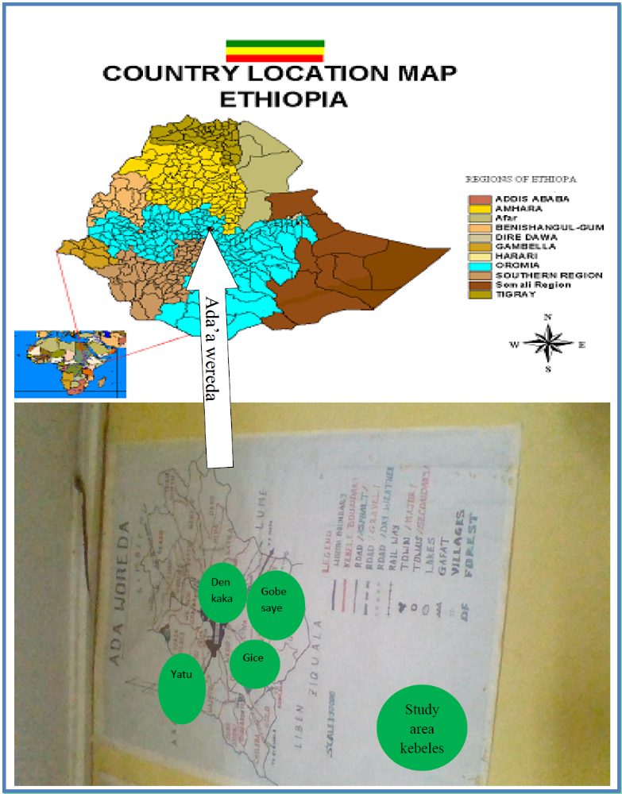Source: Rearranged from goggle Earth & taken from Ada’a Wereda finance office
Figure 2: Map of Ada’a Wereda from the country Ethiopia map

Research Design and Approach

It is known that selecting an appropriate research design to gather adequate and significant information for the study is unquestionable. Therefore, rural community crop producer involvement based study is had been employed for this proposed study to have relevant information about the study within the limited scope of time. When undertake this study, the researcher had used both qualitative and quantitative approaches. This is because of the researcher need to combine both approaches can provide broader, deeper and richer collection of data. The triangulation or mixing of data from both approaches was used to help in validating the data. The strategy to mix both qualitative and quantitative approaches were sequential quantitative so that data from both approaches were mixed in analysis and interpretation of the result in order to reduce a bias in explanation and analysis.

Population, Sample Size Determination and Sampling Technique

Ada’a Wereda is selected as a target population of this study, because the researcher has been working in the area and have experiences about the crop marketing problems of in the other similar crop producer areas of his origin. Thus, the degree of market participation of most of crop producers from their gross output crops are limited at the household level although they cover most of their life on crop production as stated in the aforementioned literatures. This reason initiated the researcher to conduct empirical evidence based research that affects rural food security of the area to take the research result as an example for the other similar crop producers also. The sample size for this study had been calculated based on the following assumption. The total population of the Ada’a wereda is about 155,035as the aforementioned literature in the description part and as Leykun and Jemma (2014) carried out the degree of market participation of the wereda is 22.4% which is around 34,728 crop market participants is available, this is less than 50,000. Therefore, Godden (2004) is appropriate to calculate sample size. So, the new sample size for the population less than 50,000 is calculated as follows:-
the formula is: $\text{New SS=}\frac{\text{SS}}{\text{(1+(}\frac{\text{SS-1))}}{\text{Pop}}}$

Where: New SS= New Sample size; Pop= Population which is 22.4% (i.e.34, 728).
Therefore, assuming that at the sample size 150, $New SS=\frac{150}{(1+(\frac{150-1))}{34,728}}=149$
The total sample of the respondents becomes 149. By assuming 8% for contingency, it
Becomes160.
The sampling design for this thesis study is a multi-stage sampling. This had been done first by selecting high, medium & low crop market participants 4 rural kebeles among the 26 kebeles, after stratifying 26 rural kebeles of the study area in to 3 stratums (kebeles holding high, medium & low crop market participant households) in the wereda; by randomizing households within the kebeles. Second, to conduct quantitative survey, respondents from each kebeles were determined with a proportional to sample size and simple random sampling is run to each member kebeles of the sampling households in order to have equal chance of being picked for the sample.(i.e.$Crop market participant Pop.of kebele (k) * 160/total pop.of the 4 kebeles).$ Numbers of crop market participants of a household were identified, by the degree of market participation which is the ratio of the gross value of all crop sales to the gross value of all crop production times hundred.
Table 1: Proportional sample size determination
Selected Kebeles | Total no. of hhs under expected market participants | Formula | Proportional sample size
TedechYatu | 2,036 | 2,036*160/18,490 | 17
Denkaka | 7,607 | 7,607*160/18,490 | 66
Giche Gara Babo | 2,860 | 2,860*160/18,490 | 25
Gubsaye | 5,987 | 5,987*160/18,490 | 52
Total | 18490 |  | 160

Source: Own construct (2017)

Data Sources

In this study both Primary and secondary sources of data were gathered. Primary data had been collected by interviewing the prepared questionnaire for smallholder crop producer household respondents in the wereda, by interviewing the agriculture extension service deliverers experts as a key informant interview with an open-ended questionnaire interview guide and also by conducting focus group discussions with household heads who are highly facing crop market challenges, none facing ones & moderately facing ones of the challenges. The researcher had distributed questionnaire for 160 household respondents randomly selected the sampled data and conducted a focus group discussions and interview for purposively selected respondents for which they have experience about crop marketing. In addition to this, secondary data was also collected from different related documents, books, journals and from other sector source of offices and fretful bureaus both within and outside the Ada’a Wereda.

Data Collection Tools/Instruments

Semi-structured questionnaire that had been adjusted with schedule and translated Amharic language & Afan Oromo language translator enumerators for effective communication with 160 respondents were used as the main instrument to quantitative data in order to investigate the association between the dependent & independent variables of the data about the general status of smallholder crop market participation, factors affecting crop market participation & effects of smallholder crop market participation on food security at the household level of the smallholder farmers.
A key informant interview of an open-ended questionnaire interview guide was the other tool which had been applied for purposively selected expert of agriculture extension service deliverers in Ada’a Wereda that was held face-to face and for qualitative information about factors affecting smallholder crop market participation intensity, the status of crop market & effects of crop marking on food security.
Focus group discussion is the other enhancing tool which was conducted by purposively selected participants in the intent of 160 sample size household representation that was applied for household heads who are highly facing crop market challenges, none facing ones & moderately facing ones of the challenges who are from formally organized structured groups of individuals from crop marketing associations and individuals from Equb, Edir of both active crop market participants & less crop market participants and also from other concerned households who came together and discuss on a series of issues within limited time period. Thus qualitative information about factors affecting smallholder crop market participation intensity, the status of crop market & effects of crop marking on food security was discussed.

Methods of Data Analysis

Both qualitative & quantitative methods of data analysis had been used in this study.
John Hoddinott, indicated as dietary diversity is among the four ways of measuring household individual food security, and he claimed the method for generating data with the measurement of dietary diversity by stated that, one or more persons within the household are asked about different items that they have consumed in a specified period. These questions can be asked to different household members where it is suspected that there may be differences in food consumption among household members (Hoddinott, 1999). The author claimed also the method of data calculation by indicating as there are two possible methods of data calculation: the first is a simple sum of the number of different foods eaten by that person over the specified time period; and the second is to calculate a weighted sum, where the weights reflect the frequency of consumption, and not merely the number of different foods. Therefore this study had been used this data generating method and had chosen the second data calculation method to measure the dependent variable of the household member individuals food security. This had been done in order to know the improvement of smallholder crop producer's food security based on the degree of their market participation.

Descriptive statistics

For objective number one (1), the study has been used descriptive statistics by applying SPSS (Statistics package for Social Science) version 20 and STATA version 13. Moreover econometric analysis is done by applying STATA version 13 for running analysis. This objective one is just to assess crop market situation of crop producer farmers with the association of food security in Ada’a Wereda which is assessed by descriptive statistics incorporating with histogram graphs, local polynomial smooth graphs, one sample T Test, and One Way ANOVA tests; It was helpful for the researcher to describe, summarize the data set with the aid of those different graphs. Thus to make it easier, to assess the association between market participation and household food security and to assess both market and household food security situation, these statistical tests of descriptive statistics T Test and on Way ANOVA tests aided with different graphs including histograms and local polynomial smooth graphs have been employed.

Regression analysis and rationales of using ordered logit and tobit models

For objective number two (2), we used ordered logit model. Because as Grilli & Rampichini (2014) stated, when the response variable of interest is ordinal, it is advisable to use a specific model such as the ordered logit model.
For objective number three (3), we use tobit model. When James Tobin had explained the necessity of tobit model stated that, in economic surveys of household, many variables has a lower, or upper limit and takes on the limit value for a substantial number of respondents. For the remaining respondents, the variable takes on a wide range of values above, or below, the limit(Tobin,J.1958).Thus for doing such variable characteristics survey of households, this tobit model is essential. Nevertheless, here James Tobin agrees that, the sample may give unbiased estimates of the parameters of the relationship, Even though it gives biased estimates of the separate frequency distribution of the variables. For such sample selection biased estimation problems, (Gujarati, 2003: pp 640) suggested as heckman model is appropriate.

Specification of the Models

To operate the specific objective two (2), the following model has been developed by using Williams (2015):-
In the ordered logit model, there is an observed ordinal variable, Y, that is in turn a function of another variable, Y*, which is not measured.
The continuous latent variable Y* has various threshold points. (κ is the Greek small letter Kappa.) Our value on the observed variable Y depends on whether or not we have crossed a particular threshold.
For example, when parameter M is equal to 3
$$Y_{i}=1 if Y_{i}^{*} is≤κ1$$
$$Y_{i}=2 if κ1≤Y_{i}^{*}≤κ2$$
$$Y_{i}=3 id{ Y}_{i}^{*}κ2$$

Therefore, in the population, we estimated that the model in the continuous latent variable Y* which is equal to:-
$$Y_{i}^{*}=\sum_{k=1}^{K}{β_{k} X_{ki}+ε_{i}=Z_{i}+ε_{i}}$$
So, by using the corresponding sample estimates for each case we had computed as follows:-
$$Z_{i}=\sum_{k=1}^{k}{β_{k}X_{k} }$$
Where,

Y*_{i} = Continuous unmeasured variable (latent Variable)
X_{ki} = is the factors indicating crop market participation intensity
Moreover, the random disturbance term Z_{i} (Because of this term, the unmeasured latent variable can be either higher or lower than Z) is equal to:-
κ = various threshold points of Y*
K βs and the M-1 κs = are parameters that need to be estimated
ε_{i} = Error term of the probability
Thus by incorporating the transactional cost linked variables and by applying this ordered logit model, the study had identified the major factors that affect the crop market participation intensity of the smallholder crop producers. The study had also overseen the detail levels of factors on each crop category of cereals, tubers/roots, beans/groundnuts.
For objective number three (3), the study used (Gujarati, 2003), tobit or for the selection biased heckman model depending on the sampling procedure that was followed during survey data collection.
Following Gujarati, the tobit model is specified as follows:-

Food security of a household (h) = I_{i} if a household h participate in the market
0 otherwise
Where
I_{i} = Unobserved utility (latent variable)
$$I_{i}=β_{o}+P_{1}X_{1}+P_{2}P_{2}+P_{3}X_{3}+P_{4}X_{4}+P_{5}X_{5}+P_{6}X_{6}+P_{7}X_{7}….P_{k}X_{k}+ε_{i}$$
$FS={α }_{i}+{β_{1}X}_{1} +β_{2}X_{2} +β_{3}X_{3} + β_{4}X_{4}+ β_{5}X_{5} +β_{6}X_{6} ......... .β_{i}+X_{i}+ε_{i}$
$FS=α_{i}+β_{1}Sex+β_{2}Age+β_{3}Edu+ β_{4}Groupmark + β_{5}Dis+ β_{6}Markinfo+β_{7}Trancost+β_{8}ACC+β_{9}D-Ratio+β_{10}price+β_{11}exten+ {β }_{12}Markpartipn +β_{13}salevalue+β_{14}Electric+β_{15}Land+ε$
α = is an intercept
βi = coefficients for the independent variables
ε = error term changing variable
As the aforementioned literature of Leykun and Jemma( 2014) defined the degree of market participation, which is as the ratio of the gross value of all crop sales to the gross value of all crop production times hundred. Therefore, this can be the measurement for the level of crop market participation of this study. Matungul et al.,(2002) also empirically indicted that, food crop income of the household is explained by the sale value of the crop producer, sale value represents the total food crop income in Birr, of marketed output per household that affect the Household food security directly. So as the household sale value raise the household crop market
Participation intensity increases this in turn increases the household income & thus enhances the household food security. Here from the aforementioned formula, food security has been dependent on transactional cost related variables (Market information, transport cost, e.t.c..), policy related variables(extension services for the household member/s, training services & financial services)and household & village characteristics such as sex, age education, access to utility & others. The household food security outcomes of smallholder crop producers are measured with dietary diversity as the aforementioned literature at the introduction part.

Table 2: Hypothesized transaction cost variables affecting crop market participation intensity of smallholders to secure their food security in the study area of Ada’a Wereda, 2017.
Variables | Code | Description | Expected sign
Age | Agehead | Age of the household head(in years) | ₊
Sex | Sexhead | Gender of the household head(For female=1,for male=2) | ₊
Education | Eduhead | Education level of the household head( literate = 1, illiterate = 0) | ₊
Distance | Dis | Household distance from the crop market(1if household has Donkey/s,0 otherwise | ₋
Dependency ratio | D-Ratio | Dependency ratio in the household (consumers/on farm worker, 1 if available,0 otherwise) | ₋
Extension | Exten | membership of the household to extension service (1if yes,0 otherwise) | ₊
Market Information | Markinfo | Household has access to market information (1if yes ,0 otherwise) | ₊
Transport cost | Trancost | Cost of household to transport crop to the market(1if they pay,0 otherwise | ₋
Electricity | Electric | Household has electric access(1if yes,0 otherwise) | ₊
Land size | Land | Amount of arable land for household in hectare/s | ₊
Bank account | ACC | Household head operates a bank account(1if yes,0 otherwise) | ₊
Group markets | Groupmark | A household head participates in a group crop markets(1if yes, 0 otherwise | ₊
Price | Price | Price of crop in the market(1if high,2 if low,3 if medium) | ₊
Crop market participation | Markpartipn | A household crop market participation intensity(1if high participation,2 if low,0otherwise) | ₊
sale value | Salevalue | The amount of sale value of crop for a household in birr(1 if sale 100%, 0 otherwise) | ₊

Based on empirical indication of Matungul et al.,(2002). The model hypothesizes that food crop revenue is explained by marketing participation intensity; as crop producers market participation increases their income increases and as their income increases the tendency to secure their household food security increases. But for doing so smoothly there are expected signs as indicated in the analysis of the aforementioned table 1 which shows the negative & positive aspects of variables for the crop market participation of smallholder crop producers to the effect of their food security. As mentioned above, the main objective of this study is to analyze the role of crop marketing among smallholder crop producer farmers in improving their food security at the household level. The study is mainly based on primary data that had been collected from 160 respondents of Ada’a Wereda. The required data had been collected by following a standard sampling technique from the smallholder farmers in the study area. Random sampling technique for the household respondents had been applied to select the sampled households. So the study had been analyzed and discussed by applying the aforementioned econometric models and descriptive statistics of simple quantitative summary of a data set that has been collected and analyzed with the aid of different graphs.

Diagnostic Test

Before the starts of complete analysis, an assortment of diagnostic tests were conducted to make the data ready for regression and also after regression, model fitness was checked. So, VIF (variance inflation factor test), pwcorr (pair wise correlation), hettest (hetroskesdacity test) were implemented before running ordered logit and tobit econometric regression for the second and third objectives respectively (see table 6). After running ordered logit and Tobit regressions for the second and third objectives, linktest (link test for model specification and margins (marginal means, predictive margins, marginal effects, and average marginal effects) were seen for both models objective (see table 6). Further for Tobit econometric model probability of chi2=0.000 were considered to check the model goodness of fit (see Appendix H).Moreover for ordered logit model, the ordered logit regression model chi-square is considered as shwon from appendix F; 108.3 with 27 d.f., indicates as the model was significant and well fitted the data for included variables (see Appendix F). Inaddtion, as William Gould claimed, the cut points_cut1, _cut2 _Cut3… are really just coefficients of the model (Gould W., 1999),so, as showon on AppendixI_{i} and AppendixI_{ii} most costant cut points of the ordered logit regerssion model results are statistically significant,which indicates that the model is statistically significant(see AppendixI_{i} & AppendixI_{ii})

CHAPTER FOUR: RESULTS AND DISCUSSIONS

This chapter presents the analysis, discussion and interpretation of the responses and reactions gathered through the semi-structured questionnaire, open- ended interviews and focus group discussion. Descriptive statistics with different graphs, Tobit & ordered logit econometric analysis have been employed. The relationship between the dependent variables that is improvement of food security versus role of crop marketing with their respective explanatory variables and the effect/assiciation of the explanatory variables (role crop marketing) on the dependent variables (improvement of food security) are also presented.

Household Socioeconomic Characteristics

Some basic descriptive statistics of gender, age, educational characteristics, households’
Dependency ratio, household’s arable land size, amount of total crop production of household, crop market participation intensity of the household and food security situation or dietary quality situation of household in reference with the total survey collected data respondents are summarized in Table 3.
As shown from table 3, the total 160 respondents, the mean value market participation intensity is near to 40 or 39.75 with 25 std. Dev. (standard deviation), about 642 variance, 0.1374 skewness and 2.02kurtosis. Whereas mean value of the household food security situation is near to 50 or 49.68 with 34.80 Std.Dev. (Standard deviation), around 1211variance, 0.5464 skewness and 2.8682 kurtosis. On the other way when we see the crop production and arable land size, the mean crop production value of Ada’a Wereda is 25.7 quintal with 25.93Std.Dev (standard deviation), about 672 variance, 1.574 skewness and 6.586 kurtosis, whereas the mean value of Ada’a Wereda arable land size is 2.09 hectare with 1.4 Std.Dev(Standard Deviation),1.98 variance,3.05 skeness and 20.68 kurtosis.
As like household food security, market participation intensity, arable land size and total crop production of the Ada’a Wereda, the other gender, education characteristics, age level and dependency ratio of the wereda household socioeconomic situation statistical descriptions are discussed below table 3.

Table 3: Household socioeconomic characteristics
The Stata command is:- Sum mp fs sexhead tcgp land dratio eduhead agehead, detail
Market participation intensity of household(h),$Degree of market participation is=Gross value of all crop sales*100/Gross value of all crop production$

Percentiles Smallest

1% 0 0
5% 0 0
10% 4.5 0 Obs 160
25% 20 0 Sum of Wgt. 160
50% 40 Mean 39.75563
Largest Std. Dev. 25.34529
75% 60 87.5
90% 75 88.9 Variance 642.3836
95% 82.85 91.4 Skewness .137468
99% 91.4 92.3 Kurtosis 2.028862
Food security (FS)of a household(h)measured in weighted sum of the household dietary diversity
Percentiles Smallest
1% 0 0
5% 0 0
10% 1.5 0 Obs 160
25% 20.5 0 Sum of Wgt. 160
50% 49.5 Mean 49.6875
Largest Std. Dev. 34.80606
75% 74 130
90% 98 144 Variance 1211.461
95% 117.5 144 Skewness .5464225
99% 144 144 Kurtosis 2.868202
Gender of the household head(for female=1,for male=2)
Percentiles Smallest
1% 1 1
5% 1 1
10% 1 1 Obs 160
25% 1 1 Sum of Wgt. 160
50% 2 Mean 1.66875
Largest Std. Dev. .4721405
75% 2 2
90% 2 2 Variance .2229167
95% 2 2 Skewness -.7170739
99% 2 2 Kurtosis 1.514195

Total amount of crop production in quintal for a respondent household(h)
Percentiles Smallest
1% 0 0
5% 0 0
10% 0 0 Obs 160
25% 5 0 Sum of Wgt. 160
50% 20 Mean 25.70625
Largest Std. Dev. 25.93111
75% 37.5 96
90% 59.5 100 Variance 672.4226
95% 73 115 Skewness 1.574257
99% 115 153 Kurtosis 6.586389

Amount of arable land for household in hectare/s

Percentiles Smallest
1% . 25 0
5% .5 25
10% .75 .25 Obs 160
25% 1 . 25 Sum of Wgt. 160
50% 2 Mean 2.098719
Largest Std. Dev. 1.408167
75% 2.75 5.5
90% 3.05 6.02 Variance 1.982936
95% 4 8 Skewness 3.054311
99% 8 12.3 Kurtosis 20.68264

Dependency ratio in the household (consumers on farm worker, 1 if available,0 otherwise

Percentiles Smallest
1% 0 0
5% 0 0
10% 0 0 Obs 160
25% 1 0 Sum of Wgt. 160
50% 1 Mean .8125
Largest Std. Dev. .3915378
75% 1 1
90% 1 1 Variance .1533019
95% 1 1 Skewness -1.601282
99% 1 1 Kurtosis 3.564103

Education level of the household head( literate =1, illiterate = 0)

Percentiles Smallest
1% 1 1
5% 1 1
10% 1 1 Obs 160
25% 1 1 Sum of Wgt. 160
50% 1 Mean 1.34375
Largest Std. Dev. .4764501
75% 2 2
90% 2 2 Variance .2270047
95% 2 2 Skewness .6579517
99% 2 2 Kurtosis 1.4329

Age of the household head(in years)

Percentiles Smallest
1% 29 28
5% 33 29
10% 37 30 Obs 160
25% 40 31 Sum of Wgt. 160
50% 45 Mean 47.48125
Largest Std. Dev. 10.01695
75% 56 68
90% 62 69 Variance 100.3393
95% 65 70 Skewness .4815506
99% 70 75 Kurtosis 2.424656

Source: Stata description from own surveyed data (2017)

Descriptive Statistics and Discussion

To identify factors affecting crop market participation intensity, to analyze the effect of crop market on household food security and to assess the situation of crop marketing for smallholder crop producers, a sample of 160 households were taken from four (4) selected rural kebeles of Tedech Yatu, Gice,Gubsaye and Denkaka which are found under Ada’a Wereda, central Ethiop. Thus, all samples of the households are used for an analysis.

Situation of crop marketing in Ada’a Wereda

As market participation intensity of Ada’a Wereda is showed on graph 1, from the total 160 sampled households, 62% households market participation level is 40% and/or less than 40%, and from the sampled households, merely the remaining 38% of the households market participation level is greater than 40%, therefore this indicates that the mean average value of degree of market participation is near to 40 which is similar with the above table 3 market participation mean value of 39.755.

Graph 1: Crop market participation situation in Ada’a Wereda

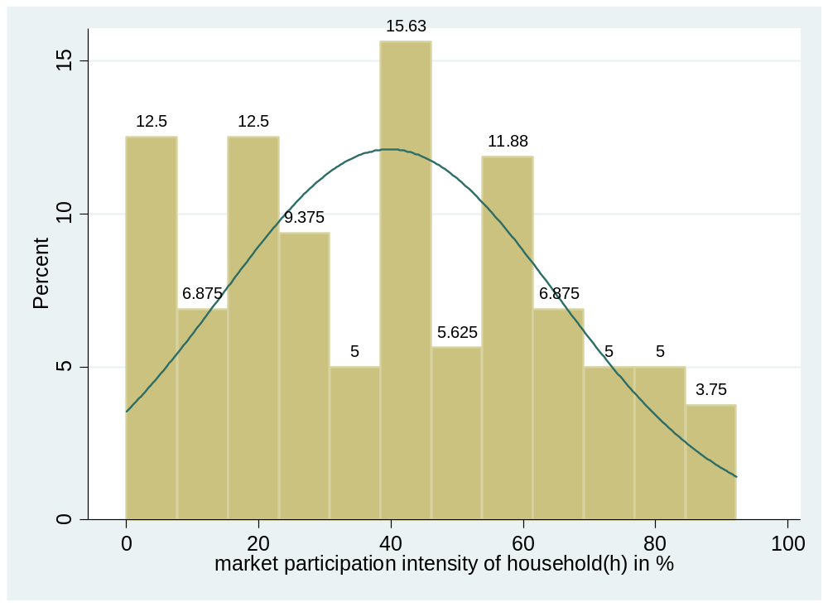
Source: Own survey data (2017)

When graph 1 is described/transformed by gladder stata command, histogram transformation cubic, square, identity & sqrt shape of graphes are displyed and identiy is the best equivalet with the normal graph1,which is the pereferable one than the others due to its simiarity to the above normal grah 1.

Graph 2:gladder,histogram by transformation
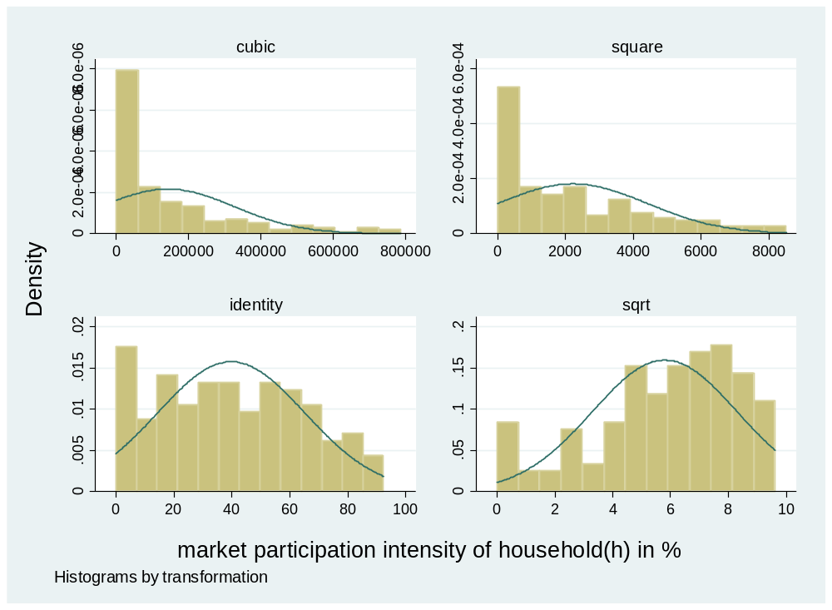
Source: Own survey data (2017)

The following graph 3: one sample t-test also indicates that the degree of household market participation intensity mean value is 39.76, which is equivalent with the above histogram graph 1 mean value and table 3: Household socioeconomic characteristics.

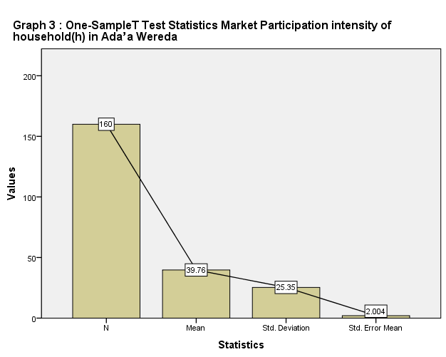
Source: Own survey data (2017)

The following graph 4 one way ANOVA statistics result shows the situation of household market participation between groups of market challenge, within groups of market challenges and at total groups of market challenge situations in Ada’a Wereda smallholder crop producer farmers.
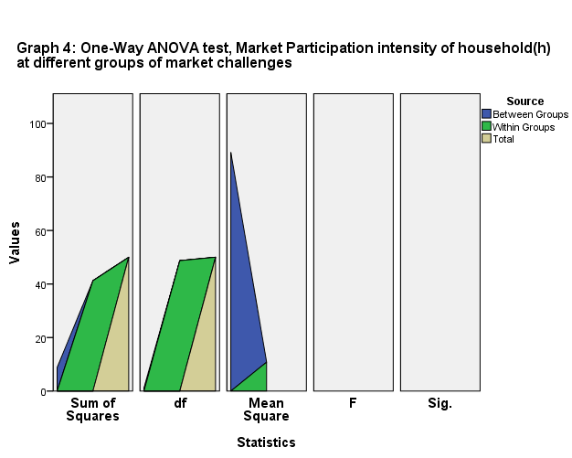

The following graph 5 indicates the respondents household food security situation of Ada’a Wereda. As shown, from the total 160 surveyed sample households, around 61% of respondents indicate that their weighted sum of food security is less than 50% whereas the remaining 39% of the respondent households weighted sum of food security is greater than 50% and the mean average of weighted sum of food security is near to 50. From this we can understand that the household level food security situation of Ada’a Wereda is similar with the respondents' household head market participation situation as shown on the above graph 1 & in the following graph 5. The situation of this less than 50% weighted sum of food security implies that 61% households dietary quality of Ada’a Wereda is less than 50% & the remaining 39% of the wereda dietary quality is greater than 50% with the reference to surveyed sample data.

Garph 5: Food security situation in Ada’a Wereda at the household level
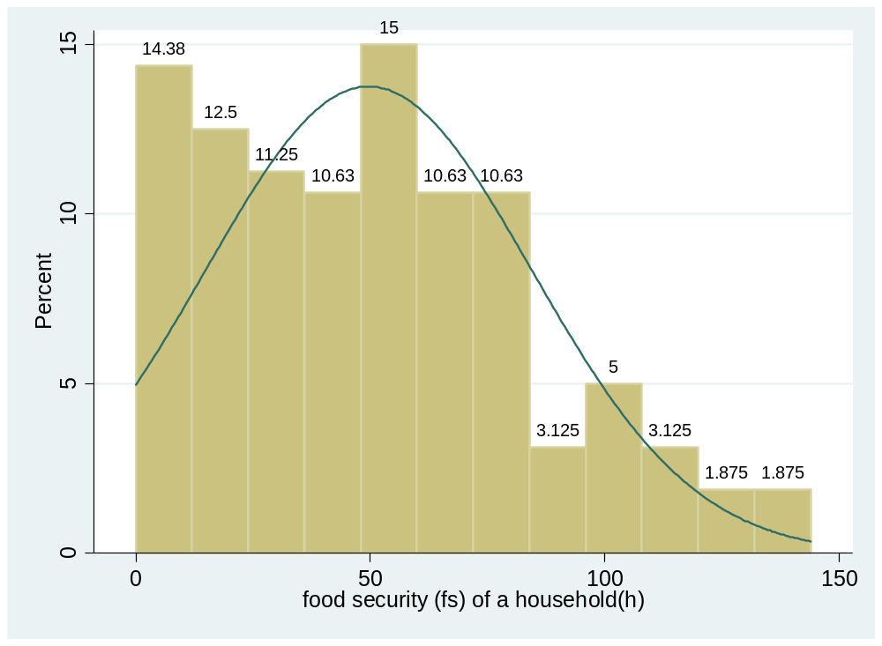
Source: Own survey data (2017)

correspondingly as the above small holder crop marke participation graph 1 is described/transformed by gladder stata command, this food security normal graph 5 is also described/transformed by gladder stata command. As shwon below from graph 6,it is likewise the market particpation histogram transformation; which is tranformed into cubic, square, identity and sqrt form among these graphes displyed, identiy is the best equivalet with the normal graph5,which is the pereferable one than the others due to its simiarity to the above normal grah 5,which is also similar with the market participation graph.

Graph 6:gladder,histogram by transformation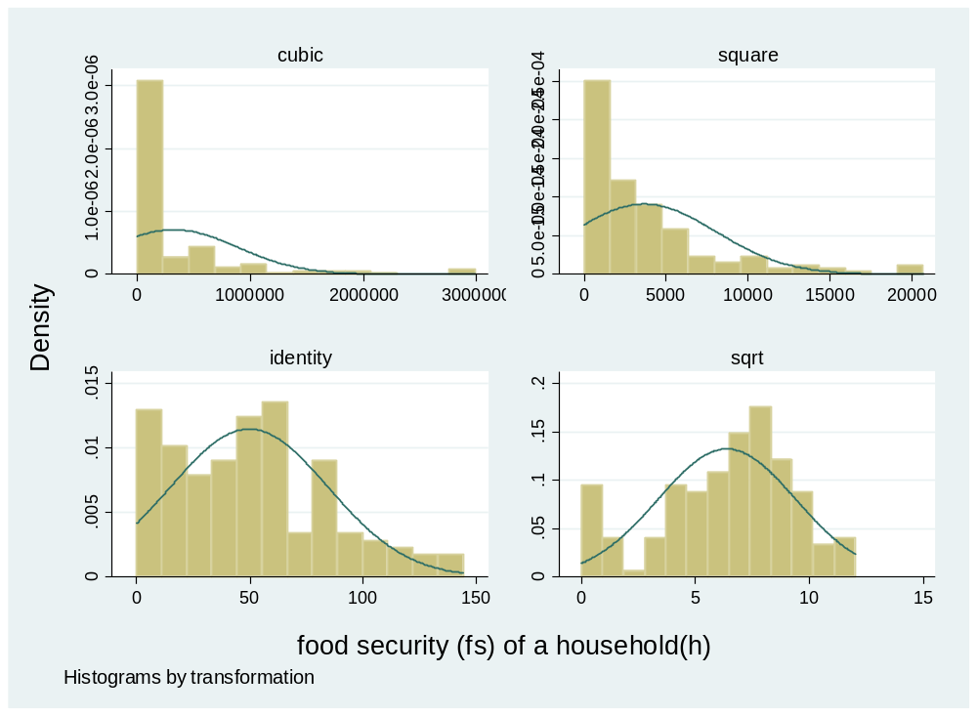

Source: Own survey data (2017)

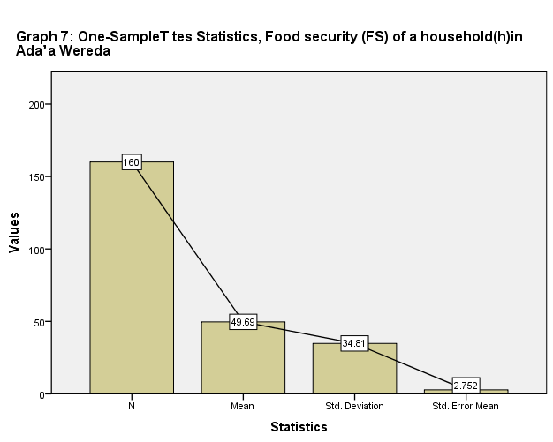
Source: Own survey data (2017)

The following graph 8 one way ANOVA statistics result shows the situation of household food security between groups of market challenge, within groups of market challenges and at the total groups of market challenge situations in Ada’a Wereda smallholder crop producer farmers. This result clearly justifies that the influence of those market challenge groups of are similar with food security, this in turn implies that as smallholder crop producer farmers market participation intensity increases their food security also increase and when their market participation is reversed or decreased the same is true for their food security enhancement. This situation is further discussed in the following sections & on graph 9 & 10

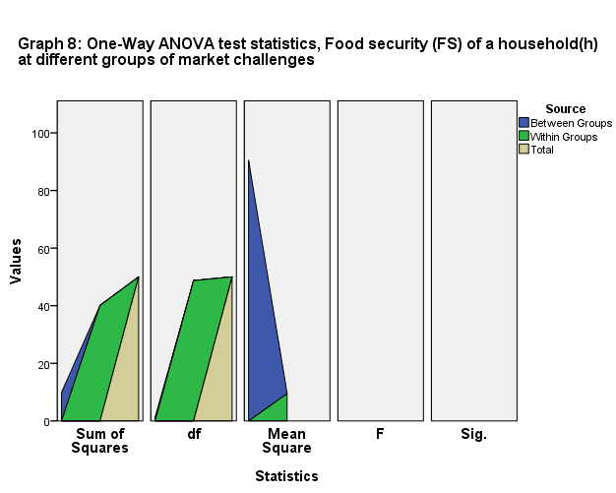

Source: Own survey data (2017)

From the graph 9 below, it is clearly showed that unavailability of market place near the surveyed sampled village, unavailability of financial institutions, unavailability or low volume of infrastructure that exposed the respondent households for high transactional costs are the main facing challenges of households in their crop marketing participation intensity. As indicated on the graph these challenges have different influencing levels on household market participation intensity. When all challenges are presented at same time/place that is as shown on the graph at number 4, degree of household market participation indicates near to 22 % which implies at high degree of crop market challenge. This signifies that on graph 9, at number 4 the degree of market challenges are high whereas at number 5 the degree of market challenges are none, on this none market challenge point the degree of households market participation rises near to 60% which is larger than households market participation mean value that was near to 40 in table 3 and on the above one sample T Test graph. Therefore, the graph implies that at high degree of market challenges, the degree/level of Ada’a Wereda's household market participation approaches to 22% & at none market challenges(none degree of crop market challenge) it rises near to 60%.

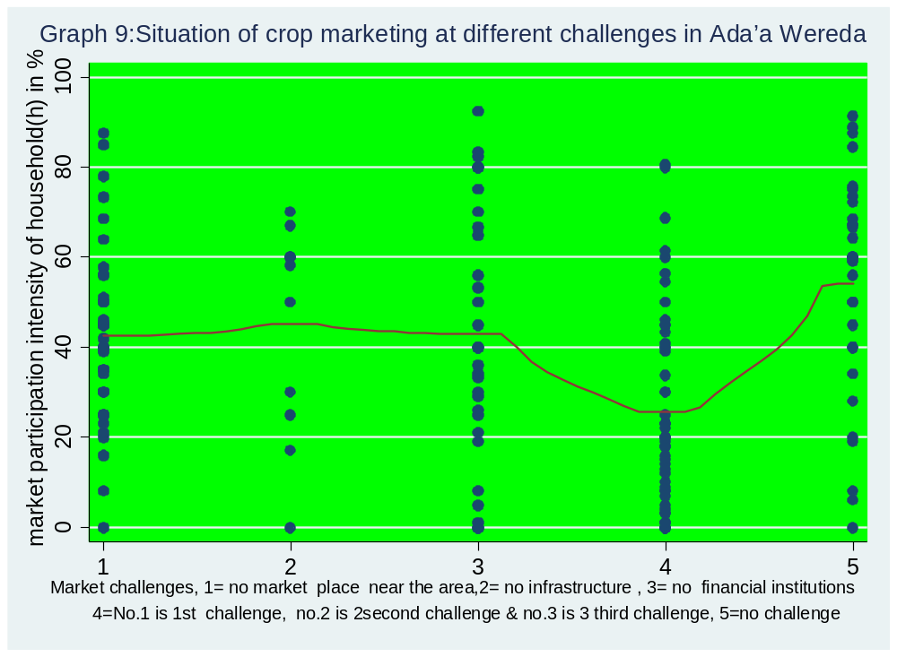
Source: Own survey data (2017)

The following graph 10 summarises the aformentioned outputs of market and food security situation with different statistical tests. This local polynomial smooth graph 10 summarises situation of food sucurity vs. situation of market participation in Ada’a Wereda. As shown from the graph the mean average value of household market participation which is near to 40 & the mean average value of the weighted sum food security at the household level which is near to 50 both are coincided on theses average values and their most values are less than or near to their mean average values. This graph clearly shows that when the situation of household market participation increases their dietary quality of food security also increases keep in mind that other situations are at constant. Therefore on graph 10 at high degree of household market participation intensity, the dietary quality situation of Ada’a Wereda's household looks improved and at low/none degree of market participation intensity the dietary quality situation also looks like the reverse.

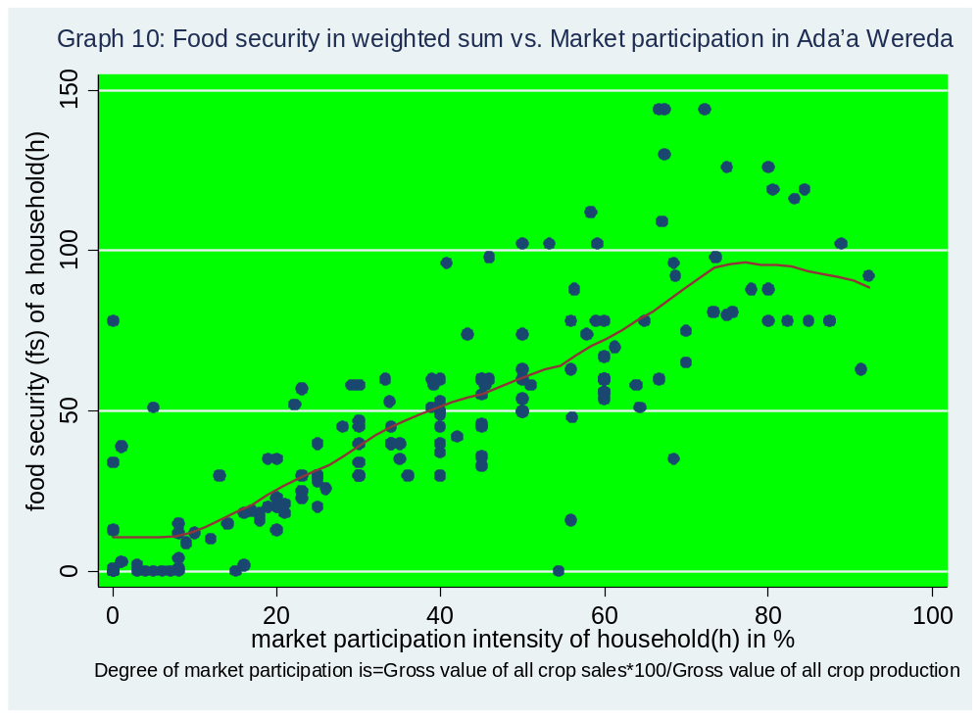

Source: Own survey data (2017)

Factors affecting crop market participation intensity

In the above descriptive statistics and discussion section, factors affecting crop market participation intensity in Ada’a Wereda were analyzed using descriptive statistics method with the application of different graphs. Further, to identify the statistically significant factors that are affecting crop market participation intensity of a household, ordered logit model has been employed with the Stata’s ologit command that gives us when market participation (mp) is regressed on control, dependent and explanatory variables. The hypothesized explanatory transaction cost variables included and analyzed in the model are summarized in chapter 3, Table 2. In addition to those hypothesized explanatory transactional cots related variables, other control and explanatory transactional costs related variables such as categorical variable of main challenges facing crop marketing expressed as high, low, medium and none challenges in categorical variable of degree of crop market challenges, producing groups of crops, household activity, access to asset, household income and total crop production and other transactional cost related variables as shown on table four are also included and discussed in the following table 4 ordered logit regression model. In addition those control and explanatory transactional cost related variables were taken into consideration in the responds of household interview, key informant interview and focus group discussions to identify factors affecting crop market participation intensity of the smallholder households.
As the following table 4 shows, the ordered logit regression estimation result identified that there are factors that have explanatory power to determine crop market participation intensity of smallholder households in Ada’a Wereda at 1 percent, 5 percent and 10 percent level of significance. This ordered logit regression result shows that arable land size, high degree of crop market challenges, low degree of crop market challenges and medium degree of crop market challenges are statistically significant and have negative relationships with the household crop market participation intensity. These statistically significant variables of different degree market challenges verifies the above descriptive statistics findings of household market situations indicted that at different levels of the market challenges, household market participation intensity is different as different graphs particularly graph 9 showed that the houshold market participation ranges from 22% -----60% depending on the level of the market challenges this ordered logit result verified the above descriptive results as shown on the table 4 below .On the other way The remaining variables of household income, market information, sale value, transport cost, group market access, household distance expressed in whether the household has donkey or not to reduce transport cost, disability situation of household all crop challenges at a place and/or at a time had been found negative factors for market participation intensity.
Moreover, the following table 4 result reveals that household crop market participation intensity had been found positive or none effect factor with variables of no crop market challenges, household activity, producing groups of roots/tubers, producing groups of beans/groundnuts, total crop production and others. From the result, those negatively associated factor variables affect crop market participation intensity negatively and those positively associated factor variables affect household crop market participation positively or they might be none affect factor variables that influence crop market participation intensity positively or mightn't have any response on them due to none activity is done on those variables to influence household crop market participation but since some positive variables on table 4 had showed as they have effect on household food security and the variable household market participation is statistically significant and positive effect on food security as shown on table 5,those variables might have a transitive relationships with household market participation due to the variable market participation has positive effect and statistically significant on food security as verified on table 5 Tobit regression result below.
Some variables included on the categorical variables, which are not displayed on the ordered logit regression such as roots/tubers from producing groups of crops, none/zero degree crop market challenge from degree of crop market challenges and no market place from main challenges of crop markets considered as thesse variables take the constant value of the model that is the coefficient of the model as indicated on Appendix I_{ii}(See Appendix I_{ii}).

Table 4: Ordered logit regression estimation result identified factors affecting smallholders' household crop market participation intensity
 | (1)
VARIABLES | Mp
 | Coeff.(SE)
Total crop production in quintal | 0.0110
 | (0.00810)
Household income(dummy) | -0.241
 | (0.527)
Market information(Dummy) | -0.246
 | (0.490)
Sale value in birr | -0.000117
 | (0.000154)
Transport cost(dummy) | -0.223
 | (0.384)
Arable land size in hectare | -0.309**
 | (0.120)
Group market access(Dummy) | -0.175
 | (0.446)
Extension service(Dummy) | 0.642
 | (0.428)
Dependency ratio(Dummy) | 0.0504
 | (0.407)
Household Education(1=literate,2=illiterate) | 0.335
 | (0.379)
Sex head(1=female,2=male) | 0.0617
 | (0.330)
Age of the household head in year | 0.0120
 | (0.0156)
Electric access of the household(Dummy) | 0.323
 | (0.476)
Access of asset(Dummy) | 0.383
 | (0.461)
Access of bank account | 0.126
 | (0.463)
Household distance(0=has donkey, 1=don't have,2=use car &others) | -0.170
 | (0.485)
Disability | -0.0716
 | (0.616)
Household activity(0=Secondary activity,1=Agriculture/Farming) | 0.378
 | (0.436)
4.Producing groups of crops cereals (4=cereals5=roots,6=Beans) | 0.431
 | (0.606)
6.Producing groups of crops Beans/groundnuts(4=cereals,5,roots6,Beans | 0.0137
 | (0.572)
1.High degree crop market challenges(0=none,1=high,2=low,3medium) | -3.869***
 | (0.737)
2.Low degree crop market challenges(0=none,1=high,2=low,3=medium) | -1.572**
 | (0.599)
3.Medium degree crop market challenges(0=none,1=high2=low,3=medi) | -1.143*
 | (0.652)
2. No infrastructure challenges for crop market (mcfcm, =1, 2, 3, 4, 5.) | 0.353
 | (0.621)
3.No financial institution challenges for crop market(mcfcm,=1,2,3,4,5) | 0.387
 | (0.544)
4.All crop market challenges at a time/place (mcfcm,=1,2,3,4,5) | -0.378
 | (0.505)
5. No crop market challenges (mcfcm,=1,2,3,4,5) | 0.177
 | (0.585)
Standard errors in parentheses
*** p<0.01, ** p<0.05, * p<0.1

Source: Own survey data (2017)

Degree/situation of crop marketing challenges: This variable is categorical variable, high degree of crop market challenges, low degree of crop market challenges, medium degree of crop market challenges and none or zero degree of crop market challenges are included on this categorical variable. Market Challenges of unavailability of market place near the household, limited infrastructure, unavailability of financial institutions and other transactional cost related market challenge variables are expressed in degree of market challenges, at high market challenge it signifies that all challenges happened at same place and time, which is negative and highly significant at 99% confidence interval. At low market challenges the challenge is still there but slight different from the high challenge and at medium market challenge still the challenge is available but with different significance level when compare with low & high degree of crop market challenges. This statistically significant situation of market challenges with household market participation intensity shown on table 4 indicated that different levels of market challenges has been found factors on crop market participation intensity of household that affects negatively the smallholders' crop market participation intensity. As indicated also in the descriptive statistics section, main challenges facing crop marketing expressed in different degree/situation of crop market challenges on different graphs of descriptive statistics section. When the degree/situation of those challenges becomes high the level of household crop market intensity shows low. Therefore the regression result on table 4 statistically verifies the descriptive results. So these crop market challenges are among negatively influencing factors of the Ada’a Wereda household crop market participation intensity.
Extension service: As hypothesized, extension service would be statistically significant factor but the regression result on table 4, extension service is found statistically insignificant for household crop market participation of smallholders. This regression result is the fit indicator for the finding on the key informant interview and focus group discussions collected data. Those collected data showed that almost all of extension service deliverers main duty is on crop productivity they are not delivering services even on market orientation (production decision based on market signals) Therefore it is highly advisable to the provision of extension services focused on crop market participation (sale of output) parallel with crop productivity issues or focused on delivering services on market orientation (production decision based on market signals).
Market information: In estimation of hypothesized transactional cost related variables on table 2, market information would be positive and statistically significant factor for crop market participation intensity but the regression result on table 4 shows, this variable has been found negative and statistically insignificant for household crop market participation of smallholders that affects crop market participation intensity negatively. This is also by itself the finding and also an indicator of as market information is one of among negatively affecting factor for crop market participation intensity. Further the regression result on market information is another indicator for the finding unavailability of extension services on crop marketing issues.
Transport cost : As hypothesized, transport cost for crop marketing has been found a negative sign, but it is statistically insignificant factor that affects negatively crop market participation intensity of smallholder households in Ada’a Wereda.
Dependency-ratio (D-ratio): Households with lower dependency ratios i.e. number of dependents per on-farm worker can market a greater share of their output and therefore face lower unit transaction costs. This transaction costs related variable regression result opposed with the hypothesized estimation result that was expected to be negative & statistically significant. The hypothesized point of view was on the suggestion that larger farm households with higher dependency ratios would generate lower crop market participation intensity. But since in the data feeding students was also considered and categorized into as member of dependent on-farm worker therefore the regression result indicates that those students considered as depended was not dependent in Ada’a Wereda they may deliver valuable services rather than to be dependent as student.
Income and group market participation: These two variables regression result showed negative relationships with crop market participation intensity and statistically insignificant with market participation. This result indicates the unavailability or low access of group marketing opportunity for crop market participant smallholder households and income situation of smallholder households are at low level that affects crop market participation intensity negatively. Therefore both income and group market participation as control transaction cost variables were found negative factors for smallholder household crop market participation intensity in Ada’a Wereda.

Sale value As stated on the hypothesized estimation in table 2, sale value is the amount of sale value of crop for a household in birr. It was hypothesized that would be positive and statistically significant. But the ordered logit regression result indicated sale value is negative and statistically insignificant factor for crop market participation of the households in Ada’a Wereda. From this it is understandable that the sale value of the wereda's household market participation intensity is a hindering factor which indicates the sale value has negative association and statistically insignificant on market participation.
Arable land size: The size of arable land was hypothesized as it would have positively influence the crop market participation intensity of smallholder households. As hypothesized, a larger area of arable land helps to reduce transaction costs per unit of output and would positively related to smallholder crop market participation intensity but on table 4, the ordered logit regression result showed the reverse but statistically significant at 95% confidence interval with household crop market participation, which indicates that the size of arable land for smallholders of Ada’a wereda's households were not larger as hypothesized and negatively affecting factor for the household market participation intensity.
Total crop production in quintal: It is the total crop production of household in Ada’a wereda as shown on table 4, empirically indicted that total crop production was found statistically insignificant with household market participation which implies that the production decision of Ada’a wereda's smallholder crop producers were not based on market signals because Berhanu & Moti empirically revealed that, "market orientation(production decision based on market signals) translates strongly into market participation(sale of output)." Therefore if the Ada’a wereda's, smallholder crop producer's production decision would be based on market signals total crop production would be statistically significant with household crop market participation, this implies that the smallholder crop producers are producing crops for their household consumption rather than for market orientation and sale the remaining products from their consumption with low sale value (because the sale value on table 4 indicated negative) and waiting for the next harvest season which is a vicious cycle. If continue in such way no more indication of market enhancement, further no more dietary quality improvement and transformation. Therefore the situation needs intervention on market orientation in the wereda.

Effect of crop marketing on household food security

In the previous section, factors affecting smallholders' household market participation intensity were analyzed using ordered logit model with the Stata’s ologit command. Further, to analyze the effect of crop marketing on household food security, tobit regression model has been employed. The hypothesized explanatory transaction cost related variables included and analyzed in the model are summarized in chapter 3, Table 2. In addition to these hypothesized explanatory transactional cots related variables, other control and explanatory transactional costs related variables like categorical variables of main challenges facing crop marketing which is expressed as high, low, medium and none market challenges in the categorical variable degree/situation of crop market challenges, producing groups of crops, household activity ,household asset, household disability situation household income and household transactional cost related variables are also included and discussed in the following table 5 tobit regression model. Moreover those control and explanatory transactional cost related variables were taken into consideration in the responds of household interview, key informant interview and focus group discussions to analyze the effect/association of crop marketing on the dependent variables of food security.

As the following table 5 shows, the tobit regression estimation result analyzed that there are variables that have explanatory power effect on food security of smallholder households in Ada’a Wereda at 1 percent, 5 percent and 10 percent level of significance. This tobit regression result indicated that, market participation was found as statistically significant at 99% confidence interval and has positive effect on household crop market participation. Extension service, beans/groundnuts producing groups of crop, none crop market challenges were found statistically significant and showed positive effect on food security. Whereas household head activity was also found statistically significant but found as it had a negative effect on household food security.
On the other way total crop production and disable situation of the household were found as it has negative effect on food security. The other transactional cost variables such as sale value, transport cost arable land size, disability and access for group markets were found negative effect on food security likewise those variables were found negative factors for household market participation via ordered logit regression result in table 4.
Moreover, sex head of the household, age head of the household, access to asset, access to bank account, high & medium degree of market challenges were found as they have negative effect on household food security. Whereas low market challenge situation and extension service were found positive as they have positive effect on household food security situation.
Variables from categorical groups of variables which are not displayed on the tobit regression such as roots/tubers from producing groups of crops, none/zero degree crop market challenge from degree of crop market challenges and no market place from main challenges of crop markets considered as those variables take the constant value of the model in table 5.
Extension services indicate positive effect and statistically significant on household food security situation in Ada’a Wereda, this implies that smallholder crop producers were accessible on dietary diversity extension service. This result indicates that as health extension service deliverers are providing services on dietary diversity, so as to improve the household dietary quality of the wereda smallholder crop producers.
Beans/ground nut
Sex head & disability were found negative effect on household food security this indicates that the wereda food security system should consider cross-cutting issues of gender & disability situation.
Age head also found negative result on household food security. As shown from table 3 most of household age from the sampled data is greater than 66 & 70 years so the tobit regression result indicated that as the age raises above 66years old & above the dietary situation of the household negatively affected in Ada’a Wereda.

Table 5: Tobit regression estimation result analyzed the effect of crop marketing on smallholders' household food security

 | (1) | (2)
VARIABLES | model | sigma
 | Coeff.(SE)
Total crop production in quintal | -0.0109
 | (0.0752)
Household market participation | 0.904***
 | (0.0780)
Household income(dummy) | 4.950
 | (5.194)
Market information(Dummy) | 0.633
 | (4.638)
Sale value in birr | -0.00186
 | (0.00151)
Transport cost(dummy) | -2.810
 | (3.767)
Arable land size in hectare | -0.465
 | (1.284)
Group market access(Dummy) | -1.451
 | (4.335)
Extension service(Dummy) | 7.770*
 | (4.134)
Dependency ratio(Dummy) | 4.001
 | (4.023)
Household Education(1=literate,2=illiterate) | 4.412
 | (3.639)
Sex head(1=female,2=male) | -0.162
 | (3.269)
Age of the household head in year | -0.122
 | (0.157)
Electric access of the household(Dummy) | 2.297
 | (4.522)
Access of asset(Dummy) | -4.787
 | (4.499)
Access of bank account | -6.661
 | (4.578)
Household distance(0=has donkey, 1=don't have,2=use car &others) | 3.380
 | (4.506)
Disability | -9.417
 | (6.046)
Household activity(0=Secondary activity,1=Agriculture/Farming) | -8.007*
 | (4.258)
4.Producing groups of crops cereals (4=cereals5=roots,6=Beans) | 6.034
 | (5.567)
6.Producing groups of crops Beans/groundnuts(4=cereals,5,roots6,Beans | 12.96**
 | (5.505)
1.High degree crop market challenges(0=none,1=high,2=low,3medium) | -9.886
 | (7.619)
2.Low degree crop market challenges(0=none,1=high,2=low,3=medium) | 0.249
 | (6.085)
3.Medium degree crop market challenges(0=none,1=high2=low,3=medi) | -0.464
 | (6.634)
2. No infrastructure challenges for crop market (mcfcm, =1, 2, 3, 4, 5.) | 6.881
 | (6.466)
3.No financial institution challenges for crop market(mcfcm,=1,2,3,4,5) | 8.260
 | (5.023)
4.All crop market challenges at a time/place (mcfcm,=1,2,3,4,5) | 3.344
 | (4.859)
5. No crop market challenges (mcfcm,=1,2,3,4,5) | 9.785*
 | (5.833)
Constant | 11.42 | 17.31***
 | (15.19) | (0.997)
Observations | 160 | 160

Standard errors in parentheses
*** p<0.01, ** p<0.05, * p<0.1

NB: For variables coding and numbers on each variable see Appendix G
Source: Own survey data (2017)

Market participation (mp): The relationship between the dependent variable food security and their market participation is described in the descriptive statistics and discussion section with different graphs particularly the association is showed on graph 10; those results are verified on table 5 which indicates the association on the graph is perfect. Tobit regression result indicted that market participation intensity of smallholder household has positive effect and statistically significant with smallholder household food security.
Market participation is the participation of smallholder households in crop marketing. As clearly verified on table 5, appendix E and on descriptive statistics and discussions section, market participation has a direct positive effect and statistically significant on food security within its control transactional cost related variables of market information, group of market participation, income situation of household and situation of crop market challenges. As discussed in table 4, on graph 9 and on graph 10, when the level of those identified factors of control transactional cost variables vary the crop market participation intensity also correspondingly vary and similarly the situation of household food security also vary. Table 5 and appendix E also verified this situation (see appendix E). Therefore crop market participation intensity statistically signified as direct positive effect on smallholders' household food security in Ada’a Wereda.

Econometric Analysis and Discussion

Model specification diagnostic tests of overall model fit, VIF(variance inflation factors test), hettest (hetroskesdacity) and pwcorr (pair wise correlation) were checked before applying ordered logit and tobit regression model to estimate the potential effect of each explanatory variable on the dependent variable of improvement of food security at the household level in smallholders(see table 6). The results of these tests shows that no problems of sever multi-collinearity, model specification bias and hetroskesdacity. As well as the ordered logit regression model chi-square from appendix F is 108.3 with 27 d.f., which indicates the model was significant and well fitted the data for included variables (see Appendix F), moreover, as William Gould claimed, the cut points_cut1, _cut2 _Cut3… are really just coefficients of the model (Gould W., 1999),so, as shown on AppendixI_{i} and AppendixI_{ii} most constant cut points of the ordered logit regression model results are statistically significant, which indicates that the model is statistically significant(see AppendixI_{i} & AppendixI_{ii}).For tobit regression model probability of chi2=0.000 were considered to check the model goodness of fit (see Appendix E).

Diagnostic test result

Richard William's defined heteroskedasticity by considering Wikipedia's meaning stated that, if the error terms do not have constant variance, they are said to be heteroskedastic. [Tidbit from Wikipedia: The term means “differing variance” and comes from the Greek “hetero” ('different') and “skedasis” ('dispersion') (Williams Richard, 2015).From this, so as to check whether the error terms have constant variance, hettest (hetroskesdacity test) is employed.
As it is known that, Variance Inflation Factor (VIF) and tolerance level (1/VIF) are two important measures of multicollinearity the study had conducted this test. Therefore VIF (variance inflation factor test), pwcorr (pair wise correlation), hettest (hetroskesdacity test) have been employed before running ordered logit regression for the second objective and tobit regression for the third objective (see Appendix D and Appendix H respectively). After running ordered logit and tobit regressions for the second and third objectives, linktest (link test for model specification) and margins (marginal means, predictive margins, marginal effects, and average marginal effects) test have been employed. In addition, for ordered logit model, model chi-square at appendix F is 109.05 with 28 d.f(degree of freedom) which implies the model is statistically significant (see Appendix F) and For tobit regression model probability of chi2=0.000 were considered to check the model goodness of fit (see Appendix E). From this, both models signifies as statistically significant. Therefore the model used for the second and third objectives were fitted well (see Appendix F, and E respectively).

Variance Inflation Factor (VIF) and tolerance level (1/VIF) are two important measures of multicollinearity problem (Wooldridge, 2002). In addition the author claimed that, by rule of thumb, VIF value of 10 or tolerance indexes of 0.10 are used as a critical point to indicate serious multicollinearity problem. And, the minimum, maximum and mean value of VIF values for this test have been found 1.24, 5.83 and 2.35 respectively for the second objective (see Appendix D) and also, the minimum, maximum and mean value of VIF values for the third objective test have been found 1.24, 7.01, 2.40 respectively (see Appendix D and H respectively). Therefore, there were no severe multicollinearity tproblems in both objectives. To test the correlation between variables included in the model pair-wise correlation test has been run. As general rule, multicollinearity is a problem when the correlation result is above 0.80 and below -0.80 (Stock and Watson, 2007). The coefficients of all variables have been found above -0.2982 and below 0.2597 and between -0.2741and 0.3164 in the second and third objectives (see Appendix D and H respectively in addition to the following table 6).

Table 6: Summary of model diagnosis test
Tests | Test names | Prob>chi2/F-value  Ordered logit model Tobit model
Pwcorr | Correlation coefficient | Below 0.2597 & above -0.2982 | Between0.3164 &-0.2741
hettest | Breusch-Pagan / Cook-Weisberg test | 0.8685 | 0.1304
vif | Minimum, Maximum & Mean respectively | 1.24,5.83 & 2.35 | 1.24,7.01 & 2.40
linktest | Hatsq | 0.265 | 0.770
linktest | Hats | 0.000 | 0.000
margins | Marginal effect | Almost all are significant at p-value | All are significant at p-value

Source: Result from own surveyed dataset (2017)

The marginal effects on categorical variables of degree of market participation, producing groups of crops and main crop market challenges all of their average marginal effects were statistically significant on tobit model at p-value whereas almost all but not totally all average marginal effects were found also significant on ordered logit model.
The link tests were run for model specification. From the above table 6 results, where the hats
were found significant with p-value of 0.000, hatsq were found to be insignificant with p-value of 0.261 and 0.556 for the ordered and tobit models, moreover for the second and third objectives (see appendix D and H) respectively.

CHAPTER FIVE: SUMMARY, CONCLUSIONS AND RECOMMENDATIONS

In this chapter the first section presents the conclusions based on the findings of the analysis and discussion part of the paper and following this, the recommendations are made based on the conclusions.

Summary and Conclusions

This study explores the role of crop marketing in improving food security among smallholder farmers: the case of ada’a wereda, central Ethiopia and tries to sort out the most influencing factors on crop market participation of smallholders, the effects of their market participation on their food security at the household level and crop market participation situation in the wereda in relation with improvement of food security. To describe and examine the association between the smallholders' market participation intensity and their food security at the household level, descriptive statistics incorporating with histogram graphs, local polynomial smooth graphs, one sample T Test, and One Way ANOVA tests have been employed. Moreover, to identify the factors that affect smallholders' market participation intensity and to analyze the effect and/or association of crop marketing on household food security ordered logit and tobit regression models have been employed respectively. For this purpose, the study has been applied primary data collected from 160 crop producer smallholder farmers of the four kebles, these kebles are Yatu, Gice,Gubsaye and Denkaka which are found under Ada’a Wereda, central Ethiopia. Main findings of this study indicated that there are factors hindering crop market participation intensity of small holders at different levels among crop market challenges, unavailability of crop market place near the smallholders, unavailability or low volume of infrastructure that exposed them for transport and other transactional costs unavailability of financial institutions near their area were found the main influential detrimental factors for smallholders market participation intensity which was expressed as high, low medium & none challenge of crop markets, those are indicated negative associations and statistically significant with market participation intensity but none degree of crop market challenge take the constant value which is statistically significant and positive factor for the market participant households. Moreover inaccessibility of group market, arable land size, crop sale value, transport cost and disability were found limiting factor for market participation intensity as well as affecting food security enhancement negatively. On the other way income, household distance from the market, all market challenges at a time and/or place and access of market information were found the hindering factor for household market participation intensity. Whereas total crop production, sex head of the household, age head of the household, access of asset and bank account were found the hindering effect for household food security enhancement.
The total crop production of household in Ada’a wereda showed on table 4, empirically indicted that total crop production was found statistically insignificant with household market participation which implies that the production decision of Ada’a wereda's smallholder crop producers were not based on market signals, rather they produce merely for household consumption which indicates negatively affecting the wereda household food security as shown on table 5.
In the descriptive statistics section both market participation and food security in one sample T Test, one Way ANOVA test, histogram graphs and polynomial smooth graphs indicated the relationships between them which showed the effect of market participation on food security this is particularly displayed on the local polynomial smooth graph 10, when market participation is increased on low and/or none level of market challenges, similarly food security also increases. The situation of market participation is parallel with food security situation on the graph which was also expressed by their mean average value that signifies the mean average value of food security was found near to 50 whereas the mean average value of market participation was similarly found near to 40.
The result from descriptive statistics signifies that market participation situation of Ada’a Wereda varies from 22% up to near to 60% when ,market challenges become high the level of market participation on the graph indicates near to 22% while the challenges reduced the participation intensity raises up to 60%. In general in Ada’a Wereda, from the total 160 sampled households, 62% households' degree/level of market participation is 40% and the remaining 38% households' market participation intensity is greater than 40%. Whereas the food security situation of Ada’a Wereda implies that from the total 160 surveyed sample households, around 61% of respondents indicate that their weighted sum of food security is less than 50%, whereas the remaining 39% of the respondent households weighted sum of food security is greater than 50%. This result shows that the majority of Ada’a Wereda smallholder households' dietary quality is less than 50%.
In this study as shown on graph 10 degree of market participation is measured as gross value of all crop sales to the ratio gross value of all crop production times hundred while food security is measured in weighted sum, where the weights reflect the frequency of consumption, and not merely the number of different foods, so it measures both the food item and the consumption frequency of household individuals which is dietary diversity measure, dietary diversity is one of the food security measurements among others which indicates the dietary quality of a household and a household member.

The results from tobit regression model signifies that market participation intensity was found statistically significant and had positive effect on household food security, which verified the descriptive statistics results.
The originality of this thesis is that it analyzes the situation of crop producer smallholders' market participation intensity and in turns its effect on the improvements of their food security in Ada’a Wereda central Ethiopia from the perspectives of market participation role on improvement of household food security; this may create an opportunity for further constructive debate.

Recommendations

For further household food security improvement understanding statistically significant factors that are affecting household crop market participation in general, specifically giving attention for negatively affecting factor variables on market participation intensity and for the negative effect variables on household food security is needed.
Based on the result and conclusion of this study, the possible suggestions are forwarded below.
Result of this study indicated that there is a positive and statistically significant association between smallholders' crop market participation and situation of their food security which is measured their dietary quality via weighted sum in terms dietary diversity.
The conclusion, from the study result shows that the majority smallholders of Ada'a Wereda's households market participation intensity and dietary quality is below 40% and 50% respectively; this is due to different factors, which needs corrective action both in policy and implementation mechanism.
Development of market infrastructure, provision on marketing issue based extension services, preferably market orientation (production decision based on market signals) focused extension services rather than to continue being dependent merely the present crop productivity extension services and marketing incentive to smallholder crop producers and enhancement of institutionalized crop marketing information services i.e. transaction cost reducing intent institution establishments for smallholders, group marketing system enhancements such as establishing involvement opportunity for the majority crop producer households in crop market associations/cooperatives for this using Equb and Edir cultural social associations, establishing farmer to farmer engagements across the wereda as well as across the country to bring best practices, in general high attention is needed for crop marketing issue specifically focusing on market orientation rather than to be dependent merely on crop productivity that should be in the intent of employing reliable and accessible marketing system for those majority smallholders. These are the recommendations based on the study findings, so as to improve the majority population smallholders' food security situation via enhanced market participation and commercializing of their producing groups of crops in Ada’a Wereda central Ethiopia.

Reference

Alberta (2015). Agricultural marketing guide, Government of Alberta, Agriculture & forestry, Alberta

Rios R., Shively E., and William A. Masters (2009). Farm Productivity and Household Market Participation: Evidence from LSMS Data, August 16-22, 2009.

Alene Arega., Manyong V., Omanya G., Migouna H. , Bokanga M., Odhiambo G (2008). Smallholder market participation under transactions costs: Maize supply and fertilizer demand in Kenya, food policy volume 33, Issue 4, August 2008, Pages 318–328,Elsevier

Department of Agriculture, Forestry & Fisheries (2012). A framework for the development of smallholder farmers through cooperative development. Directorate co-operative and enterprise development, republic of south Africa, www.daff.gov.za.

Geremew Kefyalew (2012). Analysis of smallholder farmer’s participation in production and marketing of export potential crops : the case of sesame in diga district, east wollega zone of Oromia regional state, Addis Ababa University

Stock, J. & Watson, M. (2007). Introduction to econometrics (2nd ed.). Botson: Pearson
Addison Wesley

Grilli L. & Rampichini C. (2014).Ordered logit model. In: Michalos AC (Ed.). Encyclopedia of Quality of Life and Well- Being Research. Dordrecht, Netherlands: Springer, pp 4510-4513. ISBN 978-94-007-0752-8.

Wooldridge, J. (2009). Introductory econometrics: A modern approach (4th ed.). South- Western
Cengage Learning: Macmillan Publishing Solutions.

IFDC (2015). Linking Farmers to Markets, IFDC, Nairobi, Kenya

Leykun Birhanu and Jemma Haji (2014). Econometric analysis of factors affecting market participation of smallholder farming in Central Ethiopia. Adama Science and Technology University, Haramaya University Adama & Dire Dawa, Ethiopia

Agbo M. Damien Rousseli_ere, Julien Salanie.(2013). A Theory of Agricultural Marketing Cooperatives with direct selling. Working paper gate 2013-31. 2013. halshs-00906894

Matungul M. Ortmann F. and Lyne C.(2002). Marketing Methods and Income Generation amongst Small-Scale farmers in two Communal areas of Kwazulu & Natal, South Africa, July 7-12, 2002

Williams Richard (2015). Ordered Logit Models - Overview. University of Notre Dame

Wiggins Stev & Keats Sharada (2013). linking smallholders to markets, May, 2013

Upali Wickramasinghe, Omot Norah, Patiken D ,Ryan Joshua (2014). Market Participation of Smallholder Agricultural Households in Papua New Guinea, Centre for Alleviation of Poverty through Sustainable Agriculture-Economic and social Commission for Asia and the Pacific (CAPSA-ESCAP) Working Paper No. 108, Indonesia

WFP (2015a). linking smallholder farmers to markets, Market access programme, WFP Kenya

WFP (2015b).Connecting smallholder farmers to markets, WFP support for agricultural market development

Ortmann & King (2007). Agricultural Cooperatives I: History, Theory and Problems. Agrekon, Vol 46, No 1 (March 2007)

Cotterill W. (1945). agricultural cooperatives: a unified theory of pricing, finance, and investment. www.uwcc.wisc.edu/info/theory/unified.pdf.
Nigatu Alemayehu, Hoekstra D. and Azage Tegegne (2012). Smallholder dairy value chain development: The case of Ada’a woreda, Oromia Region, Ethiopia. Nairobi: ILRI.

Godden B. (2004). “Sample Size Formulas,”. http://williamgodden.com/samplesizeformula.pdf

Gujarati, D. (2003 & 2004). Basic Econometrics (4th ed.). New Work, NY: The McGraw−Hill Companies.

Tobin, J. (1958). Estimation of relationships for limited dependent variables. Econometrica 26: 24-36.

Agriculture for impact (2013).Business solutions for African smallholder farmers to address food security and nutrition, views of agriculture for impact for the g8.

Maxwell & Smith (1991).Part I-Household food security: A conceptual review.

Hoddinott J. (1999). Choosing outcome indicators of household food security. International Food Policy Research Institute(IFPRI)2033 K Street, N.W. Washington, D.C. 20006 U.S.A. March, 1999

Berhanu Gebremedhin & Moti Jaleta (2010).Commercialization of Smallholders: Is Market Participation Enough? International Livestock Research Institute (ILRI),Addis Ababa, Ethiopia

Alderman Harold (1992). Incomes and food security in Ghana. Washington, DC, May, 1992, CFNPP Publications Department 1400 16th Street NW, Suite 420 Washington, DC 20036 202-822-6500

North Douglass (1991). Institutions. The Journal of Economic Perspectives, Vol. 5, No. 1. (Winter, 1991), pp. 97-112.

Williamson Oliver (2007).Transaction Cost Economics: An Introduction, University of California, Berkeley ,Discussion Paper 2007-3 March 1, 2007

CSA (2013). Population Projection of Ethiopia for All Regions At Wereda Level from 2014 – 2017, Federal Democratic Republic of Ethiopia Central Statistical Agency(CSA) August 2013, Addis Ababa

Delgado, C. (1999). Sources of growth in smallholder agriculture in Sub-Saharan Africa: the role of vertical integration of smallholders with processors and marketers of high-value items. Agrekon (special issue--May): 165-189.

Lyne, M.(1996). Transforming developing agriculture: Establishing a basis for growth, Agrekon, Vol.35,lSS. 4,1996.

Timmons, D. & Wang Q. (2010). Direct food sales in the US: Evidence from state and county-level data. Journal of sustainable agriculture 34(2) :229-240. February 2010 with 23.

Bijman J Hendrikse G Oijen A.(2012). Accommodating two Worlds in One Organization: Changing Board Models in Agricultural Cooperatives. Management Studies Group, Wageningen University, Wageningen. The Netherlands Rotterdam School of Management Erasmus University, Rotterdam, The Netherlands. Tilburg University, Tilburg, The Netherlands. Published online 17 December 2012 in Wiley Online Library (wileyonlinelibrary.com) DOI: 10.1002/mde.2584

Kirimi L., Gitau R. and Olunga M.(2013). Household food security and commercialization among smallholder farmers in Kenya. Tegemeo Institute of Agricultural Policy and Development, Egerton University, Nairobi, Kenya

Birara Endalew, Mequanent Muche and Samuel Tadesse (2015). Assessment of Food Security Situation in Ethiopia. College of Agriculture and Environmental Science, Bahir Dar University, Bahir Dar, Ethiopia; College of Agriculture and Veterinary Medicine, Jimma University, Jimma, Ethiopia; College of Agriculture, Wollo University, Wollo, Ethiopia. World Journal of Dairy & Food Sciences 10 (1): 37-43, 2015

Osmani Ataul G., Hossain Elias (2015). Market participation decision of smallholder farmers and its determinants in bangladesh Economics of Agriculture, 1/2015UDC: 631.1.017.3:339.3(549.3)

Nwigwe C. ,Oyekal A., Oni O. Okoruwa V. (2009).Socioeconomic Factors Affecting Intensity of Market Participation among Smallholder Yam-Based System Farmers in Oyo North Area of Nigeria. Department of Agricultural Economics, University of Ibadan, Ibadan, NIGERIA. International Journal of Economic Perspectives, 2009, Volume 3, Issue 2, 131-140.

Esther L. achandi and Gaudiose mujawamariya, (2016). Market participation by smallholder rice farmers in Tanzania: A double hurdle analysis. Studies in Agricultural Economics 118 (2016) 112-115, Africa Rice Center, Tanzania Station, P.O. Box 33581, Dar es Salaam, Tanzania. Corresponding author: g.mujawamariya@cgiar.org

Williams Richard (2015). Heteroskedasticity. University of Notre Dame, Last revised January 30, 2015, http://www3.nd.edu/~rwilliam/

Gould W. Stata Corp (19990.Interpreting the cut points in ordered probit and logit.WWW.Stata.co

Omiti Otieno, Nyanamba, Mccullough (2009).Factors influencing the intensity of market participation by smallholder farmers: A case study of rural and peri-urban areas of Kenya, Afjare Vol 3 No 1 March 2009

Appendix A: Questionnaire

Questionnaire

Introduction:
Dear respondent,
Good morning /Afternoon. My name is Chalachew Shibabaw Belay

First of all thank you for your willingness to be part of the survey. I am a graduate student in the Center for Rural Development, College of Development Studies(Rural Livelihood and Development) at Addis Ababa University. Currently, I am undertaking a research entitled with “The Role of Crop Marketing in improving Food Security among Smallholder Farmers: the Case of Ada’a Wereda, Central Ethiopia.” You are one of the respondents selected to participate in the survey. Please, support me through providing actual information for household crop marketing & food security related questions detailed with the questioner. Your participation is entirely voluntary and the questionnaire is completely anonymous.

Finally, I need to confirm you that the information that you shared me will be kept confidential and only used for the academic purpose. No individual’s responses will be identified as such and the identity of persons responding will not be published or released to anyone. All information will be used for academic purposes only.

Thank you again for your kind cooperation and time.

Household Survey Questioner General Information

Name ___________________________________________________________

ሥም __________________________________________________________

Age ______________ ____________Sex _____________________________

ዕድሜ ______________ ___________ፆታ ______________ ____________

Area/kebele _____________________________________________________

አካባቢ/ቀበሌ _____________________________________________________

Village residence distance from asphalt road ___________from all-weather gravel road___
ሠፈርዎ ከዋና አስፋልት መንገድ ያለው ርቀት___________ ከሁሉም ጠጣር መንገድ____
Household ID code: _____________________________________________________
የቤተሰቡ መለያ ቁጥር፡ _____________________________________________________
Marital Status Married Single(never married) Widowed Divorced Too young to marry
የጋብቻ ሁኔታ ያገባ/ች ያላገባ/ችባል/ሚስትየሞተባት/በት የተፋታ/የተፋታች ለጋብቻ ያልደረስ/ያልደረሰች

Household Type Joint Nuclear
የቤተሠብ ዓይነት አብሮ የሚኖር ተለያይቶ የሚኖር

Name of the enumerator:---------------------------------------------------------------------
የመረጃ ሰብሳቢው ሥም----------------------------------------------------------------------------

Date of interview: -----------------------------------------------------------------------------
ቃለ ምልልሱ የተደረገበት ቀን------------------------------------------------------------------------

Checked by: ----------------------------------------------------------------------------------
መረጃው በትክክል መሞላቱን ያረጋገጠው ሠው ሥም-----------------------------------------------
Date checked: -----------------------------------------------------------------------------
የተረጋገጠበት ቀን----------------------------------------------------------------------------
Comments by supervisor: -------------------------------------------------------------
በተቖጣጣሪው የተሰጠ አስተያየት
Data entry by: ---------------------------------------------------------------------------------
መረጃውን ያስገባው/ የውሂብ ግቤት-----------------------------------------------------

Table 1 Part I - Basic household information(ሠንጠረዥI ክፍልI መሠረታዊ የቤተሠብ መረጃ)
Code (A)  1=head(የቤተሰቡ መሪ)  2=wife/husband (ሚስት/ባል)  3=Son/Daughter(ወንድ ልጅ/ሴት ልጅ)  4=Mother/Father(እናት/አባት)  5=Brother/Sister(ወንድም/እህት)  6=Son/daughter-in -law (ወንድ/ሴት የእንጀራ ልጅ)  7=Niece/Nephew (የመንድም/የእህት ልጅ  8=Uncle/Aunt(አጎት/አክስት)  9= servants (household worker/house maid)(የቤት ውስጥ ሰራተኛ)  10= brother/sister-in-law (የእንጀራ አባት/እናት ልጅ)  11=step-son/daughter (የሚስት/የባል ልጅ)  12=grandparent (አያት)  13= grandchild (የልጅ ልጅ)  14=other relative of the head or of his/her spouse(ሌላ የቤተሰቡ መሪ/የሚስት ዘመድ ወይም ወገን  15= father/mother-in-law  ( የእንጀራ አባት/እናት | 16=others (ሌላ ይግለፁ)____  Code (B)  Male(ወንድ) =1, Female(ሴት) =2  Code (C)  0 = Early child hood education( የልጅነት የተም/ት ደረጃ ወይም 0ኬጂ)  1-10= grade level for formal schooling(ከ1-10 መደበኛ የትም/ት ደረጃ)  11-12= Preparatory grades (ከ11-12 መሰናዶ ትም/ት)  13=TVET /college diploma( የቴክኒክና ሙያ ትም/ት ዲፕሎማ)  14=university (ዩቭርስቲ የትም/ት ደረጃ ዲግሪና ከዛ በላይ) 1stdegree and above  15= never read and write (ማንበብና መፃፍ ማይችል)  16 = read and write only their name(ማንበብና መፃፍ ብቻ ሚችል)  17= read and write without formal education.(መደበኛ ትም/ት ሳይማር ማንበብና መፃፍ ሚችል)  18= traditional (religious) education.(ባህላዊ የሃይማኖት ትም/ት  19= too young to attained (child) ለትም/ት ያልደረሰ)  20= others( ሌሎች ግለፁ)---- | Code (D)  0=single(never married)(ያላገባ /ያላገባች),  1=married(ያገባ/ያገባች ,  2=widowed(ባል/ሚስት የሞተበት/ባት),  3=divorced(የተፋታ/የተፋታ),  4= too young to marry(ለጋብቻ ልደረሰ/ያልደረሰች),  6= others (specify)ሌላ ካለ ግለፅ/ጪ------  Code (E)  1=Orthodox(ኦርቶዶክስ  2=Muslim(ሙስሊም)  3=Protestant(ጴንጤ)  4=Catholic(ካቶሊክ)  5=Others (Specify)ሌሎች ካሉ ግለፁ)____  Code (F) main activity(ዋና ሥራ):  1= farming(በግብርና)  2= Off-farm(ከግብርና ውጪ በእንጨት ሥራ፣ በአናፂ፣ በጨርቃጨርቅ እና በመሳሰሉት ስራ የተሰማራ) activities (wood work, carpenter, pottery, weaving & other crafts) | 3= daily labor(የቀን ሰራተኛ)  4=petty trade(አነስተኛ ንግድ),  5= student (ተማሪ)  6 = Religious leader(priest)(የሃይማኖት መሪ)  6=civil servant(የመንግስት ሰራተኛ),  7= Kebele Administration representative (chairman, security or other)(የቀበሌ አስተዳዳሪ)  8= private enterprise employee( የግል ድርጅት ተቀጣሪ),  9= producer/ service cooperative employee(ተቀጣሪ ሰራተኛ),  10= pensioner(ጦረተኛ)  11= domestic worker (household worker/house maid)(የቤት ሰራተኛነት)  13=others (ሌሎች ካሉ ይግለፁ)_____  Code (G): Disability  0 = Normal (ጉዳት የለበትም/ባትም  1= total blinded(ሙሉ ዓይን የጠፋ)  2= partial/ single eye blind(አንድ አይን ያማያይ)  3 = total deaf(ሙሉ ጆሮ ማይሰማ)  4 = Partial deaf(አንድ ጆሮ ሚሰማ)  6= disability on lower limb (በታችኛው እጅ/እግር ላይ የአካል ጉዳት)  7= disability on upper limbs(በላይኛው እጅ/እግር ላይ የአካል ጉዳት)  8 = other disabilities (ሌሎች ጉዳት) ይግለፁ----

- Table 2; I would like to ask you few questions about all members of the household. Please include everybody who usually lives in the household (including household worker/house maid)
ሠንጠረዥ2፤ በቤትዎ ስላሉ ስለሁሉም የቤተሰብ አባልዎ እንድጠይቅዎ ይፍቀዱልኝ. እባክዎ በቤትዎ የሚኖሩ ሁሉንም (ከቤት ተቀጥረው የሚሰሩ ወንድም ሆነ ሴት የቤት ሰራተኛንም ጨምሮ)አካተዎ ይግለፁልኝ፡፡

ID.  Code of household | Name of the household members  (የቤተሠብ አባላት ሥም ) | Relationship to the household head (A)  (ከቤተሰቡ ጋር ያለው ዝምድና ከቴብል1 ላይ በኤ የተዘረዘሩትን ቁጥር በመውሰድ ይሞላ) | Sex (B)  ፆታ  ከቴብል1 ላይ በቢ የተዘረዘሩትን ቁጥር በመውሰድ ይሞላ) | Age  ዕድሜ | highest years of schooling completed(C)(የትም/ተ ደረጃ ከቴብል1 ላይ በሲ የተዘረዘሩትን ቁጥር በመውሰድ ይሞላ) | Marital  Status (D) (የጋብቻ ሁኔታ ከቴብል1 ላይ በዲ የተዘረዘሩትን ቁጥር በመውሰድ ይሞላ) | Religion  (E) (ሃይማኖት ከቴብል1 ላይ በኢ የተዘረዘሩትን ቁጥር በመውሰድ ይሞላ) | Major activities (F) (ዋና ሥራ ከቴብል1 ላይ በኤፍ የተዘረዘሩትን ቁጥር በመውሰድ ይሞላ) | Secondary Activities (F) ሁለተኛ ሥራ ከቴብል1 ላይ በኤፍ የተዘረዘሩትን ቁጥር በመውሰድ ይሞላ) | Disability  (G)የ አካል ጉዳት ሁኔታ ከቴብል1 ላይ በጂ የተዘረዘሩትን ቁጥር በመውሰድ ይሞላ))

To measure household food security

Table 3—questions on dietary diversity, I would like to ask you about all the different foods that you have eaten in the last 30 days. Could you please tell me whether you ate the following foods: 16 to 30 days in the last month (J) - that is, at least every other day if not more frequently than that; 4 to 15 days in the last month - that is, once or twice a week (S); 1 to 3 days in the last month (M); 0 days - not at all (R).
ሰንጠረዥ3- የምግብ ስብጥር አመጋገብን አስመልክቶ የተዘጋጁ ጥያቄዎች፣ ባለፉት ሠላሣ(30) ቀናት ውስጥ ስለተመገዋቧቸው የተለያዩ ምግቦች በርስዎ ፍቃደኝነት መጠየቅ እፈልጋለሁ፡፡ እርስዎ በሠንጠረዥ1 ውስጥ ከተካተቱት ምግቦች ባለፈው ወር ውስጥ ተመግበው ከሆነ የትኛውን የምግብ ዓይነት እንደተመገቡና ለምን ያህል ጊዜ እንደተመገቡ እባክዎን ይንገሩኝ፡ ካለፈው 30 ቀናት ውስጥ ከ16 እስከ 30 ቀናት የተመገቡት የምግብ ዓይነት ካለ (J)ተብሎ ይፃፋል- ይህ ማለት በተደጋጋሚ ተመግበዋል ማለት ሳይሆን ቢያንስ አንድ ቀን እየዘለልሉ በሁለተኛው ቀን የተመገቡት የምግብ ዓይነት ነው ማለት ነው; ከ4 እስከ 15 ቀናት ባለፈው ወር ውስጥ ተመግቤያለሁ የሚሉት የምግብ ዓይነት ካለ- ይሄም ማለት በሳምንት አንዴ ወይም ሁለት ጊዜ ተመግበዋል ማለት ነው (S)ተብሎ ይፃፋል; ባለፈው ወር ውስጥ ከ1 እስከ 3ቀናት ውስጥ የተመገቡት የምግብ ዓይነት ከሆነ (M)ተብሎ ይፃፋል; ባለፈው ወር ውስጥ 0 ቀናት ማለትም ምንም ያልተመገቡት የምግብ ዓይነት ከሆነ- አልተመገብሁም (R)ብሎ በመፃፍ በሚከተለው ሠንጠረዥ ላይ አስቀምጡ፡፡
Table 3(ሰንጠረዥ3)
Item(ንጥል/ዓይነት) | Frequency (ድግግሞሽ)
Item(ንጥል/ዓይነት) | J | S | M | R
Cereals
(የጥራጥሬ ምግቦች)
White teff(ነጭ ጤፍ)
Black teff(ጥቁር ጤፍ)
Wheat(ስንዴ)
Maize(በቆሎ)
Barely(ገብስ)
Sorghum(ማሽላ)
Rice(ሩዝ)
Bread(ዳቦ)
Other cereals specify----------
(ሌሎች የጥራጥሬ ምግቦች)ግለፁ/ጪ----------
Roots/ Tubers
የሥራሥርና የሀረግ ምግቦች
Potato(ድንች)
Pumpkin(ዱባ)
Beets (ቀይ ሥር)
Onion(ሽንኩርት)
Garlic(ነጭ ሽንኩርት)
Ginger(ዝንጅብል)

Watermelons(ሀባብ)

Others specify---(ሌሎች)ግለፁ/ጪ---------
Beans/Groundnuts
(የባቄላና የለውዝ ዘር ምግቦች)

Chickpeas(ሽምብራ)
Soy(አተር)
Beans(ባቄላ)
Lentils(ምስር)
Guaya(ጓያ)
Groundnut(ለውዝ)
Cooking oil (የምግብ ዘይት)
Salt (ጨው)
Other
s specify-------(ሌሎች)ካሉ ግለፁ/ጪ--------------

Table 4—Measures of dietary diversity provided as example. Based on Hoddinott,1999, to calculate a weighted sum, where the weights reflect the frequency of consumption, and not merely the number of different foods. The following weights are assigned: J: 24; S: 10; M: 3; and R ; 0.

Household ID | White teff  (ነጭ ጤፍ) | Blackteff  (ጥቁር ጤፍ) | Rice  (ሩዝ) | Chickpea  (አተር) | Bread  (ዳቦ) | Sorghum  (ማሽላ) |  | Simple Sum(Number of food Items eaten by Individual) | Weighted Sum(Number of food Items+ consumption frequency of Individual
1 | J | J | R | M | J | J |  | 5 | 99
2 | J | J | M | M | R | S |  | 5 | 64
3 | S | R | J | R | R | R |  | 2 | 34
4 | S | R | R | R | S | R |  | 2 | 20
5 | J | R | R | R | M | J |  | 3 | 51

To know general crop market situation & to measure household crop market participation
Table 4; In the following table please fill the type, amount, your estimated value per 100KG in birr & amount of your sale of output from your last year crop production? If you did not sale write 0.
ሠንጠረዥ4; በሚከተለው ሠንጠረዥ ውስጥ በባለፈው ዓመት ያመረቱትን የሰብል ዓይነት፣ መጠን፣ 100ኪ.ግ.ሊያወጣ የሚችለውን ዋጋ በብር እና ከአመረቱት ውሥጥ ምን ያህሉን እንደ ሸጡት ይሙሉ? ምንም ካልሸጡ 0 ብለው ይፃፉ፡፡

Table 4(ሠንጠረዥ4)
Household ID | Last year produced type of crop/s(በባለፈው ዓመት ያመረቱት ሰብል | Amount of crop/s in KG(የምርቱ/የሰብሉ መጠን በኪሎ ግራም) | Your estimated value in Birr per100KG (የ100ኪ.ግ. ሰብል ሊያወጣ የሚችለው ዋጋ በብር) | Amount of your sale of output(ከአመረቱት ውስጥ ምን ያህሉን ሸጡት)

Has your income in this year increased compare to last year or just what is the trend of your income over the last five years?
1/ Yes it has increased
2/ No It has decreased
3/ My income has no change at all it is the same
4/Others specify---------
በዚህ ዓመት ውስጥ ገቢዎ ከባለፈው ዓመት ጋር ሲወዳደር ጨምሯል ወይም ልክ ባለፉት አምስት ዓመታት በላይ ካለው ገቢዎ ጋር ሲነፃፀር ያለውን አዝማሚያ ምን እንደሚመስል ይግለፁልኝ?
1/ አዎ ጨምሯል
2/ አይ ይህ ቀንሷል
3/ የእኔ ገቢ ተመሳሳይ ነው ምንም ለውጥ የለውም
4/ሌሎች ካሉ ግለፁ-----------------

How you transport to sell your crop?
1/ By carrying on head
2/ By using donkey
3/ By using vehicle
4 / others specify-----------

ምርትዎን ለመሸጥ እንዴት ነው የሚያጓጉዙት?
1/ በሰው ራስ በመሸከም
2/ በአህያ በመጫን
3/ በመኪና በመጫን
4/ ሌሎች ካሉ ይግለፁ---------------

Is there any fee for transporting crop to the market for selling & buying of crops?

Yes=1 No=2

የሰብል እህሎችን ወደገበያ ለመሸጥም ሆነ ለመግዛት የማጓጓዣ ክፍያ ትከፍላላችሁ?

አዎ እንከፍላለን=1 አንከፍልም=2

If your answer on question number 4 is "1" how much you pay in birr per quintal/100KG on average to transport it to the market & from the market?----------------------------------
ለጥያቄ ቁጥር 4 ምልስዎ አዎ ወይም 1 ከሆነ አንድ ኩንታል/ለ100ኪ.ግ. የሰብል እህል ወደ ገበያ ለመውሰድም ሆነ ከገበያ ወደ ቤት ለማምጣት ምን ያህል ብር ይከፍላሉ ----------

Do you buy or sell crops based on market information?

Yes =1 No=2

የገበያውን መረጃ መሠረት አድርገው ነው የምግብ ሰብልዎን የሚሸጡት ወይም የሚገዙት?

አዎ በገመያ መረጃ መሠረት ነው=1 አይ ስለገበያ መረጃ ሳላገኝ ነው=2

On question number seven(6) if your answer is ''1" where you get the market information about crops?
1/ From local Government crop market expert
2/ From local crop market associations/co-operatives
3/ From Extension service deliverers
4/ others specify____________________________

በጥያቄ ተራ ቁጥር(6) ለተጠየቀው መልስዎ ''1" ከሆነ የገበያ መረጃውን ከየት ያገኛሉ?
1/ በአካባቢው ካለው የመንግስት አስተዳደር የሰብል ገበያ ባለሙያ
2/ መአካባቢው ከሚገኝ የሰብል ገበያ ማህበራት
3/ የኤክስቴንሽን አገልግሎት ከሚሠጡ ባለሙያዎች/አካላት
4/ ከሌሎች ከሆነ ለይ/ግለፅ/ጪ____________________________

Is there crop market associations/cooperatives in your area?

Yes=1 No=2

በአካባቢዎ የሰብል ገበያ ማህበራት አሉ?
አዎ አሉ=1 የሉም=2

If your answer for question no.8 is "1" is there a household member who participate in the local crop market association/s or cooperatives?
Yes =1 No=2

ለጥያቄ ተራ ቁጥር ስምንት(8) ለተጠየቀው መልስዎ ''1" ከሆነ ከቤተሰቡ አባል ውሰጥ በአካበባቢ ከሚገኝ የሰብል ገበያ ማህበራት ውስጥ ሰብልን በመግዛትና በመሸጥ የሚሳተፍ አለ?
አዎ አለ=1 አይ የለም=2

Access to Agricultural extension services.

የግብርና ኤክስቴንሽን አገልግሎት መዳረሻ

Did you or anyone in your household receive any agricultural extension service /advice from
extension personnel/ DAs in last 12 months? Yes=1 No=2

ባለፉት 12 ወራት በቤትዎ የግብርና ኤክስቴንሽን አገልግሎት ከሚሰጡ
አካላት(ከዲኤዎች) አገልግሎቱን አግኝተዋል? አዎ አግኝቻለሁ=1 አይ አላገኘሁም=2

If your answer on question number 10.1 is "1", how many days did, the official of
extension personnel visited you or your household members in the last year? ____day/s

ለጥያቄ ቁጥር 10.1 መልስዎ "1" ከሆነ የግብርና ኤክስቴንሽን አገልግሎት
ሰጭው(ዲኤው) ለምን ያህል ጊዜ ቤትዎን ጎብኝቷል?ለ ______ቀን/ናት

What was the purpose of these visits? (Ordered Multiple answer is possible)
1/ To provide advice on marketing issue
2/ To provide advice on credit services
3/ To provide advice about productivity such as about new seed varieties and about fertilizer
use
4/ To provide advice on weather problem & to provide advice on irrigation
5/others specify-------------------------------------
የእነዚህ ጉብኝቶች ዓላማ ምን ነበር? (በቅደም ተከተል ብዙ መልስ ይቻላል)
1/ በግብይት ጉዳይ ላይ ምክር ለመስጠት
2/ የብድር አገልግሎት ላይ ምክር መስጠት
3/ ስለ ምርታማነት ምክር ለመስጠት ለምሳሌ ስለ ምርጥ ዘር (የተሻሻሉ) ዝርያዎች እና ማዳበሪያ
አጠቃቀም ላይ ምክር ለመስጠት
4/ የአየር ሁኔታ ችግር ላይ ምክር ለመስጠት & የመስኖ ላይ ምክር ለመስጠት
5/ ሌሎች ካሉ ለይ/ግለፅ/ጪ-------------------------------

Do you have saving bank account? Yes=1 No=2

የባንክ የቁጠባ ደፍተር አለዎት? አዎ አለኝ=1 አይ የለኝም=2

Is there electric, water & other utilities in your house? Yes=1 No=2

በቤትዎ ውስጥ የኤሌክትሪክ፣የውሃ እና የመሳሰሉ አገልግሎቶች አሉ?

አዎ አሉ=1 አይ የሉም=2

What are the main challenges facing crop marketing in your area?(Multiple answer is possible by ranking the degree of challenges)
1/Unavailability of physical crop market place near our area
2/ Unavailability of financial institutions near our area
3/Unavailability of infrastructure(high transactional cost).
4/There is no challenge to sell all cereals, roots/tubers, beans/groundnuts
5/Others Specify----------------------
በአካባቢዎ ከእህል ግብይት ጋር በተያያዘ የሚያጋጥሙ ዋና ዋና ችግሮች ምን ምን ናቸው? (የተግዳሮቶችን ደረጃ በማስቀመጥ በርካታ መልሶችን በመመለስ ይቻላል)
1/በአቅራቢያችን የሰብል ገበያ ቦታ አለመኖር/አለመገኘት
2/ በአቅራቢያችን የገንዘብ ተቋማት አለመኖር/አለመገኘት
3/መሠረተ ልማት አለመኖር/አለመገኘት (ከፍተኛ የግብይት ወጪ)
4/ሁሉንም የጥራጥሬ፣ሥሮች/ሀረጎችና ባቄላ/የለውዝ ዘር ምግቦችን ለመሸጥ ምንም ችግር
የለብንም
5/ሌሎች ካሉ ለይ/ግለፅ/ጪ------------------------
Among producing groups of crops please fill the degree of crop marketing challenges on the following table5, fill the challenge by writing the challenge of crop marketing is high, medium , low or none?
በሚከተለው ሠንጠረዥ5 ከምታመርቷቸው የሰብል ምርቶች መካከል ለግብይት(ለመሸጥ ወይም ለመግዛት) በከፍተኛ፣በመካከለኛ፣በዝቅተኛ እና ምንም በማያስቸግር ደረጃ ላይ ያሉ በማለት የግብይቱን ፈታኝ/አስቸጋሪ ሁኔታ ግለፁ/ሙሉ፡፡
(Table5)ሠንጠረዥ5
Household ID | Groups of crops  የሰብል ዓይነቶች | Degree of challenges for marketing(Put the challenge by writing High, Medium, Low None)  በከፍተኛ፣በመካከለኛ፣በዝቅተኛ እና ምንም በማያስቸግር ደረጃ ላይ ያሉ በማለት የግብይቱን ፈታኝ/አስቸጋሪ ሁኔታ ግለፁ
 | Cereals(የጥራጥሬ ሰብሎች)
Roots/Tubers
(የስራስርና/የሃረግ ሰብሎች)
Beans/Groundnuts
(የባቄላ/የለውዝ ሰብሎች

Resource/Asset ownership of the household (የቤተሰቡ ሃብት/ንብረት ባለቤትነት)
- Land Ownership of the Household(የቤተሰብ የመሬት ባለቤትነት)

Would you tell me about the land owned by household members? Do not include any plot of land which is used by the household through crop sharing system or rented from other households.(First look table6 to fill table7)
በቤተሰብዎ አባላት ስላለው የእርሻ መሬት ሊነግሩኝ ይችላሉ? መሬቱን ከሌላ ቤተሰብ አባላት የተከራዩት ወይም የሰብል ምርቱን በማጋራት የያዙትን አያካትትም ወይም አይጨምርም፡፡(በቅድሚያ ሠንጠረዥ6ትን ይመልከቱ ሠንጠረዥ7ትን ለመሙላት)

Table 6(ሠንጠረዠ6)
Code (A) 1=redistribution(በቦታ ዝውውር/በሰፈራ የተገኘ) ,2= transfer from family/relative(ከቤተሰብ/ ከዘመድ የተላለፈ), 3=through disputes(በፍርድ ቤት ክስ የተገኘ), 4= Replacement(በትክ የተገኘ), 5=others (specify) ___________5/ሌሎች ካሉ ግለፁ/ጪ---------------

Code (B) 1=Owned cultivate(የግል ማሳ) , 2= Owned but cultivated by other (sharecropped out) (የግል ማሳየ ነው ግን ምርቱን በማጋራት ሌላ ሰው ያርሰው ነበር), 3= Owned but (rented out)(ለግለሰብ ተከራይቶ የነበር), 4=grazing land(የግጦሽ መሬት ነበር), 5=fallow land(ከአሁን በፊት ያልታረሰ መሬት ነበር), 6=Forestland(ጫካ በመመንጠር የተገኘ መሬት ነው), others specify______5/ሌሎች ካሉ ግለፁ/ጪ---------------

Table7(ሠንጠረዥ7)

Household  ID  የቤተሰቡ መላያ ቁጥር | Plot No.  የእርሻ መሬት ቁጠር | A/ Plot size (in hectar)  የእርሻ መሬቱ ብዛት በሄክታር | B/ When did you get this land? Year (E.C)  ይሄን መሬት መቼ አገኙት ዓ.ም.ቱን ይንገሩኝ እንደ ኢትዮጵያ አቆጣጠር | C/ What was the Source of this land(A)?  to fill this part look table6 on (A)row መሬቱን ከየት አገኙት?  የዚህን ክፍል ለመሙላት ሠንጠረዥ6 የ(A)ን መስመር ይመልከቱ | D/ Use of the plot in last main production season (kiremt) in Hectares(B) to fill this part look table6 on (B)row  መሬቱ ባለፈው የምርት ዘመን(ክረምት) በሄክታር ምን ያህሉ ለምን አገልግሎት ይውል ነበር?  የዚህን ክፍል ለመሙላት ሠንጠረዥ6 የ(B)ን መስመር ይመልከቱ
 | 01
 | 02
 | 03
 | 04
 | 05
 | 06
 | 07
 | 08
 | 09

Livestock ownerships (የቤት እንስሳት ባለቤትነት)
Do you have Owen livestock at present? Yes =1, No =2,
እርስዎ በአሁኑ ጊዜ የቤት እንስሳት አለዎት? አዎ = 1, አይ የለኝም = 2,
If your answer on question no.(2) is "1"or "yes" indicate the number and types of livestock that you owned in the following table8? Included any animals that belong to you; but, being reared by other households. Do not include any animal that you are rearing for someone else, but do not belong to you.
ለጥያቄ ቁጥር(2) መልስዎ "1" ወይም አዎ ከሆነ በሚከተለው ሠንጠረዥ8 ያለዎትን የእንስሳት ብዛትና አይነት ያመልክቱ፤በሌላ ቤተሰብ እየረቡ ያሉ እንስሳት ነገር ግን ንብረትነታቸው የእርስዎ ከሆኑ አካታችሁ/ጨምራችሁ ግለፁ፡፡ ለሌላ ሰው የምታረቡአቸውን እንስሳት ነገር ግን ንብረትነታቸው የእርስዎ ያልሆኑተን አታካቱ/አትጨምሩ፡፡
Table 8(ሠንጠረዥ8)
Household ID | Types of livestock  (የእንስሳት አይነት) | Number owned at present  (በአሁኑ/በዛሬ ስዓት ያለው የእንስሳት ብዛት) | Total value at current market in birr per individual livestock  (በአሁኑ/በዛሬ ገበያ የአንዱ እንስሳ ጠቅላላ ዋጋ በብር)
 | Oxen(በሬ)
Local cows
(የአካባቢ ዝርያ ላም)
Improved cows
(ዝርያዋ የተሻሻለ ላም
 | Heifer(ጊደር)
 | Bull(ቡል)
 | Calf(ጥጃ)
 | Sheep(በግ)
 | Goat(ፍየል)
 | Donkey(አህያ)
 | Mule(በቅሎ)
 | Horse(ፈረስ)
 | Poultry(ዶሮ)
 | Bee colony(ንብ)

Access to irrigation and ownership of irrigable land
የመስኖ እና በመስኖ የመሬት ባለቤትነት መዳረሻ

Are there any irrigation access/ irrigable water source in your community?
Yes = 1, No=2

በእርስዎ አካባቢ ወይም ማህበረሰብ ውስጥ የመስኖ መዳረሻ ወይም መስኖ የማግኘት እድል ይኖር ይሆን/ ለመስኖ የሚሆን የውኃ ምንጭ አለ?
አዎ አለ = 1, አይ ምንም የለም = 2

If your answer on question no. 4 is "Yes" or "1", do you or your household member has irrigable land? Yes= 1, No=2

ለጥያቄ ቁጥር 4 መልስዎ "አዎ አለ" ወይም "1" ከሆነ የእርስዎ ወይም የቤተሰብ አባልዎ የመስኖ መሬት አላችሁ? አዎ አለን = 1, አይ ምንም የለንም = 2

If your answer on question no. 5 is "Yes" or "1",answer the following 7,8 & 9 consecutive questions by filling the following table9.

ለጥያቄ ቁጥር 5 መልስዎ "አዎ አለን" ወይም "1" ከሆነ የሚከተሉትን ጥያቄ ቁጥር 7፣8 እና 9ኝን ሠንጠረዥ9ኝን በመሙላት መልሱ፡፡

Table 9(ሠንጠረዥ9)
Household ID | Plot no. | 7) Irrigable plot size in Hectares or --- meter by --- meter (የመስኖው እርሻመጠን በሄክታር ወይም ሜትር በሜትር) | 8) How many times do you produce per year using irrigation(መስኖውን በመጠቀም በዓመት ምን ያህል ጊዜ ያመርታሉ) | 9)Irrigable water source(A) (የመስኖ ውሃ የሚገኘው ከየት ነው?  ይሄን ለመመለስ ከታች የተቀመጠውን ኮድ በመጠቀም ከ1---5 የተቀመጡትን ቁጥር ይሙሉ )
To answer question no.9) use the Code ( A) 1=River diversion, 2= spring 3= River using motor pumps, 4= Water well, 5= Pound, other specify --------

If your answer on question No. 5 is "No" or "2", what are the main reasons?(Based on their degree ordered multiple answers are possible)
1/ Lack of water source
2/ Lack of capital
3/Lack of interest
4/Lack of technical skill
5/steeply slope of plots
6/ Others (specify) _________________________
ለጥያቄ ቁጥር 5 መልስዎ "አይ ምንም የለንም " ወይም "2" ከሆነ መሠረታዊ ምክንያቶቹ ምንድን ናቸው?(በክብደታቸው ቅደም ተከተል መሠረት ብዙ መልስ መስጠት ይቻላል)

1/ ለመስኖ የሚሆን ውሃ አለመኖር
2/ ለመስኖ የሚሆን የገንዘብ ስለሌለ
3/ ለመስኖ ፍላጎት ስለሌለ
4/ መስኖ ለመስራት ምንም ችሎታ ስለሌለ
5/ የእርሻ መሬቱ ለመስኖ ስለማይመች
6/ ሌሎች ምክንያቶች ካሉ ይግለፁ------------------

Appendix B: Focus group discussion

Good morning /Afternoon. My name is Chalachew Shibabaw Belay

First of all thank you for your willingness to be part of the survey. I am a graduate student in the Center for Rural Development, College of Development Studies (Rural Livelihood and Development) at Addis Ababa University. Currently, I am undertaking a research entitled with “The Role of Crop marketing in improving Food Security among Smallholder Farmers: the Case of Ada’a Wereda, Central Ethiopia.” You are the member of the focus group discussion part selected. Please, support me through providing actual information for household crop marketing and food security related questions in detailed. Your participation is entirely voluntary and the questionnaire is open-ended and completely anonymous.
Finally, I need to confirm you that the information that you shared me will be kept confidential and only used for the academic purpose only.

Thank you again for your kind cooperation and time!

- What would be the effect of your crop producers household food security, if you were sold your produced crop in a better price from the current one?
1/ Their household food security would be improved
2/ We could feed our household member in a better way than the other day
3/ There wouldn't be any change on our household food security situation
4/ Others specify-----------

ያመረቱትን የሰብል ምርት አሁን ካለው የሰብል ምርት ዋጋ በተሻለ ዋጋ ቢሸጡ ኖሮ የቤተሰብዎ የምግብ ዋስትና ውጤት ምን ይሆን ነበር?
1/ የቤተሰብ የምግብ ዋስትና ይሻሻል ነበር
2/ ከሌላው ጊዜ በተሻለ መንገድ የቤተሰብ አባላትን ለመመገብ ይቻላል
3/ የቤተሰብ የምግብ ዋስትና ሁኔታ ላይ ምንም ዓይነት ለውጥ ሊኖር አይችልም ነበር
4/ ሌሎች ካሉ ግለፁ/ጪ-----------------------------

Is there an established and implementing marketing system in your area? Yes=1 No=2
በአካባቢዎ የተመሠረተ እና ተግባራዊ እየሆነ ያለ የገበያ ሥርዓት አለ?
አዎ = 1 አይ አይደለም =2

Is there key role that the government is playing in facilitating and making the links between among you with markets in your area? Yes=1 No=2
በአካባቢዎ መንግስት በአነስተኛ አርሶ አደሮች ማለትም በእናንተ እና በገበያ መካከል የግብይት ግንኙነት ስርዓትን በማመቻቸት ረገድ ቁልፍ ሚና እየተጫወተ ነው?
አዎ = 1 አይ አይደለም =2
Are there promotions of a socially inclusive business-friendly policy environment for the food and agriculture industry (agro-processing sector) and the adoption of predictable rules-based forms of state operations and trade in food markets to promote private sector food and agriculture investment(agro-processing sector)? Yes=1 No=2
ለምግብ እና ግብርና ኢንዱስትሪ ዘረፍ(በአግሮ-ፕሮሰሲንግ ዘርፍ) ማህበራዊ አካታች የሆኑ አበራታች ተስማሚ የፖሊሲ አካባቢ እንዲሁም በንግድ የግሉን ዘርፍ በምግብ እና የእርሻ ኢንቨስትመንት(በአግሮ-ፕሮሰሲንግ ዘርፍ) ለማበረታታት መንግስት የተሻሉ ሁኔታዎችን ለመከወን የሚያስችሉ መሰረቶችን ከሌሎች ተሞክሮ የተወሰዱ ቅጾች ደንቦች አሉት?
አዎ አሉ = 1 አይ የሉም = 2
Is there a crop market promoting system in Ada’a Wereda? Yes=1 No=2
በአድአ ወረዳ ውስጥ የምርት ገበያን ለማስፋፋት አጋዥ ሥርዓት አለ?
አዎ = 1 የለም = 2
Are there availability of strategic partnerships between individual farmers, farmer organizations, researchers and technicians, the private sector, government, development agencies and are there initiatives designed to increase the business capacity of small and medium enterprises (SMEs) and to link with farmer groups and cooperatives in the agribusiness sector across the wereda and is there common principle for engaging the private sector in public-private partnership? Yes=1 No=2
በግለሰብ ገበሬዎች ማለትም በእናንተ እና በሌሎች ገመሬዎች ፣ በገበሬ ድርጅቶች ፣ በተመራማሪዎች ፣ በቴክኒሻኖች፣ በግሉ ዘርፍ እና በመንግስት ልማት ድርጅቶች መካከል ስልታዊ የጉድኝት ግኑኝነት አለ? እንዲሁም በአነስተኛ እና መካከለኛ ኢንተርፕራይዞች የንግድ አቅምን ለመጨመር እና የገበሬ ቡድኖች ጋር ለማገናኘት ታስቦ የተዘጋጁ ተነሳሽነቶች እና በወረዳው ውስጥ የግሉን ዘርፍ እና የገበሬ ቡድኖችን አሳታፊ የሆነ በሕዝብ-የግል ሽርክና ዘርፍ ማህበራት ውስጥ የጋራ መሠረታዊ መግባባት አለ? አዎ = 1 የለም = 2

How can smallholder household farmers in Adaa wereda, can be best linked to markets, to sell their crop products and to obtain inputs, finance and to know-how to stimulate their crop market participation growth and improve food security?
1/Establishing physical crop market place near the area
2/ Establishing financial institutions near the area
3/Establishing better infrastructure that can reduce transactional cost
4/There is no need of doing anything for market linkage
5/others specify--------------------------
የአደአ ወረዳ ገበሬዎች የሰብል ምርታቸውሁን በተሻለ ዋጋ በመሸጥ እና ገንዘብ በማግኘት የምግብ ዋስትናችሁንን እና የግብዓት አቅርቦትን ለማሻሻል እንዲያግዛችሁ ከገበያ ጋር እንዴት ብትተሳሰሩ ነው ጥሩ የሚሆነው?
1/ በአቅራቢያችን አካላዊ የሰብል ገበያ ቦታ ቢቋቋም
2/በአቅራቢያችን የገንዘብ ተቋማት ቢቋቋሙ
3/ የግብይት ወጪን ሊቀንስ የሚችል የተሻለ የመሰረተ ልማት ቢኖር
4/ የገበያ ትስስር ለመፍጠር ምንም ነገር ማድረግ አያስፈልግም
5/ሌሎች ካሉ ለይ/ግለፅ/ጪ------------------------------------
What support is expected from the government & other supporting body to enhance the current household food security of the wereda(Ada'a wereda? Please list the required supports to enhance food security at the household level.
---------------------------------------------------------------------------------------------
----------------------------------------------------------------------------------------------
----------------------------------------------------------------------------------------------
በእናንተ በኩል አሁን በወረዳው(በአደአ ወረዳ) በቤተሠብ ደረጃ ያለውን የምግብ ዋስትና ለማሻሻል ከመንግስት እና ከሌሎች አጋዥ ደርጅቶች ምን ዓይነት ድጋፍ ነው የሚምትጠብቁት? በቤተሰብ ደረጃ የምግብ ዋስትናችሁን ለማሻሻል ያስፈልጋሉ የምትሏቸውን ድጋፎች እባክዎ ዘርዝሯቸው፡፡
---------------------------------------------------------------------------------------------
----------------------------------------------------------------------------------------------
----------------------------------------------------------------------------------------------

Appendix C: Key informant interview questions

Good morning /Afternoon. My name is Chalachew Shibabaw Belay

First of all thank you for your willingness to be part of the survey. I am a graduate student in the Center for Rural Development, College of Development Studies(Rural Livelihood and Development) at Addis Ababa University. Currently, I am undertaking a research entitled with “The Role of Crop Marketing in improving Food Security among Smallholder Farmers: the Case of Ada’a Wereda, Central Ethiopia.” You are one of the key informant interviewee selected. Please, support me through providing actual information for household crop marketing and food security related questions in detailed. Your participation is entirely voluntary and the questionnaire is open-ended and completely anonymous.
Finally, I need to confirm you that the information that you shared me will be kept confidential and only used for the academic purpose only.

Thank you again for your kind cooperation and time!

- What would be the effect of crop producers household food security, if they were sold their produced crop in a better price from the current one?
1/ Their household food security would be improved
2/ We could feed our household member in a better way than the other day
3/ There wouldn't be any change on our household food security situation
4/ Others specify-----------

ሰብል አምራቾች ያመረቱትን የሰብል ምርት አሁን ካለው የሰብል ምርት ዋጋ በተሻለ ዋጋ ቢሸጡ ኖሮ የቤተሰባቸው የምግብ ዋስትና ውጤት ምን ይሆን ነበር?
1/ የቤተሰብ የምግብ ዋስትና ይሻሻል ነበር
2/ ከሌላው ጊዜ በተሻለ መንገድ የቤተሰብ አባላትን ለመመገብ ይቻላል
3/ የቤተሰብ የምግብ ዋስትና ሁኔታ ላይ ምንም ዓይነት ለውጥ ሊኖር አይችልም ነበር
4/ ሌሎች ካሉ ግለፁ/ጪ-----------------------------

Is there an established and implementing marketing system in your area? Yes=1 No=2
በአካባቢዎ የተመሠረተ እና ተግባራዊ እየሆነ ያለ የገበያ ሥርዓት አለ?
አዎ = 1 አይ አይደለም =2

Is there key role that the government is playing in facilitating and making the links between smallholder farmers with markets in your area? Yes=1 No=2
በአካባቢዎ መንግስት በአነስተኛ አርሶ አደሮች እና በገበያ መካከል የግብይት ግንኙነት ስርዓትን በማመቻቸት ረገድ ቁልፍ ሚና እየተጫወተ ነው?
አዎ = 1 አይ አይደለም =2
Are there promotions of a socially inclusive business-friendly policy environment for the food and agriculture industry (agro-processing sector) and the adoption of predictable rules-based forms of state operations and trade in food markets to promote private sector food and agriculture investment(agro-processing sector)? Yes=1 No=2
ለምግብ እና ግብርና ኢንዱስትሪ ዘረፍ(በአግሮ-ፕሮሰሲንግ ዘርፍ) ማህበራዊ አካታች የሆኑ አበራታች ተስማሚ የፖሊሲ አካባቢ እንዲሁም በንግድ የግሉን ዘርፍ በምግብ እና የእርሻ ኢንቨስትመንት(በአግሮ-ፕሮሰሲንግ ዘርፍ) ለማበረታታት መንግስት የተሻሉ ሁኔታዎችን ለመከወን የሚያስችሉ መሰረቶችን ከሌሎች ተሞክሮ የተወሰዱ ቅጾች ደንቦች አሉት?
አዎ አሉ = 1 አይ የሉም = 2
Is there a crop market promoting system in Ada’a Wereda? Yes=1 No=2
በአድአ ወረዳ ውስጥ የምርት ገበያን ለማስፋፋት አጋዥ ሥርዓት አለ?
አዎ = 1 የለም = 2
Are there availability of strategic partnerships between individual farmers, farmer organizations, researchers and technicians, the private sector, government, development agencies and are there initiatives designed to increase the business capacity of small and medium enterprises (SMEs) and to link with farmer groups and cooperatives in the agribusiness sector across the wereda and is there common principle for engaging the private sector in public-private partnership? Yes=1 No=2
በግለሰብ ገበሬዎች እና በገመሬዎች ፣ በገበሬ ድርጅቶች ፣ በተመራማሪዎች ፣ በቴክኒሻኖች፣ በግሉ ዘርፍ እና በመንግስት ልማት ድርጅቶች መካከል ስልታዊ የጉድኝት ግኑኝነት አለ? እንዲሁም በአነስተኛ እና መካከለኛ ኢንተርፕራይዞች የንግድ አቅምን ለመጨመር እና የገበሬ ቡድኖች ጋር ለማገናኘት ታስቦ የተዘጋጁ ተነሳሽነቶች እና በወረዳው ውስጥ የግሉን ዘርፍ እና የገበሬ ቡድኖችን አሳታፊ የሆነ በሕዝብ-የግል ሽርክና ዘርፍ ማህበራት ውስጥ የጋራ መሠረታዊ መግባባት አለ? አዎ = 1 የለም = 2

How can smallholder household farmers in Adaa wereda, can be best linked to markets, to sell their crop products and to obtain inputs, finance and to know-how to stimulate their crop market participation growth and improve food security?
1/Establishing physical crop market place near the area
2/ Establishing financial institutions near the area
3/Establishing better infrastructure that can reduce transactional cost
4/There is no need of doing anything for market linkage
5/others specify--------------------------
የአደአ ወረዳ ገበሬዎች የሰብል ምርታቸውን በተሻለ ዋጋ በመሸጥ እና ገንዘብ በማግኘት የምግብ ዋስትናቸውን እና የግብዓት አቅርቦትን ለማሻሻል እንዲያግዛቸው ከገበያ ጋር እንዴት ቢተሳሰሩ ነው ጥሩ የሚሆነው?
1/ በአቅራቢያችን አካላዊ የሰብል ገበያ ቦታ ቢቋቋም
2/በአቅራቢያችን የገንዘብ ተቋማት ቢቋቋሙ
3/ የግብይት ወጪን ሊቀንስ የሚችል የተሻለ የመሰረተ ልማት ቢኖር
4/ የገበያ ትስስር ለመፍጠር ምንም ነገር ማድረግ አያስፈልግም
5/ሌሎች ካሉ ለይ/ግለፅ/ጪ------------------------------------
What support is expected from the government & other supporting body to enhance the current household food security of the wereda(Ada'a wereda? Please list the required supports to enhance food security at the household level.
---------------------------------------------------------------------------------------------
----------------------------------------------------------------------------------------------
----------------------------------------------------------------------------------------------
በእርስዎ በኩል አሁን በወረዳው(በአደአ ወረዳ) በቤተሠብ ደረጃ ያለውን የምግብ ዋስትና ለማሻሻል ከመንግስት እና ከሌሎች አጋዥ ደርጅቶች ምን ዓይነት ድጋፍ ነው የሚጠበቀው/የሚያስፈልገው ይላሉ? በቤተሰብ ደረጃ የምግብ ዋስትናውን ለማሻሻል ያስፈልጋሉ የሚሏቸውን ድጋፎች እባክዎ ይዘርዝሯቸው፡፡
---------------------------------------------------------------------------------------------
----------------------------------------------------------------------------------------------
----------------------------------------------------------------------------------------------

Appendix D: Diagnosis test for appendix F
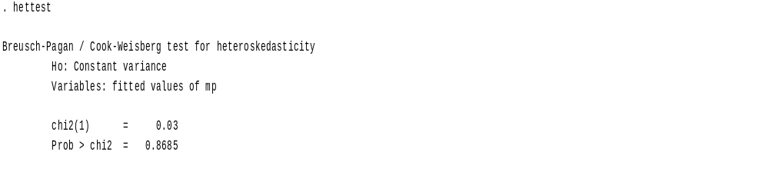
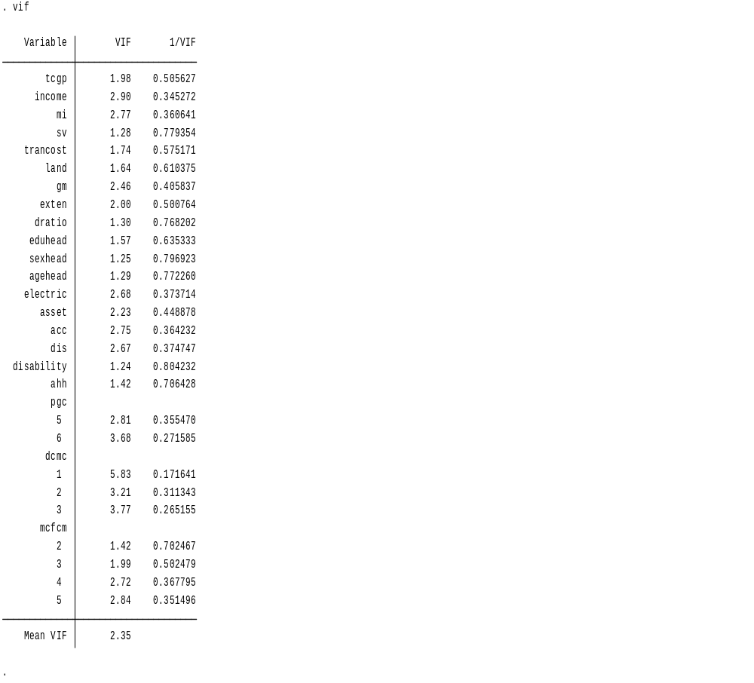

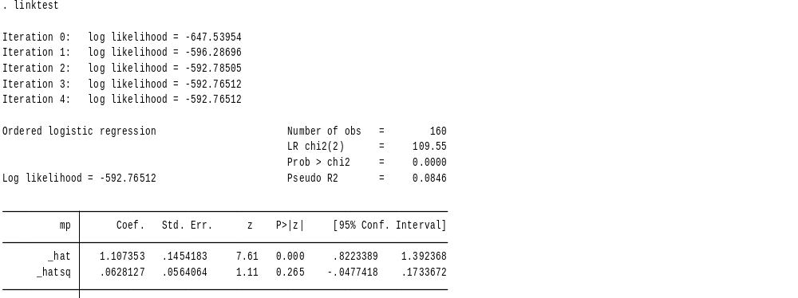

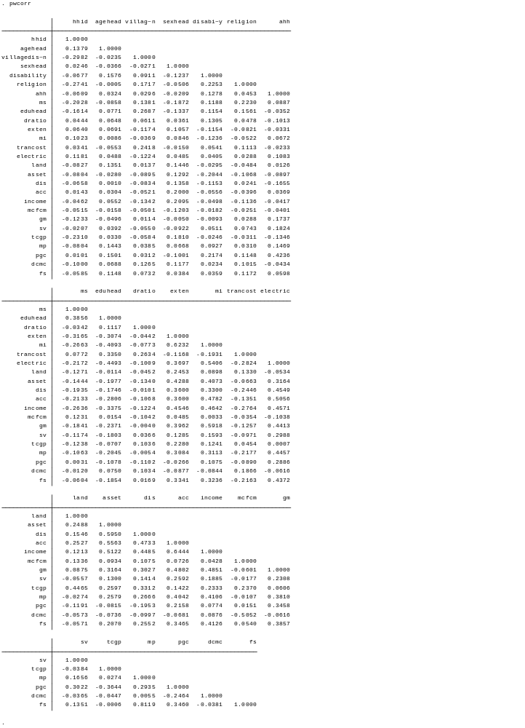
Appendix F: Ordered logit regression estimation result showed identified factors affecting Smallholders household crop market participation intensity

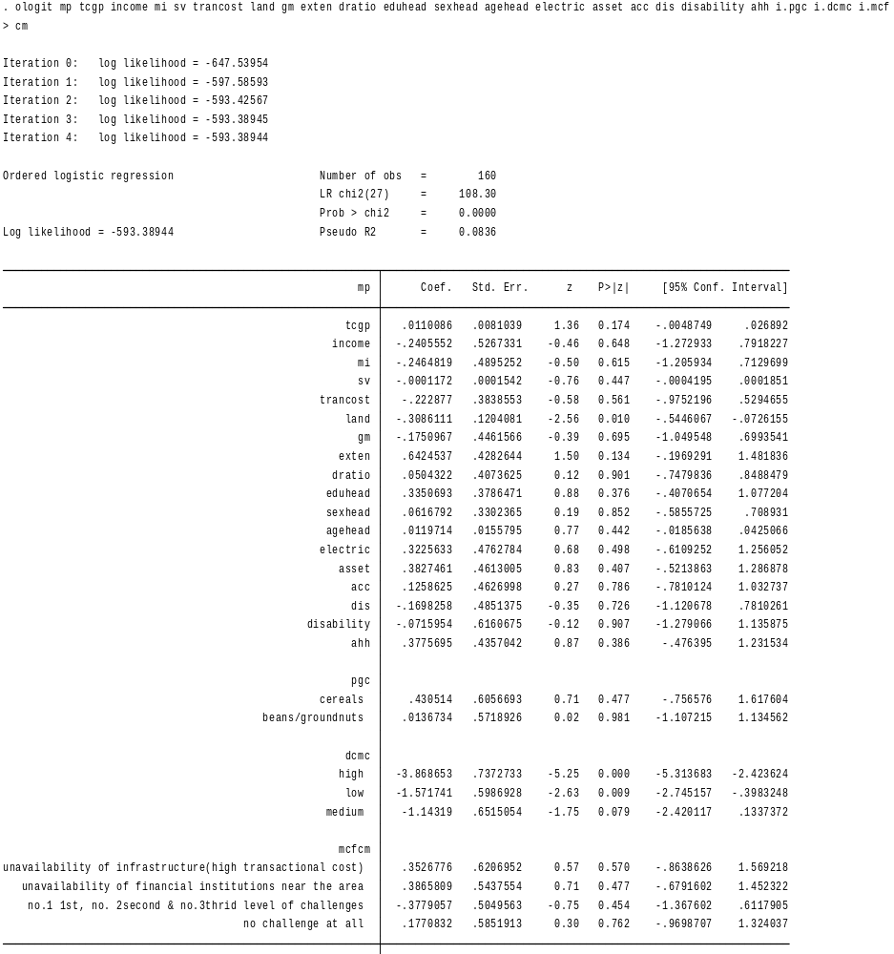
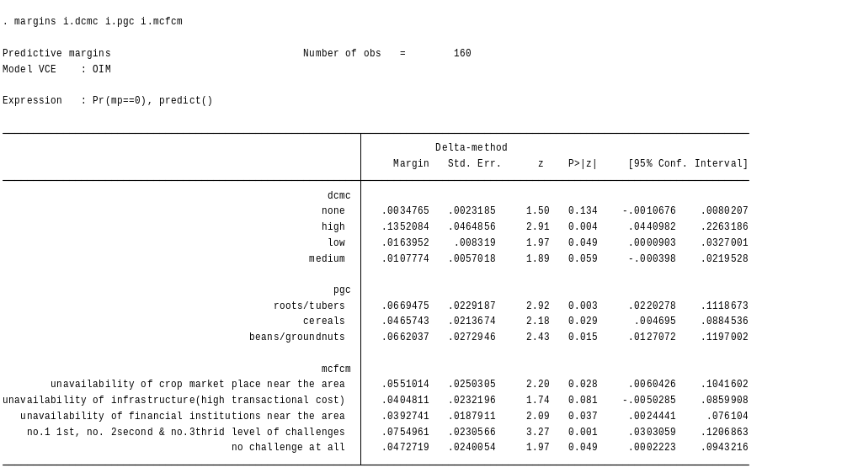

Appendix H: Diagnosis test for appendix E

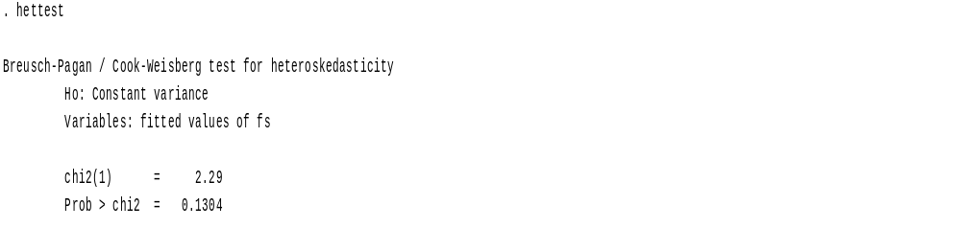
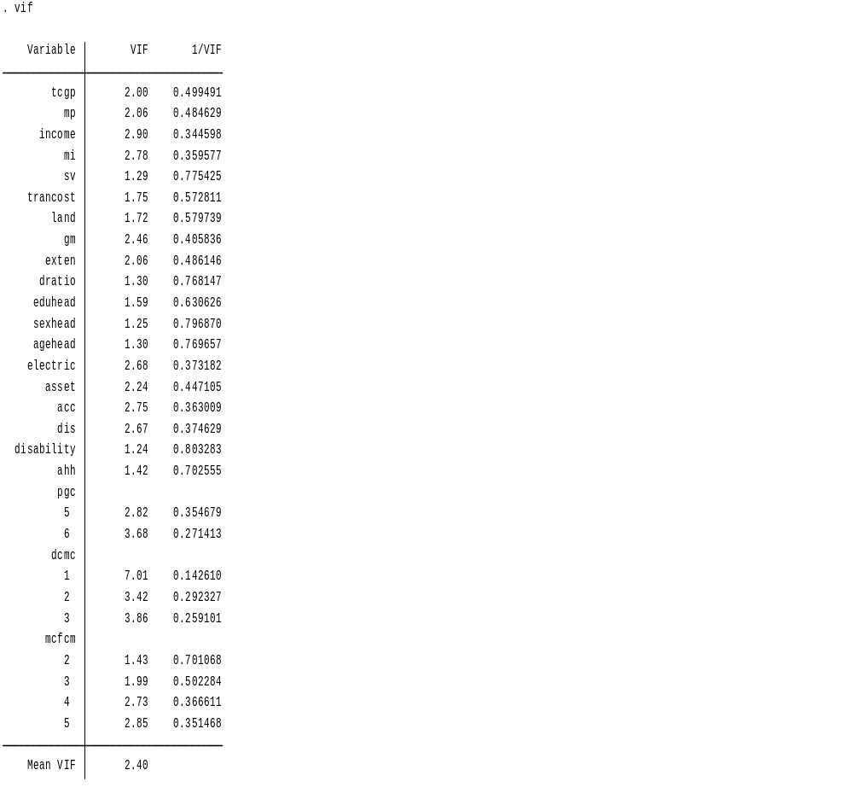

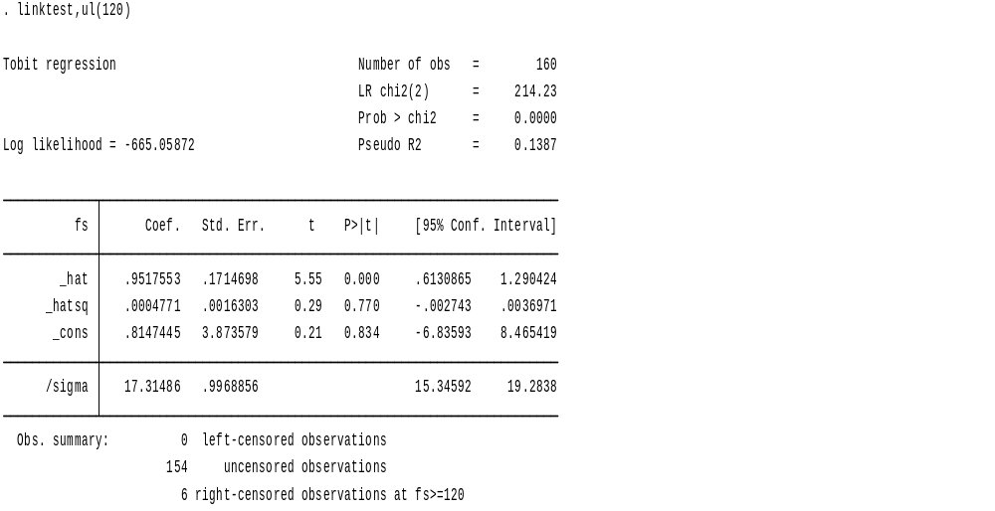

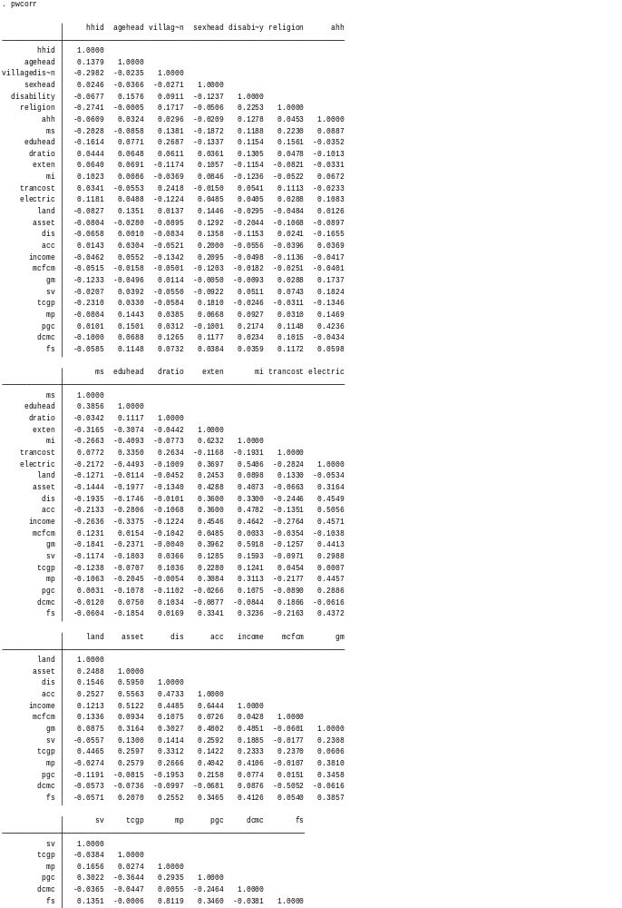

Appendix E: Tobit regression estimation result analyzed the effect of crop marketing on smallholders household food security

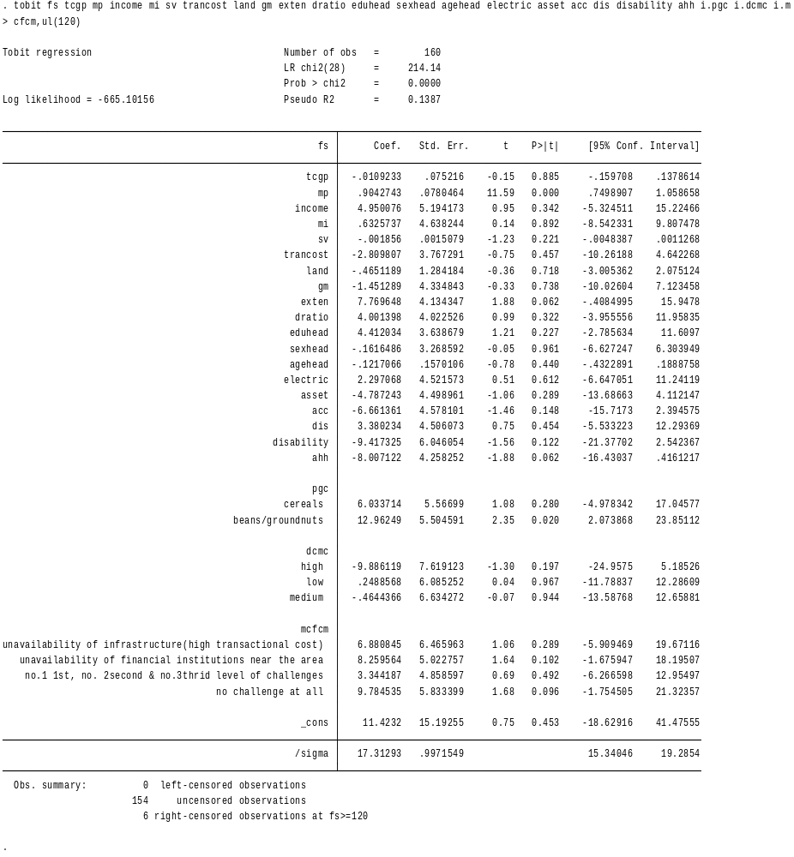

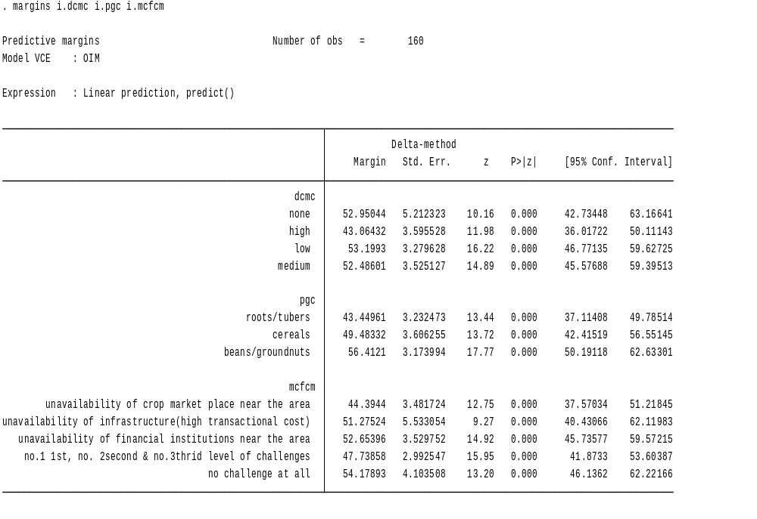

Appendix G: Variable Information

Variable | Position | Label | Measurement Level | Role | Column Width | Alignment | Print Format | Write Format
hhID | 1 | Identification number of household head(in number) | Scale | Input | 8 | Right | F8 | F8
Agehead | 2 | Age of the household head(in years) | Nominal | Input | 8 | Right | F8 | F8
Villagedistan | 3 | Village distance from asphalt & from gravel road in kilometer | Scale | Input | 8 | Right | F8.1 | F8.1
Sexhead | 4 | Gender of the household head(For female=1,for male=2) | Nominal | Input | 8 | Right | F8 | F8
Disability | 5 | Disability status of household head(1,if disable,0otherwise) | Nominal | Input | 8 | Right | F8 | F8
Religion | 6 | Religion of the respondent | Nominal | Input | 8 | Right | F8 | F8
Ahh | 7 | Activity of a household (h),1if a household(h) main activity is agriculture/farming,0otherwise | Nominal | Input | 8 | Right | F8 | F8

MS | 8 | Marital status of household head | Nominal | Input | 8 | Right | F8.2 | F8.2
Eduhead | 9 | Education level of the household head( literate = 1, illiterate = 0) | Nominal | Input | 8 | Right | F8 | F8
DRatio | 10 | Dependency ratio in the household (consumers/on farm worker, 1 if available,0 otherwise) | Nominal | Input | 8 | Right | F8 | F8
Exten | 11 | membership of the household to extension service (1if yes,0 otherwise | Nominal | Input | 8 | Right | F8 | F8
MI | 12 | Household has access to market information (1if yes ,0 otherwise) | Nominal | Input | 8 | Right | F8 | F8
Trancost | 13 | Cost of household to transport crop to the market(1if they pay,0 otherwise | Nominal | Input | 8 | Right | F8 | F8
Electric | 14 | Household has electric access(1if yes,0 otherwise) | Nominal | Input | 8 | Right | F8 | F8
Land | 15 | Amount of arable land for household in hectare/s | Nominal | Input | 8 | Right | F8.2 | F8.2
Asset | 16 | 1asset accessibility of a household(h), 0 inaccessibility of asset for a household(h) | Nominal | Input | 8 | Right | F8 | F8
Dis | 17 | Household distance from the crop market(1if household has Donkey/s,0 otherwise | Nominal | Input | 8 | Right | F8 | F8
ACC | 18 | Household head operates a bank account(1if yes,0 otherwise) | Nominal | Input | 8 | Right | F8 | F8
Income | 19 | Income status of household(h) in this year compared with last year, | Nominal | Input | 8 | Right | F8 | F8
MCFCM | 20 | Marketing Challenge of a household(h),1= no market ,2= no infrastructure,3= no financial institutions,4=No.1st no.2second & no.3thrid ,5=no challenge | Nominal | Input | 8 | Right | F8 | F8
GM | 21 | Group Market participation of household(h) | Nominal | Input | 8 | Right | F8 | F8
SV | 22 | The amount of sale value of crop for a household in birr per 100kg | Scale | Input | 8 | Right | F8.1 | F8.1

TCGP | 23 | Total amount of Crop group production in quintal for a respondent household(h) | Scale | Input | 8 | Right | F8.1 | F8.1
MP | 24 | Market Participation intensity of household(h) in % | Ordinal | Input | 8 | Right | F8.1 | F8.1
PGC | 25 | Producing Groups of Crops for a household(h)4=Cereals,5=Roots/Tubers,6=Beans/Groundnuts | Nominal | Input | 8 | Right | F8 | F8
DCMC | 26 | Degree of Crop Marketing Challenges(DCMC) for crop groups cereals, Roots/Tubers, Beans/groundnuts 0=none,1=high,2=low,3=medium | Nominal | Input | 8 | Right | F8 | F8
FS | 27 | Food security (FS) of a household(h) | Scale | Input | 8 | Right | F8 | F8
Variables in the own data working file:(2017)
Appendix I_{i}: Ordered logit regression estimation result with cuts/ (cofficients of the model)
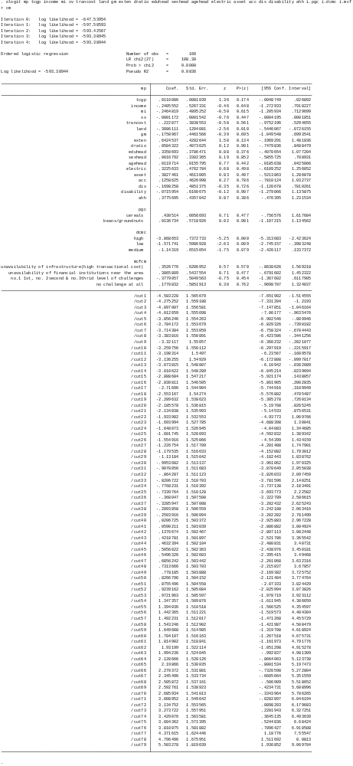
Appendix I_{ii}: Ordered logit regression estimation outreg2 result with cuts/ (cofficients of the model)

 | (1)
VARIABLES | mp
 | Coeff.(SE)
Total crop production in quintal | 0.0110
 | (0.00810)
Household income(dummy) | -0.241
 | (0.527)
Market information(Dummy) | -0.246
 | (0.490)
Sale value in birr | -0.000117
 | (0.000154)
Transport cost(dummy) | -0.223
 | (0.384)
Arable land size in hectare | -0.309**
 | (0.120)
Group market access(Dummy) | -0.175
 | (0.446)
Extension service(Dummy) | 0.642
 | (0.428)
Dependency ratio(Dummy) | 0.0504
 | (0.407)
Household Education(1=literate,2=illiterate) | 0.335
 | (0.379)
Sex head(1=female,2=male) | 0.0617
 | (0.330)
Age of the household head in year | 0.0120
 | (0.0156)
Electric access of the household(Dummy) | 0.323
 | (0.476)
Access of asset(Dummy) | 0.383
 | (0.461)
Access of bank account | 0.126
 | (0.463)
Household distance(0=has donkey, 1=don't have,2=use car &others) | -0.170
 | (0.485)
disability | -0.0716
 | (0.616)
Household activity(0=Secondary activity,1=Agriculture/Farming) | 0.378
 | (0.436)
5.Producing groups of crops Roots/Tubers(4=cereals5=roots,6=Beans) | 0.431
 | (0.606)
6.Producing groups of crops Beans/groundnuts(4=cereals,5,roots6,Beans | 0.0137
 | (0.572)
1.High degree crop market challenges(0=none,1=high,2=low,3medium) | -3.869***
 | (0.737)
2.Low degree crop market challenges(0=none,1=high,2=low,3=medium) | -1.572***
 | (0.599)
3.Medium degree crop market challenges(0=none,1=high2=low,3=medi) | -1.143*
 | (0.652)
2. No infrastructure challenges for crop market (mcfcm, =1, 2, 3, 4, 5.) | 0.353
 | (0.621)
3.No financial institution challenges for crop market(mcfcm,=1,2,3,4,5) | 0.387
 | (0.544)
4.All crop market challenges at a time/place (mcfcm,=1,2,3,4,5) | -0.378
 | (0.505)
5. No crop market challenges (mcfcm,=1,2,3,4,5) | 0.177
 | (0.585)
Constant cut1 | -4.583***
 | (1.566)
Constant cut2 | -4.275***
 | (1.559)
Constant cut3 | -4.097***
 | (1.557)
Constant cut4 | -4.013***
 | (1.556)
Constant cut5 | -3.856**
 | (1.554)
Constant cut6 | -3.784**
 | (1.554)
Constant cut7 | -3.714**
 | (1.553)
Constant cut8 | -3.384**
 | (1.551)
Constant cut9 | -3.321**
 | (1.551)
Constant cut10 | -3.260**
 | (1.550)
Constant cut11 | -3.198**
 | (1.550)
Constant cut12 | -3.136**
 | (1.549)
Constant cut13 | -3.074**
 | (1.549)
Constant cut14 | -3.011*
 | (1.548)
Constant cut15 | -2.889*
 | (1.547)
Constant cut16 | -2.831*
 | (1.547)
Constant cut17 | -2.717*
 | (1.545)
Constant cut18 | -2.553*
 | (1.543)
Constant cut19 | -2.290
 | (1.539)
Constant cut20 | -2.186
 | (1.537)
Constant cut21 | -2.135
 | (1.536)
Constant cut22 | -1.934
 | (1.533)
Constant cut23 | -1.694
 | (1.528)
Constant cut24 | -1.648
 | (1.527)
Constant cut25 | -1.602
 | (1.526)
Constant cut26 | -1.555
 | (1.525)
Constant cut27 | -1.227
 | (1.518)
Constant cut28 | -1.180
 | (1.517)
Constant cut29 | -1.132
 | (1.516)
Constant cut30 | -0.995
 | (1.513)
Constant cut31 | -0.908
 | (1.512)
Constant cut32 | -0.864
 | (1.511)
Constant cut33 | -0.821
 | (1.511)
Constant cut34 | -0.777
 | (1.510)
Constant cut35 | -0.734
 | (1.510)
Constant cut36 | -0.368
 | (1.508)
Constant cut37 | -0.329
 | (1.507)
Constant cut38 | -0.289
 | (1.507)
Constant cut39 | -0.250
 | (1.506)
Constant cut40 | 0.0207
 | (1.503)
Constant cut41 | 0.0590
 | (1.503)
Constant cut42 | 0.138
 | (1.502)
Constant cut43 | 0.422
 | (1.502)
Constant cut44 | 0.463
 | (1.502)
Constant cut45 | 0.506
 | (1.502)
Constant cut46 | 0.550
 | (1.503)
Constant cut47 | 0.686
 | (1.503)
Constant cut48 | 0.731
 | (1.504)
Constant cut49 | 0.778
 | (1.504)
Constant cut50 | 0.827
 | (1.504)
Constant cut51 | 0.876
 | (1.505)
Constant cut52 | 0.924
 | (1.505)
Constant cut53 | 0.972
 | (1.506)
Constant cut54 | 1.347
 | (1.510)
Constant cut55 | 1.394
 | (1.511)
Constant cut56 | 1.442
 | (1.511)
Constant cut57 | 1.492
 | (1.512)
Constant cut58 | 1.543
 | (1.513)
Constant cut59 | 1.650
 | (1.515)
Constant cut60 | 1.704
 | (1.516)
Constant cut61 | 1.815
 | (1.519)
Constant cut62 | 1.932
 | (1.522)
Constant cut63 | 1.994
 | (1.524)
Constant cut64 | 2.129
 | (1.528)
Constant cut65 | 2.199
 | (1.530)
Constant cut66 | 2.270
 | (1.532)
Constant cut67 | 2.345
 | (1.534)
Constant cut68 | 2.506
 | (1.537)
Constant cut69 | 2.593*
 | (1.539)
Constant cut70 | 2.686*
 | (1.541)
Constant cut71 | 3.009*
 | (1.550)
Constant cut72 | 3.135**
 | (1.554)
Constant cut73 | 3.274**
 | (1.558)
Constant cut74 | 3.429**
 | (1.564)
Constant cut75 | 3.604**
 | (1.571)
Constant cut76 | 3.810**
 | (1.582)
Constant cut77 | 4.372***
 | (1.624)
Constant cut78 | 4.796***
 | (1.676)
Constant cut79 | 5.503***
 | (1.820)
Observations | 160

