Selectivity of Infrared Treatment on Inactivation of Fungi on Corn
Griffiths G. Atungulu PhD, The University of Arkansas, USA
Shantae Wilson M.Sc, The University of Arkansas, USA

Abstract
Fungi are associated with enormous diversity of habitats which include grains. Once occurring on grains, the spores easily proliferate on high moisture content grains, increasing the risk of toxin production, and potentially contaminate the grain thereby posing important risk to the public. The objective of this study was to characterize effects of using selected peak wavelengths of infrared (IR) heat emission for varied durations on inactivation responses of fungi. Previous study was done using a newly-built, single-zone, continuous-flow IR heating system, which utilized catalytic IR heaters powered by natural gas, to dry freshly-harvested corn at initial moisture contents (MC) of 24% to 13% (wet basis). The microbial load on corn at 24% MC when dried at the high intensity and intermittent heating duration of 180 s to 13% MC were significantly reduced from 4.79 ± 0.15 to 2.03 ± 1.2 log CFU/ g of corn (figure 1). In order to identify specific mold that was inactivated, metagenomics techniques was used to characterize effects of selected peak wavelengths that falls in the mid and far IR heating region of the electromagnetic spectrum (3.1 μm, 4.2 μm, and 5.8 μm) for IR heat emission on inactivation responses of the general fungal microflora on corn; this was tracked for variable treatment durations and IR heating intensities as regulated by the product-to-emitter-gap sizes (11, 22, and 44 cm). Based on the previous results, IR drying of corn shows potential benefits of microbial decontamination which may help the industry prevent mycotoxin development on corn.

Image
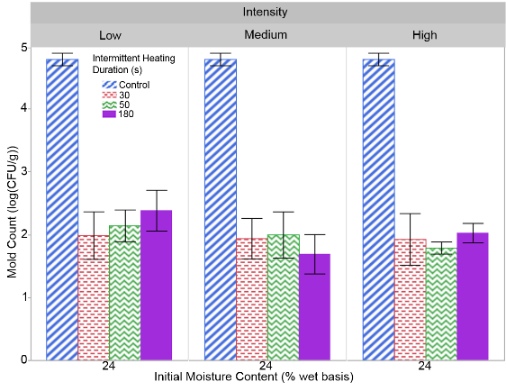
Figure 1. Effect of initial moisture content and infrared heating intensity (Low, Medium and High corresponding to 2.9, 3.78 and 5.55 kW/m2, respectively) on mold counts (log colony forming units (CFU) per gram of corn sample).
Recent Publications
- Wilson S. A., Atungulu, G.G., Couch, A., Sadaka, S. 2015. Radiant heating and tempering treatments for improving rate of moisture removal during drying of shelled corn. American Society of Biological and agricultural Engineers, Applied Engineering Journal, 31(5), 799-808. DOI 10.13031/aea.31.11243.
- Atungulu Griffiths, Koide Shoji, Shantae Wilson. Fumigation of Brown Rice with Volatiles from Bee Propolis and Impact on Storage Characteristics. J Nutrition Health Food Sci 3(2): 1-9. DOI: http://dx.doi.org/10.15226/jnhfs.2015.00136.LiX,
- Atungulu G.G., Smith D., Wilson S., Sadaka S., Rogers S. (2016). Assessment of onepass drying of rough rice with an industrial microwave system on milling quality. American Society of Biological and agricultural Engineers, Applied Engineering Journal, Vol. 32(3): 417-429. DOI 10.13031/aea.32.11484.
- Atungulu G., Thote S., Wilson S. 2016. Storage of Hybrid Rough Rice – Consideration of Microbial Growth Kinetics and Prediction Models. Journal of Stored Product Research, 69(2016), 235-244. http://dx.doi.org/10.1016/j.jspr.2016.09.003.
- Wilson S.A, Okeyo A.A, Olatunde G.A, and Atungulu G.G. 2016. Radiant heat treatments for corn drying and decontamination. Journal of Food Processing and Preservation. 2016; e13193. doi:10.1111/jfpp.13193.

Biography


Dr. Griffiths G. Atungulu is an Assistant Professor of Grain Process Engineering in the Food Science Department at the University Of Arkansas Division Of Agriculture. Griffiths’ education has been in agricultural engineering with research specialization in grains process engineering. He holds Bachelors of Science degree in Agricultural Engineering from Jomo Kenyatta University of Agriculture and Technology, Kenya and MS and Ph.D. degrees in Agricultural Engineering from Iwate University, Japan. At present, his program is focused on engineering effective strategies to maintain grain quality and prevent mycotoxin development.
Email: atungulu@uark.edu


Shantae Wilson is a PhD student at The University of Arkansas in the department of food science with 4 years of research experience in the genetic basis of plant-fungal interactions and microbiology. She is interested in obtaining a challenging position in the Food Industry to utilize her research abilities to improve the efficiency and safety of agricultural establishments and products.
Email: saw012@uark.edu

