Abstract
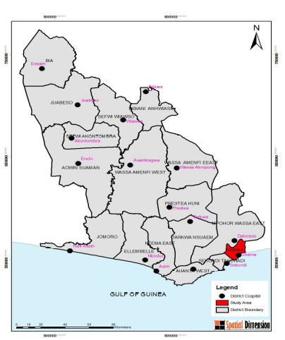
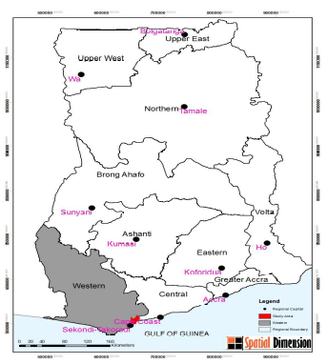
Recent oil discovery, extraction and further exploration along the coast of the Western region of Ghana has created competition between agriculture lands and companies whose activities falls along the value chain of hydrocarbon industry. This situation is alarming, particularly within the three coastal districts of the western region of Ghana (Ahanta west, Shama and Ellembelle). For these oil companies and other developers, in the pursuit of their commercially businesses have bought thousands of acres of existing farm lands for their industrial set-up, real estate and warehouses across the length and breadth of the districts posing food and nutritional security implication. This research was conducted across three coastal districts of the Western region, where oil exploration is on-going. A sample size of 350 was used with both qualitative and quantitative research methods of data collection, participatory Rural Appraisal (PRA) tools such as Focus Group Discussions (FGDs), direct observation, semi-structured interviews, transect walk and Key Informant Interviews (KIIs) were employed. The result reveals that at least about 3,500 –4,500 acres of fertile agricultural land have been cleared for oil and gas companies, real estate or warehouses in Ahanta west district alone. Three hundred and fifty (350) households have lost their livelihood. Cumulatively, a total of 25000 acreages of arable lands have been lost to industrial use in the context of oil and gas exploration. The situation has food and nutritional menace, both young and old are losing their agricultural lands. The situation has livelihood implication and if not tackled, the Niger delta incidence may occur. The study identified chiefs as the drivers of this act. In all, 55% total agriculture lands have been lost in all these districts. Farming activity, literally grinded to a halt with the construction of industries/ warehouse, offices and real estate’s on fertile and existing farm lands. Study area

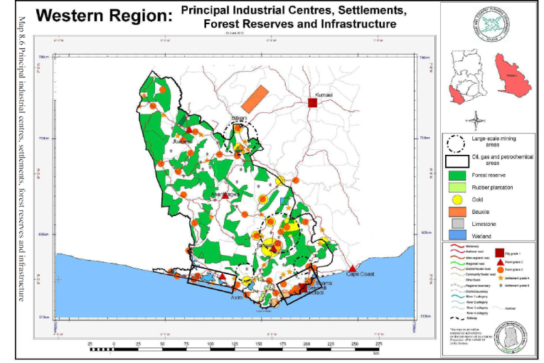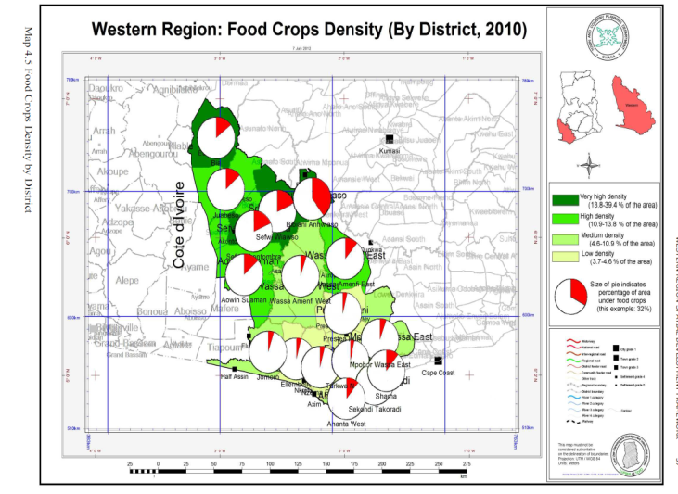
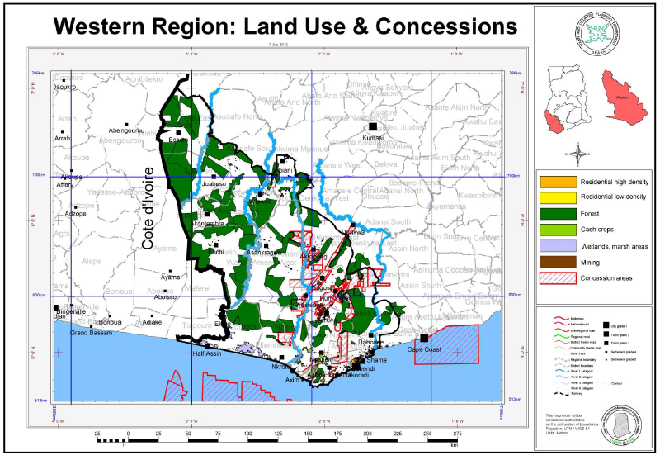
Spatial map of development and corresponding food crop density
Profile
Francis Adarkwah is a development specialist with 10 years’ experience in livelihood including natural resource enterprises. The experiences span from climate change to food and nutritional security. Over the years, Francis has employed multi-disciplinary participatory community engagement tool in administering intervention across the country, particularly oil exploitation affected farmers. He is the deputy director and programme coordinator for MANGROVE. Francis holds B.sc in Agricultural science, M.phil Crop science and currently PhD fellow in Environmental and sanitation at the University of Ghana.

