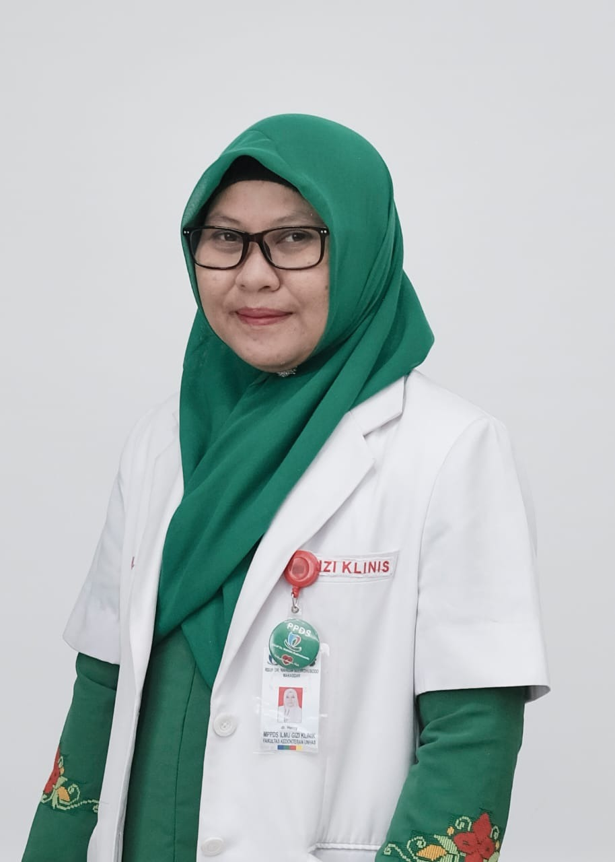

Nutrition Therapy for Pancreatic Cancer With Severe Malnutrition and Hypoalbuminemia
Herny, Agussalim Bukhari
Department of Nutrition, School of Medicine, Hasanuddin University of Makassar, Indonesia

Pancreatic cancer is a disease in which malignant (cancerous) cells formed in the tissues of the pancreas. Symptoms may include abdominal pain, weight loss, diarrhea and jaundice. The disease and its treatment can cause significant nutritional impairments that often impact patient’s quality of life. Effective and proper nutritional therapies are important to improve this condition. We present a case of 65-years old man, admitted to hospital complaining abdominal pain with nausea and jaundice. Patient was diagnosed with pancreatic cancer and severe malnutrition. We found jaundice (total bilirubin 8,73µ/L, direct bilirubin 8,3µ/L), anemia (11,2 g/dL), leukocytosis (25.000/mm²) hypoalbuminemia (2,4 g/dL), hypokalemia (3,3 mmol/L), and decreased renal function (ureum 103 mg/dl, creatinine 1,73 mg/dl). Nutritional intervention was done by giving 1600 kcal of energy, 1,2 g/IBW/day protein, 55%-60% carbohydrate and 25-30% fat via oral and parenteral. Supplementations administered were zinc, vitamin B1, vitamin B6, vitamin B12, vitamin C, curcuma and snake head fish extract ( a high protein supplementations (Pujimin®)). After 15 days, we were found clinical and metabolic improvement in the laboratory results we found Hb (11,2 to 11.4 g/dL), potassium (3,3 to 3,8mmol/L), ureum (103 to 28mg/dl), creatinine (1,73 to 0,41 mg/dl) albumin (2,4 to 3,0 g/dL). Patient underwent laparatomy surgery on 22nd day. Because the tumor was unresectable during surgery, the double bypass bilioenteric action (choledochojejunostomy and gastrojejunostomy) and Braun procedure (jejunostomy) were done. After surgery, the complaints of nausea and jaundice were improved and the patient was discharged after 25 days of treatment.

Biography
Herny has completed her MD at the age 26 years from Hasanuddin University of Medicine. She is a third year Clinical Nutrition Resident at Department of Nutrition, Hasanuddin University of Makassar, Indonesia.

Presenting author details
Full name : Herny
Contact number : +628114445424
Twitter account : -
Linked In account : -
Session name/ number:
Category: Poster presentation

