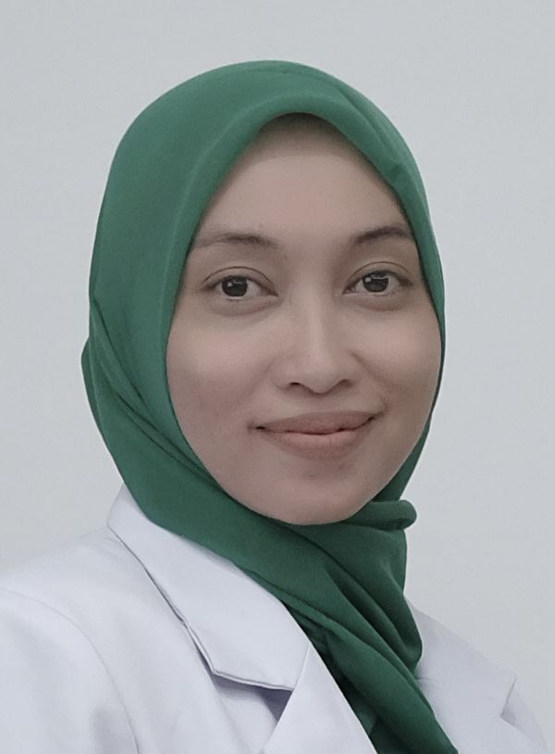

Nutrition Therapy in End Stage Renal Diseases (ESRD) patients under go Continous Ambulatory Peritoneal Dialysis (CAPD)

Andi Azizah, Mardiana Madjid, Haerani Rasyid
Departemen of Nutrition, School of Medicine, Hasanuddin University, Makassar, Indonesia

Malnutrition occurs in about one-third of patients with end-stage renal disease (ESRD) patients who undergo Continous Ambulatory Peritoneal Dialysis (CAPD). Malnutrition in chronic dialysis patients may be due to poor nutritional intake, excessive losses, increased protein catabolism, and acidosis. The need for protein increases in peritoneal dialysis patients due to severe peritoneal protein loss which is aggravated due to peritoneal infections. Losses of free and bound amino acids during CAPD are substantial and contribute to negative balance during dialysis. In CAPD patients severel studies report loss of 5.5-11.8 g of protein into dialysate daily. A large amount of these losses consist of albumin, along with immunoglobulin as well as amino acids. During episodes of peritonitis, these losses increases substantially. Moreover, inflammation and inflammatory factors have an important role in malnutrition in patients with ESRD. We Present a case in a 47-years old women with ESRD who under go peritoneal dialysis. The patient present with moderate protein energy malnutrition, infected CAPD, anemia (6.4 g/dl), hypoproteinemia (4.8 g/dl), hypoalbuminemia (2 gr/dl), hyponatremia (126 mmol/L), hypokalemia (3.1 mmol/L). Nutritional therapy given was gradually from 1000 kkal until 2000 kkal based on patients condition. Protein 1.2-1.5 gr/kg IBW/day consist of high biologycal value protein combine with plant protein, carbohydrate 55 % and fat 28-33 %. Supplementation including zinc, vitamin B compleks, vitamin C and curcuma. After 19 days of hospital treatment, we found clinical and metabolic improvement.
Biography
Andi Azizah has completed her MD at age 26 years old from Hasanuddin University School of Medicine. She is Clinical Nutrition Resident at Hasanuddin University School of Medicine Makassar, Indonesia.
Presenting author details
Full name : Andi Azizah
Contact number : +628114112523
Twitter account : -
Linked In account : -
Session name/ number:
Category: Poster presentation

