Draining Effects on the Quality of Processed Leafy Vegetable

Shufang Zheng Beijing Vegetable Research Center China
Jing Wang Beijing Vegetable Research Center, China
Yuanyuan Zhao Beijing Vegetable Research Center, China

Abstract
Excessive water on the surface of minimally processed vegetable can cause rapid bacteria spoilage under temperature stress. In processing industry the spin dryer is technically and economically adopted to remove surface water. But drastic centrifuge always results in tissue bruising, especially for leafy vegetable which is usually much more sensitive to mechanical injury. In order to investigate the draining effects on the quality of minimally processed leafy vegetable, pakchoi was introduced in the experiment.
Only one time cut was applied at leaf base for each pakchoi and the leaves were separated from short stem, in order to minimize the cut damage to the integrity of leaves. The leaves were rinsed with tape water and chlorinated in Sodium hypochlorite. One part pakchoi is for draining by spinning machine and the other part is by (gravitation) no-spinning. The vegetable was stored at 4 Celsius degrees, the conductivity, aerobic plate count, chlorophyll and Vitamin C were analyzed. The results showed that the conductivity and aerobic count of pakchoi by spinning are 15% and 40% higher respectively than that without spinning, but Vitamin C and chlorophyll have no much difference.
It can be concluded that the spinning can cause some tissue damage and leakage of cell juice, give the seemly medium to bacteria amplification. So it is essential to adopt less damage draining to avoid the loss of freshcut tissue integrity, especially for leafy vegetables.
The results can be summarized as fallow:
the conductivity of spinning was more than 2% and the one of non spinning less 2%；aerobic count of spinning was more than 365CFU/ml and non spinning was less than 260 CFU/ml; the chlorophyll was about 0.4mg/g; Vitamin C was about 1.6mg/g.

Image
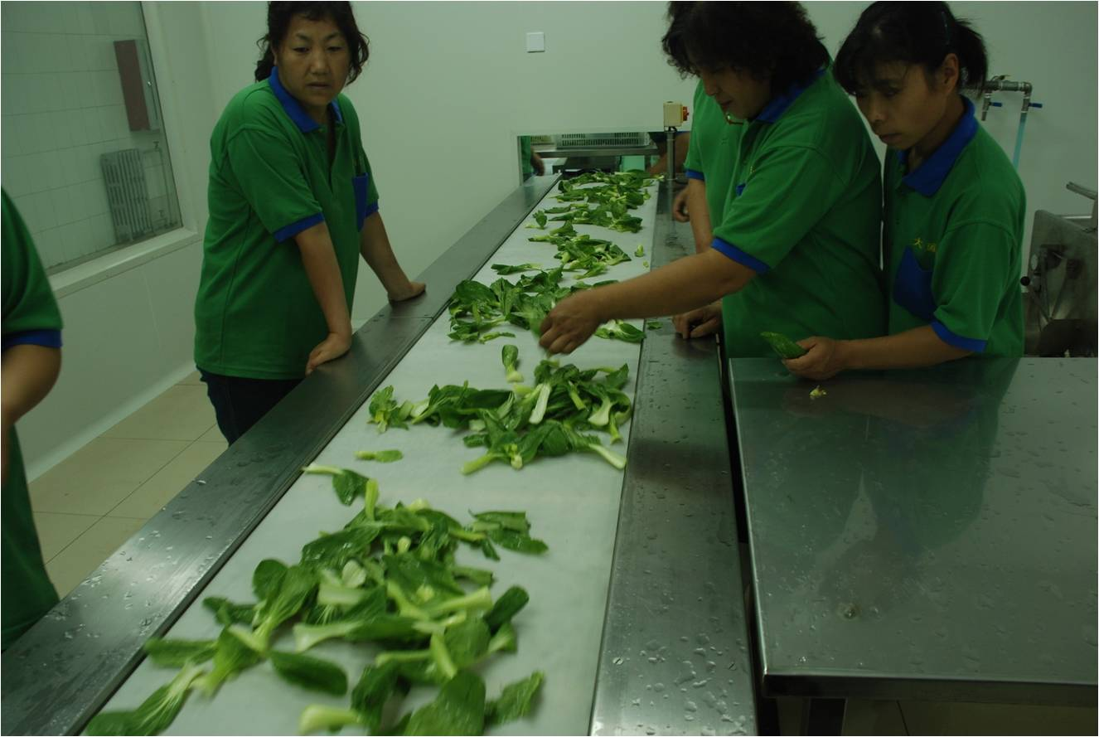
Recent Publications
1.S.F Zheng and C.X. Sun 2007. The effects of chloride oxide on browning of fresh cut potato. Modern food technology Vol.23 (4), 31-33.
2. S.F Zheng and C.X. Sun 2006. The effects of anti- browning agents on browning and quality of the fresh-cut potato. Food Research and Development Vol.27(7), 108-111.
3.Ling Zhe and S.F. Zheng 2008. The method of analysis of endo ethylene in plant tissue. Henan Agriculture Science 2008(4), 51-53.
4.S.F. Zheng and T.Y. Hou 2010. Bactericidal efficacy evaluation of recycling used sodium hypochlorite during fresh-cut vegetable processing. Food Science Vol. 31(13), 28-31
5.S,F. Zheng 2010. The effects of disinfectant on the quality loss of fresh cut produce. ISHS Acta Horticulturae 856: International Symposium on Vegetable Safety and Human Health 256-259.
6. S.F. Zheng and T.Y. Hou 2012. Effects of 1一MCP on storage characteristics and quality of oriental melon with different m maturity. China Fruit 25(2), 6-10.


- Graduate of: Horticulture Department, Hebei Agriculture University
- Bachelor study specialization: BSc. in Vegetable Science
- Master study specialization: MSc. in Postharvest Technology in Beijing Agriculture and Forestry Science
Email: Zhengnercv@outlook.com; Phone:8617896009081

