ACCEL ELISA for Highly Sensitive, Rapid and Convenient Detection of Contaminants in Food
Teri J Slack, PhD, Plexense, Inc.

Abstract (300 word limit)
Antibiotics, mycotoxins, pesticides and plant pathogens are small molecules that can contaminate food and pose long term health risks. International guidelines recommending the maximum concentration of contaminants in food has been set by the Codex Alimentarius Commission (CODEX) and is adopted by many nations. Timely detection and removal of these contaminants can greatly reduce health risks and prevent shipments of food being rejected and discarded. However, detection of small molecule contamination with conventional methods such as mass spectrometry (MS) and high-performance liquid chromatography (HPLC) are costly and time consuming. Plexense has developed ACCEL ELISA, a detection method based on Enzyme-Linked Immunosorbent Assay (ELISA) technology that outperforms conventional methods. ACCEL ELISA is a proprietary platform combined with unique surface chemistry and reagent formulation. ACCEL ELISA yields reliable results with up to 100x the sensitivity within 15 to 45 minutes of reaction time. Detection methods for a wide range of applications are available to reliably screen for proteins and small molecules. ACCEL ELISA is especially useful in food safety applications with optimized reagents for mycotoxin, residual antibiotics and pesticide screening.

Image
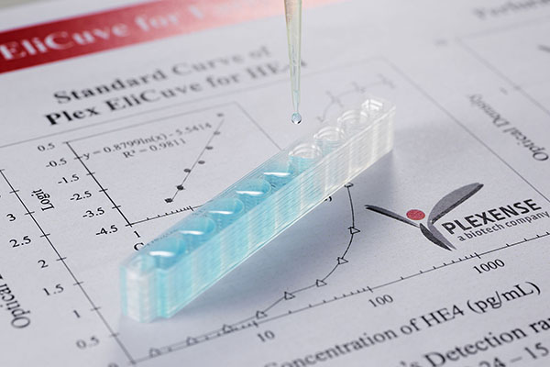

Biography (150 word limit)
Teri J. Slack

Dr. Slack earned her PhD in organic chemistry from UC Davis before joining the team at Plexense, Inc. She now leads the business development efforts in the United States for Plexense located in Davis, California. Her passion lies in making a positive impact on the food and agricultural sector with simple and sensitive detection tools developed to ensure public access to healthy, uncontaminated food.

Email: tslack@plexense.com

Notes/Comments:

