Determination of Alkenylbenzenes in Indonesian plant-based drink and associated safety assessment using the Margin of Exposure (MOE) approach
Siti Mariyam, Master Student of Food Safety Wageningen University and Research, The Netherlands
Suparmi, PHD in Toxicology Departement, Wageningen University and Research, The Netherlands
Sebastiaan Wesseling, Professor in Toxicology Departement Wageningen University and Research, The Netherlands
Ivonne M.C.M Rietjens, Professor in Toxicology Departement Wageningen University and Research, The Netherlands

Abstract (300 word limit)
This study was done to determine the alkenylbenzenes in Indonesian plant-based drink and safety assessment using the Margin of Exposure (MOE) approach. The level of alkenylbenzenes reached 0.4 to 563.5 µg/g samples. 24 over 25 samples positively contained alkenylbenzenes with major compound is methyleugenol. The Estimated Daily Intake (EDI) were calculated for individual and combined exposure used the equal potency and TEQ approach. For the assumption, Indonesian lifetime of 69 years and average body weight of 54 kg were used. The EDI ranged from 0.1 to 48.3 μg/kg body weight per day for assuming consumption of 1 cup each day. The combined EDI values considered assuming equal potency was amounted 23.7 μg/kg body weight per day. In addition, the combined EDI based on TEF of methyleugenol calculated 74.7 μg methyleugenol equivalents/kg body weight per day. The individual MOE was calculated vary from 168 to 183,901. For the combined exposure, the MOE values were reached 645 and 205 for equal potency approach and TEQ approach, respectively. These values showed lower than 10,000 except for sample 18 and sample 20, thus it may be priority for risk management. Nevertheless, the consumption of samples would not for a lifetime, the short time exposure extrapolated by Haver rules showed increasing of MOE and lead to low priority for risk management. All in all, the consumption of plant-based drink will be at risk if the consumer consumes high concentration alkenylbenzenes in long period of time.

Image
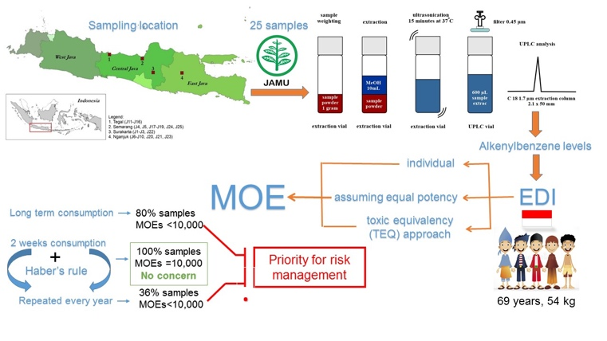

Biography (150 word limit)
Siti mariyam is master student of food safety in Wageningen University and Research, The Netherlands. She is originate from Indonesia. She was awarded LPDP scholarship from Indonesian government to pursue a master degree in The Netherlands. Beside on academic rush, she spend most of my free time as member of Indonesian Student Association and International Student Organisation Wageningen. I also involved as student ambassador in Study Portals, to helps to promote, find and compare international education, the mission is to bring transparency to the wealth of study opportunities worldwide. She had finished thesis with the topic of risk assessment of Botanical Food product from Indonesian market.
Email: siti.mariyam@ewur.nl

Notes/Comments:

