Prevalence of brucellosis in slaughter animals in Gauteng Province abattoirs, South Africa: Food safety implications
Francis B. Kolo,DVM, M.Sc., Ph.D. candidate
Abiodun A. Adesiyun, DVM, MPH, Ph.D., Department of Production Animal Studies, University of Pretoria, South Africa
Charles Katsande, BVSc, MVSc, Gauteng Department of Agriculture and Rural Development, South Africa
Dayo Fasina, DVM, M.Sc., Ph.D., Department of Veterinary Tropical Diseases, University of Pretoria, South Africa
Henriette Van Heerden, BSc, BSc (Hons), MSc, Ph.D., Department of Veterinary Tropical Diseases, University of Pretoria, South Africa

Statement of Problem: Brucellosis is one of the neglected zoonotic diseases, a highly infectious and contagious zoonotic disease of humans, and a wide range of domestic animals. Globally, abattoirs are used for passive and active surveillance of diseases of both economic and public health significance.This research goal was to determine the prevalence of Brucella spp. in slaughter livestock in abattoirs in Gauteng Province, andthe risk posed to consumers of Brucella-contaminated meat. Methodology: Eleven livestock abattoirs were included in the study from where 266 serum samples and 798 tissue samplescomprising lymph nodes, spleen and liver were collected from 266 animals.An 11.5% and 5% seroprevalance were detected from RBT and iELISA respectively from cattle. Eighty nine percent of iELISA positive samples were also tissue-positive for Brucella spp. by PCR.The PCR positive samples originated from 54.5% of the abattoirs visited. It was concluded that meat from slaughtered Brucella spp. infected livestock pose a potential food safety risk to consumers.

Fig. 1Abattoir workers dressing carcasses at an abattoir in Gauteng Province, South Africa 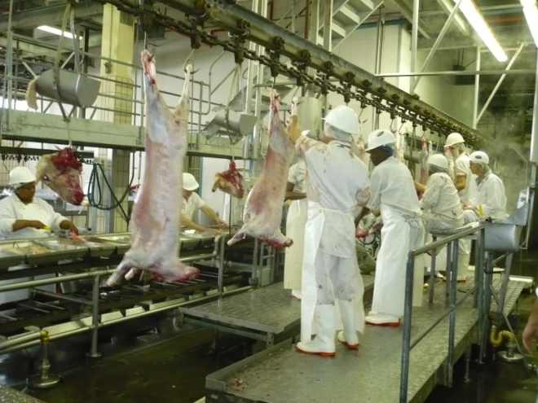
Recent publications

1. Fekete, A., Bantle, J.A., Halling, S.M. and Sanborn, M.R., 1990. Preliminary development of a diagnostic test for Brucella using polymerase chain reaction. Journal of Applied Bacteriology, 69(2), pp.216-227.

2. Yu, W.L. and Nielsen, K., 2010. Review of detection of Brucella spp. by polymerase chain reaction. Croatian medical journal, 51(4), pp.306-313.

3. Love, S. 2010. Zoonoses–animal diseases transmissible to humans. Primary Industries & Biosecurity, 1-8.

4. O’Leary, S., Sheahan, M. and Sweeney, T., 2006. Brucella abortus detection by PCR assay in blood, milk and lymph tissue of serologically positive cows. Research in veterinary science, 81(2), pp.170-176.

5. Taylor, L. H., Latham, S. M. & Mark, E. 2001. Risk factors for human disease emergence. Philosophical Transactions of the Royal Society of London B: Biological Sciences, 356, 983-989

 Biography

Francis Kolo has a degree of Doctor of Veterinary Medicine. He worked as a veterinary officer in Nigeria. He started working as a Veterinary officer in 2004, and was primarily responsible for the diagnosis and treatment of different animal diseases. He facilitated sensitization lectures sponsored by UNICEF to human healthcare practitioners in various local government councils in Niger State, Nigeria on biosecurity. He obtained a MSc. Veterinary Science from the University of Pretoria in December 2015 cum laude. His Masters research was focused on dog population demographics, as it relates to herd immunity in the control of rabies in dog and human populations, in the Mnisi community area, in rural South Africa which shares land borders with the Kruger National Park, and was nestled in the heart of a human/wildlife/domestic animal interface. Currently registered for a PhD in the same University and his research is focused on brucellosis in abattoirs and in abattoir workers.
kolofrancis@hotmail.com

