Study of Reducing the concentration of MTBE from groundwater by waste pistachio tree

Saman Hajmohammadi; Department of Chemistry, Sirjan Branch, Islamic Azad University, Sirjan, Iran

Sohrab Hajmohammadi; Young Researchers and Elites Club, Sirjan Branch, Islamic Azad University, Sirjan, Iran

Abstract (300 word limit)

In recent years MTBE is an octane enhancer in gasoline in the world and has been replaced by tetraethyl lead. Transportation accidents of this matter , pouring gasoline on distribution sites and leaking gasoline storage tanks and pipelines is effective on groundwater contamination. Elimination of this material from contaminated wells is difficult because of its physical and chemical properties such as high solubility , low Henry constant and resistance to biodegradation in normal conditions. Due to limited water resources, especially in desert regions, the importance of the water crisis in Iran and restoring the water, in addition to groundwater and surface water pollution from gasoline pollutants such as MTBE, finding effectives environmental and economic solutions to remove these materials from water resources is essential. In this regard, using low price agricultural wastes such as bark and shell of oil seeds such as soybean, rice, pistachios, almonds, and so on, they can be very helpful due to their low prices, availability and strong affinity with some materials. In this study, the pistachio tree waste, such as leaves, bark, sawdust and wood nuts are used to reduce the concentration and the removal of MTBE in the water.
Key words:MTBE,pistachio tree, Adsorption,
groundwater

Image

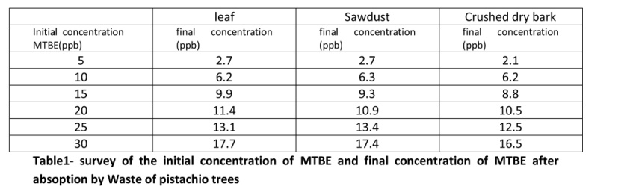
Recent Publications (minimum 5)
1.McCabe. Survey on Community water supply system. Journal of the American Public HealthAssociation 1990;62:67-72.
2.World Health Organization. Health and environment in sustainable development.WorldOrganization / Evil Horde Generator: 1997, 97-8.
3.Wachinski AM. Water quality.3rd ed. AWWA; 2003.
4.The plan of contamination of underground water basins at Tehran dessert, assistant of Ministry of Utilization, Water & Wastewater Organization, Tehran Province.
5.Alizadeh Amin, Hydrology principles, Imam Reza University Press, (1998)
6.Lotfi Sedigh, Ahmad, Hydrology of underground waters, Sahand University press, (1995).


Biography
Saman Haji Mohammadi, a professor of Islamic Azad University, Sirjan has 20 international paper. Most of his papers in the field of water treatment. This study lasted for a year and finally got some interesting results. Haj Mohammadi researches has been done in the City of Sirjan (in southeastern of Iran) , and this research has been done too.

Email: samalbert_908@yahoo.com

