The use of edible films and coatings for preservation of cheeses

Mohamed H. Abd El-Salam¹, Ahmed M. Youssef², Faiza M. Assem¹, Samah M. El-Sayed¹ and Heba Salama¹
¹Dairy Science Department, Food Industries and Nutrition Division, National Research Centre, 33 El Bohouth St. (former El Tahrir St.), Dokki, P.O. 12622, Giza, Egypt.
²Packing and Packaging Materials Department, National Research Centre, 33 El Bohouth St. (former El Tahrir st.), Dokki, Giza,Egypt, P.O. 12622.

Abstract
The diversity of cheese varieties, dynamic microbiological and biochemical changes undergo during cheese manufacture, ripening and marketing need special care to meet the desired consumer acceptability and satisfaction. In this area packaging plays an important role in cheese industry. Application of films or coatings to cover cheese surfaces has long been recognized as an important treatment for the protection of the quality and safety of the product. The growing environmental concern about the use of un-biodegradable materials in cheese packaging encouraged research on the development of edible materials for coating and packaging of cheese. Several polysaccharides and proteins with or without plasticizers, antimicrobial agents and nanoparticles have been used as basis for the development of edible cheese coating. The present manuscript gives an overview on the development and use of edible cheese coating in relation to the cheese quality and safety

Keywords: Cheese, edible coatings/films, antimicrobial agents, nanoparticles
Recent Publications
- Ahmed Youssef; Samah EL-Sayed; Huda EL-Sayed; Heba Salama; Alain Dufresne. Influence of packaging material on shelf life of Egyptian soft white cheese. Carbohydrate Polymers. 151 (2016) 9–19
- Ahmed M. Youssef; Samah EL-Sayed; Heba Salama; Huda EL-Sayed; Alain Dufresne, Evaluation of bionanocomposites as packaging material on properties of soft white cheese during storage period. Carbohydrate Polymers, 132 (2015) 274–285.
- Ahmed. M. Youssef, Hussein Abou-Yousef, Samah M. El-Sayed, Samir Kamel. Mechanical and antibacterial properties of novel high performance chitosan/nanocomposite films. International Journal of Biological Macromolecules,76 (2015) 25–32.

Image
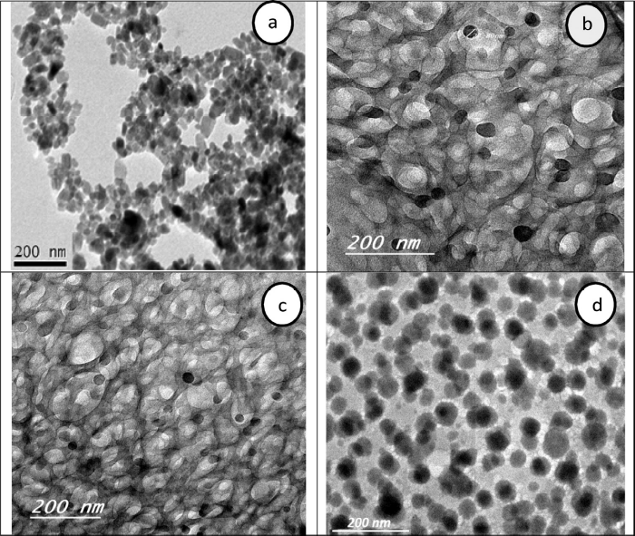
TEM images of (a) ZnO nanoparticles, as well as CH/CMC/ZnO bionanocomposites containing different concentrations of ZnO-NPs, (b) 2%, (c) 4% and (d) 8%.
- Ahmed M. Youssef , Amany M. El-Nahrawy, Ali B. Abou Hammad. Sol-gel synthesis and characterizations of hybrid chitosan-PEG/calcium silicate nanocomposite modified with ZnO-NPs and (E102) for optical and antibacterial applications, International Journal of Biological Macromolecules, Volume 97, April 2017, Pages 561–567
- Ahmed. M. Youssef, S. A. Mohamed, M. S. Abdel-Aziz, M. E. Abdel-Aziz. G. Turky, S. Kamel, Biological studies and electrical conductivity of paper sheet based on PANI/PS/Ag-NPs nanocomposite. Carbohydrate Polymers 147 (2016) 333–343

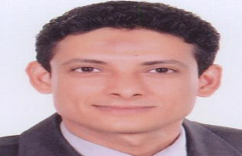Biography
Assco. Prof. Ahmed M. Youssef has completed his Ph.D at the age of 29 years from Ain Shams University; He has so far won the Ford Foundation Scholarship (2004), the AU-TWAS Young Scientist National Awards in field of Basic Sciences, Technology and Innovation (2013), the winner of Unilever for the best applied article (2015), and the NRC Award of Encouragement in Applied Chemistry (2015). Also, he awarded the Scholarship from France institute in Egypt (IFE/STDF, 2014). He had postdoctoral studies in Arkansas University, USA and Grenoble Institute of Technology (Grenoble INP)-France. He has many scientific missions to different countries (e. g, USA, France, Hungary, and China). In peer-reviewed international journals, he got > 50 papers, and an H-index=16 and citations=620 (Google scholar).. He is currently engaged in several research grants in the field of polymer nanotechnology, preparation of nanomaterial’s, packaging, wastewater treatment and solar cell. Research interests involve optimization of preparation of different nanomaterials, production of low-cost sustainable wastewater treatment technologies using agricultural wastes. For 13 years, he has coupled research experience with industrial work with National and International Counterparts.
.Email: amyoussef27@yahoo.com

