Causative factors of obesity among children with non-alcoholic fatty liver disease and hunger hormones after using probiotic and lifestyle intervention
Pooja Goyal, Directorate of Health and Family Welfare, Government of Punjab, India
ABSTRACT
OBJECTIVES: To identify the factors responsible for obesity in children with non-alcoholic fatty liver disease (NAFLD) and hunger hormones after using Probiotic (De Simone Formulation) and Lifestyle intervention. METHODS: We diagnosed 80 obese children with NAFLD in between age group of 5-18 years by ultrasonography and divided in to three groups 1. Probiotic (n= 27), 2. Lifestyle (n= 26) and 3. Placebo (n= 27). We also identified their family history, stress eating, dietary habits and physical activity among these children. Anthropometric measurements: BMI (body mass index), MAC (mid arm circumference) and TSF (triceps skinfold thickness) were taken. Hunger hormones: leptin and ghrelin were measured at fasting along with some liver enzymes: Serum ALT (alanine aminotransferase) and AST (aspartate aminotransferase) and blood glucose (BG) in fasting were also measured. RESULTS: In present study 60% obese children with NAFLD had family history of obesity and 44% were overeating due to stress. 48.7% of children consumed soft drinks, fried chips 55% and pizza, burger and noodles 26.2% on daily basis. Overall 85% children were not indulged in physical activity and only 15% were doing exercise. Probiotic and lifestyle are effective for managing NAFLD in obese children (p<0.05).
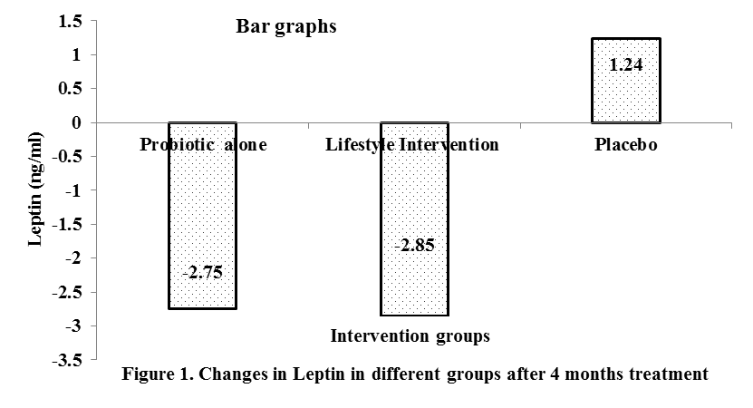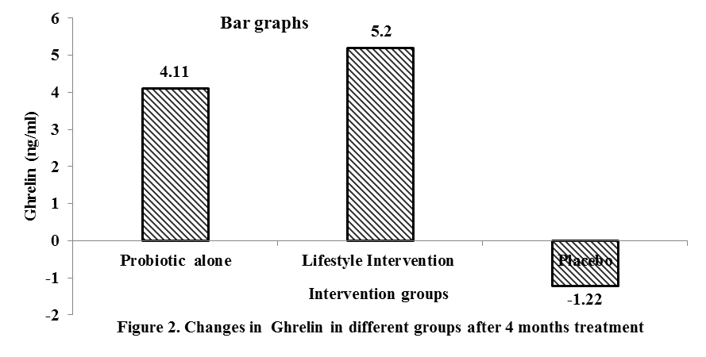
CONCLUSION: Probiotic and lifestyle treatment are effective and observed independently significant changes in BMI, ALT and BG. Both therapies had also beneficial effect on hunger hormones.

Preferred Presentation Type
- Oral


Pooja Goyal has her expertise in Nutrition in clinical researches & passion in improving the health of individuals with right diet. She has particularly dealt with Malnutrition and Clinical Nutrition. She is Registered Dietician (RD) and presently working in Health Department Govt. of Punjab, India. She is having 8 years’ experience in Nutrition field. She is life member of Indian Dietetic Association (IDA) & also Nutrition Society of India (NSI). She has presented her research papers in conferences and also given lectures in schools and colleges. She attended Probiotics conference in 2017 at London, UK and also presented her research work at hypertension conference in Sep, 2019 at London, UK. She has published her research articles in International and National journals. She has done her PhD in Nutrition. She is also active speaker and gives talks about Nutrition on 3rd Eye News Channel.
Email: pooja_goyal9@yahoo.com

