
The American University in Cairo
School of Sciences and Engineering
Chemistry Department
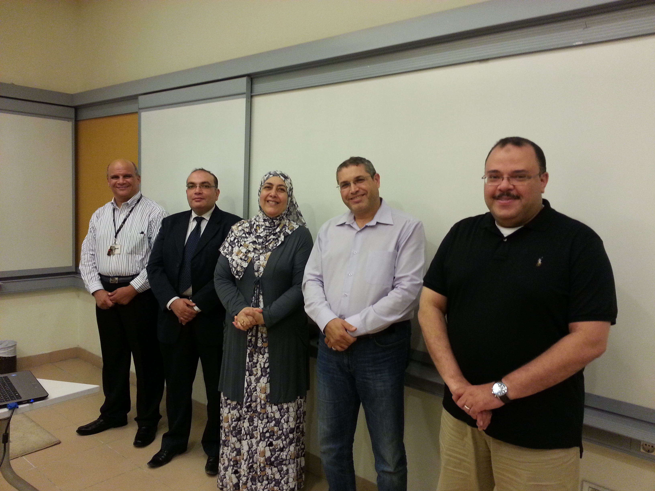
Title: Antimicrobial activity of grape seed and skin extracts coated on Corona treated LDPE and PET films
Scientific Track: Food Science
Full Name: Nahla Mohamed Abdel khalek Khalil

Affiliation: Department of Chemistry, American University/Cairo, Egypt, Zip code: 11765

Abstract
Consumer demand for ready-to-eat ‘fresh’ and safe food products with less synthetic preservatives together with well documented food-borne microbial outbreaks drive both research and food industry toward new innovative methods for microbial growth inhibition while keeping food freshness, quality, and safety. Incorporation of natural bioactive agents in the packaging material to increase the shelf life of meat products is a promising technology. Grapes are of special interest because of their high content of phenolic compounds that showed antimicrobial and antioxidant effects. The aim of the present work was to investigate grape seed (GSE) and skin (GSKE) extracts’ antibacterial activity and developing bioactive LDPE/PET films that could be used as food packaging for poultry and meat products. Commercial corona treated LDPE and PET were coated with either grape seed or grape skin extract. Agar plate diffusion method was used for the investigation of the microbial properties of both extracts’ coated films against E.coli as a Gram-negative bacterium and Staphylococcus aureus as a Gram-negative one. LDPE and PET films coated with GSE showed inhibition zones of E.coli growth in the range of 16-25mm, while Staph.aureus growth inhibition zones were in the range of 15-20mm. For LDPE corona films coated with grape seed extract, the minimum inhibitory concentration (MIC) was 0.002g/1cm² for E.coli and 0.003g/1cm² for Staph.aureus. While for corona treated PET films/GSE, the MIC for both E.coli and Staph.aureus was 0.002g/1cm². Corona treated LDPE and PET coated with GSKE showed inhibition zone range of 13-16.3mm with E.coli and 12-20mm with Staph.aureus. For LDPE corona films/GSKE, the minimum inhibitory concentration (MIC) was 0.0009g/1cm²for E.coli and 0.003g/1cm²for Staph.aureus. While for corona treated PET films/GSKE, the MIC was 0.002g/1cm² for E.coli and 0.003g/1cm² for Staph. aureus. The Total Phenolic Content of both GSE and GSKE was determined using the Folin- Ciocalteu methodology to be 315.32g (GAE)/kg, and 265.326g (GAE)/kg for GSE and GSKE respectively. The coated films; LDPE/GSE or GSKE, were used to wrap fresh chicken fillets, TVC, Pesudmonads, Brochothrix thermosphacta, Lactic acid bacteria and Enterobacteriaceae counts were determined during the storage period; 10 days for test samples and 8 days for controls. Microbiological analysis for tested samples was done on day 0, 2,4, 6, 8, and10, while for control till day 8. There was a reduction in the populations of the examined bacteria in the range of 0.2-1.4 log cfu/g in case of GSE, while with GSKE the reduction of bacterial populations range was 0.3-1.95 log cfu/g.
Biography
I completed my MS in Food Chemistry at the American University in Cairo, School of Sciences and Engineering, Chemistry Department. I’m a Research Assistance at Chemistry Department, American University in Cairo, this thesis will be published soon, and it will be my first published paper. I have started disscussions concerning my PhD with my adviaors at the American University in Cairo, I intend to complete my research focusing on the other important charcteristcs of both grape seed and skin extracts e.g. anticancer and antinflamatory.
Presenting author details
Full name: Nahla Mohamed Abdel khalek Khalil
Contact number: 01001561270
Email address: nana@aucegypt.edu
Category: Oral presentation

