Health related benefits of barley as prebiotic in our diet

Naima Khalid, Ph.D Faculty of Food, Nutrition and Home Sciences
University of Agriculture, Faisalabad Pakistan.

Abstract
Barley has new functional and nutritional properties so has high acceptance in our diet. It was used a staple food in past. It is used as whole dehulled grain as well as flour and semolina. It is used to prepare bread, soups and couscous. Barley has a major component known as β glucan. It is an essential component of soluble fiber suggested for hypoglycemia, hypercholesterolemia and used to reduce chemically induced colon cancer. Barley has recently gain commercial attention and attracted research due to its high content of β-glucan. It has efficient antioxidant activity. β-glucan used in cholesterol reduction, glucose metabolism and improved gastrointestinal function. β-glucan acts as soluble fiber and play an important role in the digestive tract as a prebiotic. It is used to maintain the colonic environment and a healthy colon wall where it is available for fermentation by probiotics. Soluble fiber-based prebiotics are important health-promoting functional foods. Soluble fibers are mainly oligosaccharides (e.g. fructo-oligosaccharides) and polysaccharides such as β-glucan, plant gums and arabinoxylans. It is not digested in stomach and small intestine. It is mainly intact into the colon where available for microbial fermentation.

Table
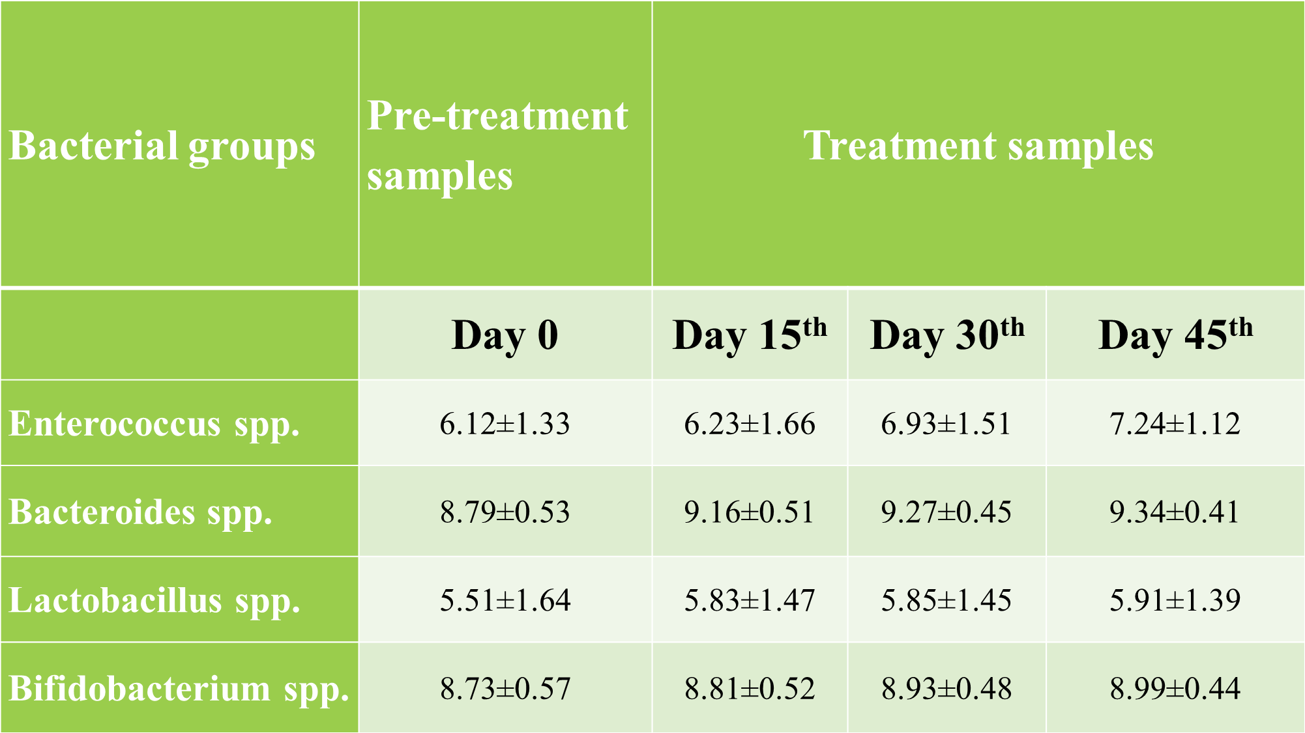


Naima Khalid has her expertise in evaluation and passion in improving the health and wellbeing. She is doing now PhD in Human Nutrition and Dietetics from the faculty of Food Nutrition and Home Sciences, University of Agriculture, Faisalabad Pakistan.
Email: naimamalik51@gmail.com

Notes/Comments

