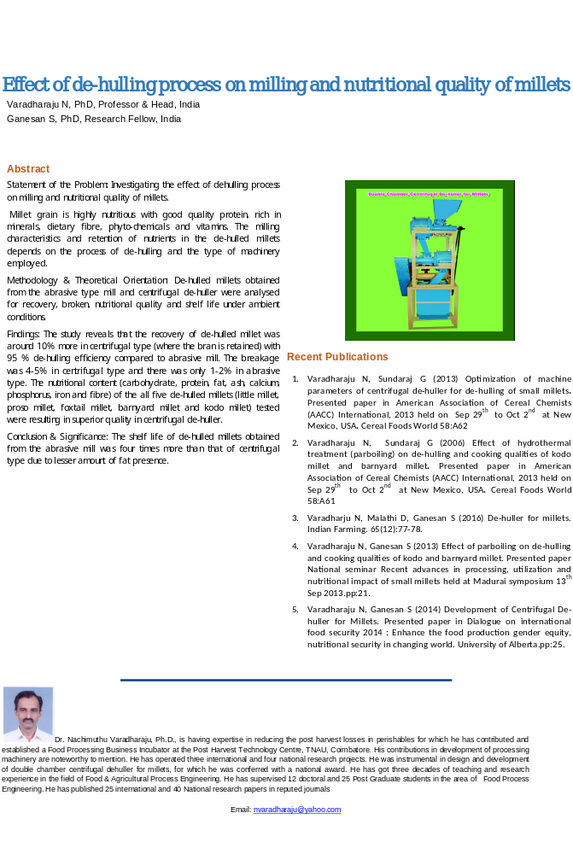Effect of parboiling (thermal treatment) on de-hulling and cooking qualities of little millet (Panicum sumatrense) and foxtail millet (Setaria italic)
Varadharaju N, PhD, Professor & Head, India
Ganesan S, PhD, Research Fellow, India

Abstract
Statement of the Problem: Investigating the effect of parboiling on dehulling process and cooking qualities of millets.
Millet grains are considered to be one of the most important sources of dietary proteins, carbohydrates, vitamins, minerals and fibre for people all over the world. The nutrient composition of millets compares well with other cereals. The tiny "grain" is gluten-free and contains nutrients such as magnesium, calcium, manganese, tryptophan, phosphorus, fibre and antioxidants. Methodology & Theoretical Orientation: De-hulling of little millet (Panicum sumatrense) and foxtail millet (Setaria italic) is a cumbersome process since husk and bran layers are bound tightly on the endosperm and their removal needs a special treatment. To ease the milling process, these millets were subjected to hydrothermal treatment at different levels of soaking temperature (60, 70, 80⁰C), soaking time (6, 7, 8h), steaming periods (10, 15, 20 min.) shade dried and milled in a centrifugal de-huller. The milled samples were analysed for hulling efficiency, head rice recovery, degree of parboiling, hardness, colour, cooking time, water up take and swelling index using standard procedures
Findings: Increase in hulling efficiency (20.8 - 26.5%) was recorded over control in little millet and foxtail millet (20.5 – 25.3%) and the head rice recovery enhanced by 26.7% and 24.8 % in little millet and foxtail millet respectively over the range of experiments conducted. The increase in temperature of soaking, soaking time and steaming period increased the degree of parboiling, hardness (30.8 – 34.2 N in little millet and 32.6-34.5 N in foxtail millet) and cooking time (10.4- 10.8 min.) for both millets. Water uptake and swelling index decreased appreciably due to hydrothermal treatment. The treated samples were dark in colour compared to raw grains and the change in L*, a*,b* values were highly significant.
Conclusion & Significance: The parboiling treatment increased the hulling efficiency and enhanced the head rice recovery in little millet and fox tail millet.

Recent Publications
- Varadharaju N, Sundaraj G (2013) Optimization of machine parameters of centrifugal de-huller for de-hulling of small millets. Presented paper in American Association of Cereal Chemists (AACC) International, 2013 held on Sep 29th to Oct 2nd at New Mexico, USA. Cereal Foods World 58:A62
- Varadharaju N, Ganesan S (2015) Influence of moisture content on physical properties of foxtail millet. Trends in Bioscience. 8(2): 390-395.
- Varadharju N, Malathi D, Ganesan S (2016) De-huller for millets. Indian Farming. 65(12):77-78.
- Varadharaju N, Ganesan S (2015) Influence of moisture content on physical properties of little millet. Trends in Bioscience. 8(2): 384-389.
- Varadharaju N, Ganesan S (2015) Development of Centrifugal De-huller for Millets. Presented paper in Dialogue on international food security 2014 : Enhance the food production gender equity, nutritional security in changing world. University of Alberta.pp:25.

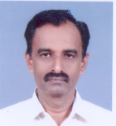Dr. Nachimuthu Varadharaju, Ph.D., is having expertise in reducing the post harvest losses in perishables for which he has contributed and established a Food Processing Business Incubator at the Post Harvest Technology Centre, TNAU, Coimbatore. His contributions in development of processing machinery are noteworthy to mention. He has operated three international and four national research projects. He was instrumental in design and development of double chamber centrifugal dehuller for millets, for which he was conferred with a national award. He has got three decades of teaching and research experience in the field of Food & Agricultural Process Engineering. He has supervised 12 doctoral and 25 Post Graduate students in the area of Food Process Engineering. He has published 25 international and 40 National research papers in reputed journals
Email: nvaradharaju@yahoo.com

Notes/Comments:

