Effect of de-hulling process on milling and nutritional quality of millets
Varadharaju N, PhD, Professor & Head, India
Ganesan S, PhD, Research Fellow, India

Abstract
Statement of the Problem: Investigating the effect of dehulling process on milling and nutritional quality of millets.
Millet grain is highly nutritious with good quality protein, rich in minerals, dietary fibre, phyto-chemicals and vitamins. The milling characteristics and retention of nutrients in the de-hulled millets depends on the process of de-hulling and the type of machinery employed.
Methodology & Theoretical Orientation: De-hulled millets obtained from the abrasive type mill and centrifugal de-huller were analysed for recovery, broken, nutritional quality and shelf life under ambient conditions.
Findings: The study reveals that the recovery of de-hulled millet was around 10% more in centrifugal type (where the bran is retained) with 95 % de-hulling efficiency compared to abrasive mill. The breakage was 4-5% in centrifugal type and there was only 1-2% in abrasive type. The nutritional content (carbohydrate, protein, fat, ash, calcium, phosphorus, iron and fibre) of the all five de-hulled millets (little millet, proso millet, foxtail millet, barnyard millet and kodo millet) tested were resulting in superior quality in centrifugal de-huller.
Conclusion & Significance: The shelf life of de-hulled millets obtained from the abrasive mill was four times more than that of centrifugal type due to lesser amount of fat presence.

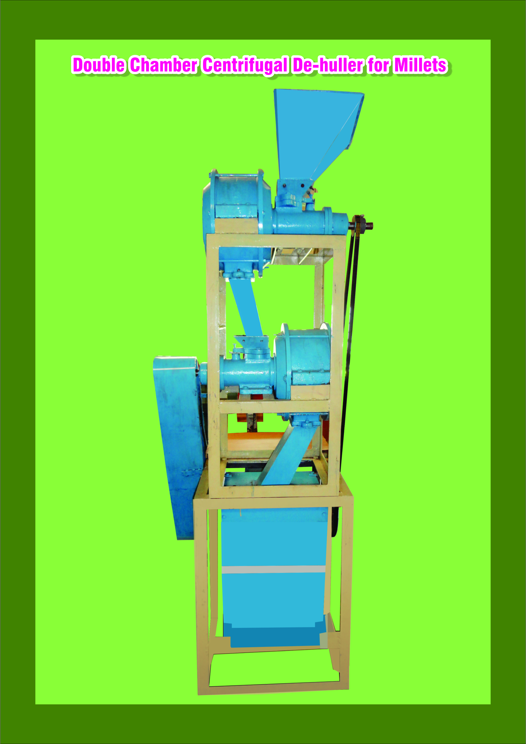
Recent Publications
- Varadharaju N, Sundaraj G (2013) Optimization of machine parameters of centrifugal de-huller for de-hulling of small millets. Presented paper in American Association of Cereal Chemists (AACC) International, 2013 held on Sep 29th to Oct 2nd at New Mexico, USA. Cereal Foods World 58:A62
- Varadharaju N, Sundaraj G (2006) Effect of hydrothermal treatment (parboiling) on de-hulling and cooking qualities of kodo millet and barnyard millet. Presented paper in American Association of Cereal Chemists (AACC) International, 2013 held on Sep 29th to Oct 2nd at New Mexico, USA. Cereal Foods World 58:A61
- Varadharju N, Malathi D, Ganesan S (2016) De-huller for millets. Indian Farming. 65(12):77-78.
- Varadharaju N, Ganesan S (2013) Effect of parboiling on de-hulling and cooking qualities of kodo and barnyard millet. Presented paper National seminar Recent advances in processing, utilization and nutritional impact of small millets held at Madurai symposium 13th Sep 2013.pp:21.
- Varadharaju N, Ganesan S (2014) Development of Centrifugal De-huller for Millets. Presented paper in Dialogue on international food security 2014 : Enhance the food production gender equity, nutritional security in changing world. University of Alberta.pp:25.

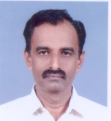Dr. Nachimuthu Varadharaju, Ph.D., is having expertise in reducing the post harvest losses in perishables for which he has contributed and established a Food Processing Business Incubator at the Post Harvest Technology Centre, TNAU, Coimbatore. His contributions in development of processing machinery are noteworthy to mention. He has operated three international and four national research projects. He was instrumental in design and development of double chamber centrifugal dehuller for millets, for which he was conferred with a national award. He has got three decades of teaching and research experience in the field of Food & Agricultural Process Engineering. He has supervised 12 doctoral and 25 Post Graduate students in the area of Food Process Engineering. He has published 25 international and 40 National research papers in reputed journals
Email: nvaradharaju@yahoo.com

Notes/Comments:

