Modulation in growth, gas exchange and antioxidant activities of salt stressed rice (Oryza sativa L.) genotypes by zinc fertilization
Shah Saud¹†, Chen Yajun^{1:} Caowei li¹, Luqman Muhammad², Shah Fahad³ ,,
¹College of Horticulture, Northeast Agricultural University Harbin, Heilongjiang, China 150030
2 College of Landscape Architecture,Northeast Forestry University,Harbin 150040,China

³ College of Plant Science and Technology, Huazhong Agricultural University, Wuhan, Hubei 430070, China
*Corresponding Author: Shah Fahad (shah_fahad80@yahoo.com);
ABSTRACT
Salt stress poses a major threat against rice that is reinforced by Zn deficiency especially in calcareous and alkaline soils due to high pH, calcareousness and climate of arid to semi arid. With the objective to ameliorate the salt stress through exogenous Zn application. There were four rice genotypes (BAS- 2000, KSK- 133, IR- 6 and Bas- 198) were subjected to two salinity levels (control and 70 mM) in the presence of two levels of zinc (control and 15.00 mgkg⁻¹ ). Results revealed that salinity stress adversely affected the biochemical, morphological, physiological activities of all rice genotypes. The application of Zn significantly improved the crop performance both under saline and non-saline conditions. Studies further exhibited that KSK-133 found leading genotype at salt stressed conditions by showing less reduction in plant growth attributes i.e plant biomass, SPAD value, stomatal conductance, photosynthetic rate, transpiration rate, antioxidant enzymes i-e Superoxide dismutase (SOD) and Catalase (CAT) activities, Zn concentration and K⁺/Na⁺, relative to percent of control treatment. The results of our experiment clearly indicated that under salt stressed conditions KSK-133 performed well then BAS- 2000 and IR- 6while genotype Bas- 198 was observed sensitive against salinity stress. In case of non-saline conditions by Zn application, Basmati-2000 performed well compared to others.
Key words: salt stress, gas exchange, chlorophyll contents, antioxidant enzymes, K⁺/Na⁺ ratio
Introduction
Soil salinity is a global environmental challenge to sustainable agriculture which has been increasing over the time [1]. As indicated by [2], more than 800 million ha will be influenced by salinity in future, making it a noteworthy requirement to sustenance creation for an enduring expanding population. Salt negative impact on plant development have at first been connected with the osmotic stress created by decline in soil water potential and subsequently, limitation of water uptake by roots [3]. Soil salinity in general reduces the plant growth or may lead to plant death due to osmotic ions toxicity and nutrient imbalance [4.5]. Generally a variation was observed among the rice cultivars performance regarding its growth stages against saline conditions. The saline sensitive stages are vegetative and reproductive stages as compared to its germination stage [6]. For the evaluation of rice response against salinity stress several studies were conducted. The phenotypic response of FL-478 (Salt tolerant) and IR-29 (Salt sensitive) were studied at vegetative growth stage. It was concluded that the rice cultivar FL-487 accumulate low Na+ to K+ ratio in leaf which was evaluated as a salt tolerant rice cultivar.
Zinc nutrition have a vital role for plant growth, development and different metabolic process such as carbohydrates metabolism, expression and regulation of genes, development of cell wall and respiration. Among the crops disorders, the deficiency of Zn is considered as wide micronutrient disorder which is mostly common in rice fields where actually reduced conditions exist [7].
Zinc deficiency results due the inhibitory effect of Zn with alkaline earth metal cations which are dominant in salt-affected soils and ultimately result into Zn deficiency [8]. The application of Zn reduces the activity of membrane bound NADPH oxidase which have a key role in delivering reactive oxygen species [9] and reduce photo oxidation while improve the activity of SOD and CAT [10]. Zinc assume a crucial part in a few basic cell functions, for example, metabolism of protein and indole acetic acid [11]. Moreover, Zn addition relieves the adverse impact of NaCl [9]. In submerged soils the deficiency of the Zn may result due to the formation of insoluble ZnCO₃ (partial pressure of CO₂ coupled with decomposition of OM), ZnS (due to the intensively reduced conditions) and insoluble franklinite (ZnFe₂O₄) under submerged conditions and insoluble Zn (OH)₂ at alkaline pH [12].
The use of Zn under saline conditions can suppress the uptake of Na and Cl from root to leaves [13]. The current study conducted with the objectives to assess the Zn function in alleviating the salinity stress for rice growth and its role for nutrient uptake under saline conditions.
Materials and methods
Plant material, growth and treatment condition:
A hydroponic study was performed at Agriculture Research Centre (ARC), Northeast Agriculture University Harbin, and china. Seeds were collected from Kala Shah Kaku, Research Station, and Punjab, Pakistan. Seeds of 4 rice genotypes (Oryza sativa L.) i.e. BAS- 2000, Bas- 198 KSK- 133, IR- 6 were sown in iron trays having washed sand. Separate iron tray was used for each rice genotype during germination. Water was spread daily over these iron trays to sustain optimum moisture. When seedling growth reached at two leaf stage (after 8 days of sowing), the seedlings of each rice genotype were transplanted in holes of thermopal sheet with the help of foam wrapped at shoot root junction, suspended on 100 L iron tub, having ½ strength Yoshida nutrient solution [10]. The composition of the basic nutrient media was (gL⁻¹): (NH₄NO₃ 91.4, MgSO₄.7H₂O 324, K₂SO₄ 71.4, CaCl₂ 88.6, NaH₂PO₄.2H₂O 40.3, MnCl₂.4H₂O 1.5, ZnSO₄.7H₂O 0.035, CuSO₄.5H₂O 0.031, H₃BO₃ 0.934, FeCl₃.6H₂O 7.70, (NH₄)₆Mo₇O₂₄.4H₂O 0.074 and Citric acid (monohydrate) 11.9. The solution of culture was renewed once a week. Completely randomize design (CR D) with factorial arrangement was used with four replicates. After the transplanting of four days, salinity treatments (control, 70 mM) and Zn treatments were applied (control and 15 mg kg⁻¹) using sodium chloride and Zn-EDTA. The solution pH was adjusted to 5.5±0.5 throughout the experiment with 1 M NaOH or HCl. The desired level of EC was developed by using NaCl salt and measured with EC meter.
Plant growth and biomass measurement:
Four weeks after transplantation, plants were separated into shoots and roots and dried at 75 ⁰C for 48 h and plant height, fresh and dry weight of shoot and root were measured. .

Measurements of SPAD value, Antioxidant enzymes activity and Gas Exchange parameters:
The chlorophyll contents were measured with a chlorophyll meter (Minolta Co. Ltd., Japan). The activities of enzymes like catalase (CAT) and superoxide dismutase (SOD) measured by the method of [14.15] respectively. A portable Infra-red gas analyser (ADC Bio-scientific Ltd., UK) was used to measure the gas exchange parameters including net photosynthetic rate(A), transpiration rate(E), stomatal conductance(gs) and intracellularCO₂ concentration (Ci).
Plant harvest:
Shoot and root samples (1.0 g) were digested in a di-acid (HNO₃:HClO₄ ratio of 2:1) mixture [16]. The concentration of Zn was measured by using atomic absorption spectro photometer (AASP) (PerkinElmer, 100 Analyst, Waltham, USA). The concentration of K⁺, Na⁺ was measured by using Sherwood-410 Flame Photometer.
Statistical analysis
All values are means for four replicates. The data was analyzed by using the analysis of variance (ANOVA) with two factors performed using, SPSS form 16.0 (SPSS, Chicago, IL). Least Significant Difference (LSD) test was adopted for the comparison of treatment means.
Results
Plant growth and chlorophyll contents
The plant growth of all rice genotypes i-e plant height, fresh and dry biomass of shoot, and chlorophyll contents reduced significantly under NaCl salinity stress. In case of both non-saline and saline, soil applied Zn increased these growth related parameters (Figures 1A, 1B, 2A and 2B). The application of Zn increased shoot fresh and dry weight, plant height and chlorophyll contents under non-saline conditions by applying Zn- ED TA. In case of saline condition, highest performance was observed in KSK- 133 rice genotype while minimum performance was observed in Bas-198but in case of non-saline condition no significant difference was observed.
Antioxidant enzymes activities
An increase in the antioxidant enzyme activity was seen in the plant exposed to salinity. Zinc application additionally increased the activity of these two enzymes under saline and non saline conditions, and demonstrated its part in increasing salt resilience. Effects of salinity on CAT and SOD activities were genotypic dependent; genotype KSK-133 and Basmatii-2000 were not much affected as the other genotypes showed reduction under saline conditions (Fig. 3A and 3B).
Salt stress significantly reduced the gas exchange parameters i-e rate of photosynthetic and transpiration, stomatal conductance and internal CO₂ concentration. Effect of Zn application significantly increased the photosynthetic rate, transpiration rate, stomatal conductance and internal CO₂ concentration (Fig. 4A, 4B, 5A and 5B). The application of Zn under both non-saline and saline increased the gas exchange parameters i-e rate of photosynthetic and transpiration, internal CO₂ concentration and stomatal conductance. Among the genotypic response there was no significant difference was observed under non-saline condition while in case of saline condition KSK- 133 performed best while lower performance was observed in Bas-198.
Leaf Ionic Concentrations
The leaf ionic concentration like Zn and K were reduced under saline condition (Fig. 6A, 6B and 7). A huge increment was observed only in case of Na. In case of saline condition, rice genotype Bas-198 accumulated more sodium then the remaining ones genotypes. A contradictory affect was observed among soil applied Zn and saline condition. The application of Zn increased the concentration of Zn and K while decreased the sodium concentration under both non-saline and saline conditions. In case of Zn concentration soil applied Zn increased the Zn concentration while a reduction was observed in Zn concentration under saline conditions.
Discussion
Plant growth parameters including plant height, fresh and dry biomass and chlorophyll contents significantly reduced under saline condition. The application of Zn increased all the attributes under both non-saline and saline condition. Actually, plant roots which have a direct contact with the medium and considered as the plant nutrient suppliers which provides very helpful information about the potential of salt tolerance. Salinity stress adversely decreased the growth of root actually it was already reported that rice root are more sensitive to salt stress under solution medium which results into a reduction in root growth [16]. Plant growth parameters and plant biomass was significantly reduced by increasing salinity. In case of rice crop same finding were reported by [17]. Some other researchers [18] also observed same findings for cereals and especially for rice [19]. Increasing salinity decreased the shoot and the root length and the seedling dry weight of rice genotypes [20].
An increase in the antioxidant enzyme activity was seen in the plant exposed to salinity. Zinc application additionally increased the activity of these two enzymes under control and saline conditions, and demonstrated its part in increasing salt resilience. Changes in the activity of antioxidants enzymes like SOD and CAT were also observed under salinity stress in our study. The activity of SOD and CAT decreased under saline environment which is also widely studied by [7] they observed that even the NaCl minute concentration speed up the antioxidant enzymes activities. Changes in the antioxidant enzyme activities under salinity stress is also reported by [22]. Zinc application increased the activity of SOD and CAT which is also widely studied by [23]. Zn increased the activity of SOD and CAT which have a key role to scavenge and detoxify the reactive oxygen species [24].
Salt stress significantly reduced the gas exchange parameters i-e rate of photosynthetic and transpiration, stomatal conductance internal and CO₂ concentration were significantly reduced. Effect of Zn application significantly increased the internal CO₂ concentration, transpiration rate, stomatal conductance and photosynthetic rate. A significant decrease in gas exchange parameters of all rice genotypes was observed due to salinity. The adverse effect of salinity reduced the transpiration rate and rate of CO₂ fixation. This effect has been widely studied by some other researchers [25] which results due to mesophyll limitations and stomatal closure [26.27]. The application of Zn improved assimilation rate of CO₂ and transpiration rate in our study. These results were also observed under control and saline conditions; Zn mitigating role the adverse effect of salinity becomes clear. Zinc application on photosynthesis enhancing effect was obtained in the experiments of [28]. These effects might be due to Zn role in many enzyme systems [24]. Zinc is also involve in many photosynthetic enzymes like Ribulose bisphosphate carboxylase and Carbonic anhydrase which have an important role in the CO₂ fixation [29]. Both of these enzymes have a key role in process of photosynthesis and any modification in these enzymes activities results into several effects on photosynthetic rate [30].
The contents of Zn, Na and K concentration varied under salinity stress in the current study. Except the Na, the concentration of Zn and K decreased with imposition of salt stress. Same other findings are also studied by [31.32]. Zn application decreased Na contents while Zn and K contents increased. Similar observations also observed by [33. 34] because the chelated sources having the ability to minimize counteract with the soil compaction and prevent the Zn losses because Zn is bounded with the ligand [35].

Conclusion
In conclusion, we conclude that Zn application significantly improved the uptake of some nutrients based on these results. Zn application decreased the Na contents and while increased K and Zn contents which caused the improvement in the growth of rice through turgor maintenance and increase in net CO₂ assimilation rate (Pn) under both normal and saline conditions. Application of Zinc also enhanced the activity of SOD and CAT under salinity stress. The above described results are in agreement with the proposed hypothesis and further it is an indication of strategy for rice production under saline condition. However further investigation is required to study Zn role in searching the reactive oxygen species and zinc connection with different supplements is still obliged a get a reasonable picture to exploring its part in nutrient uptake. Under saline conditions Zn accessibility is restricted so the use of chelated source is by all accounts the best technique to conquer the disturbances due to salinity.
ACKNOWLEDGMENT
The author wish to thank M. Anwar ul Haq and Javaid Akhtar for their technical and moral support. This study was funded by Higher Education Commission Pakistan.

References
- Ashraf M, Foolad MA (2007) Improving plant abiotic-stress resistance by exogenous application of osmoprotectants glycine betaine and proline. Environ Exp Bot 59:206-216. doi.org/10.1016/j.envexpbot.2005.12.006.

- FAO (2008) Food and Agriculture Organization Global network on integrated soil management for sustainable use of salt-effect soils. Rome: FAO Land and Plant Nutrition Management Service
- Munns R, Tester M (2008) Mechanisms of salinity tolerance. Annu Rev Plant Biol 59:651-681.
- 4 .Tao, WK, Chern J, Atlas R, Randall D, Lin X, Khairoutdinov M, Li J, Waliser D, Hou A, Peters-Lidard C, Lau W, Simpson, J (2008) Multi-scale modeling system Development, applications and critical issues. BAMS. doi.org/ 10.1175/2008BAMS2542.1.
- Afifi M, M. Saker, M Ahmed, Khatab S (2010) Morphological and Physiological Studies on the effect of salinity and growth promoters on rice plant. Acta Agronomice Hungarica 58:11-20. doi: 10.1556/AAgr.58.2010.1.2.
- Zhao A, Yang S, Wang B, Tian X, Zhang Y (2018) Effects of ZnSO₄ and Zn-EDTA broadcast or banded to soil on Zn bioavailability in wheat (Triticum aestivum L.) and Zn fractions in soil. Chemosphere 205: 350-360. doi.org/10.1016/j.chemosphere.2018.04.115
- Wang H, and J Jin (2005) Photosynthetic rate, chlorophyll fluorescence parameters, and lipid peroxidation of maize leaves as affected by zinc deficiency. Photosynthetica. 43:591-596. doi.org/ 10.1007/s11099-005-0092-0.
- Gramlich A, Tandy S, Frossard E, Eikenberg J, Schulin R. 2013. Availability of zinc and the ligands citrate and histidine to wheat: does uptake of entire complexes play a role? J
  - Agric Food Chem. 61:10409-10417. doi:10.1021/jf401117d. Epub 2013 Oct 22.

- Cakmak I (2000) Possible roles of zinc in protecting plant cells from damage by reactive oxygen species. New Phytol 146: 185–205. Doi.org/10.1046/j.1469-8137.2000.00630.x
- Yoshida S, Forno AD, Cock JH Gomez KA (1972) Laboratory manual for physiological studies of rice. IRRI Los Banos Philippines p. 66
- Marschner H (2011) Marschner's mineral nutrition of higher plants. Academic press .

- Bouis HE, Hotz C, McClafferty B, Meenakshi JV, Pfeiffer WH (2011) Biofortification: A new tool to reduce micronutrient malnutrition. Food Nutr Bull 32: S31–S40. doi:10.1177/15648265110321S105.
- Saleh J, Maftoun M (2008) Interactive effect of NaCl levels and zinc sources and levels on the growth and mineral composition of rice. Agri Sci Technol 10: 325-336
- Chance M, Maehly AC (1955) Assay of catalases and peroxidases. Methods Enzymol 2:764-817. doi.org/10.1016/S0076-6879(55)02300-8
- Giannopolitis CN, Ries SK (1977) Superoxide dismutases. Occurrence in higher plants. Plant Physiol 59:309-14. doi.org/10.1104/pp.59.2.309.
- Jones JRJ, Case VW (1990) Sampling, handling, and analysing plant tissue samples. In Soil Testing and Plant Analysis, Westerman RL (ed.). pp. 389-428 SSSA Madison WI USA
- Ashraf M (2004) Some important physiological selection criteria for salt tolerance in plants. Flora 199: 361–76. doi.org/10.1078/0367-2530-00165
- Garcia MS, Trejo-Tellez LI, Gomez FC Merino Caldana F, Espinosa-Victoria D, Herrera BEC (2012) Growth, photosynthetic activity, and potassium and sodium concentration in rice plants under salt stress Acta Sci Agron 34: 317-324. doi.org/10.1590/S1807-86212012000300012.
- Rajendran K, Tester M, Roy R (2009) Quantifying the three main components of salinity tolerance in cereals. Plant Cell Environ 32: 237-249. doi.org/10.1111/j.1365-3040.2008.01916.x.
- Rad HE, Aref F, Rezaei M (2000) Rice growth and yield components respond to changes in water salinity stress. World Applied Sci 20: 997-1007. doi. 10.5829/idosi.wasj.2012.20.07.157
- Wang M, Zou J, Duan X, Jiang W, Liu D (2007) Cadmium accumulation and its effects on metal uptake in maize Zea maysL. Bioresour Technol 98:82–88. doi: 10.1016/j.biortech.2005.11.028.
- Venkatesan A, Sridevi S (2009) Response of antioxidant metabolism to NaCl stress in the halophyte salicorniabrachiataroxb. J Phytology 4: 242-248
- Hendawy SF, Khalid KA (2005) Response of sage (Salvia Officinalis L.) plants to zinc application under different salinity levels. J Appl Sci Res 1(2); 147-155
- Weisany S, Yousaf H, Gholamreza S, Adel KG (2012) Changes in antioxidant enzymes activity and plant performance by salinity stress and zinc application in soybean (Glycine max L.). Plant Omics Journal 5(2): 60-67
- Athar H, Ashraf M (2005) Photosynthesis under drought stress. In: Pessarakli, M. (Ed.), Handbook of Photosynthesis, Second Ed. CRC Press New York pp. 795–810.
- Liang Y, Sun W, Zhu YG, Christie P (2007) Mechanisms of silicon-mediated alleviation of abiotic stresses in higher plants: A Review Environ Pollution 147: 422-428. doi.org/10.1016/j.envpol.2006.06.008.
- Foyer CH, Noctor G (2003) Redox sensing and signaling associated with reactive oxygen in chloroplasts, peroxisomes and mitochondria. Physiol Plant 119:355-364. doi.org/10.1034/j.1399-3054.2003.00223.x
- Misra A, Srivastava AK, Srivastava NK, Khan A (2005) Zn-acquisition and its role in growth photosynthesis photosynthetic pigments and biochemical changes in essential monoterpene oil(s) of Pelargonium graveolens Photosynthetica 43(1): 153-155. doi.org /10.1007/s11099-005-3155-3.
- Bouis HE, Welch RM (2010) Biofortification: A sustainable agricultural strategy for reducing micronutrient malnutrition in the global south. Crop Sci 50: S20–S32.doi: 10.2135/cropsci2009.09.0531.
- Hussein M, Alva A (2002) Effects of zinc and ascorbic acid application on the growth and photosynthetic pigments of millet plants grown under different salinity. Agric Sci 5:1253. doi.org/10.4236/as.2014.513133.
- Tavallali V, (2010) Zinc alleviates salt stress and increases antioxidant enzyme activity in the leaves of pistachio (PistaciaveraL.‘Badami’) seedlings. Turk J Agri For 34: 349-359. doi:10.3906/tar-0905-10.
- Dubey RS (2005) Photosynthesis in plants under stressful conditions. In: Pessarakli, M (Ed.) Handbook of Photosynthesis Second Ed. CRC Press New York pp. 717-718
- Hacisalihoglu G, Kochian LV. 2003. How do some plants tolerate low levels of soil zinc?
- Mechanisms of zinc efficiency in crop plants. New Phytol. 159:341-350. doi.org/10.1046/j.1469-8137.2003.00826.x.
- Prasad B, Kumar M, Prasad J (1989) Direct residual effect of organic wastes and zinc sulphate on zinc availability under cropping sequence of wheat (Triticum aestivum)-rice (Oryza sativa) in calcareous soil. Indian Agric Sci 59: 300–305. doi.org/10.1146/annurev.arplant.59.032607.092911.
FIGURE LEGENDS
Fig 1: Effect of NaCl and zinc application on shoot fresh and dry weight (g) weight (g) of four rice genotypes; the averagevalue ±standarddeviation of four measurementsfor treatment performed twice a week.

Fig 2: Effect of NaCl and zinc application on plant height (cm) and Chlorophyll content (SPAD value) of four rice genotypes; the averagevalue ±standarddeviation of four measurementsfor treatment performed twice a week.

Fig 3: Effect of NaCl and zinc application on CAT activity (U mg⁻¹ protein) and SOD activity (U mg⁻¹ protein) of four rice genotypes; averagevalue ±standarddeviation of four measurementsfor treatment performed twice a week.

Fig. 4: Effect of NaCl and zinc application on photosynthetic rate (μmol CO₂ m⁻² s⁻¹) and transpiration rate (mmol H₂O m⁻² s⁻¹) of rice genotypes; averagevalue ±standarddeviation of four measurementsfor treatment performed twice a week.

Fig. 5: Effect of NaCl and zinc application on stomatal conductance (mmol H₂O m⁻² s⁻¹) and internal CO₂ concentration (μmol H₂O mol⁻¹) of rice genotypes; averagevalue ±standarddeviation of four measurementsfor treatment performed twice a week. .

Fig 6: Effect of NaCl and zinc application on leaf Na⁺ concentration (mmol m⁻³) and leaf K⁺ concentration (mmol m⁻³) of four rice genotypes; averagevalue ±standarddeviation of four measurementsfor treatment performed twice a week.

Fig 7: Effect of NaCl and zinc application on Leaf Zn concentration (mg kg⁻¹)of four rice genotypes; the averagevalue ±standarddeviation of four measurementsfor treatment performed twice a week.

FIGURES
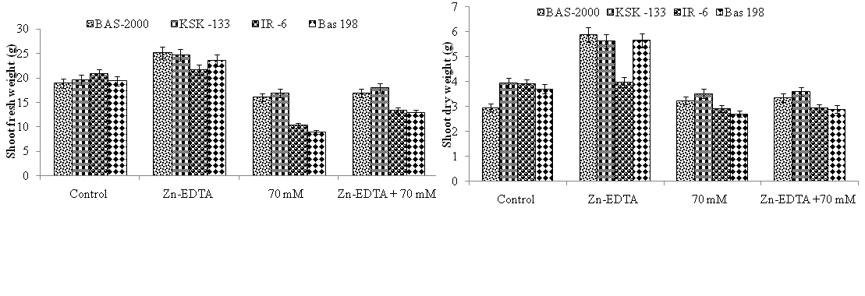
B
A
Fig 1: Effect of NaCl and zinc application on A) shoot fresh and B) shoot dry weight (g) weight (g) of four rice genotypes; the averagevalue ±standarddeviation of four measurementsfor treatment performed twice a week.
.
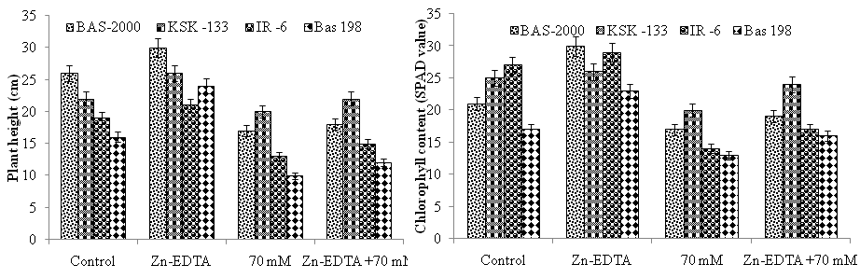
B
A
Fig 2: Effect of NaCl and zinc application on A) plant height (cm) and B) Chlorophyll content (SPAD value) of four rice genotypes; the averagevalue ±standarddeviation of four measurementsfor treatment performed twice a week.

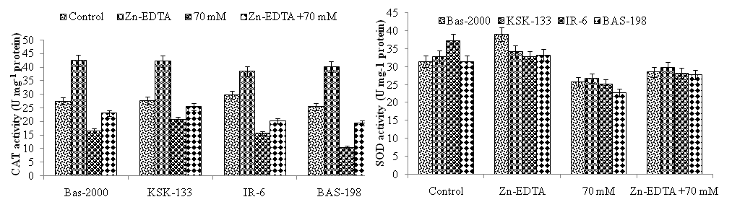
A
B

Fig 3: Effect of NaCl and zinc application on CAT activity (U mg⁻¹ protein) and SOD activity (U mg⁻¹ protein) of four rice genotypes; the averagevalue ±standarddeviation of four measurementsfor treatment performed twice a week
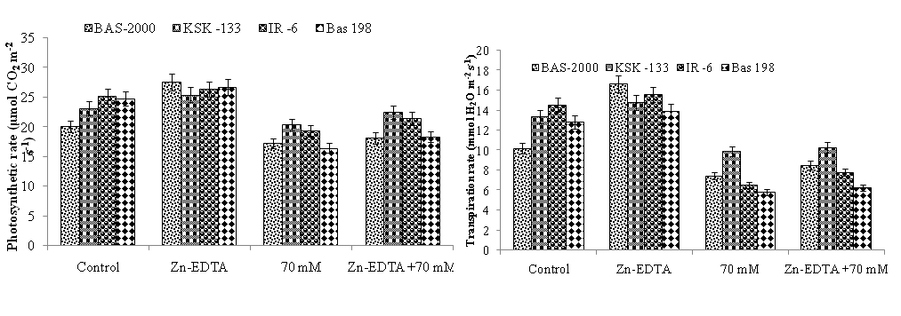
A
B
Fig. 4: Effect of NaCl and zinc application on photosynthetic rate (μmol CO₂ m⁻² s⁻¹) and transpiration rate (mmol H₂O m⁻² s⁻¹) of rice genotypes; the averagevalue ±standarddeviation of four measurementsfor treatment performed twice a week
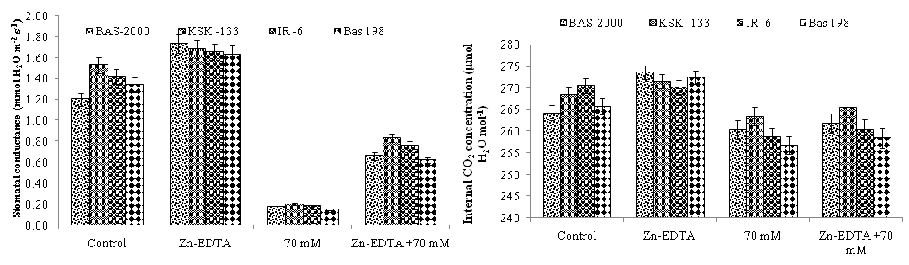
A
B
Fig. 5: Effect of NaCl and zinc application on stomatal conductance (mmol H₂O m⁻² s⁻¹) and internal CO₂ concentration (μmol H₂O mol⁻¹) of rice genotypes; averagevalue ±standarddeviation of four measurementsfor treatment performed twice a week
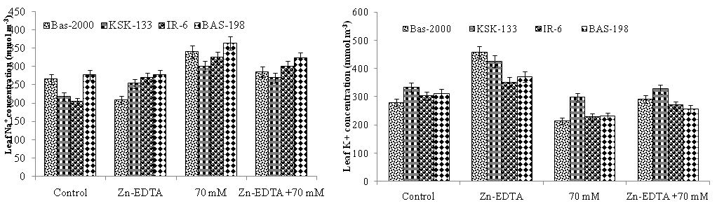
A
B
Fig 6: Effect of NaCl and zinc application on leaf Na⁺ concentration (mmol m⁻³) and leaf K⁺ concentration (mmol m⁻³) of four rice genotypes; the averagevalue ±standarddeviation of four measurementsfor treatment performed twice a week.
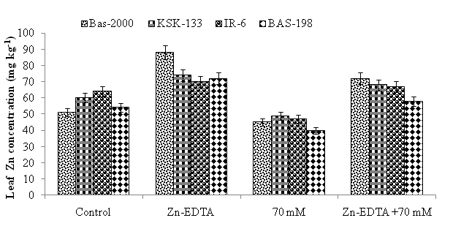
Fig 7: Effect of NaCl and zinc application on Leaf Zn concentration (mg kg⁻¹) of four rice genotypes; the averagevalue ±standarddeviation of four measurementsfor treatment performed twice a week.

