Evolution of the lactic acid bacterial biofilms on different wood typologies applied for the production of vats intended for cheese making

Raimondo Gaglio ^{1,2}, Margherita Cruciata ¹, Maria Luisa Scatassa ², Giovanna Sala ¹, Marisa Palmeri ², Cinzia Cardamone ², Giancarlo Moschetti ¹, Tommaso La Mantia ¹, Luca Settanni ¹

¹ Dipartimento Scienze Agrarie, Alimentari e Forestali, Università di Palermo, Viale delle Scienze 4, 90128 Palermo, Italy
² Istituto Zooprofilattico Sperimentale della Sicilia “Adelmo Mirri”, Via G. Marinuzzi 3, 90129, Palermo, Italy

Abstract (300 word limit)
The present work was carried out to evaluate the lactic acid bacterial biofilms formation on wooden vat produced with seven different woods, derived from trees species grown in Sicily. The biofilm formation on the wooden surfaces was performed as reported by Gaglio et al. (2016). Microbiological and scanning electron microscopy analyses did not show differences in terms of microbial levels and composition within the neoformed biofilms (Fig.1). The specific investigation of Salmonella spp., Listeria monocytogenes, Escherichia coli and positive-coagulase staphylococci did not generate any colony for all vats before and after microbial activation. Lactic acid bacteria (LAB) populations dominated the surfaces of all vats and the highest concentration of approximately 7.63 Log CFU/cm² was registered for thermophilic cocci. All colonies of different morphologies were isolated and characterized for their physiological and biochemical characteristics before being investigated genetically at strain level by RAPD-PCR and species level by a polyphasic approach consisting of 16S rRNA gene sequencing. As reported in a preview investigation conducted on wooden vat surfaces (Di Grigoli et al. 2015; Licitra et al. 2007; Scatassa et al. 2015) we found species within the genera Enterococcus, Lactobacillus, Lactococcus and Streptococcus. The species most frequently present were Lactobacillus fermentum and Lactococcus lactis. The technological characterization of the LAB found at high numbers onto the surfaces of the wooden vats showed interesting dairy properties. In order to deeply investigate on the safety of the wooden vat, test of artificial contamination on new Calabrian chestnut vats were carried out showing that the acidity and the bacteriocin generated by LAB represent efficient barriers to their adhesion (Lortal et al., 2009). This study highlights the importance to use the wooden vats for traditional cheese production and provides evidences for their safety in terms of bacterial community evolution.

Image

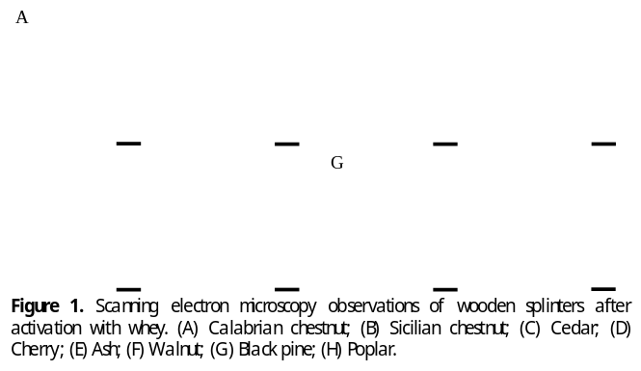
Recent Publications (minimum 5)
- Di Grigoli A et al. (2015) The influence of the wooden equipment employed for cheese manufacture on the characteristics of a traditional stretched cheese during ripening. International Journal of Food Microbiology 46:81-91.
- Licitra G et al. (2007) Variability of the bacterial biofilms of the “tina” wood vat used in the Ragusano cheese making process. Applied and Environmental Microbiology 73:69806987.
- Lortal S et al. (2009) Tina wooden vat biofilm. A safe and highly efficient lactic acid bacteria delivering system in PDO Ragusano cheese making. International Journal of Food Microbiology 132:1-8.
- Gaglio R et al. (2016) Microbial activation of wooden vats used for traditional cheese production and evolution of neoformed biofilms. Applied and Environmental Microbiology 82:585-595.
5. Scatassa ML et al. (2015) Transfer, composition and technological characterization of the lactic acid bacterial populations of the wooden vats used to produce traditional stretched cheeses. Food Microbiology 52:31-41.

Biography
Raimondo Gaglio (Ph.D.) is Post-Doc in Agricultural Microbiology at University of Palermo (Italy), Department of Agricultural, Food and Forest Sciences. He is also a contract collaborator of Institute for Experimental Veterinary Medicine of Sicily (Palermo). His research topics of are mainly included in the food microbiology field, considering several genetic, physiological and technological aspects of lactic acid bacteria isolated from fermented food matrices, different biopreservation strategies and hygienic safety of food products. He has been co-author of of 22 publications in various journals. His publications reflect his research interests in the field of food microbiology.
Email: raimondo.gaglio@unipa.it

