Polyphenols from potato (Solanum tuberosum L.) tubers: during growth and storage and their anticancerous effect on animal cell lines.
Gurpreet Kaur, Yadveer Kaur and Niranjan Das,
Department of Biotechnology, T.I.E.T Patiala, Punjab, India
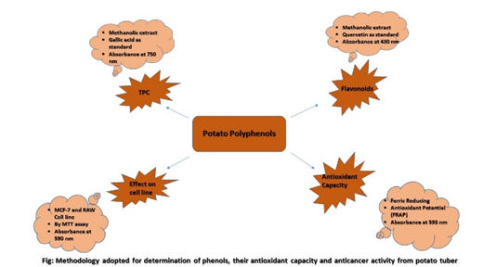
E-mail: gsainibt@gmail.com, ndas@thapar.edu

Abstract

Polyphenols are the secondary metabolites in plants which play crucial role in cell defence; also,being antioxidants they lower the risk of developing some chronic and fatal diseases like diabetes, heart attacks and cancer. Thus, it is pivotal to study the polyphenols .Many plant species are known to contain different types of polyphenols. The intracellular level of polyphenols depends on the type of organs and their developmental stages and storage conditions. Potato (Solanum tuberosum L.) is the most important non-grain food crop and known to be rich in polyphenols particularly in tubers. In this study, polyphenols were isolated from methanolic extracts of the field-grown tubers of different Indian potato cultivars at different stages of growth and tubers stored at different storage conditions. Apart, from this some locally available varieties were also used in this study. The methanolic extracts from the field grown and market tubers estimated spectrophotometrically. The effect of various temperature storage conditions were studied. Their antioxidant potential was also measured. The effect of polyphenolic extracts were also studied on various cell lines like breast cancer (MCF-7) and macrophages (RAW246.7) by the MTT essay. From the studies it could be deduced that developmental stage and storage conditions significantly effects the polyphenolic content of potato tubers. A potential decrease in cell viability marked the anticancerous properties of these plant metabolites. Therefore, plant-based polyphenols serve as potential additives in various food products and nutraceuticals.

- Albishi T, John JA, Al-Khalifa AS, Shahidi F (2013) Phenolic content and antioxidant activities of selected potato varieties and their processing by-products. Journal of Functional Foods 5: 590-600
- Andreu AB (2018) Chemical characterization of polyphenol extracts from Andean and indus-trial Solanum tuberosum tubers and their cytotoxic activity on human hepatocarcinoma cells. Journal of Food Science & Technology 2: 205-217
- Apel K, Hirt H (2004) Reactive oxygen species: metabolism, oxidative stress, and signal transduction. Annu. Rev. Plant Biol. 55:373–399
- Boguszewska D, Grudkowska M, Zagdañska B (2010). Drought-responsive antioxidant enzymes in potato (Solanum tuberosum L.).Potato Res.53:373–382.
- Sugata, M, Lin CY, Shih YC (2015) Anti-inflammatory and anticancer activities of Taiwanese purple-fleshed sweet potatoes (Ipomoea batatas L. Lam) extracts. BioMed research international 1-10


Biography
Gurpreet Kaur has her expertise in plant molecular biology, biochemistry and in silico biology. She is recently focusing on genes involved in potato tuberization.Apart from this she has proliferated research domains to animal tissue and plant tissue culture. She also has keen interest in biodiesel production and biodegradable polymer formation. Sugars in ROS signaling in plants is in her bucket list. Moreover, she is always keen to learn new techniques.
go here
Email: gsainibt@gmail.com

Twitter account:
Notes/Comments:

Presenting author details
Full name: Gurpreet Kaur
Contact number: +91-788901-0466
Linked In account:
Session name/ number:
Category: (Oral presentation/ Poster presentation)

