Electronic water can reduce oxidative stress in cancer and diabetes patients for 3 weeks drinking.
Masahiro Onuma President of Trisguide ltd Japan

Oxidative stress means a state there is imbalance between the oxidizing action and the reducing action due to reactive oxygen species (ROS) in a living body, resulting in the oxidizing action becoming dominant. Oxidative stress arises as the balance between production and removal is disrupted through excessive production of ROS and impairment of the antioxidant system. Oxidative stress has been reported to be involved in the onset and progress of various diseases. Characteristics of Type 2 diabetes are insulin secretion failure and insulin resistance, but it seems that oxidative stress is greatly involved in insulin secretion failure. In the insulin secretion-inducing β cells of Langerhans islets in the pancreas, the amount of superoxide dismutase (SOD), which is representative of the ROS elimination system, is small and resistance to oxidative stress is considered to be weak. Regarding cancer, it is well known that chronic inflammatory conditions increase the risk of carcinogenesis. Cells such as neutrophils and macrophages are activated in the inflammation area leading to increase in production of active oxygen and nitric oxide. These free radicals cause DNA mutation and cell proliferation thereby promoting cancer development. When chronic inflammation is present, cancer develops more easily.
Electronic water, which was developed to generate electron in water, was consumed for three weeks, after meals, between meals and before sleeping 6 times a day, and according to the test subjects' possible time periods. The amount of drinking water was 750-1000 mL, and BAP and d-ROMs checks for all cases were carried out at 4:30 pm. The results of cancer patients and diabetes patients were seen as attached.
As a result, the d-ROMs value in the degree of oxidative stress has reduced, and the BAP value, which is an indicator of plasma antioxidant capacity, has improved significantly.

Image
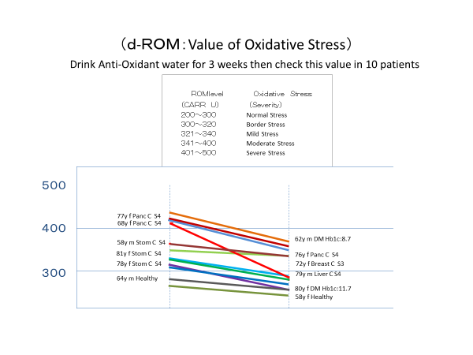
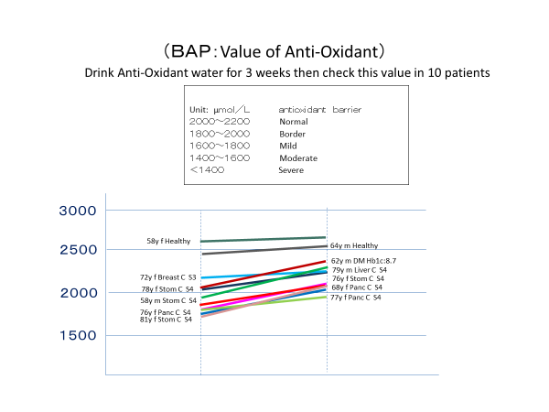

Recent Publications
Potential of Electronic Water as a Therapeutic Treatment for Oxidative Stress-Related Diseases Int J Diabetes Metab Disord, 2018 Volume 3 | Issue 2 | 1 of 4

 Masahiro Onuma has expertise in oxidative disease prevention to use non-medical product based on GSK’s experience of Allopurinol which is the strongest anti-oxidant efficacy in this world. He creates new indication of Allopurinol for stomatitis induced by cancer treatment which was approved by the Japanese Cancer treatment committee to propose new mechanism of Allopurinol for anti-oxidant. And now, there are so many new research papers of Allopurinol in the world. And Masahiro Onuma developed Electronic Water can reduce Oxidative stress in Cancer and Diabetes patients. This can be used so many disease are as the causal mechanism of so many disease is Oxidative Stress.

Email: onuma@trisguide.com
Contact Information: +81-8040916617

