Effects of Bamboo shavings Extract on Blood Pressure and Vascular Active Substance in Spontaneously Hypertensive Rats
Jianxin Han, PhD, Zhejiang University, China
Yanpei Gu, PhD, Zhejiang University, China
Ying Zhang, Prof., Zhejiang University, China

Abstract (300 word limit)
Bamboo shavings (Bambusae Caulis in Taeniam, BCT) has been used as a traditional Chinese medicine for the treatment of hypertension and cardiovascular disease in China. Objective:To observe the control of the ethyl acetate fraction of BCT (BCE) on blood pressure and the changes of related indexes in spontaneously hypertensive rats. Methods: Four groups, 10 rats in each group. The drug was administered from the age of 14 weeks, once a day, and continuously administered for 5 weeks. Body weight, the systolic blood pressure and behavioral indexes of the rats were collected and taken out after 5 weeks administration. Results: Compared with the each groups had a certain degree of reduction in systolic blood pressure (P<0.05), among which the high dose of BCE had better antihypertensive effect than other groups. With the prolongation of the administration time, the rotation tolerance time and irritability scores were improved to different extents. After 5 weeks intervention with BCE, the serum ANGII concentration of the positive drug group and the high dose group of BCE was lower than that of the model group. The concentrations of NE, ET and TXB2 in each groups were lower than that in the model group (P<0.05) , and the concentration of CGRP was higher than that in the model group (P<0.05) . Conclusion:The mechanism of antihypertensive effect of BCE may be related to reducing serum NE and ET contents and increasing serum CGRP content, and there is a dose effect relationship.

Image
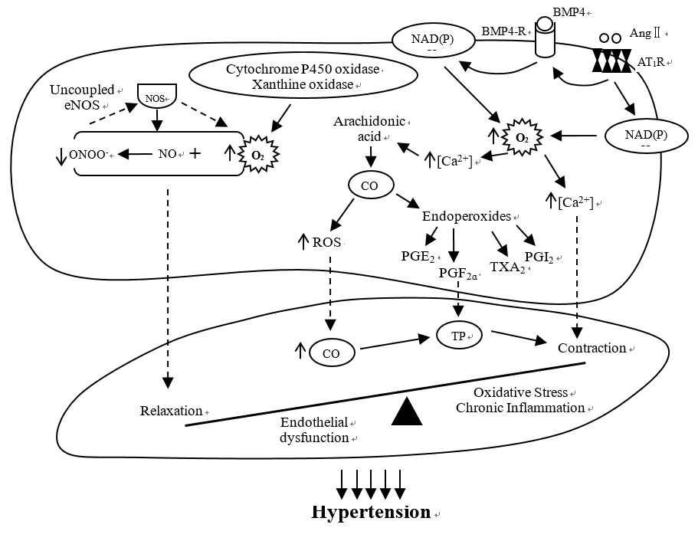
Fig 1. The influence of hypertension on oxidative stress and inflammatory reaction

Recent Publications (minimum 5)
- Neal, B. , Macmahon, S. , Chapman, N. , Cutler, J. , & Woodward, M. . (2000). Effects of ace inhibitors, calcium antagonists, and other blood-pressure-lowering drugs: results of prospectively designed overviews of randomised trials. The Lancet, 356(9246), 1955-1964.
- D'Amours, M. , Chbinou, N. , Beaudoin, J. , Lebel, M. , & Richard Larivière. (2010). Increased et-1 and reduced et b receptor expression in uremic hypertensive rats. Clinical and Experimental Hypertension, 32(1), 61-69.
- Berg, R. M. G. , Taudorf, S. , Bailey, D. M. , Dahl, R. H. , Lundby, C. , & Kirsten Møller. (2017). Transcerebral net exchange of vasoactive peptides and catecholamines during lipopolysaccharide-induced systemic inflammation in healthy humans. Canadian Journal of Physiology & Pharmacology, 96(3).
- Dorfmüller, P., Perros, F., Balabanian, K., & Humbert, M. (2012). Inflammation in pulmonary arterial hypertension. , 141(1), 210.
- Justin Rucker, A. , & Crowley, S. D. . (2017). The role of macrophages in hypertension and its complications. Pflügers Archiv - European Journal of Physiology, 469(3-4), 419-430.
- Dionne, J. M. , Harris, K. C. , Benoit, Geneviève, Feber, J. , Poirier, L. , & Cloutier, L. , et al. (2017). Hypertension Canada's 2017 Guidelines for the Diagnosis, Assessment, Prevention, and Treatment of Pediatric Hypertension. Canadian Journal of Cardiology, 33(5), 577-585.

 Biography (150 word limit)
Jianxin Han has completed his PhD from University of Chinese Academy of Sciences, China and postdoctoral studies from Zhejiang University, China. His research focuses on the extraction and purification of natural flavonoides, the synthesis and structure of flavonoid metal complexes and their pharmaceutical activity.

Email: 77454287@qq.com

Notes/Comments:

