Amelioration of Allergic Airway Inflammation by Fatty Acids Composition from Sea cucumber
Da-In Lee, MMed, Parasitology and Tropical Medicine, School of Medicine, Pusan National University, Korea
Hak Sun Yu, DVM, PhD, Parasitology and Tropical Medicine, School of Medicine, Pusan National University, Korea

Abstract (300 word limit)
In a previous study, our research group demonstrated that sea cucumber (Apostichopus japonicus) extracts ameliorated allergic airway inflammation via CD4+CD25+Foxp3+ T (regulatory T) cell activation and recruitment to the lung. Here, we aimed to determine which components of sea cucumber contribute to the amelioration of airway inflammation. We used n-hexane fractionation to separate sea cucumber into three phases (n-hexane, alcohol, and solid) and evaluated the ability of each phase to elevate Il10 expression in splenocytes and ameliorate symptoms in mice with ovalbumin/alum-induced asthma. Splenocytes treated with the n-hexane phase showed a significant increase in Il10 expression. In the n-hexane phase, 47 fatty acids were identified. Individual fatty acids that comprised at least 5% of the total fatty acids were 16:0, 16:1n-7, 18:0, 18:1n-7, 20:4n-6, and 20:5n-3 (eicosapentaenoic acid). After administering the n-hexane phase to mice with ovalbumin/alum-induced asthma, their asthma symptoms were ameliorated. Several immunomodulatory effects were observed in the n-hexane phase-pretreated group, compared with a vehicle control group. First, eosinophil infiltration and goblet cell hyperplasia were significantly reduced around the airways. Second, the concentrations of Th2-related cytokines (IL-4, IL-5, and IL-13) and Th17-related cytokines (IL-17) were significantly decreased in the spleen and bronchoalveolar lavage fluid. Finally, the concentrations of TGF-β and IL-10, which are associated with regulatory T cells, were significantly increased in the bronchoalveolar lavage fluid and splenocyte culture medium. In conclusion, a fatty acid-rich fraction (n-hexane phase) of sea cucumber extract ameliorated allergic airway inflammation in a mouse model.

Image
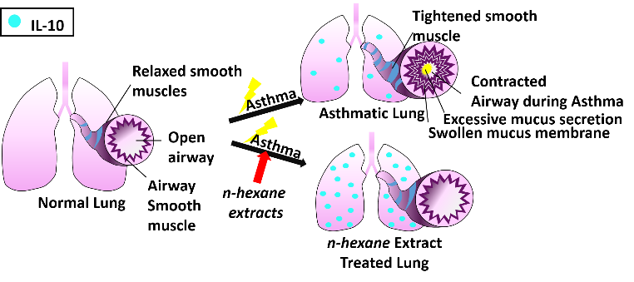
Recent Publications (minimum 5)
- Lee, D. I., Park, M. K., Kang, S. A., Choi, J. H., Kang, S. J., Lee, J. Y., & Yu, H. S. (2016). Preventive Intra Oral Treatment of Sea Cucumber Ameliorate OVA-Induced Allergic Airway Inflammation. The American journal of Chinese medicine, 44(08), 1663-1674..
- Culture supernatant of adipose stem cells can ameliorate allergic airway inflammation via recruitment of CD4+CD25+Foxp3 T cells. Yu HS, Park MK, Kang SA, Cho KS, Mun SJ, Roh HJ. Stem Cell Res Ther. 2017 Jan 23;8(1):8.
- The induction of the collagen capsule synthesis by Trichinella spiralis is closely related to protease-activated receptor 2. Park MK, Cho MK, Kang SA, Kim BY, Yu HS. Vet Parasitol. 2016 Oct 30;230:56-61
- Local immune response to primary infection and re-infection by Clonorchis sinensis in FVB mice. Kim EM, Yu HS, Jin Y, Choi MH, Bae YM, Hong ST. Parasitol Int. 2017 Aug;66(4):436-442.
- Activation and Recruitment of Regulatory T Cells via Chemokine Receptor Activation in Trichinella spiralis-Infected Mice. Ahn JB, Kang SA, Kim DH, Yu HS. Korean J Parasitol. 2016 Apr;54(2):163-71.

HAK SUN YU Email: hsyu@pusan.ac.kr

I received my Ph.D. degree in veterinary Medicine from Kyungpook National University, Daegu, Rep. of Korea. Since 2004, I have worked as professor in the Dept. of Parasitology at Pusan National University School of Medicine, Busan Rep. of Korea. My interests and specialties include parasitology, immune regulation, immunology, molecular biology, and allergy.

Notes/Comments: Recently my colleague and I found some interesting thing about sea cucumber extract have great effect to reduce artificial induced asthma in mice. Also regulatory T cell was significantly increased in sea cucumber extract oral administration group.

