Relation of Beverages intake and obesity in Korean children aged 6-11: Analysis of the 6th Korean National Health and Examination Survey (2013-2015)

Yoon Jung Kang, Nutrition and Functional Food Research Team, National Institute of Food and Drug Safety Evaluation, Korea

Na Hui Kim, Nutrition and Functional Food Research Team, National Institute of Food and Drug Safety Evaluation, Korea

Ha Young Jeong, Nutrition and Functional Food Research Team, National Institute of Food and Drug Safety Evaluation, Korea

Hye Won Wang, Nutrition and Functional Food Research Team, National Institute of Food and Drug Safety Evaluation, Korea

Hwa Jung Lee, Nutrition and Functional Food Research Team, National Institute of Food and Drug Safety Evaluation, Korea

Kyung Mi Hwang, Nutrition and Functional Food Research Team, National Institute of Food and Drug Safety Evaluation, Korea

Keum Soon Oh, Nutrition and Functional Food Research Team, National Institute of Food and Drug Safety Evaluation, Korea

Abstract
Statement of the Problem: Prevalence of obesity in childhood is increasing worldwide and it has become a global public health problem. Also, there were a few papers on a relation between beverage intakes and childhood obesity. But, there is a lack of studies on an association between beverage consumption and obesity for Korean children. So, the purpose of this study is to investigate the relationship of beverages intake and the prevalence of obesity in Korean children. Methodology & Theoretical Orientation: We used data from 1,500 participants (784 men and 716 women) aged 6-11 years, from the 2013-2015 Korea National Health and Nutrition Examination Survey (KNHANES). In these cross-sectional surveys, information on beverage intake was assessed by one day 24-hour recall method. We classified beverages into five types, including tea, coffee, fruit and vegetable, soda, and others. Multivariate logistic regression analysis was used to calculate odds ratio (OR) of the association between consumption of beverage and obesity (with a body mass index over 25). Findings: The average amount of daily beverage consumption per person from 2013 to 2015 was increased 97.0g in 2013, 103.2g in 2014 and 120.3g in 2015 for all subjects. Among beverage types contributing to total sugar intake were shown in the following order; soda(55.7g) > fruit and vegetable(26.8g) > others(19.9g) > tea(3.4g)> coffee(0.7g). The adjusted OR for obesity associated with excess of median beverages consumption was 1.91 (95% CI: 1.12-3.27) for the total study population. There were no significant relation to risk of obesity in men and women, but beverages consumption over median tend to increase risk of obesity. Conclusion & Significance: Our findings suggest an independent relationship between beverage intake and as increased risk of obesity in Korean aged 6-11 years, implying the necessity of future research on low- beverage consumption intervention in relation to obesity.

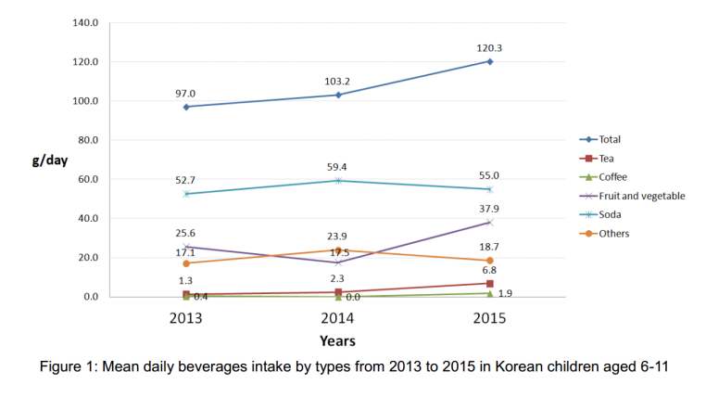
Recent Publications
- Ogden, C.L.; Flegal, K.M.; Carroll, M.D.; Johnson, C.L (2002) Prevalence and trends in overweight among US children and adolescents. JAMA 288: 1728–1732.
- Chung, S.W.; Ha, K.H.; Lee, H.S.; Kim, C.I.; Joung, H.J.; Paik, H.Y.; Song, Y.J.: (2015) Soft drink consumption is positively associated with metabolic syndrome risk factors only in Korean women: Data from the 2007–2011 Korea National Health and Nutrition Examination Survey . Metabolism 64:1477-1484
- Bremer, A.A.; Auinger, P.; Byrd, R.S. (2009) Relationship between insulin resistance-associated metabolic parameters and anthropometric measurements with sugar-sweetened beverage intake and physical activity levels in US adolescents: Findings from the 1999–2004 National Health and Nutrition Examination Survey. Arch. Pediatr. Adolesc. Med 163:328-335
- Ambrosini, G.L.; Oddy, W.H.; Huang, R.C.; Mori, T.A.; Beilin, L.J.; Jebb, S.A. (2013) Bremer, A.A.; Auinger, P.; Byrd, R.S Prospective associations between sugar-sweetened beverage intakes and cardiometabolic risk factors in adolescents. Am. J. Clin. Nutr. 98:327-3345.
- Bae, J,S.; et al.(2014)Higher consumption of sugar-sweetened soft drinks increases the risk of hyperuricemia in Korean population: The Korean Multi-Rural Communities Cohort Study. Seminars in Arthritis and Rheumatism 43:654–661


Yoon-Jung, Kang has her expertise in research on potentially hazardous nutrients and passion in improving the health and nutrition. She is working in National Institute of Food and Drug Safety Evaluation for ten-years.
Email: kangyj2000@korea.kr

