Valorization of phytochemical composition of industrial tomato byproduct: carotenoids, free, conjugated and bound phenolics and antioxidant activity.

Xiomara Patricia Perea-Domínguez, MSc, CIIDIR-IPN, México
Laura Gabriela Espinosa-Alonso, PhD, CIIDIR-IPN, México
Maribel Valdez-Morales, PhD, CONACyT-CIIDIR-IPN, México
Sergio Medina-Godoy, PhD, CIIDIR-IPN, México

Abstract

Industrial processing of tomato generates a considerable amount of byproducts, which constitute a promising source of bioactive compounds that could be used for human health promotion pourposes, however, those are used mainly for animal feed or natural fertilizer. The aim of this study was to characterize different bioactive compounds present in an industrial tomato byproduct and to evaluate their bioactive potential. The general strategy of this work is described in Figure 1. The carotenoids lycopene and β-carotene were quantified by HPLC-DAD. In addition, different fractions of phenolic compounds were obtained: SFP, AHP, AKHP and BP were analyzed by HPLC-DAD and their antioxidant capacity was determined using the ORAC and DPPH methods. The industrial tomato byproduct contains 52.82±1.94 μg lycopene/mg dry extract and a slightly higher concentration of β-carotene (69.64±2.18). The major phenolic compounds in tomato byproduct determined by Folin-Ciocalteu’s method were in insoluble-bound form, which represent ∼67% of TPC. Five phenolic acids and five flavonoids were identified and quantified by HPLC-DAD. Caffeic and ferulic acids were the most abundant phenolic acid while naringenin was the most abundant flavonoid. Total phenolic acids (as the sum of the individual phenolic acids) were predominantly in the alkaline-hydrolysable fraction, while flavonoids were mainly in bound form. BP extracts showed the highest antioxidant capacity by DPPH and ORAC assays. This implies the importance of extracting the insoluble-bound fraction during phenolic compounds determinations and evaluation of biological activity. The valorization of the industrial tomato byproduct, through the recovery of carotenoids and the use of its different fractions of phenolic antioxidant compounds, could generate additional income to the tomato industry and reduce the waste disposal problem.

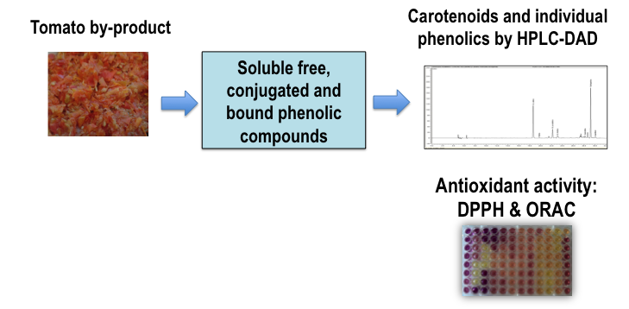

Figure 1. General strategy for valorization of phytochemical composition of industrial tomato byproduct.

Biography
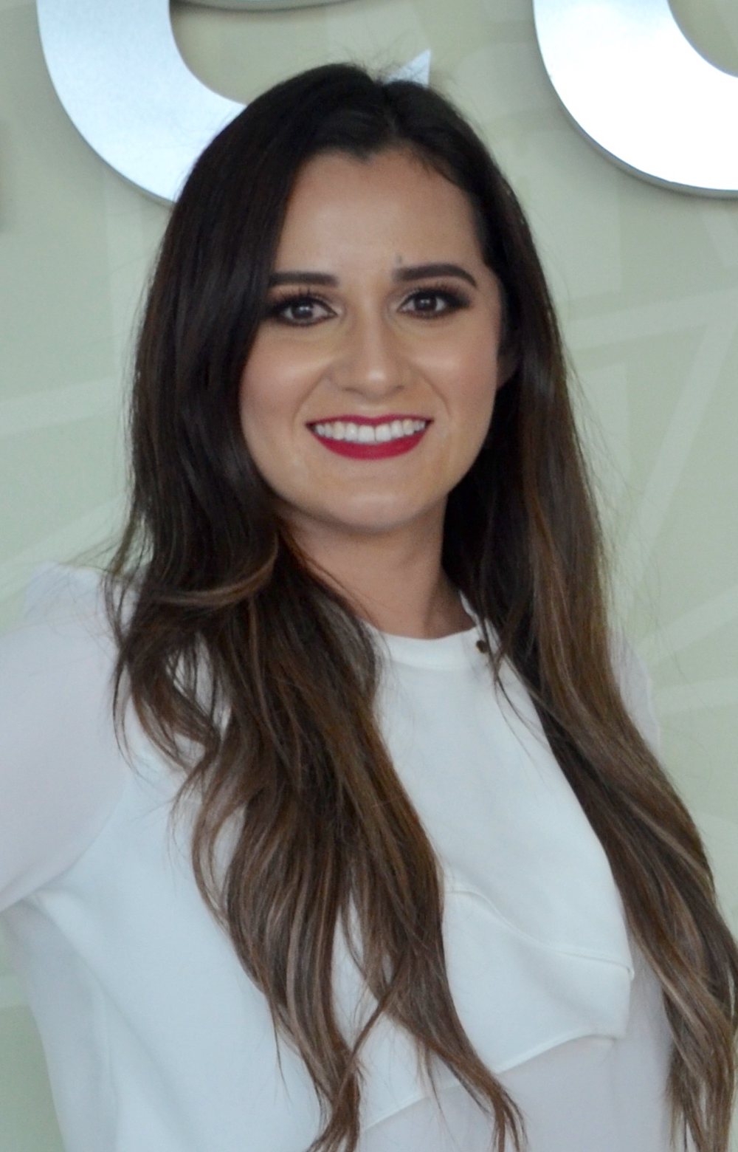
Xiomara Patricia Perea-Domínguez has completed her master in Science from National Polytechnic Institute in Mexico. She is PhD student at the same institution and she has worked in the development of research projects in food biotechnology and environmental toxicology. She has her expertise in evaluation of bioactive compounds from agroindustrial byproducts to generate options that allow their maximum utilization in food industry and reduction of waste disposal problems.
Email: patricia_34@hotmail.com

Recent Publications

Perea-Domínguez, XP, Espinosa-Alonso, LG, Hosseinian, F, HadiNezhad, M, Valdez-Morales, M and Medina-Godoy, S. 2016. Phenolic profile and antioxidant activity from non-toxic Mexican Jatropha curcas L. shell methanolic extracts. Natural Product Research, available in: http://dx.doi.org/10.1080/14786419.2016.1209665.

Sandoval-Castro, CJ; Valdez-Morales, M; Perea-Domínguez, XP; Medina-Godoy, S and Espinosa-Alonso, LG. 2014. Antioxidant Activity of Processed and Raw Seed Byproduct from Jalapeño Pepper. Journal of Chemical, Biological and Physical Sciences, Section A: Food Biotechnogy; Special Issue. 4 (5):00-00.

