Antibacterial activity of p-menta-1,4-dien-7-al, the main component of Cuminum cyminum L. essential oil
Zhilin Gan, Ph.D, Lecturer, Beijing Forestry University, China
Aidong Sun, Ph.D, Professor, Beijing Forestry University, China

Abstract


Statement of the Problem: Cuminum cyminum L.，commonly known as cumin，belongs to the Apiacea family. It is a very important spice as a flavouring agent in cooking and widely cultivated in India, China, Pakistan Argentina, Tran and Turkey. According to present studies, cumin’s distinctive flavor and intense aroma are due to its essential oil content. The chemical composition of cumin essential oil (CEO) is very complicated. In our study, CEO was obtained by supercritical carbon dioxide and molecular distillation. p-menta-1,4-dien-7-al is one major constituent of CEO, a new compound without standard and prepared by high speed countercurrent chromatography (with purity above 96%). Previous studies provide substantial evidences that CEO is effective inhibitors of microorganisms. However, the antibacterial activity of p-menta-1,4-dien-7-al has not been reported. The aim of this work is to evaluate the ability against bacteria for p-menta-1,4-dien-7-al, which may be considered as potent agent in food preservation. Methodology & Theoretical Orientation: Disc diffusion, minimum inhibitory (MIC) and bactericidal (MBC) concentrations were used to qualitatively measure the antibacterial effect of p-menta-1,4-dien-7-al. Then the mechanism was described by determination of cell-membrane conductivity and micromorphology analysis. Findings: Based on the results of disc diffusion diameter, MIC and MBC, p-menta-1,4-dien-7-al was effective to inhibit the growth of Escherichia coli and Shigella flexneri. The results also indicated that membrane permeability of cells was changed and destroyed after treatment by p-menta-1,4-dien-7-al. The micrographs of the cell illustrated aberrant morphology such as shrinkage, partial distortion, depletion of cytoplasm. Conclusion & Significance: p-menta-1,4-dien-7-al has potential to be preservative applied in food industry.
Biography

Zhilin Gan is a young faculty of Dept. of Food Science and Engineering in Beijing Forestry University. He got his Ph.D degree in China Agricultural University and he was ever a visiting scholar in Iowa State University, USA (2014.10-2015.11). He has his expertise in processing of agricultural and forestry products. Recently, he mainly focused on essential oil (EO) of spices like cumin and ginger. He has built the method to extract, purify and separate essential oil by using supercritical carbon dioxide, molecular distillation and high speed countercurrent chromatography. Also he did works on bioactive compounds from EO for functional properties.
Email: ganzhilin@bjfu.edu.cn

ha

Image
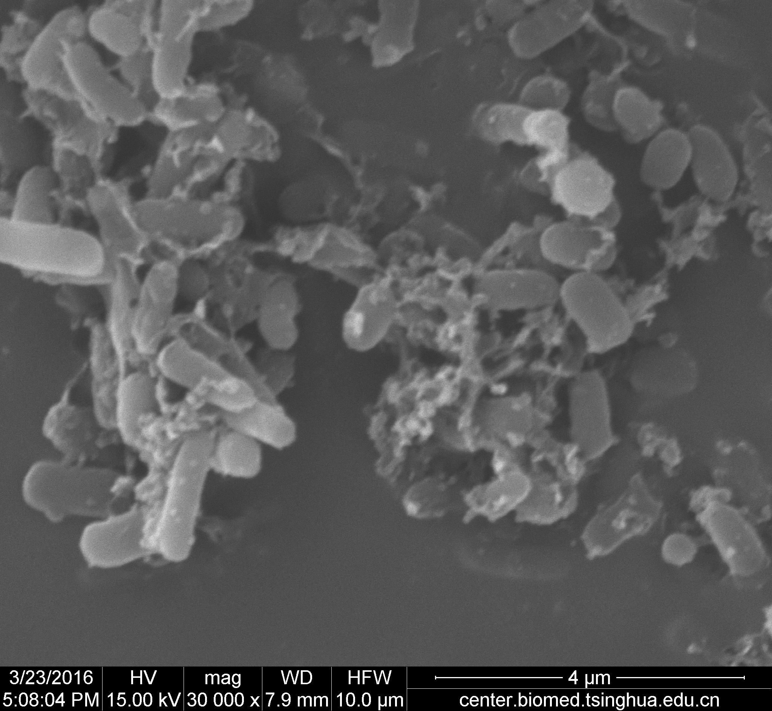
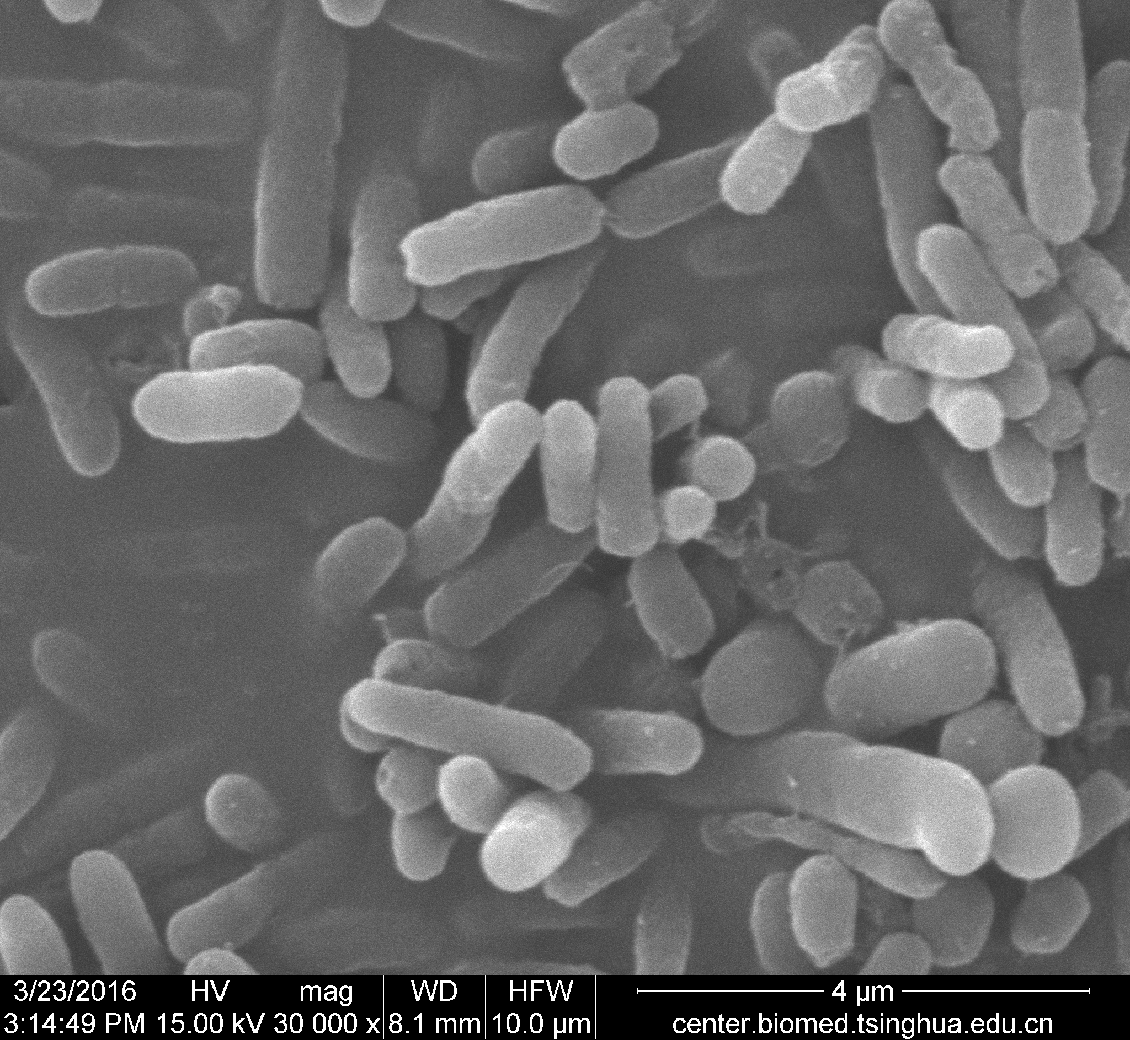

(a) (b)
Figure 1. p-menta-1,4-dien-7-al treated cells of E.coli with scanning electron microscope
(a) p-menta-1,4-dien-7-al treated (0.1 mg/mL, 24 h) (b) control

Notes/Comments:

Recent Publications (minimum 5)*
- Gan Z, Zheng L, Chen X, et al. Separation and preparation of 6-gingerol from molecular distillation residue of Yunnan ginger rhizomes by high-speed counter-current chromatography and the antioxidant activity of ginger oils in vitro [J]. Journal of Chromatography B Analytical Technologies in the Biomedical & Life Sciences, 2016, 1011:99-107.
- Gan Z, Yang Y, Li J, et al. Using Sensor and Spectral Analysis to Classify Botanical Origin and Determine Adulteration of Raw Honey [J]. Journal of Food Engineering, 2016, 178:151-158.
- Gan Z, Ni Y, Guo Y, et al. Separation and purification of rosehip polyphenols by macroporous resin and its antioxidant activity [J]. Transactions of the Chinese Society of Agricultural Engineering, 2015(24): 298-306.
- Chen Q, Gan Z (co-first author), Zhao J, et al. In vitro, comparison of antioxidant capacity of cumin (Cuminum cyminum, L.) oils and their main components[J]. LWT - Food Science and Technology, 2014, 55(2): 632–637.
- Zhilin Gan, Ming Yu, Xuefang Hu, Shuyan Li, Zheng Liang, Yuanying Ni: Extraction of cumin oil using optimization of supercritical CO2 fluid extraction technology, Science and Technology of Food Industry, 2010, 31(8), 283-289.
*optional for students and young researchers

