

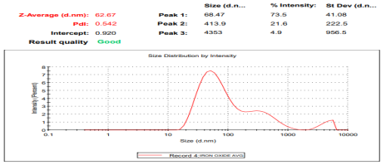
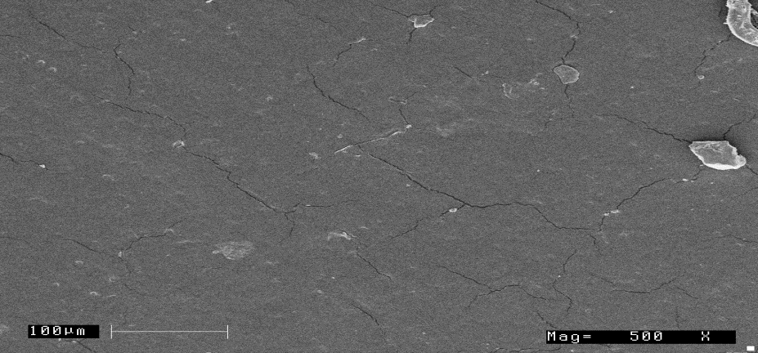
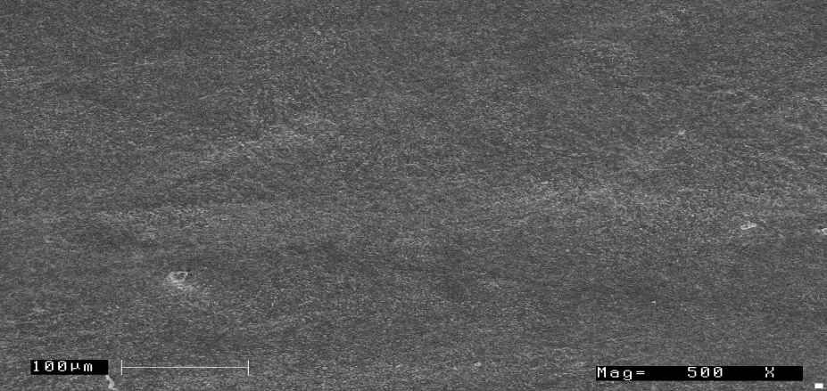
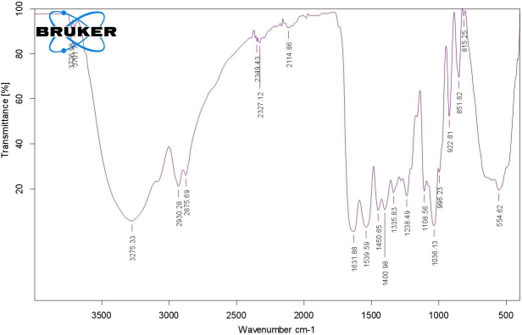
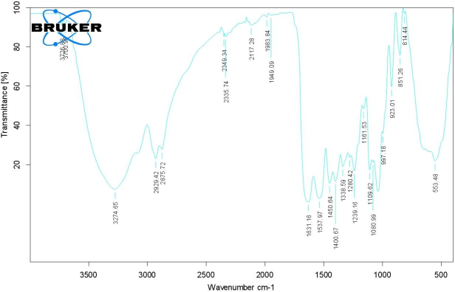
Edible, Biodegradable Composite Films For Food Packaging Applications A.Rahul, Rajeshwar S Matche1, Dr.S.Rupachandra2
1. Department of Food Packaging Technology, CSIR-CFTRI, Mysore-570020
2. Department of Biotechnology, School of Bioengineering, SRM IST, Chennai-603203 Corresponding author 1 email id: rajeshmatche@yahoo.com Corresponding author 2 email id: rupachandra.s@ktr.srmuniv.ac.in

ABSTRACT RESULTS & DISCUSSION

Plastics are widely used all over the world, and have become an integral part of daily life. But they have
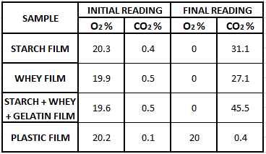
become an environmental hazard due to their inability to degrade. Plastics have been known to make up to 20%
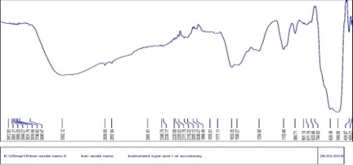
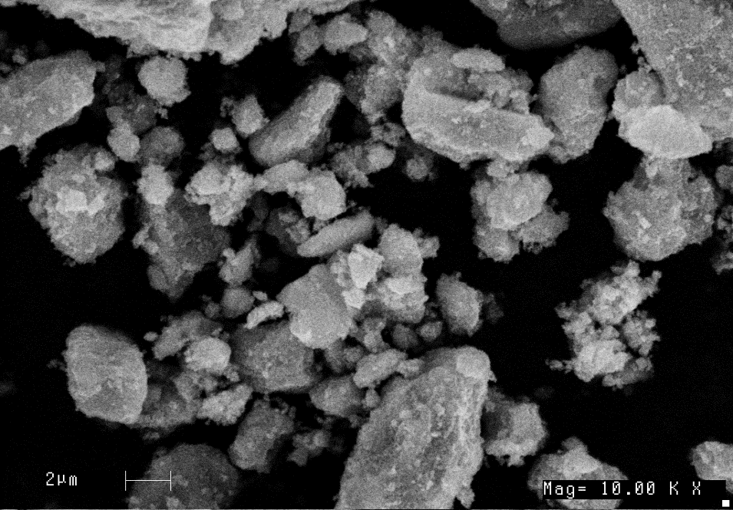
by volume of total waste per year. To contain the problem of ecological pollution, the concept of Biodegradable
Plastics as primary packaging material especially for food products has been introduced. The two main reasons
for using biodegradable materials are the growing problem of waste resulting in the shortage of landfill
availability and the need for sustainable use of resources. A variety of substances including microbial by-
products, natural polymers like Proteins, Starch, Gluten and Cellulose are used in new age packaging. (e)

Starch-based Plastics were mainly harvested from Wheat, Potatoes, Rice, and Corn. The plasticization
of starch is complex due to the extensive Hydrogen bonding between chains. Limitation of using Starch as the
primary source includes increased water permeability. Protein-based layers have efficient Oxygen barrier
properties thereby enhancing the shelf life of food. The sustainability and the effectiveness of such protein-
based edible films vary with the source of protein, e.g. Whey protein (from milk). This has a potential to be
used in new cost-effective and ecological Food packaging designs. Nanoparticles have found immense
popularity in the recent times with applications in almost all phases of biological sciences, the field of
packaging is no new to this too. They are added to enhance the mechanical and barrier properties in the
packaging material. While incorporating into edible films the biocompatibility is a significant concern.

Shelf life is an essential parameter for all foods, and the main aim of packaging material is to enhance
the shelf life of the food that it encases. Hence, an optimized combination of Starch and Protein with the desired
percentage of inert nanoparticles into the film is expected to overcome all the above-mentioned shortcomings.
The field of eco-friendly packaging has seen an exponential rise in the recent years with the implementation of
various protocols and laws. Use of such films leads to reduced manageable waste and also reduces the pressure
on the environment.

Fig 1: SEM micrograph of IO nanoparticles

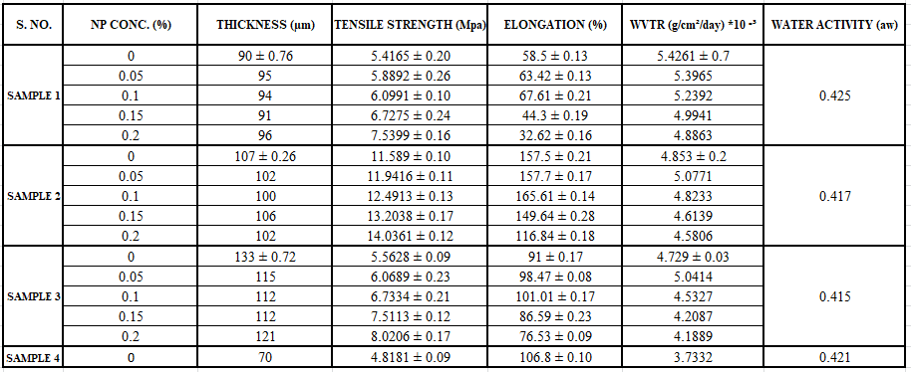
Fig 3: Particle size analysis of Nano-particles

Fig 2: FT-IR analysis of IO nanoparticles

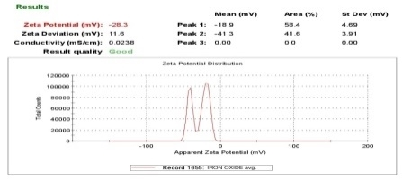
Table 3: Quantitative analysis of biodegradability (CO2 production)

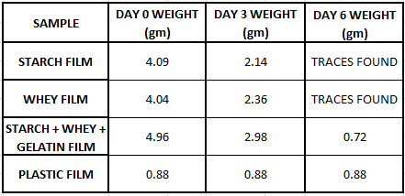
Fig 4: Zeta potential analysis

Keywords: Environmental pollution, Bioplastics, Plasticity, Shelf life, Biodegradability
Table 4: Quantitative analysis of biodegradability (Weight reduction)

INTRODUCTION
CONCLUSION

Foo Packaging is important to ensure the quality and safety of the food during its travel from the origin
and still be wholesome during consumption. It is also responsible in maintaining the process benefits as
well as increase the shelf-life along with showcasing nutritional information of the product. However,
packaging technology must not only ensure the food safety but also keep a check on the energy and
material costs including the social and environmental concerns. Advancements in packaging have led to
consumer friendly and quality packaging. Plastic is extensively used in packaging as it has very good
barrier properties, shields food from mechanical damage and against the shock and vibration encountered
during distribution. Some become stagnant in landfills for ages and the rest pollutes our environment and
water bodies due to non-biodegradability. With the raising concern regarding the protection of the
environment and the growing problem of waste resulting in the shortage of landfill availability, an

Table 1: Analysis of the mechanical properties of the biodegradable films
•

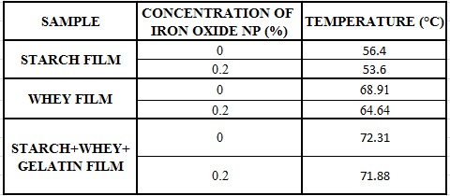
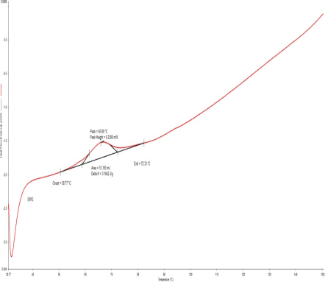
•

•

•

Whey protein films show better Tensile Strength when compared to Potato Starch

films.

Potato Starch films have better water barrier properties than Whey protein films.

There is an overall increase in the mechanical properties with the incorporation of

Nanoparticles and also increased the smoothness of the films.

No chemical/thermal change in the films has been noted with the incorporation of

Nanoparticles.

alternative source of packaging is being developed

Table 2: DSC Analysis of films
w/ Nano-particles

Fig 5: DSC Analysis of hybrid films
w/o Nano-particles

• Films were successfully proven to be biodegradable under ASTM standard

conditions.

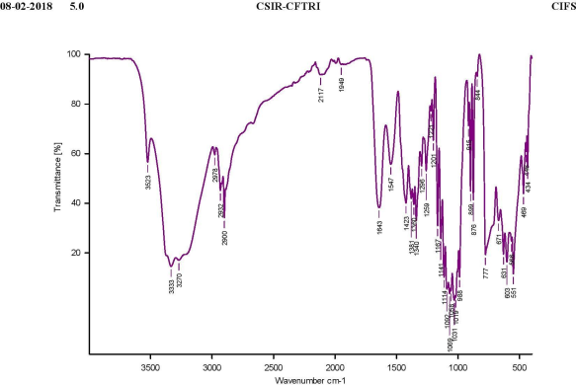
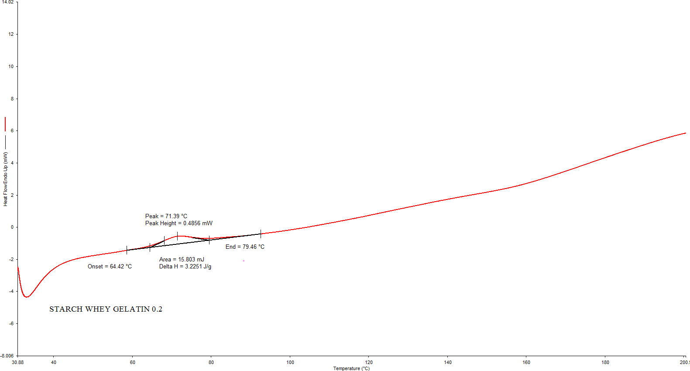
MATERIALS & METHODS REFERENCES

Selection of chemicals and raw materials for film production

Process design and parameter optimization

Production of iron oxide nanoparticles by green synthesis method (Gottimukkala et al., 2017)

Characterization of above mentioned Nano-particles • Zeta potential assessment • Particle size assessment

Optimization of Nano-particle concentration and subsequent addition to the Biodegradable film mixture

Production of Biodegradable film by casting onto a Teflon coated non-stick plate with subsequent drying under IR lamps

Characterization of films (Physical & Chemical): •Thickness : Measured according to ASTM F6988-13
•Tensile Strength : Measured according to ASTM D638-14
•Water Vapor Transmission Rate (WVTR) : Measured according to ASTM E96
•Scanning Electron Microscopy (SEM)
•Fourier Transform Infrared Spectroscopy (FT-IR) •Particle Analysis: Malvern Zetasizer 3000 HS •Differential Scanning Calorimetry (DSC)
•Particle Analysis and Zeta Potential : Malvern Zetasizer 3000 HS •Biodegradability Test: measured using DANSENSOR checkpoint 2(ISO

Fig 6: DSC analysis of films w/ Nano-particles

Fig 8: FTIR analysis of hybrid films w/ Nano-particles(0.05% w/w)

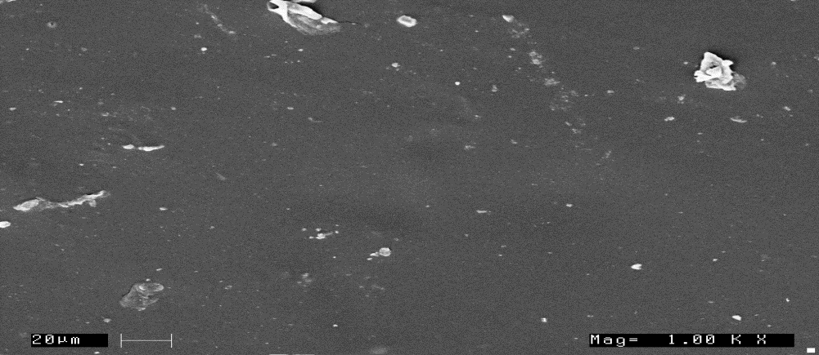
Fig 10: SEM analysis of hybrid films w/o Nano-particles

Fig 7: FTIR analysis of hybrid films w/o Nano-particles

Fig 9: FTIR analysis of hybrid films w/ Nano-particles(0.2% w/w)

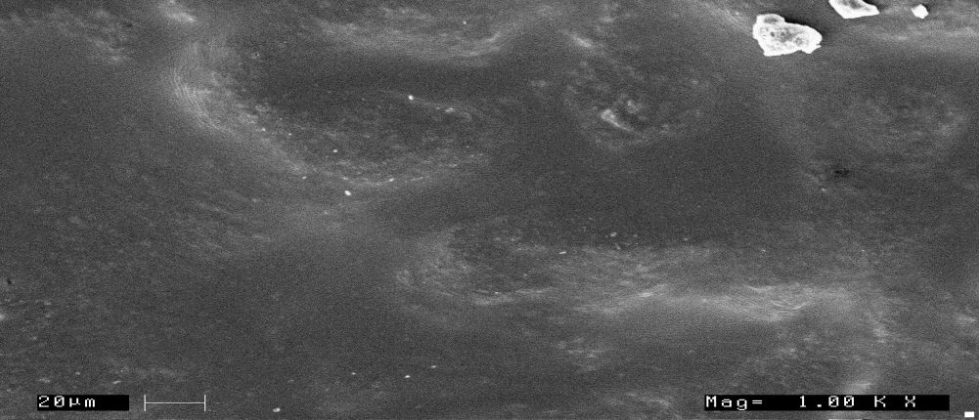
Fig 11: SEM analysis of hybrid films w/ Nano-particles

• Al-Hassan, A. A., & Norziah, M. H. (2012). Starch–gelatin edible films: water vapor permeability and mechanical properties as affected by plasticizers. Food hydrocolloids, 26(1), 108-117.
• Ali, R. R., Rahman, W. W. A., Ibrahim, N. B., & Kasmani, R. M. (2013). Starch-based biofilms for green packaging. In developments in sustainable chemical and bioprocess technology (pp. 347-354). Springer, Boston, MA.
• Almasi, H., Ghanbarzadeh, B., & Entezami, A. A. (2010). Physicochemical properties of starch–CMC–Nano clay biodegradable films. International journal of biological macromolecules, 46(1), 1-5.
• ASTM D618-13 standard test method for conditioning of plastics for testing. • ASTM D638-14 standard test for tensile properties of plastics.
• ASTM E96 standard test method for water vapor transmission of materials.
• ASTM F6988-13 standard test method for thickness measurement of flexible packaging material.
• Auras, r. A., Singh, S. P., & Singh, J. J. (2005). Evaluation of oriented poly (lactide) polymers vs. Existing PET and oriented PS for fresh food service containers. Packaging technology and science, 18(4), 207-216.
• Chae, s. I., & Heo, T. R. (1997). Production and properties of edible film using whey protein. Biotechnology and bioprocess engineering, 2(2), 122- 125.
• Chillo Flores, S., Mastromatteo, M., Conte, A., Gerschenson, L., & Del nobile, M. A. (2008). Influence of glycerol and chitosan on tapioca starch-based edible film properties. Journal of food engineering, 88(2), 159-168.
• Chirife J., & Fontana, A. J. (2008). Introduction: historical highlights of water activity research. Water activity in foods: fundamentals and applications, 3-13.
• Ghanbarzadeh, b., Almasi, H., & Entezami, A. A. (2010). Physical properties of edible modified starch/carboxymethyl cellulose films. Innovative food science & emerging technologies, 11(4), 697-7
• Ghanbarzadeh, B., Musavi, M., Oromiehie, A. R., Rezayi, K., Rad, E. R., & Milani, J. (2007). Effect of plasticizing sugars on water vapor permeability, surface energy and microstructure properties of zein films. LWT-food science and technology, 40(7), 1191-1197.
• Gottimukkala, k. S. V. (2017). Green synthesis of iron nanoparticles using green tea leaves extract. J nanomedicine biotherapeutic discovery, 7(151), 2.

ACKNOWLEDGEMENT

14851 : 1999) and Soil burial test.

Biodegradability test methods: • ASTM D6400 • ASTM D5338

MAC

Fig 12: SEM analysis of hybrid films w/o Nano-particles

SF-MAC

Fig 13: SEM analysis of hybrid films
w/ Nano-particles

I would like to thank Dr. S. Rupachandra, Associate Professor, Department of
Biotechnology and Mr. Rajeshwar.S.Matche, Senior Principal Scientist, CSIR-
CFTRI for their constant guidance and encouragement throughout the project. My
sincere thanks to Dr. M. Vairamani, Dean, School of Bioengineering and
Dr. S. Thyagarajan, Head, Department of Biotechnology and Dr. K. A Athmaselvi,
Head, Department of food process engineering, SRM Institute of Science and
technology for providing all the available facilities for the completion of my project
work.

