Every year more than 1 billion 300,000 tons of food is thrown away or misused. The main reason for this is poor planning and consumer behavior.
Now, the mismanagement of organic waste leads to an attempt to fraud food and inappropriate application.

The reasons that lead to this crisis are economically motivated:

The two main types of economically-motivated adulteration are:

• Sale of food which is unfit and potentially harmful, such as: – recycling of animal by-products back into the food chain; – packing and selling of meat with unknown origin; – knowingly selling goods past their ‘use by’ date.

• Deliberate mislabelling of food, such as: – products substituted with a cheaper alternative, e. g. farmed salmon sold as wild, or Basmati rice adulterated with cheaper varieties; – false statements about the source of ingredients, i.e. their geographic, plant or animal origin.

one of the technical solutions to such problems can be the use of new motivational methods for the processing of food waste.

The applied biotechnology with the use of the black soldier larva implies the processing of FF-organic waste and the production of high q-1 products that can be used in the food, feed, pharmaceutical and cosmetic industries.
The black soldier larva is a biological object that in the wild is intended for the complete utilization of organic waste of any stage.

in other words, we invite you to introduce the technology of processing organic food waste using the black soldier larva, thus creating a direct economic motivation for organic waste processing and generating income precisely by extracting high value-added products for subsequent sale in key markets.

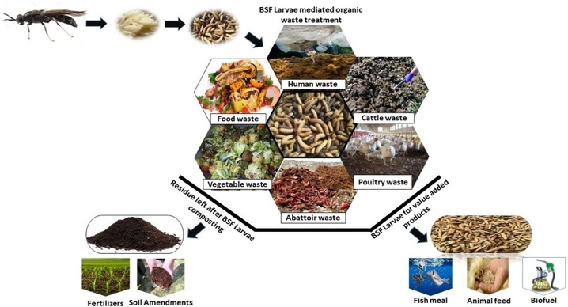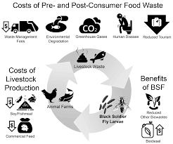

Akram Talibov is a high-level professional in the production of alternative proteins and their use in the feed and food industry. The main focus of his work in the last 15 years has been application of innovative proteins in young animal nutrition. Mr. Talibov's key competencies lie in the production of vegetable, dairy, animal proteins and isolates with a high degree of digestibility and low production costs as well as the lowest possible CO2 emission.

