Modification of cheese ripening process and support to the small dairy producers
Marijana Blažić, PhD, Karlovac University of Applied Sciences, Croatia

Abstract
Statement of the Problem: Maintaining the microbiological quality of cheese throughout ripening is one of the major problems faced by small cheese producers. Because of the cross contamination, and inability to maintain and control the atmosphere quality in the ripening chamber, small cheese producer have major problems with moulds and yeast development which adversely affects cheese microbiological and sensory properties. There are several proposals for this problem solving, but the orientation of this topic was on the control of atmosphere conditions in the ripening chamber. The aim was to determine potential contamination preventing methods affordable to small cheese producers and setting the basis for development of online platform for worldwide connection of small dairy producers and easier dissemination of knowledge.
Methodology & Theoretical Orientation: In first phase of this project, research team held several meetings with the representatives of small dairy producers from different parts of the country, in their homeland, to determine the current state in contamination reducing and to discuss the improvement abilities based on recent findings. Also, the basis for the development of the uniform platform was set, on which all producers could be connected for easier dissemination of knowledge.
Findings: Most of the small cheese producers have problems with mould development during cheese ripening. Because of the frequent hygiene protocols and treatments to reduce the contamination, producers also noticed the decrease in sensory quality of cheese. Collected findings slightly differed depending on the location of the production facility. Recent publications pointed the possibility of application of modified, ozonized and prepressed atmosphere in cheese ripening chambers for optimization of cheese hygiene and microbiological properties.
Conclusion & Significance: Educational online platform will enable easier dissemination of novel findings in dairy field. Detail research on contamination reducing methods will be the topic of the further phase of this project.
Recent Publications
- Panfil-Kuncewicz, H., Lis, A., Majewska, M. (2015): The use of oxygen absorbers for packaging ripened cheese, Pol. J. Nat. Sci., 30 (3), 285–295.
- Picque, D., Leclercq-Perlat, M.N., Corrieu, G. (2006): Effects of Atmospheric Composition on Respiratory Behavior, Weight Loss, and Appearance of Camembert-Type Cheeses During Chamber Ripening, J. Dairy Sci., 89, 3250–3259
- Picque, D., Leclercq-Perlat , M.N., Guillemin, H., Perret, B., Cattenoz, T., Provost, J.J., Corrieu, G. (2010): Camembert-type cheese ripening dynamics are changed by the properties of wrapping films, J. Dairy Sci., 93, 5601–5612.
- Serra, R., Abrunhosa, L., Kozakiewicz, Z., Venâncio, A., Lima, N. (2003). Use of ozone to reduce molds in a cheese ripening room. Journal of food protection, 66(12), 2355-2358.
5. Pinto, A. T., Schmidt, V., Raimundo, S. A., Raihmer, F. (2007) Use of ozone to control fungi in a cheese ripening room (In Portuguese). Acta Scientiae Veterinariae, 35, 333–337.
6. Marino, M., Maifreni, M., Baggio, A., & Innocente, N. (2018). Inactivation of foodborne bacteria biofilms by aqueous and gaseous ozone. Frontiers in microbiology, 9, 2024.

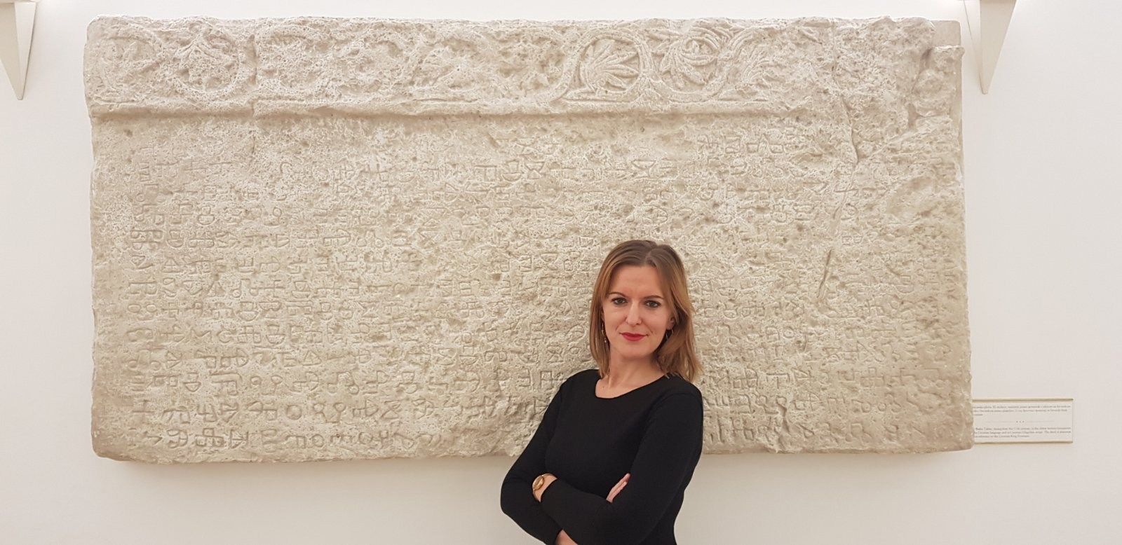Biography
Marijana Blažić is a Head of Department of Food technology at Karlovac University of Applied Sciences, Croatia. Her scientific interest is focused on dairy and cheese making. Currently she is leading partner on projects “Atrium of Knowledge” and “Modification of cheese ripening process and whey product development” financed from European Regional Development Fund, and associate partner on project “MILK-ed: Modern and Innovative onLine-based Know-how on European Dairy processing” financed from Erasmus+ Programme trough KA2 - Cooperation for innovation and the exchange of good practices, KA202 - Strategic Partnerships for vocational education and training.
email: marijana.blazic@vuka.hr

Notes/Comments:

