Gastrointestinal digestion of chlorophyll from chloroplast thylakoid membrane in Spinach and Moringa: Impact of oil in vitro infant and adult digestion conditions
Yuanyuan Li, Jiarui Cao, Yan Zhang*
College of Food Science and Nutritional Engineering, China Agricultural University, Beijing, China

Abstract
Statement of the Problem: Chlorophylls are broadly distributed in green vegetables as the primary photosynthetic pigments, which exhibit a variety of pharmacological benefits. Previous reviews indicated the difference between infants and adults in the availability of some digestive enzymes, and gastric pH. Hence, it is important to study the digestibility of chlorophyll to better understand the degradation mechanism in the gastrointestinal tract in infant and adult. In green vegetables, chlorophylls are embedded within thylakoid membrane and are mainly present in free and bounded states. While the overall composition of spinach and moringa are similar, there are differences in the content of chlorophyll and the stability of chlorophyll-protein complex in thylakoid membrane, which may affect chlorophyll digestion characteristics and nutrition in infants and adults.
Methodology & Theoretical Orientation: The objective of this study was to provide valuable information about the release of chlorophyll from chloroplast thylakoid membrane after the consumption of spinach and moringa and then to compare the impact of oil on chlorophyll in vitro infant and adult gastrointestinal digestion conditions.
Findings: The content of chlorophyll a and b significantly decreased under the infant and adult gastrointestinal digestion compared to the control (p<0.05). Inverted fluorescent microscopy revealed that the gastrointestinal digestion weakened the auto-fluorescence of chlorophylls. Particle size determination proved that oil had a positive effect on improving the gastrointestinal digestion of chlorophylls. Absorption and fluorescence spectra further conveyed that the presence of oil was more advantageous to the digestion of chlorophylls subjected to infant and adult gastrointestinal digestion in spinach and moringa, respectively. Chlorophylls were in large quantities degraded during gastrointestinal digestion, leading the formation of high content of pheophorbide a.
Conclusion & Significance: The study demonstrated that both chemical structure of chlorophyll and the nature of food matrix were decisive for the digestive behaviour of chlorophylls.

Image
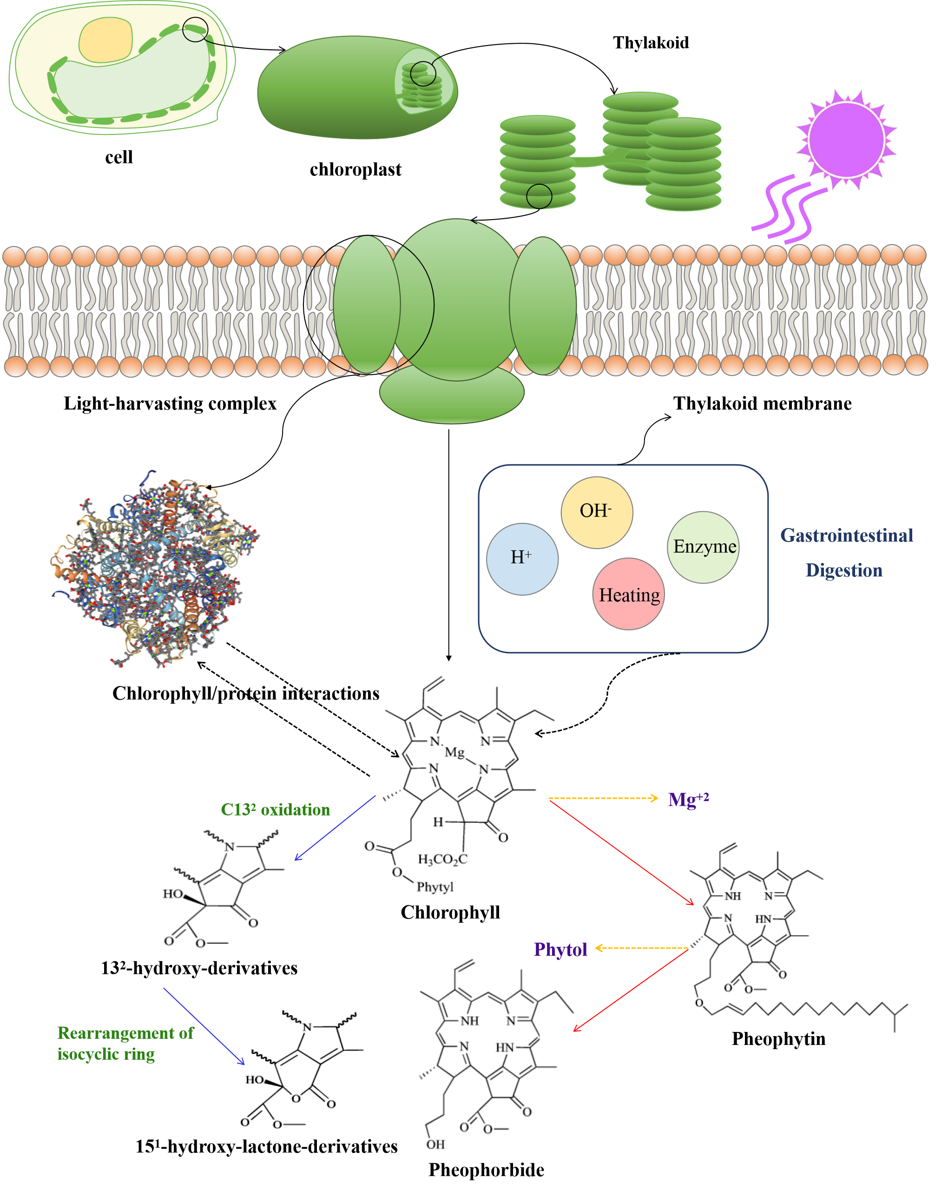
Recent Publications
- Yuanyuan Li, Yu Cui, Xiaosong Hu, Xiaojun Liao, Yan Zhang* (2019) Chlorophyll supplementation in a critical developmental window prevent diet-induced obesity and modulate gut microbiota in mice. Molecular nutrition and food research, 1801219, 1-13;
- Yuanyuan Li, Yu Cui, Feng Lu, Xiao Wang, Xiaosong Hu, Yan Zhang* (2019) Beneficial effects of chlorophyll on prevention of obesity through modulation of gut microbiota in high-fat diet mice. Journal of functional foods, 60, 103436;
- Yuanyuan Li, Haotian Liu, Qian Liu, Baohua Kong∗, Xinping Diao* (2019) Effects of zein hydrolysates coupled with sage (salvia officinalis) extract on the emulsifying and oxidative stability of myofibrillar protein prepared oil in-water emulsions. Food Hydrocolloids, 87, 149-157;
- Yuanyuan Li, Haotian Liu, Qi Han, Baohua Kong*, Qian Liu* (2017) Cooperative antioxidative effects of zein hydrolysates with sage (salvia officinalis) extract in a liposome system. Food Chemistry, 222,74-83;
- Yuanyuan Li, Baohua Kong*, Qian Liu, Xiufang Xia, Hongsheng Chen (2017) Improve the emulsifying and oxidative stability of myofibrillar protein prepared oil-in-water emulsions by zein hydrolysate. Process Biochemistry, 53, 116-124.

 Biography
Yuanyuan Li, a PhD candidate of China Agricultural University, has her expertise in Processing and Storage of Agriculture Products, especially on Food Nutrition, Fruit and Vegetable Processing and Preservation Technology and Theory, Fruit and Vegetable Resources Comprehensive Utilization.
Email: liyuanyuan.1992@163.com

Notes/Comment

