

 Official Photo

University/Organization Logo

Numerical investigation of Fluidic active flow control on circular cylinder in transitional regime
Wasim Sarwar, PhD student, UPC, Spain
Fernando Mellibovsky, PhD, UPC, Spain

Abstract (300 word limit)
The fluid flow past bluff bodies, even in the low to moderate regimes, results in large unsteady wakes that are the source of high aerodynamic drag, vibration, noise etc. Most applications aim at the reduction of the drag force and vibrations to improve aerodynamic performance, while an enhancement of the wake instability can be beneficial for energy harvesting applications.
In the present numerical study, we apply spanwise-dependent fludic actuation, both steady and time-periodic, on the flow past a circular cylinder at Reynolds number 2000. The actuation takes the form of in-phase blowing and suction from slits located at ±90º (top and bottom) with respect to the upstream stagnation point. Optimal forcing amplitude and wavelength are obtained by sweeping across the parametric space. A promising reduction in drag force, combined with the suppression of lift fluctuations, is obtained for spanwise-dependent steady actuation with appropriate actuation wavelength. Several actuation frequencies are investigated for time-dependent actuation. Lift fluctuations and drag force are found to increase significantly under actuation at frequencies close to the shear layer instability, thus indicating a potential interest for energy harvesting applications at these low Reynolds numbers.

Key words: Bluff body, Active flow control, Cylinder, Transitional regime, blowing and suction.

Image
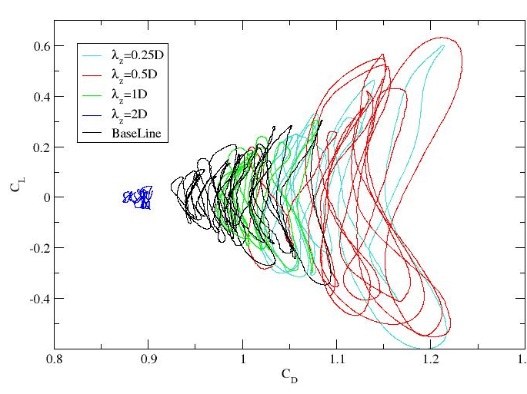
Figure 1: Spanwise-dependent steady actuation of flow past circular cylinder at Re=2000 with wavelengths $λ_{z}$= 0.25D, 0.5D, 1D, and 2D, where D is the cylinder diameter.
Recent Publications (minimum 5)
- Jeon S, Choi J, Jeon WP, Choi H, Park J. Active control of flow over a sphere for drag reduction at a subcritical Reynolds number. Journal of Fluid Mechanics. 2004 Oct;517:113-29.
- Williams DR, Mansy H, Amato C. The response and symmetry properties of a cylinder wake subjected to localized surface excitation. Journal of Fluid Mechanics. 1992 Jan;234:71-96.
- Cattafesta III LN, Sheplak M. Actuators for active flow control. Annual Review of Fluid Mechanics. 2011 Jan 21;43:247-72.
- Choi H, Jeon WP, Kim J. Control of flow over a bluff body. Annu. Rev. Fluid Mech.. 2008 Jan 21;40:113-39.
- Rashidi S, Hayatdavoodi M, Esfahani JA. Vortex shedding suppression and wake control: A review. Ocean Engineering. 2016 Nov 1;126:57-80.
- Kim J, Choi H. Distributed forcing of flow over a circular cylinder. Physics of Fluids. 2005 Mar;17(3):033103.

Biography
Wasim Sarwar is pursuing his PhD at the Technical University of Catalonis, Department of Physics, Aerospace Engineering Division, under the supervision of Dr. Fernando Mellibovsky. His research interests include boundary layer separation, turbulent transition, active flow control, dynamical systems, bifurcation theory, etc.

Presenting author details
Full name (As per the passport): Wasim Sarwar
University / Industry / Organization name: Universitat Politecnica de Catalunya
Designation (Director/Prof/Assistant or Associate prof/Researcher/Student): Student
Country: Pakistan
Mobile number (country code – number): +34632518246
Email: waseemsarwardogar121@gmail.com
Track number: https://fluid-aerodynamics.global-summit.com/abstract-submission.php (For track number follow this link)
Category (Oral presentation / Poster presentation / Young researcher forum / E-poster): Oral presentation
Research interest: Active flow control, fluidic actuators, transitional flows, boundary layer separation
Your profile page URL in your department:
Year of birth:1984
Linked In/Facebook/twitter account:waseemsarwar121@hotmail.com

Note: Please fill up the Red mark fields so that it would be easier for us to cite your details in the conference particulars. (Please do not forget to fix your photo and Logo above the title)

