

Effect of the height of the horizontal layer of a liquid and pressure on hydrodynamic regimes of evaporation/boiling and critical heat flux
Vladimir Zhukov, Associate prof PhD, NSTU, Russia Aleksandr Pavlenko, Prof DSc, IT SB RAS, Russia

Abstract
Evaporation regimes at low reduced pressures were characterized by formation of dry spots and structures with the shape of ‘‘funnels” (depressions with a hemispherical bottom on the layer surface) and ‘‘craters” in the layers. In contrast to dry spots, the surface of ‘‘craters” is covered with a residual layer of liquid. The structures with the shape of “funnels” and “craters” were formed on the layer surface under the action of vapor recoil force. This study presents regime maps indicating the regions of dry spots, ‘‘funnels”, ‘‘craters”, and nucleate boiling observed for each layer height depending on the reduced pressure and heat flux density. Dry spots occurred in the layer with the height less than Laplace constant under reduced pressure, that was caused by the action of thermo-capillary forces. When the layer height was approximately equal to Laplace constant at low reduced pressures, instability arose, and that led to the formation of “funnels” and “craters”. The “funnels” will be certain to form because of the intensive evaporation of the overheated fluid if the thermal plume rises to the free surface of the horizontal layer. The minimum layer height will be approximately equal to Laplace constant in case it is the reason of instability causing thermal plumes formation at the outer edge of the boundary film layer. We observed three types of boiling crises: a nucleate boiling crisis, a crisis of surface dryout, and a crisis due to the Leidenfrost phenomenon.

Key words: horizontal liquid layer, vapor recoil force, critical heat flux, dry spots, thermal plumes.

Image

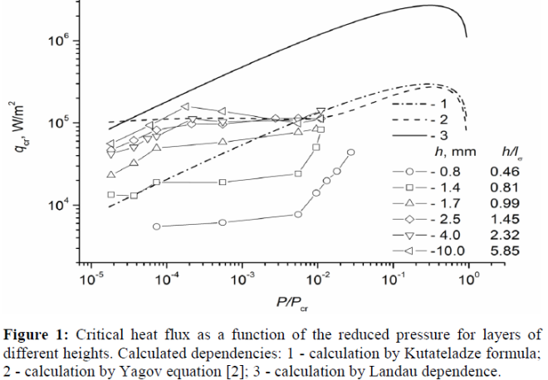
Recent Publications
- Zhukov VI, Pavlenko AN (2018) Int. J. Heat and Mass Transfer. 117:978–990.
- Yagov VV (2014) Int. J. Heat and Mass Transfer. 73:265-273.
- Zhukov VI, Pavlenko AN (2013) J. Eng. Thermophys. 22(4):257-287.
- Shishkina O, Wagner C (2008) J. Fluid Mech. 599:383-404
- Zhukov VI, Pavlenko AN, Nagaitseva YV, Weiss D (2015) High Temperature. 53:690-696.

Biography
Dr. Vladimir Zhukov is an Associate Professor at Novosibirsk State Technical University (since 1998). He graduated from the Department of Physics of Novosibirsk State University with a Speciality in Physics in 1982. He worked as an Еngineer at Novosibirsk Branch of the Chemical, Engineering Design Institute (1982-1993). He received his Ph.D. in Engineering Sciences (Kutateladze Institute of Thermophysics SB RAS) in 1991. To date, he has published 26 papers in journals in the field of science and technology. The scope of his scientific interests includes experimental study of heat and mass transfer processes in vacuum diffusion pumps, swirling flows, heat transfer and crisis phenomena at boiling and evaporation the film of liquids.

Presenting author details
Full name: Vladimir Zhukov
University: Novosibirsk State Technical University
Designation: Associate prof
Country: Russia
Mobile number: +7-905-937-02-60
Email: vizh@inbox.ru
Track number: 8-1
Category: Oral presentation
Research interest: heat transfer and crisis phenomena at boiling and evaporation
Your profile page URL in your department: https://ciu.nstu.ru/kaf/persons/1015
Year of birth: 04.10.1959
Linked In/Facebook/twitter account:

