New similarity solution of micropolar fluid flow problem over an upper horizontal surface of a paraboloid of revolution in the presence of quartic kind of autocatalytic chemical reaction
I. L. Animasaun,
Department of Mathematical Sciences, Federal University of Technology, Akure, PMB 704, Nigeria

Abstract (300 word limit)
The motion of air (i.e fluid) in which tiny particle rotates past a pointed surface of a rocket (as in space science), over a bonnet of a car and past a pointed surface of an aircraft is of important to experts in all these fields. Geometrically, all the domains of fluid flow in all these cases can be referred to as the upper horizontal surface of a paraboloid of revolution (uhspr). Meanwhile, the solution of the corresponding partial differential equation is an open question due to unavailability of suitable similarity variable to non-dimensionalize the angular momentum equation. This article unravels the nature of skin friction coefficient, heat transfer rate, velocity, temperature, concentration of homogeneous bulk fluid and heterogeneous catalyst which exists on a stretchable surface which is neither a perfect horizontal/vertical nor inclined/cone. Theory of similarity solution was adopted to obtain the similarity variable suitable to scale the proposed angular momentum equation. These equations along with the boundary conditions are solved numerically using Runge-Kutta technique along with shooting method. The similarity variable successfully non-dimensionalized and parameterized the angular momentum for boundary layer flow past uhspr. Temperature dependent dynamic viscosity parameter increases vertical velocity near a free stream but reduces micro-rotation near uhspr. Effect of thermal radiation parameter on temperature profile and heat transfer rate can be greatly influenced by thickness parameter.

Image
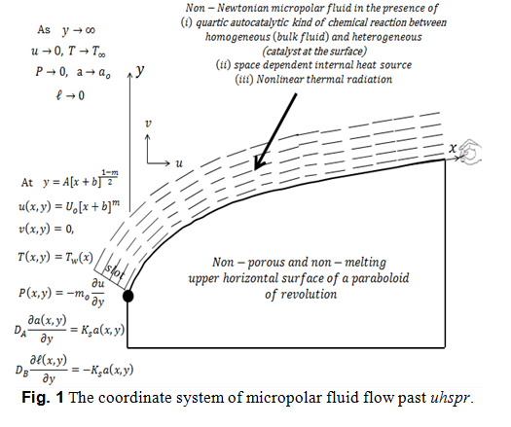
Recent Publications (minimum 5)
- Motsa S. S. and Animasaun I. L. (2016) Paired Quasi-Linearization Analysis of Heat Transfer in Unsteady Mixed Convection Nanofluid Containing Both Nanoparticles and Gyrotactic Microorganisms Due to Impulsive Motion. Journal of Heat Transfer 138: 114503. doi: 10.1115/1.4034039
- Makinde O. D. and Animasaun I. L. (2016) Bioconvection in MHD nanofluid flow with nonlinear thermal radiation and quartic autocatalysis chemical reaction past an upper surface of a paraboloid of revolution. International Journal of Thermal Sciences 109:159-171. doi: 10.1016/j.ijthermalsci.2016.06.003
- Koriko O.K., Omowaye A.J., Sandeep N. and Animasaun I.L. (2017) Analysis of boundary layer formed on an upper horizontal surface of a paraboloid of revolution within nanofluidflow in the presence of thermophoresis and Brownian motion of 29 nm CuO. International Journal of Mechanical Sciences 124 – 125: 22 – 36. doi: 10.1016/j.ijmecsci.2017.02.020
- Animasaun I. L. (2016) 47nm alumina–water nanofluid flow within boundary layer formed on upper horizontal surface of paraboloid of revolution in the presence of quartic autocatalysis chemical reaction. Alexandria Engineering Journal 55(3): 2375 – 2389. doi: 10.1016/j.aej.2016.04.030
- Animasaun I.L., Prakash J., Vijayaragavan R.and Sandeep N. (2017) Stagnation Flow of Nanofluid Embedded with Dust Particles Over an Inclined Stretching Sheet with Induced Magnetic Field and Suction. Journal of Nanofluids 6: 1–10. doi:10.1166/jon.2017.1308



Animasaun Isaac Lare was born and brought up in Osun-State, Nigeria. He obtained his first degree (Bachelor of Technology in Pure and Applied Mathematics; Fluid Dynamics) from Ladoke Akintola University of Technology, Oyo State, Nigeria. He completed his second degree (Masters of Technology in Industrial Mathematics; Fluid Dynamics) at Federal University of Technology, Akure, Ondo State (FUTA). Likewise his fourth degree (Doctor of Philosophy) in FUTA. Presently, he is doing his third degree (Post Graduate Diploma in Education) in National Open University of Nigeria. His research interests are educational research (survey research), mathematical modeling, boundary layer analysis, heat and mass transfer, dynamics of Newtonian and non-Newtonian fluid, flow through porous or non-porous media, approximate and analytical solution of ordinary and partial differential equation. He has published more than thirty (30) articles through various international peer-review journals. Also, he is a verified reviewer with 139 Reviewer Merit as at April 2017.
Email: anizakph2007@gmail.com
ilanimasaun@futa.edu.ng

Notes/Comments:

