Rapid Drop Bouncing on Oblique Superhydrophobic Surfaces with Two-tier Roughness
Rui Zhang, Pengfei Hao and Feng He*, Department of Engineering Mechanics, Tsinghua University, Beijing, China

Abstract
This paper investigates the complex physical phenomenon of oblique drop impact on superhydrophobic substrates with two-tier roughness (patterned with varied submillimeter-scale posts and coated with nano-particles). Experimental results show that the impact Weber number of drops and the solid fraction of the submillimeter-scale post structures are crucial for the outcomes of oblique drop collisions. Water droplets with 10<Wen<245 are found to rebound on all the test substrates. As the surface solid fraction decreases, four possible bouncing patterns occur in sequence, sliding rebound, stretched rebound, penetration rebound and breakup rebound. We demonstrate that the stretched rebound, in which the drops bounce off the surface rapidly in an elongated shape without tangential retraction, allows a 10%~30% reduction of contact time compared with conventional sliding rebound on oblique surfaces. Three types of stretched rebound are observed on substrates with moderate solid fraction (0.1<φ<0.5), in which the liquid detachment starts from front, center and tail, respectively. A simple analytical argument is presented to explain the occurrence of distinct patterns. These findings are believed to provide valuable guidance to the design of self-cleaning and anti-icing surfaces under oblique liquid impacts where rapid drop shedding is profitable.

Image
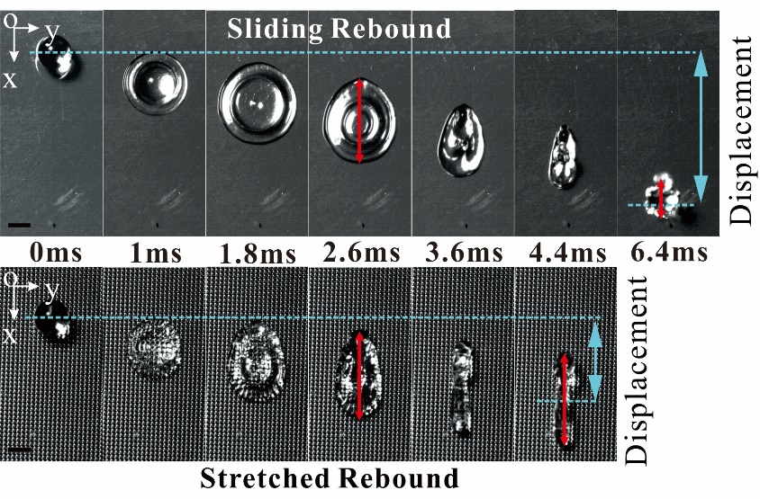
Recent Publications
- Zhang R, Hao PF, Zhang XW, He F. (2016) Dynamics of High Weber Number Drops Impacting on Hydrophobic Surfaces with Closed Micro-cells. Soft Matter 12: 5808.
- Zhang R, Hao PF, He F. (2016) Rapid Bouncing of High-speed Drops on Hydrophobic Surfaces with Micro-cavities. Langmuir 32: 9967-9974.
- Wang LW, Zhang R, Zhang XW, Hao PF. (2017) Numerical simulation of droplet impact on textured surfaces in a hybrid state. Microfluid Nanofluid 21: 61.
- Zhang R, Hao PF, He F. (2017) Drop Impact on Oblique Superhydrophobic Surfaces with Two-tier Roughness. Langmuir 33: 3556-3567.
- Zhang R, Hao PF, He F. (2017) Internal Rupture and Rapid Bouncing Induced by Submillimeter-scale Textures. Phys. Rev. E (Under Review)

 Biography
Rui Zhang has her expertise in microfluidic and passion in studying the microscopic nature of drop impacts and phase transition. She has done much research on the designing of self-cleaning and anti-icing materials in high-speed drop impact conditions. She found that hydrophobic surfaces with closed micro-cells could better repel impacting drops due to the air bubbles entrapped at the center. A center-assisted recoil was found by her on micro-cavities to induce internal rupture at a lower Weber number and rapid drop bouncing. The employment of submillimeter-scale posts on superhydrophobic surfaces could result in internal rupture on sparse posts and stretched rebound in oblique impact, both of which could reduce the contact time of bouncing drops. These findings are believed to provide valuable guidance to the design of self-cleaning and anti-icing surfaces in high-speed collisions.
Email: r-zhang13@mails.tsinghua.edu.cn

Notes/Comments:

