Partial and full substitution of fish meal and soybean meal by canola meal in diets for genetically improved farmed tilapia (O. niloticus):
Growth performance, carcass composition, serum biochemistry, immune response, and intestine histology
Maryam Iqbal Pakistan

Abstract (300 word limit)
The present study aimed to assess the eﬀects of partial or full
replacement of fish meal (FM) and soy bean meal (SBM) by canola meal (CM) on growth performance, health status, and cost benefit ratio of genetically improved farmed tilapia, Oreochromis niloticus. Fish (mean body weight 4.67 ± 0.07 g) were fed with five isonitrogenous (crude protein 396 g kg-1) diets: D I was set as the control; D II, D III, D IV, and D V were supplemented with CM at 25%, 50%, 75%, and 100% respectively. After 16 weeks of feeding, the optimum CM (%) for growth performance, feed utilization, carcass composition, and body indexes of O. niloticus were predicted at D III. Also, the following linear regression equation was acquired for weight gain versus CM (%) in diets: Y = -2.542x + 23.232; R2 = 0.9474. The survival rate remained unaﬀected among all the groups. Serum total protein, albumin content, and lysozyme activity increased in D I, D II, and D III; activity of liver functioning enzymes (SGPT and SGOT), triglycerides, total cholesterol, low-density lipoprotein-cholesterol, blood urea nitrogen, and creatinine level were elevated in groups D IV and D V (P < 0.05). Also, a significantly increased degree of variation and Uran’s pooled score were measured in intestine histology with increasing levels of CM supplementation (P < 0.05). Additionally, the optimum unitary feeding cost (UFC) was obtained in group D III (P < 0.05) along with polynomial equation: Y = 9.8 × 2– 47.39x + 176.44; R2 = 0.9674 between UFC and CM (%) in diets. Thus, FM and SBM could be replaced by CM up to 50% without compromising production, health status, and cost benefit for O. niloticus culture.

Image
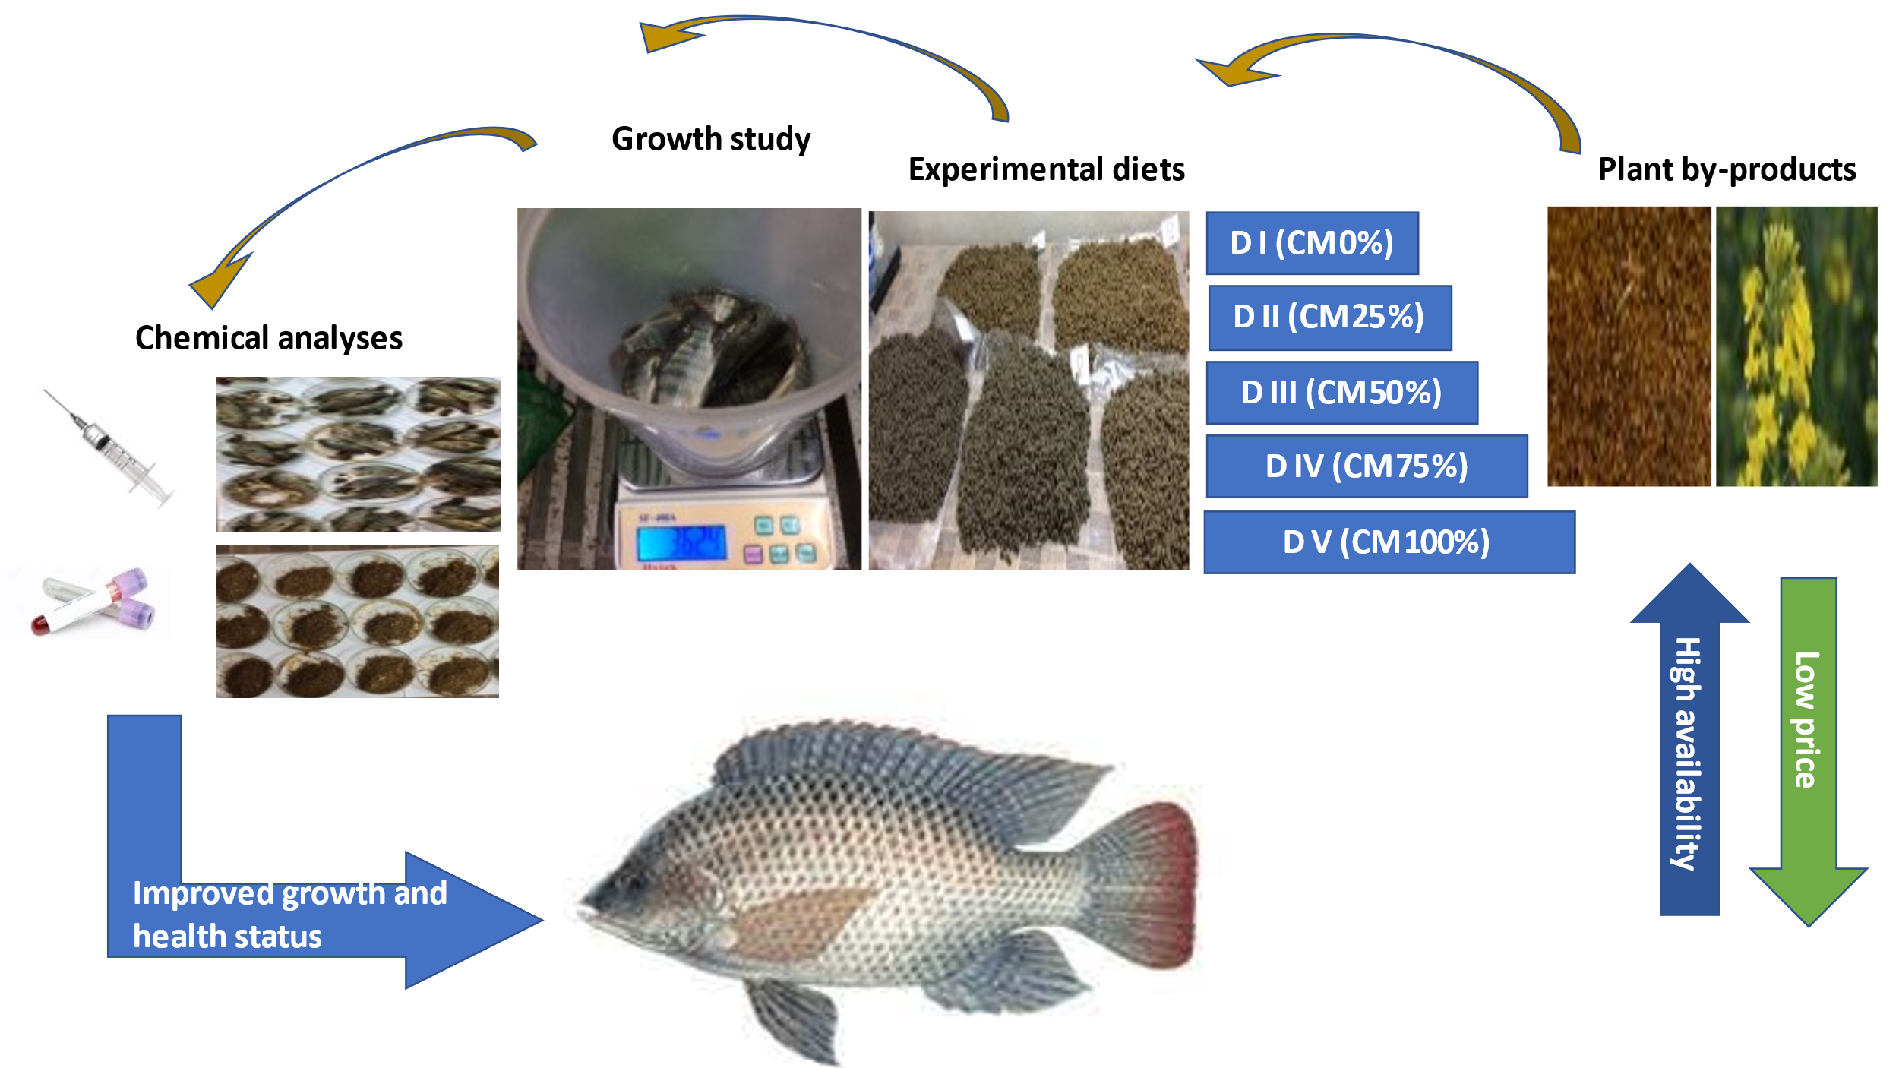
Recent Publications (minimum 5)
- Iqbal M, Afzal M, Yaqub A, Anjum KM, Tayyab K (2022). Combined Effects of Citric Acid and Phytase Supplementation on Growth Performance, Nutrient Digestibility and Body Composition of Labeo rohita Fingerlings. Aquaculture Studies 22: AQUAST656. http://doi.org/10.4194/ AQUAST656.
- Iqbal M, Yaqub A, Ayub M (2021). Partial and full substitution of fish meal and soybean meal by canola meal in diets for genetically improved farmed tilapia (O. niloticus): Growth performance, carcass composition, serum biochemistry, immune response, and intestine histology, Journal of Applied Aquaculture, DOI: 10.1080/10454438.2021.1890661.
- Yaqub, A, Kamran M, Malkani N, Anjum KM, Faheem M, Iqbal M, Khan R (2019). Mitochondrial COI gene based molecular identification and phylogenetic analysis in exotic fish of Pakistan (Oreochromis mossambicus). The Journal of Animal & Plant Sciences, 29(5): 1501-1518.
- Iqbal M, Afzal M, Anjum KM, Yaqub A, Shah SZH, Fatima M (2018). Growth response, antioxidant status and fatty acid profile of Cirrhinus mrigala fingerlings fed on practical diet after treated with vitamin E supplementation. Pakistan Journal of Zoology. Supplementary Issue, 13: 120-128.
- Tayyab K, Afzal M, Iqbal M, Arshad A, Aslam S, Batool M (2017). Enhanced digestibility of phytase treated canola meal-based diet for Labeo rohita fingerlings. The Journal of Animal & Plant Sciences, 27: 1386-1393.


Biography (150 word limit)

Maryam Iqbal has her expertise in the field of fisheries and aquaculture. She has contributed to a number of publications in fish nutrition and fish taxonomy. She has also participated in various national and international workshops, conferences and symposiums related to different fields of Fisheries & Aquaculture. She has worked as research assistant in a research project related to the tilapia productivity and also co-supervised various graduate and post-graduate fisheries and aquaculture students. She has vast experience in fish rearing and handling techniques, aquaculture feed designing and formulations, experiment designing, data collection and analysis techniques, research evaluation and using of statistical methodologies.
Email: maryam38c@yahoo.com

Notes/Comments:

NA
Presenting author details
Full name: Maryam Iqbal
Contact number: +92 331 8429767 (WhatsApp)
Twitter account: NA
Linked In account: NA
Session name: Fisheries Science and Fish Nutrition
Category: (Oral presentation)

