EVALUATION OF CORNEAL TOMOGRAPHIC CHANGES AFTER CORNEAL COLLAGEN CROSS LINKING IN PEDIATRIC KERATOCONUS

Ahmed Mohamed Osman ⁽¹⁾, Mohamed Shafik Shaheen ⁽²⁾, Tarek Abdel Razek Hafez ⁽³⁾ , Nancy Hazem Mohammed Zakaria⁽⁴⁾
⁽¹⁾Professor of Ophthalmology, Faculty of Medicine, University of Alexandria.
⁽²⁾Professor of Ophthalmology, Faculty of Medicine, University of Alexandria.

⁽³⁾ Assistant Professor of Ophthalmology, Faculty of Medicine, University of Alexandria.
⁽⁴⁾⁾Resident of Ophthalmology, Faculty of Medicine, University of Alexandria.
e-mail: nancyzakaria91@gmail.com

Introduction:
Pediatric keratoconus is a disease entity that is underdiagnosed. Even though there are extensive studies focusing on adult keratoconus, pediatric keratoconus is often overlooked.⁽¹⁾ This is probably due to the acceptable visual function in its early stages, which does not influence daily life activities, and therefore the effects of the condition are generally not evident to the patient nor the caregivers like parents or teachers.⁽²⁾ Nevertheless, it eventually results in considerable visual impairment that negatively impacts the quality of life by affecting social and educational development. This disease tends to be more aggressive in the children than in adults due to the dynamic environment in the young cornea as well as the often presence of co-existing atopy and vernal keratoconjunctivits. Both pediatric and adult keratoconus are managed using the same regimen based on the disease stage. Options include cross-linking, glasses, contact lenses, and keratoplasty. Corneal cross-linking treatment in particular has gained popularity over the past two decades. Due to its promising results in managing adult keratoconus, corneal cross-linking has recently been studied as therapy to slow advancement in pediatric keratoconus as well.⁽¹⁾ Although a recent global consensus on keratoconus states that there is no age restriction to CXL, literature on CXL in the pediatric population is limited compared with that of adults. Many published articles, however, report good safety and efficacy as well as substantial improvement of K readings, UCVA, and BCVA. ⁽³⁾

Objective:
To evaluate the corneal tomographic effects of cross-linking on pediatric keratoconus
Methods:
This research is retrospective, non-randomized, consecutive interventional study design in a sample of 30 eyes of 15 patients with Topographic findings consistent with keratoconus according to Robinowitz criteria from January 2012 to October 2016 of patient ages less than 18 years old, with a minimum corneal thickness at least 400 micrometers, and a minimum follow up period of 1 year after excluding those with history of herpetic keratitis and those with ocular or systemic disease that prevents wound healing. All patients were treated with CXL following the modified Dresden protocol by the same surgeon under sterile conditions. Records about the medical and surgical history were reviewed; all patients’ full pentacam study were reviewed pre-operatively and then at 3 months, 6 months, 1 year, and then annually thereafter.

Results:
A total of 30 eyes of 15 patients with mean age of 13.3 years (SD: 2.6, median: 13.0, range: 9 to 17 years) were enrolled. The sample was comprised of 35 males (47.9%) and 38 females (52.1%). Table 1 summarizes the preoperative and postoperative corneal topographic data obtained in the sample evaluated. As shown, statistically significant changes were detected during the follow-up in keratometric readings, Q, ACE, ISV, IVA, KI, and IHA (p≤0.030). Table 2 summarizes the preoperative and postoperative corneal pachymetric data obtained in the sample evaluated. As shown, statistically significant changes were detected during the follow-up in CCT and MCT (p<0.001). Concerning the X and Y coordinates of the position of the point of minimum thickness, no significant changes were detected during the follow-up (p≥0.169).
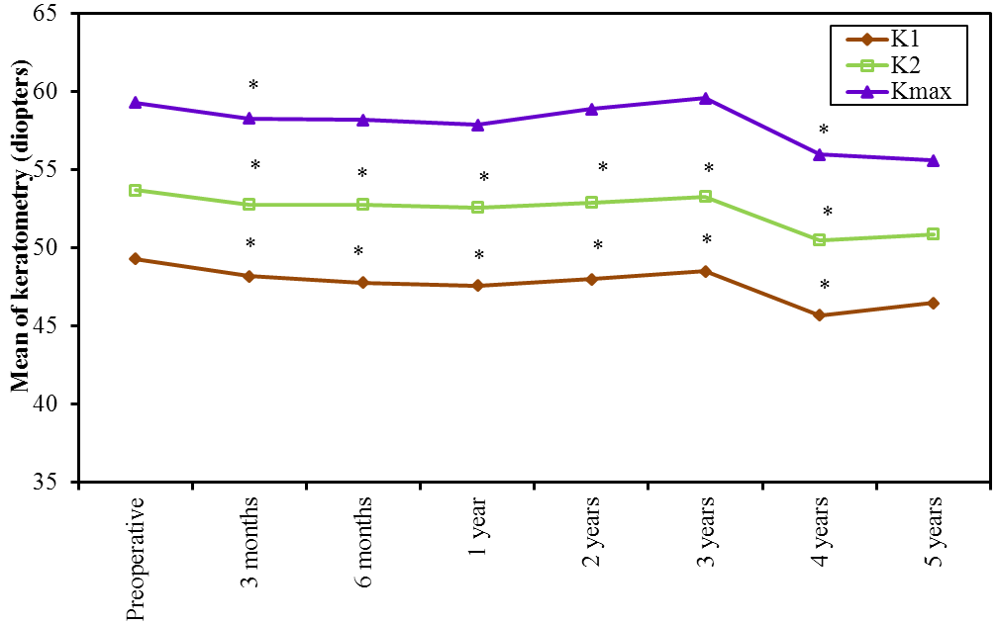

Figure (1): Comparison between the studied periods according to K1, K2 and Kmax
*: Statistically significant between preoperative and each other period
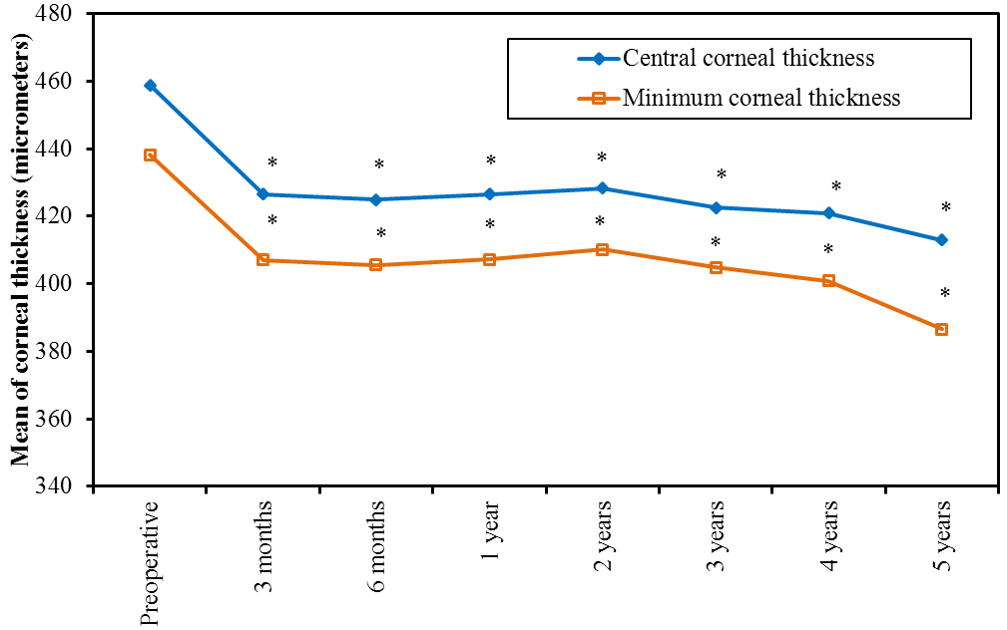
Figure (2): Comparison between the studied periods according to Central corneal thickness (micrometers) and minimum corneal thickness (MCT)
*: Statistically significant between preoperative and each other period

Conclusion
Cross-linking these children at first presentation shows benefits that outweigh risk factors of the procedure. From our point of view, cross-linking all pediatric keratoconus cases seems to be a logical decision taking into consideration that the consequences of the disease could be much more aggressive than the remote possibility of complications of the procedure itself. This is in line with literature regarding complications of cross-linking, especially that almost most reported no major complications.

References

- Mukhtar S, Ambati BK. Pediatric keratoconus: a review of the literature. Int Ophthalmol 2018; 38(5):2257-66.
- Buzzonetti L, Valente P, Petrocelli G. Keratoconus in Children. In: Alió JL (ed). Keratoconus: Recent Advances in Diagnosis and Treatment. Switzerland: Springer; 2017. 43-52.
- Gomes JA, Tan D, Rapuano CJ, Belin MW, Ambrósio R, Guell JL, et al. Global consensus on keratoconus and ectatic diseases. Cornea 2015; 34(4):359-69.

