New insights into deformation mechanisms for improved tensile properties in ‎nanocrystalline aluminum alloys
Khaled M Youssef, Qatar University, Doha, Qatar 2713
Sara I. Ahmed, Hammad Bin Khalifa University, Doha, Qatar

Abstract
Statement of the Problem: recent studies on the deformation behavior of nc Al reported unconventional plastic deformation ‎by twinning. It is well known that coarse-grained (CG) Al possesses a high stacking fault energy ‎that restricts its deformation by twinning. Yet molecular dynamic simulations (MDS) predicted ‎the formation of deformation twins in nc Al. Furthermore, twinning had been observed ‎experimentally in nc Al produced by ball milling and in nc Al films produced by physical ‎vapor deposition that was exposed to plastic deformation by micro indentation. It is ‎believed that the distinct structural features of the new nc atomic structure along with the ‎associated extremely high strength, could trigger unique plastic deformation mechanisms that can improve both mechanical strength and ductility‎.
Methodology & Theoretical Orientation: A bulk nanocrystalline (nc) Al-2%Li alloy was synthesized in this study using a combination of ‎cryogenic and room temperature milling. The mechanical behavior of this alloy was investigated ‎by tensile testing and microhardness measurements and compared with coarse-grained (CG) Al ‎alloys and pure nc Al synthesized by the same methodology.‎
Findings: The transmission electron microscopy analysis revealed that the grain size values of the nc Al-Li ‎alloy and nc pure Al are 18 nm and 29 nm, respectively. The nc Al-Li alloy showed ‎extraordinarily high yield and ultimate tensile strength values of 493 MPa and 618 MPa, ‎respectively. In addition, a high tensile ductility value of 14% was achieved in the nc Al-Li alloy ‎along with relatively high strain hardening exponent (0.11). The HR-TEM investigations ‎indicated the dependency of these extraordinarily tensile properties on multiple deformation ‎mechanisms such as dislocation slip and pile-up and deformation twinning.
Conclusion & Significance: The nanoscale grains along with deformation twining were observed in the Al-Li alloy. These structural features are believed to be responsible for the high yield and tensile strengths for nc Al-Li alloy, 493 MPa and 618 MPa, respectively and the high tensile ductility values of the nc Al-Li alloy of 14%.‎
Image

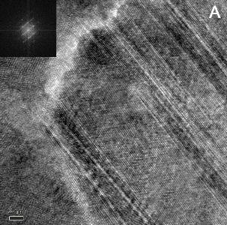
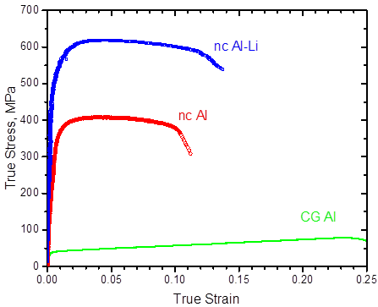

Figure: Tensile stress-strain curves for the nc Al, nc Al-Li, and the CG Al alloy sample along with the corresponding deformation twins in the nanograins.

Recent Publications (minimum 5)
- Yahia H. Ahmad, Assem T. Mohamed, Khaled M. Youssef, Subhajit Kundu, Andre Mkhoyan, ‎Siham Y. Al-Qaradawi, Electrochemistry ‎Communications, 101, 61-67 (2019).‎
- Mohamed Abaza, Leena Al-Sulaiti, Ronald Scattergood, Khaled Youssef, ‎Advanced Engineering Materials, 21, issue 2, 1800859 (2019).‎
- Khaled Youssef, Mohamed Abaza, Ronald Scattergood, and Carl Koch, ‎Materials Science and Engineering, A711, 350-355 (2018).‎
- Khaled Youssef, Alexander Zaddach, Changning Niu, Douglas Irving, Carl Koch “A Novel ‎Low Density, Materials Research Letters, Volume 2, Issue 3, 95-99 (2016).‎
- Suhrit Mula, Daria Setman, Khaled Youssef, R.O. Scattergood, Carl C Koch, Journal of Alloys and Compounds, 627, 108-116 (2015).‎
.

Biography
Dr. Khaled Youssef is an Associate Professor at the Department of Materials Science and Technology, Qatar University. ‎He got his PhD in Materials Science and Engineering from North Carolina State University, Dr. Youssef research ‎interests focuses on the evolution of nanostructures in metals, alloys, and composites using non-equilibrium processing ‎techniques, thermodynamics and kinetics of grain growth in nanomaterials, deformation mechanisms of ultra-fine ‎grained and nanocrystalline materials, and processing of ultra-tough, light-weight nanomaterials. He also was a ‎co-director of the Silicon Solar Consortium at North Carolina State University that mainly direct photovoltaic (PV) ‎research to achieve fundamental materials science and mechanics-based understanding on the influence of defects, ‎residual stresses, and impurities on the electrical properties and fracture mechanics/strength of mono- and ‎multi-crystalline PV silicon. Dr. Youssef got several research awards from the National Science Foundation (NSF), ‎Department of Energy (DOE), and Qatar Foundation National Priorities Research Proposal (QF-NPRP).
Email: kyoussef@qu.edu.qa

Notes/Comments:

