Ion Hopping in Protic Organic Ionic Plastic Crystals as Anhydrous Electrolytes For Fuel Cell Applications
Dr. Anurag Prakash Sunda
¹Department or Chemistry and Biochemistry,
Sharda University, INDIA

Abstract
Statement of the Problem: Highlighting importance of Polymer Electrolyte Membranes such as Nafion and current challenges for their use in PEM Fuel cells, I would like to introduce potential use of ionic liquids in anhydrous polymer electrolyte composites. I will discuss the use of theoretical methods such as Molecular Dynamics simulations in unveiling structural characteristics of these electrolyte materials at molecular level. I would like to discuss Ammonium-based ionic liquids and Organic Ionic Plastic Crystals which are suitable for PEM fuel cells as electrolyte. Most crucial aspect of electrolyte in fuel cell point of view is proton conduction and I will show ion-hopping mechanism in Protic Organic Ionic Plastic Crystals with an example of 1,2,4-triazolium perfluorobutanesulfonate ([TAZ][pfBu]).
Findings: In the plastic crystalline phase, ion rotation leads to a short life-time of the N–H…O hydrogen bond. The same has been characterized via h-bond lifetime correlation functions. The rotational disorder also allows for the hopping of ions at higher temperatures. The disorder and consequent ion hopping are accelerated due to vacancies in the crystal, and thus occur at lower temperatures (by at least 20 K) than in a perfect crystal. One-dimensional vacancy motion has been delineated and the free energy barrier for ion hopping has been estimated to be 2.5 and 6.0 kcal mol-1for cations and anions, respectively.

Conclusion & Significance: The results show the existence of a rotator phase wherein the cations, although translationally ordered are disordered rotationally and exhibit a tumbling motion which significantly affects hydrogen bond lifetimes. van Hove correlation functions characterize the concerted hopping of ions (cation or anion) at 500 K. Findings suggest that proton and ion transport influenced by facile hydrogen bond dynamics in the rotator phase contribute to the solid-state conductivity of POIPCs.

Ion-Hoping Mechanism and Free Energy
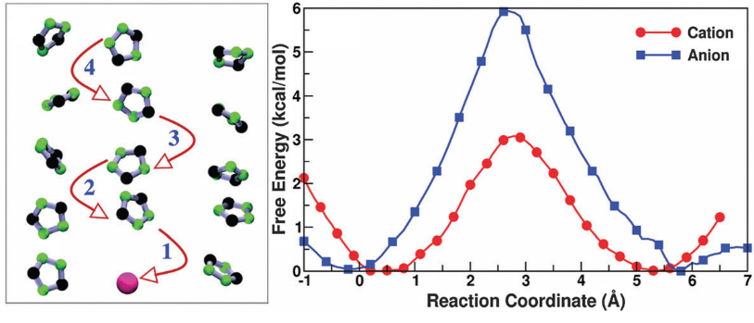
Recent Publications (minimum 5)
- Molecular Dynamics Simulations of Ammonium/Phosphonium-based Protic Ionic Liquids: Influence of Alkyl to Aryl Group
A. Mondal and A. P. Sunda* Phys. Chem. Chem. Phys., 2018, 20, 19268-19275.
- Nanoscale Defolding Influence of Polypeptide in Charge-Transfer Process through Organic-Inorganic Nano Hybrid System
P. Roy*, N. Kantor-Uriel, and A. P. Sunda* Nanoscale, 2018, 10, 11143-11149.
- Thermal Phase Bahavior and Ion Hopping in 1,2,4-Triazolium Perfluorobutanesulfonate Protic Organic Ionic Plastic Crystals,
A. Mondal, A. P. Sunda, and S. Balasubramanian* Phys. Chem. Chem. Phys., 2016, 18, 2047-2053.
- Ammonium-based Protic Ionic Liquid Doped Nafion Membrane as Anhydrous Fuel Cell Electrolyte,
A. P. Sunda* J. Mater. Chem. A, 2015, 3, 12905-12912.
- Atomistic Simulations of Ammonium-based Protic Ionic Liquids: Steric Effects on Structure, Low Frequency Vibrational Modes and Electrical Conductivity,
A. P. Sunda*, A. Mondal, and S. Balasubramanian* Phys. Chem. Chem. Phys., 2015, 17, 4625-4633.


Biography (150 word limit)
Dr. Anurag obtained M.Sc. Chemistry (2008), and M. Phil. Energy (2009) degree from University of Rajasthan, Jaipur and later moved to National Chemical Laboratory (NCL), Pune. He did Ph.D. (2010 - 2014) in Chemistry at Indian Institute of Science Education and Research (IISER), Pune and further pursued Post-doctoral Research supervised by Prof. Balasubramanian Sundaram at Jawaharlal Nehru Centre for Advanced Scientific Research (JNCASR), Bangalore. He received prestigious DST INSPIRE Faculty award and served as Assistant Professor in Central University of Haryana (2015-2017) and Central University of Rajasthan (2017-2019). At present, he obtained the position of an Associate Professor at the Sharda University and have published research articles in the area of Theoretical and Materials Chemistry.
Email: anurag.sunda@gmail.com

Notes/Comments:

