Knockdown of PGM1 enhances anticancer effects of orlistat in gastric cancer under glucose deprivation
Bo Cao, MD,PhD, Department of General Surgery, Chinese PLA General Hospital, Beijing 100853, China
Bo Wei, MD,PhD, Department of General Surgery, Chinese PLA General Hospital, Beijing 100853, China
Lin Chen, MD,PhD, Department of General Surgery, Chinese PLA General Hospital, Beijing 100853, China

Abstract (300 word limit)
Statement of the Problem: Phosphoglucomutase 1 (PGM1) acts as an important regulator in glucose metabolism. However, the role of PGM1 in gastric cancer (GC) remains unclear. This study aims to investigate the role of PGM1 and develop novel regimens based on metabolic reprogramming in GC. Methodology & Theoretical Orientation: Data derived from the Kaplan–Meier Plotter database were analyzed to evaluate correlations between PGM1 expression and survival time of GC patients. Cell counting kit-8, 5-Ethynyl-2-deoxyuridine, flow cytometry assays, generation of subcutaneous tumor and lung metastasis mouse models were used to determine growth and metastasis in vitro and in vivo. Cell glycolysis was detected by a battery of glycolytic indicators, including lactate, pyruvic acid, ATP production and glucose uptake. Fatty Acid Synthase (FASN) activity and expression levels of lipid enzymes were determined to reflect on lipid metabolism. Findings: Correlation and enrichment analyses suggested that PGM1 was closely associated with cell viability, proliferation and metabolism. PGM1 was overexpressed in GC tissues and cell lines. High PGM1 expression served as an indicator of shorter survival for specific subpopulation of GC patients. It was also correlated with pathological tumor stage and pathological tumor node metastasis stage of GC. Under the glucose deprivation condition, knockdown of PGM1 significantly suppressed cell viability, proliferation and glycolysis, whereas lipid metabolism was enhanced. Orlistat, as a drug that was designed to inhibit FASN activity, effectively induced apoptosis and suppressed lipid metabolism in GC. However, orlistat conversely increased glycolytic levels. Orlistat exhibited more significant inhibitive effects on GC progression after knockdown of PGM1 under glucose deprivation due to combination of glycolysis and lipid metabolism both in vitro and in vivo. Conclusion & Significance: Downregulation of PGM1 expression under glucose deprivation enhanced anti-cancer effects of orlistat. This combination application may serve as a novel strategy for GC treatment.

Image
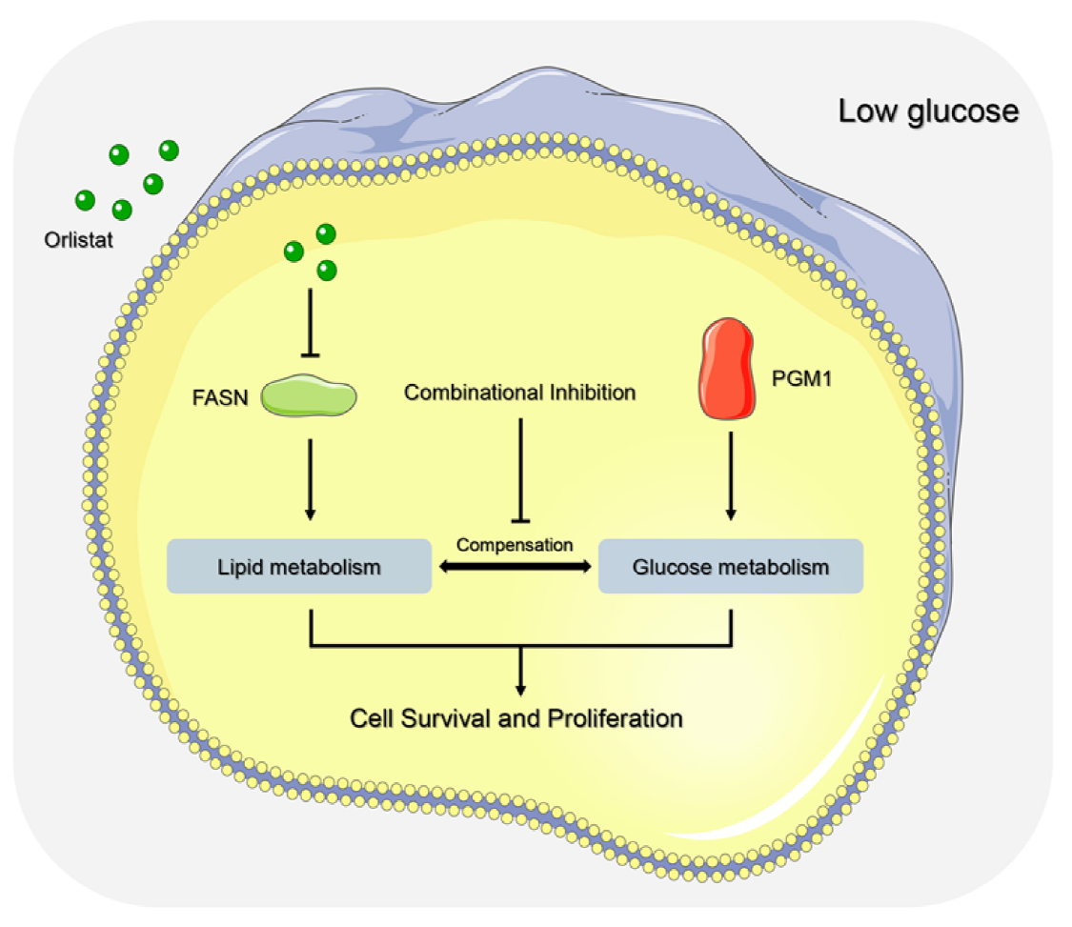
Fig.1 Schematic illustration of mechanisms of PGM1
Knockdown plus orlistat treatment in GC therapy.
Recent Publications (minimum 5)
1. Cao B, Liu G, Zhang W, Shi Y, Wei B. Role of circular RNAs and long non‑coding RNAs in the clinical translation of gastric cancer. Int J Mol Med 2021;47: 77-91.
2. Cao B, Zhang KC, Wei B, Chen L. Status quo and future prospects of artificial neural network from the perspective of gastroenterologists. World J Gastroenterol 2021;27: 2681-709.
3. Cui H, Cao B, Liu G, Xi H, Chen Z, Liang W, Zhang K, Cui J, Xie T, Deng H, Tang Y, Chen L, et al. Comparison of short-term outcomes and quality of life in totally laparoscopic distal gastrectomy and totally robotic distal gastrectomy for clinical stage I-III gastric cancer: study protocol for a multi-institutional randomised clinical trial. BMJ open 2021;11: e043535.
4. Wang Y, Cao B, Zhao R, Li H, Wei B, Dai G. Knockdown of circBFAR inhibits proliferation and glycolysis in gastric cancer by sponging miR-513a-3p/hexokinase 2 axis. Biochem Biophys Res Commun 2021;560: 80-6.
5. Zhao R, Cao B, Li H, Li T, Xu X, Cui H, Deng H, Wei B. Glucose starvation suppresses gastric cancer through targeting miR-216a-5p/Farnesyl-Diphosphate Farnesyltransferase 1 axis. Cancer Cell Int 2021;21: 704.

 Biography (150 word limit) 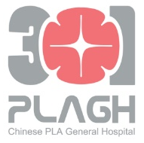
Bo Cao has his expertise in mechanism exploration of metabolic reprogramming and gastric cancer development. His findings uncover the mechanistic associations between glucose, lipid metabolism and cancer progression, further enriching the proof for the hypothesis of metabolism-driven cancer initiation and progress. They also provide novel diagnostic biomarkers, prognostic factors and therapeutic targets for clinical practice of gastric cancer. The regulatory relationships between noncoding RNAs and critical enzymes by the existing studies of Bo Cao.
Email: caobo_dark@163.com

Presenting author details
Full name: Bo Cao
Contact number: +86 13366898958
Twitter account: Not applicable
Linked In account: caobo_dark@163.com
Session name/ number: Metabolomics in the field of Oncology / Cancer Metabolomics
Category: Oral presentation or poster presentation

1. Cao B, Liu G, Zhang W, Shi Y, Wei B. Role of circular RNAs and long non‑coding RNAs in the clinical translation of gastric cancer (Review). Int J Mol Med 2021;47: 77-91.
2. Cao B, Zhang KC, Wei B, Chen L. Status quo and future prospects of artificial neural network from the perspective of gastroenterologists. World J Gastroenterol 2021;27: 2681-709.
3. Cui H, Cao B, Liu G, Xi H, Chen Z, Liang W, Zhang K, Cui J, Xie T, Deng H, Tang Y, Chen L, et al. Comparison of short-term outcomes and quality of life in totally laparoscopic distal gastrectomy and totally robotic distal gastrectomy for clinical stage I-III gastric cancer: study protocol for a multi-institutional randomised clinical trial. BMJ open 2021;11: e043535.
4. Wang Y, Cao B, Zhao R, Li H, Wei B, Dai G. Knockdown of circBFAR inhibits proliferation and glycolysis in gastric cancer by sponging miR-513a-3p/hexokinase 2 axis. Biochem Biophys Res Commun 2021;560: 80-6.
5. Zhao R, Cao B, Li H, Li T, Xu X, Cui H, Deng H, Wei B. Glucose starvation suppresses gastric cancer through targeting miR-216a-5p/Farnesyl-Diphosphate Farnesyltransferase 1 axis. Cancer Cell Int 2021;21: 704.

