Using Electrocoagulation to remove Chloride and Ammonium from Reject Brine treated by Solvay Process

Miada A. Ali, Master student, UAE University School of Chemical Engineering, UAE
Sulaiman Al-Zuhair, Professor, UAE University School of Chemical Engineering, UAE
Muftah H. El-Naas, Professor, Qatar University, Gas Processing Center, Doha, Qatar

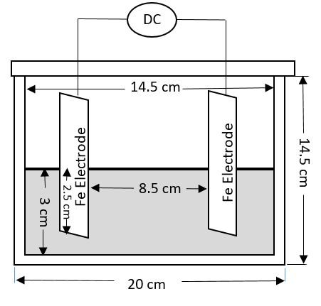

Abstract:
The excessive use of desalination, which is due to the increase in fresh water demand, results in large productions of reject brine. Therefore, the development of an efficient treatment process of the reject brine becomes vital. The Solvay process is one of the main treatment technologies, wherein NH₃ is introduced to converting soluble Na⁺ into insoluble NaHCO₃. Although the concentration of Na⁺ ions are reduced in this process, Cl⁻ ions are not affected. In addition, the concentration of ${NH}_{4}^{+}$ ions increase. Electrocoagulation has been tested for the remove Cl⁻ and ${NH}_{4}^{+}$ ions and to regenerate the NH₃. When no current was applied, a very small removal of the ions was recorded. Applying a current density of 0.1167 A/cm² caused an increase in the removal of${NH}_{4}^{+}$ and Cl⁻, by 45.9% and 25.87%, respectively at 20°C, 71.55% and 26.88%, respectively at 30°C. This clearly proves that the main removal was due to the electrocoagulation. The effects of current density, initial concentration, and temperature have been studied on the ions removal. It was found that increasing the current density and/or the temperature was found to decrease the residual ions concentration. Whereas, increasing the initial ions concentration resulted in decreasing the percentage removal.

Figure1: Schematic diagram of the batch reactor


Miada A. Ali has completed her bachelor at the age of 26 years from UAE University. Since 2014, she joined United Arab Emirates University as a research assistant. Currently, she is a post graduate student in Chemical Engineering Department at the United Arab Emirates University.
Email: miada-ali@hotmail.com

