Evaluation and design of different membrane plants
Grazia Leonzio
Department of Industrial and Information Engineering and Economics, University of L'Aquila, Via Giovanni Gronchi 18, 67100 L'Aquila, Italy;

In this research, two different plants combining nanofiltration and ultrafiltration are evaluated and compared, for a wastewater treatment plant at industrial scale. A design and economic analysis is developed using the experimental data of a pilot plant. In the first plant, an ultrafiltration module is followed by nanofiltration module. The retentate of the ultrafiltration is recycled to the feed, that is partially sent to the permeate of the nanofiltration module. In this way, the area of membrane is reduced. In the second scheme, all feed is sent to the nanofiltration module. The feed stream, in the two conditions, is the current at the exit of sand filters, at the downstream of settler.
From a pilot plant data, an average feed flow rate equal to 4.46 m³/h result. In the first plant, from material balance it is found that for the ultrafiltration the value of retentate and permeate flow rate, membrane area and VCR are equal to 27 m³/h, 32 m³/h, 797 m² and 2.2 respectively. For the nanofiltration the value of retentate and permeate flow rate, membrane area and CVR are respectively equal to 11.4 m³/h, 21 m³/h, 1711 m² and 2.8. The COD at the exit of the system is 197 mg/l. The energetic cost is 57300 €/year.
In the second plant, for the ultrafiltration, the value of retentate and permeate flow rate and membrane area are respectively 33.5 m³/h, 40.3 m³/h and 2155 m². For the nanofiltration, the value of retentate and permeate flow rate and membrane area are respectively 14.4 m³/h, 25.9 m³/h and 2155 m². The COD at the exit is 95 mg/l while the energetic cost is 73200 €/year. The higher cost is due to the higher flow rate at the ultrafiltration system, however the value of COD at the exit is lower and according the legislation.

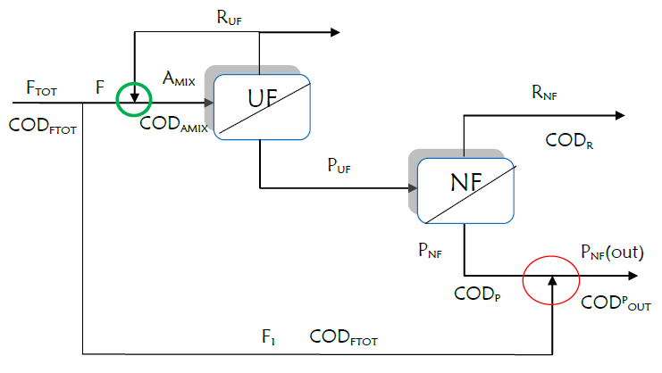
Figure 1 Process scheme of membrane plant with ultrafiltration and nanofiltration: the feed is partially sent to the permeate of the nanofiltration

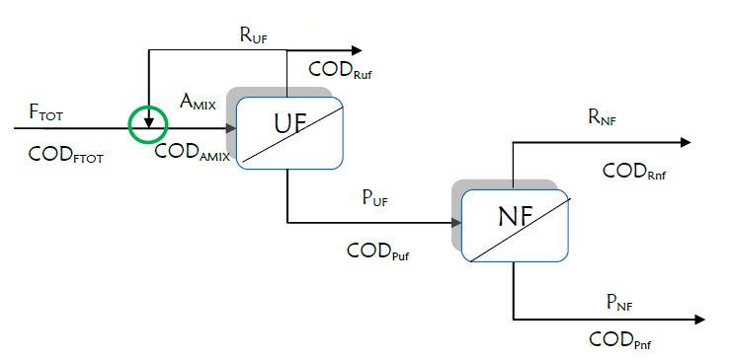
Figure 2 Process scheme of membrane plant with ultrafiltration and nanofiltration


Biography
Grazia Leonzio is a PhD student from L’Aquila University. She published several articles and participated to several international and national congresses about environmental and energy aspect of chemical processes. She wrote an article about waste management in Italian regions and published in Columbia University web-side. She participated to M.U.N conferences and she is a member of several associations: A.I.D.I.C. (Italian Association of Chemical Engineering), S.C.I. (Italian Chemical Society), I.S.S.N.A.F. (Italian Scientists and Scholars in North America), E.C.A.S. (European Commission Authentication Service). She is a referee of several journals.
Email: grazia.leonzio@graduate.univaq.it

Notes/Comments:

