Study of the Retention of Hydrophobic Actives From Cosmetic Emulsions on Optimized Human Skin Mimics
Georgios Gkotsis, PhD, School of Chemical Engineering, University of Birmingham

Abstract (300 word limit)

All in one shower products, that not only clean but also hydrate and nutrient human skin, exhibit an increased popularity in the current cosmetic market making it vital to study and understand the efficiency of these products and compare them to conventional body wash emulsions. Retention of hydrating actives on human skin following the use of these skin care formulations is a very good indication of the performance of the deposited products. In this work, a system that replicates all the steps of interaction between human skin and cosmetic emulsions has been developed to define the key parameters driving retention. This system included the fabrication of an optimized skin mimic, the formulation of a model system cosmetic emulsion, the development of a deposition set-up, a cleaning set-up and the characterization process of retention that included optical and surface characterization techniques. The hydrating agent studied was petrolatum, an extensively used material in various cosmetic and pharmaceutical applications because of its moisturizing and occlusive abilities. The effect of particle size of this hydrophobic agent in retention was studied by producing three different levels of particle size formulations and test them all in the same skin mimics. It was proved that larger particle size products exhibited increased retention a phenomenon that was attributed to the smaller surfactant to petrolatum ratio and consequently the reduced counter effect of the surfactant.

Image
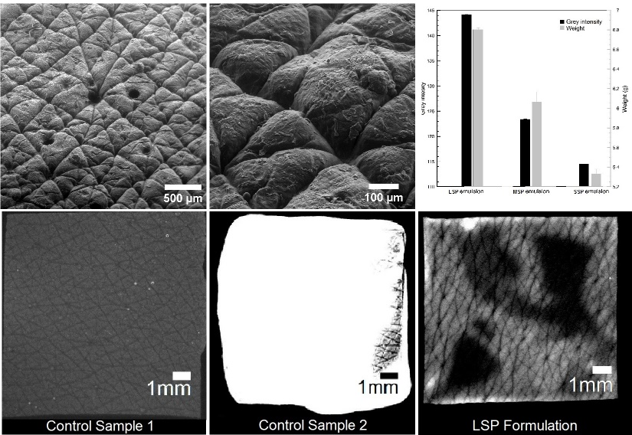
Recent Publications (minimum 5)
[1] Facq J., A simple replica technique for the ocservation of human skin, J. Soc. Cosmet. Chem., 15, 87-98 (1964)
[2] Charkoudian J. C., A model skin surface for testing adhesion to skin, J. Soc. Cosmet. Chem., 39, 225-234 (July/August 1988)
[3] Flick E. W., Cosmetic and toiletry Formulations, Second edition, Volume 2, Noyes Publications, New Jersey, USA, 1992
[4] Morrison D. S., Petrolatum A Useful Classic, Cosmetics & Toiletries magazine Vol. 111, January 1996
[5] Mercade-Prieto R., Methodological study on the removal of solid oil and fat stains from cotton fabrics using abrasion, Textile Research Journal 84(1) 52–65, 2014

Biography (150 word limit)
Georgios Gkotsis is a chemical engineer with a five-year diploma from the National and Technical University of Athens. During his undergraduate studies his expertise was in polymer technology and biomedical applications of nano-composite materials. He is currently working as a PhD student in the chemical engineering department of the University of Birmingham in a project funded by Procter and Gamble and under the supervision of Pola Goldberg Oppenheimer. The project aims in understanding the mechanisms of retention of hydrophobic actives in cosmetic formulations on human skin. A multi-method approach of characterizing retention and the development of a skin mimic, a deposition and a cleaning set up that mimic all parts of the skin-product interactions are all subjects of interest and investigation in his work.

Email: GXG434@student.bham.ac.uk
Notes/Comments:

