Exo-III Assisted Amplification Strategy through target recycling of Hg²⁺ detection in Water: A GNP Based Label-free Colorimetry employing T-rich hairpin-loop metallobase


Paste your Logo here
Abdul Ghaffar Memon^{a,b}, Zhou Xiaohong^{a*}, Xing Yunpengª, Wang Ruoyuª, He Miao^{a**}
a. State Key Joint Laboratory of ESPC, Center for Sensor Technology of Environment and Health, School of Environment, Tsinghua University, Beijing 100084, China
b. Department of Environmental Engineering, NED University of Engineering and Technology, Karachi 75270, Pakistan.

Abstract (300 word limit)
Due to deleterious environmental and health effects of the Hg²⁺ ions, various online, detection methods apart from the traditional analytical tools have been developed by researchers. Biosensors especially, label, label-free, colorimetric and optical sensors have advanced with sensitive detection. However, there remains a gap of ultrasensitive quantification as noise interact significantly especially in the AuNP based label-free colorimetry.
This study reported an amplification strategy using Exo-III enzyme for target recycling of Hg²⁺ ions in a T-rich hairpin loop metallobase label-free colorimetric nanosensor with an improved sensitivity using unmodified gold nanoparticles (uGNPs) as an indicator. The two T-rich metallobase hairpin loop structures as 5’- CTT TCA TAC ATA GAA AAT GTA TGT TTG -3 (HgS1), and 5’- GGC TTT GAG CGC TAA GAA A TA GCG CTC TTT G -3’ (HgS2) were tested in the study. The thermodynamic properties of HgS1 and HgS2 were calculated using online tools (http://biophysics.idtdna.com/cgi-bin/meltCalculator.cgi). The lab scale synthesized uGNPs were utilized in the analysis. The DNA sequence had T-rich bases on both tails end, which in the presence of Hg²⁺ forms a T-Hg²⁺-T mismatch, promoting the formation of dsDNA. Later, the Exo-III incubation enable the enzyme to cleave stepwise mononucleotides from the 3’ end until the structure become single-stranded. These ssDNA fragments then adsorb on the surface of AuNPs in their presence and protect AuNPs from the induced salt aggregation. The visible change in color from blue (aggregation stage in the absence of Hg²⁺) and pink (dispersion state in the presence of Hg²⁺ and adsorption of ssDNA fragments) can be observed and analyzed through UV spectrometry.
An ultrasensitive quantitative nanosensor employing Exo-III assisted target recycling of mercury ions through label-free colorimetry with nanomolar detection using uGNPs have been achieved and is further under the optimization to achieve picomolar range by avoiding the influence of the environmental matrix. The proposed strategy will supplement in the direction of uGNP based ultrasensitive, rapid, onsite, label-free colorimetric detection.

Image
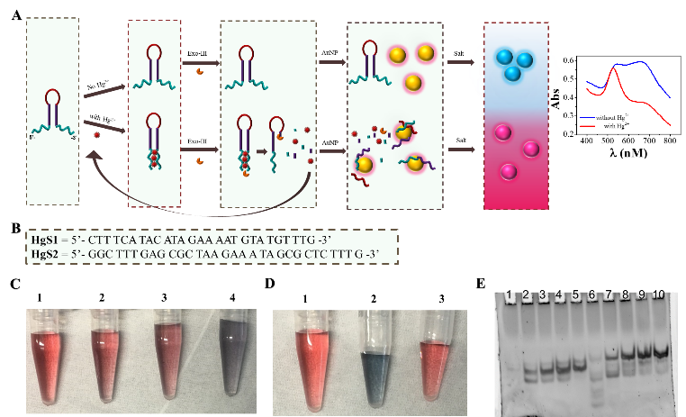
Figure 1 Schematic diagram of the sensing principle (A), T-rich hairpin sequences used in the study (B), optimization parameters using salt (C), DNA (D), and performance of the two sequences (E)
Recent Publications (minimum 5)
- A. G. Memon, X. Zhou, R. Wang, L. Liu, Y. Peng, J. Liu, M. He, (2017) “Label-free colorimetric nanosensor with improved sensitivity for lead ions (Pb²⁺) in water,” The 5th International Conference on Environmental Simulation and Pollution Control, 2017
- R. Wang, X. Zhou, B. Liedberg, X. Zhu, A. G. Memon, and H. Shi, “Screening Criteria for Qualified Antibiotic Targets in Unmodified Gold Nanoparticles-Based Aptasensing,” ACS Appl. Mater Interfaces, vol. 9, no. 40, pp. 35492–35497, 2017.
- A. G. Memon, X. Zhou, J. Liu, R. Wang, L. Liu, B. Yu, M. He, and H. Shi, “Utilization of unmodified gold nanoparticles for label-free detection of mercury (II): Insight into rational design of mercuryspecific oligonucleotides,” J.Hazard.Mater.,vol. 321, 2017.
- L. Liu, X. Zhou, M. Lu, M. Zhang, C. Yang, R. Ma, A. G. Memon, H. Shi, and Y. Qian, “An array fluorescent biosensor based on planar waveguide for multi-analyte determination in water samples,” Sensors Actuators, B Chem., vol. 240, pp. 107–113, 2017.
- A. G. Memon, J. Liu, R. Wang, L. Zhang, L. Liu, M. He, X. Zhou, (2016) "Utilization of unmodified gold nanoparticles for label-free detection of Hg2+: Insight into rational design of aptamer," 26th Anniversary World Congress on Biosensors


Biography (150 word limit)
Memon Abdul Ghaffar is a PhD scholar in the School of Environment, Tsinghua University, His area of research is label-free colorimetric biosensor for water environment monitoring. He is affiliated with the Modern Environmental Monitoring Technology lab of the State Key Joint Laboratory of Environmental Simulation and Pollution Control (ESPC), Center for Sensor Technology of Environment and Health, School of Environment, Tsinghua University, Beijing 100084, China. Mr. Memon is faculty member and on study leave from the Department of Environmental Engineering, NED University of Engineering and Technology, Karachi 75270, Pakistan
Email: agm4us@gmail.com, Contact no: +86 130 1126 5447
Track name: Environmental Biosensors
Notes/Comment

