Title: Measles Inclusion Body Encephalitis Case
Name: David Muir¹, Nick Davies¹, Michael Osborn¹, Alessia Dalla Pria² and Kevin Brown³
1: Imperial College Healthcare NHS Trust, London.
2: Chelsea & Westminster NHS Trust, London.
3: Virus Reference division, PHE, Colindale, London.

Abstract (300 word limit)
An HIV-positive man with low CD4 count and a history of childhood measles infection, and who had a probable measles contact a month after successfully completing rituximab chemotherapy for lymphoma, developed a progressive meningoencephalitis to which he succumbed within 2 months of onset. The patient did not develop a rash or other signs of measles infection, but clinical presentation and laboratory findings were typical of measles inclusion body encephalitis, which was ultimately confirmed on brain biopsy. The viral strain obtained from the brain biopsy in this case was subsequently determined as being the same as that of the index case. No mutations of potential relevance have so far been identified.

Image

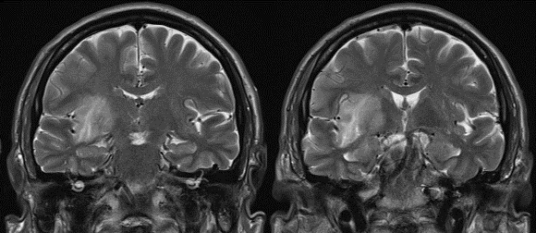

Recent Publications

- Consistent high prevalence of undiagnosed blood-borne virus infection in patients attending large urban emergency departments in England Hopkins, Mark; Todd, Stacy; Beadsworth, Mike; Anderson, Charlotte; Mohamed, Zameer; Muir, David; Vivancos, Roberto; Brown, Ashley; Ruf, Murad; Chawla, Anu, Journal of Viral Hepatitis – 2020; 27:88-91

Cerebrospinal fluid HIV RNA in persons living with HIV. Di Carlofelice M¹, Everitt A², Muir D², Winston A^{1,2}. HIV Med. 2018 April;19(5):365-368
- The ENABLE projects: Consistent high prevalence of undiagnosed active blood borne virus infection [HBV, HCV, HIV] across four urban emergency departments in England – Data for action? M. Hopkins, S. Todd, M. Beadsworth, R. Vivancos, C. Anderson, D. Muir… Journal of Hepatology, April 2018; 68(1): S156
- Chronic Hepatitis E-Genotype 3 Infection in Transplant Recipients: A Single Kidney and Pancreas Transplant Centre Experience. Kousios A, Charif R, Sanchez E, Khan S, Regan F, Ijaz S, Muir D, Smith B, Tedder R, Taube D, Galliford J. Am J Transplant. 2017; 17 (suppl 3).




Biography (150 word limit)

David Muir works as a Consultant Virologist at Imperial College Healthcare NHS Trust (London, UK), also covering a number of neighbouring hospitals. His main interest is clinical virology, including diagnosis and patient management, and he enjoys partaking in collaborative projects with colleagues from various departments and institutions.

Email: david.muir6@nhs.net

Notes/Comments:

